1. Design a Login page

activity_main.xml

<**LinearLayout**

**android:layout_height="match_parent"**

**android:layout_width="match_parent"**

**android:orientation="vertical"**

**xmlns:android="http://schemas.android.com/apk/res/android"**>

<**TextView**

**android:paddingTop="50dp"**

**android:id="@+id/tv1"**

**android:layout_width="204dp"**

**android:layout_height="wrap_content"**

**android:layout_gravity="center"**

**android:text="Username"** />

<**EditText**

**android:id="@+id/et1"**

**android:layout_width="204dp"**

**android:layout_height="wrap_content"**

**android:layout_gravity="center"** />

<**TextView**

**android:id="@+id/tv2"**

**android:layout_width="200dp"**

**android:layout_height="wrap_content"**

**android:layout_gravity="center"**

**android:text="Password"** />

<**EditText**

**android:id="@+id/et2"**

**android:layout_width="200dp"**

**android:layout_height="wrap_content"**

**android:layout_gravity="center"**

**android:inputType="textPassword"**/>

<**Button**

**android:id="@+id/bt1"**

**android:layout_width="wrap_content"**

**android:layout_height="wrap_content"**

**android:layout_gravity="center"**

**android:background="@color/colorPrimary"**

**android:text="Login"**

/>

</**LinearLayout**>

MainActivity.java

**package** com.example.sjcet.loginpage;

**import** android.support.v7.app.AppCompatActivity;

**import** android.os.Bundle;

**public class** MainActivity **extends** AppCompatActivity {

@Override

**protected void** onCreate(Bundle savedInstanceState) {

**super**.onCreate(savedInstanceState);

setContentView(R.layout.***activity_main***);

}

}

Output

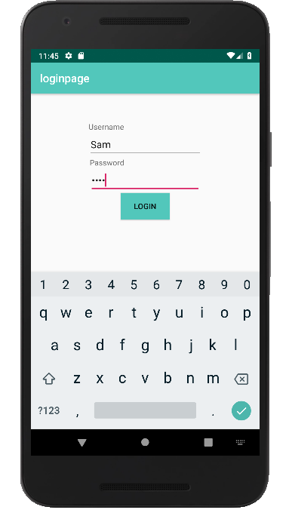

2.Change the content in the textview on a Button click.

activity_main.xml

<**LinearLayout**

**android:layout_height="match_parent"**

**android:layout_width="match_parent"**

**android:orientation="vertical"**

**xmlns:android="http://schemas.android.com/apk/res/android"**>

<**TextView**

**android:id="@+id/tv1"**

**android:textAlignment="center"**

**android:paddingTop="200dp"**

**android:paddingBottom="10dp"**

**android:layout_width="94dp"**

**android:layout_height="wrap_content"**

**android:layout_gravity="center"**

**android:text="sam john vj"** />

<**Button**

**android:id="@+id/b1"**

**android:layout_width="98dp"**

**android:layout_height="wrap_content"**

**android:layout_gravity="center"**

**android:onClick="change"**

**android:text="change"** />

</**LinearLayout**>

MainActivity.java

**package** com.example.sjcet.buttononclick;

**import** android.support.v7.app.AppCompatActivity;

**import** android.os.Bundle;

**import** android.view.View;

**import** android.widget.Button;

**import** android.widget.TextView;

**public class** MainActivity **extends** AppCompatActivity {

TextView **tv**;

@Override

**protected void** onCreate(Bundle savedInstanceState) {

**super**.onCreate(savedInstanceState);

setContentView(R.layout.***activity_main***);

**tv** = findViewById(R.id.***tv1***);

}

**public void** change(View view) {

**tv**.setText(**"SAM JOHN VJ"**);

}

}

output

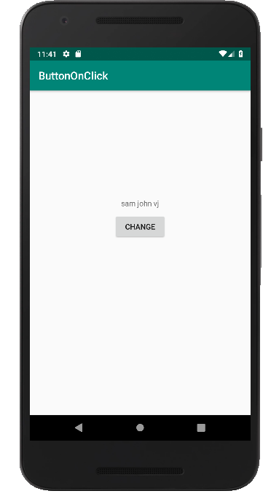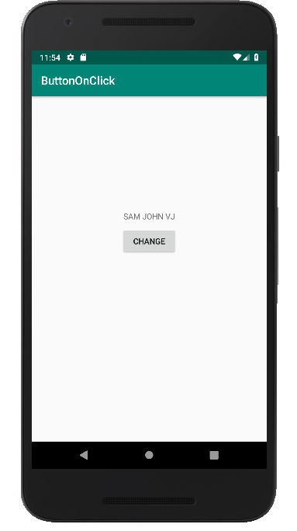

3. Read input from EditText and print it in a TextView.

activity_main.xml

<**LinearLayout**

**android:layout_height="match_parent"**

**android:layout_width="match_parent"**

**android:orientation="vertical"**

**xmlns:android="http://schemas.android.com/apk/res/android"**>

<**EditText**

**android:id="@+id/et1"**

**android:paddingTop="200dp"**

**android:layout_width="wrap_content"**

**android:layout_height="wrap_content"**

**android:ems="10"**

**android:layout_gravity="center"**

**android:inputType="textPersonName"**

**android:hint="Enter your name"** />

<**Button**

**android:id="@+id/button"**

**android:layout_width="218dp"**

**android:layout_height="wrap_content"**

**android:onClick="change"**

**android:layout_gravity="center"**

**android:text="Submit"** />

<**TextView**

**android:id="@+id/tv1"**

**android:layout_width="378dp"**

**android:layout_height="89dp"**

**android:layout_gravity="center"**

**android:textAlignment="center"**

**android:textSize="30dp"** />

</**LinearLayout**>

MainActivity.java

**package** com.example.sjcet.edittext3;

**import** android.support.v7.app.AppCompatActivity;

**import** android.os.Bundle;

**import** android.view.View;

**import** android.widget.EditText;

**import** android.widget.TextView;

**public class** MainActivity **extends** AppCompatActivity {

TextView **tv**;

EditText **et**;

@Override

**protected void** onCreate(Bundle savedInstanceState) {

**super**.onCreate(savedInstanceState);

setContentView(R.layout.***activity_main***);

**tv** = findViewById(R.id.***tv1***);

**et** = (EditText)findViewById(R.id.***et1***);

}

**public void** change(View view) {

String name = **et**.getText().toString();

**tv**.setText(name);

}

}

output

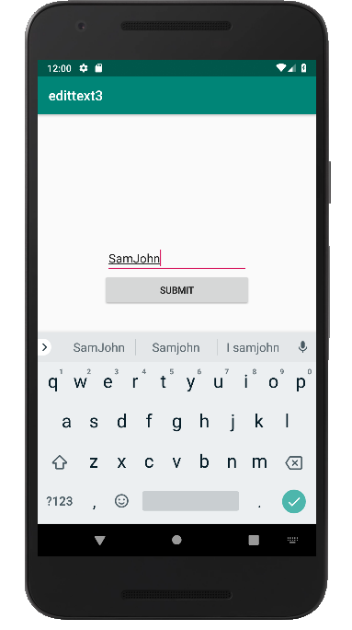

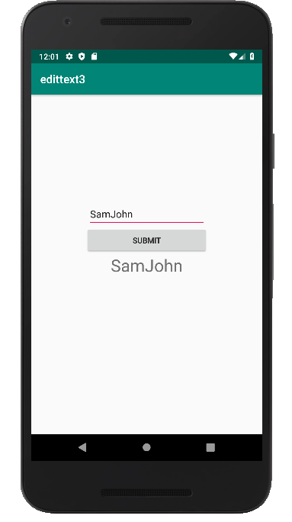

4.Change Background color on a ButtonClick.

activity_main.xml

<**LinearLayout**

**android:id="@+id/l1"**

**android:layout_height="match_parent"**

**android:layout_width="match_parent"**

**android:paddingTop="200dp"**

**xmlns:android="http://schemas.android.com/apk/res/android"**>

<**Button**

**android:id="@+id/b1"**

**android:layout_width="match_parent"**

**android:layout_height="wrap_content"**

**android:text="click to change color"**

**android:onClick="click"**

/>

</**LinearLayout**>

MainActivity.java

**package** com.example.sjcet.bgcolor4;

**import** android.support.v7.app.AppCompatActivity;

**import** android.os.Bundle;

**import** android.view.View;

**import** android.widget.Button;

**import** android.widget.LinearLayout;

**public class** MainActivity **extends** AppCompatActivity {

@Override

**protected void** onCreate(Bundle savedInstanceState) {

**super**.onCreate(savedInstanceState);

setContentView(R.layout.***activity_main***);

Button b;

**final** LinearLayout layout;

layout = findViewById(R.id.***l1***);

b = findViewById(R.id.***b1***);

b.setOnClickListener(**new** View.OnClickListener() {

@Override

**public void** onClick(View view) {

layout.setBackgroundResource(R.color.***colorPrimaryDark***);

}

});

}

**public void** click(View view) {

}

}

output

