**OPERATING SYSTEM**

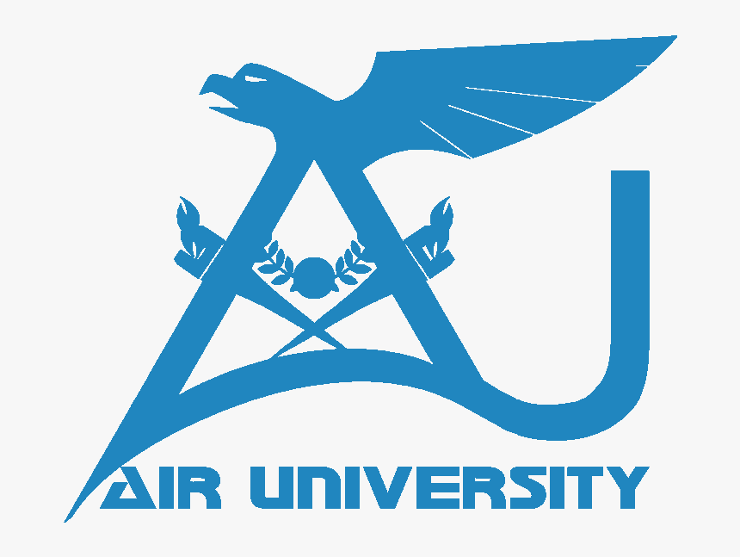

Session-Fall-24

**Submitted by:**

**Name:** Syed Mozamil Shah

**ID:** 221418

**Section:** BSCS-4-C

**Submitted to:** Mam Warda Aslam

**Department of Computer Science**

**Faculty of Computing and AI**

**Air University, Islamabad**

**1. Introduction**

Operating systems (OS) form the backbone of modern computing, orchestrating hardware and software to deliver seamless user experiences. Among the plethora of operating systems, mobile OS like iOS and Android dominate the smartphone market, while macOS caters to the desktop and laptop segments with its focus on creative and professional users. Each OS has evolved uniquely, offering distinct features and architectures that address varying user needs and technological landscapes.

The significance of a comparative analysis between mobile and desktop operating systems lies in understanding their design philosophies, technological advancements, and their adaptation to user demands. For example, mobile OS emphasizes portability, energy efficiency, and app ecosystems, while macOS excels in robust file systems, multitasking, and integrated ecosystems. Such analyses also reveal how innovations in one domain influence the other, fostering a symbiotic evolution.

This paper draws insights from two key research studies: "Development of iOS: A Revolutionary Transformation and the Future" by Verma and Sambhav​, and "Specification Study of Android Operating System" by Kumar​. These works provide a comprehensive understanding of the architecture, features, and security mechanisms of iOS and Android, while this analysis contrasts them with macOS in the context of core operating system concepts.

### ****2. Overview of the Selected Operating Systems****

#### **2.1. iOS Overview**

**Historical Development and Core Architecture**

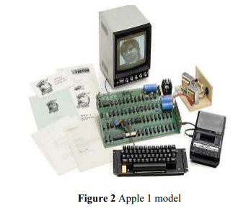  
iOS, first launched as iPhone OS in 2007, marked a revolutionary shift in mobile technology with its pioneering multi-touch interface. Developed exclusively by Apple Inc., it introduced a tightly integrated ecosystem of hardware and software. The rebranding to "iOS" in 2010 reflected its broader applicability across devices like the iPhone, iPad, and iPod. Its layered architecture includes the Core OS, Core Services, Media, and Cocoa Touch frameworks, each fulfilling essential roles like multitasking, network access, and UI management. This architecture enables developers to create efficient, secure, and user-friendly applications (Verma & Sambhav, 2020)​.

**Key Features and Innovations**  
Notable innovations in iOS include the introduction of the App Store in 2008, which transformed app distribution and monetization. Apple's emphasis on security is evident through features like application sandboxing and encryption mechanisms. Cutting-edge technologies, such as Face ID and integration of hardware-specific machine learning via A-series Bionic chips, have made iOS synonymous with innovation (Verma & Sambhav, 2020)​.

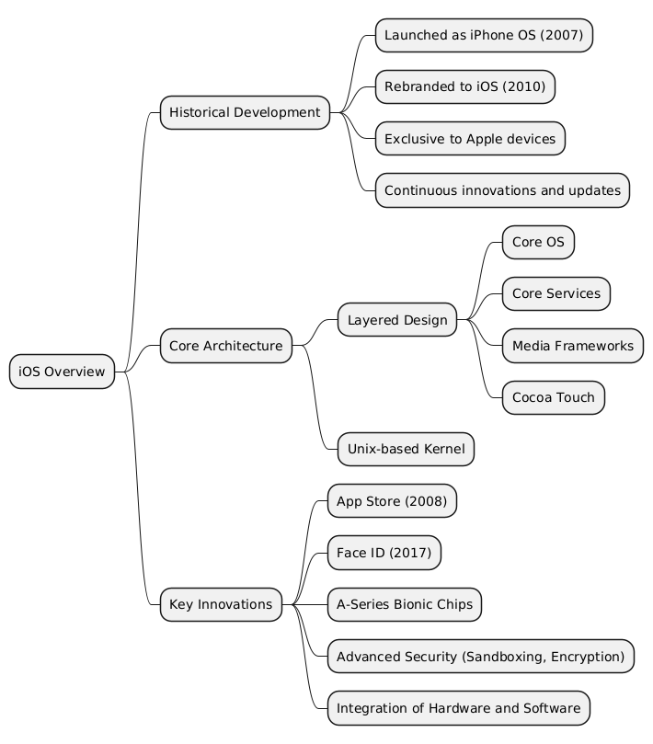

#### **2.2. Android Overview**

**Historical Evolution and Architecture**

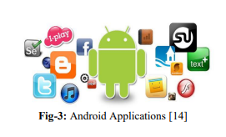

Android, launched by Google in 2008, quickly became the world's leading mobile OS. Its open-source nature, based on the Linux kernel, allows for extensive customization by developers and manufacturers. The OS has evolved through numerous versions named after desserts, with each iteration introducing significant enhancements in user experience and system efficiency. Android's layered architecture consists of the Linux Kernel, Native Libraries, Android Runtime, Application Framework, and Applications, collectively enabling comprehensive app support and user functionality (Kumar, 2020)​.

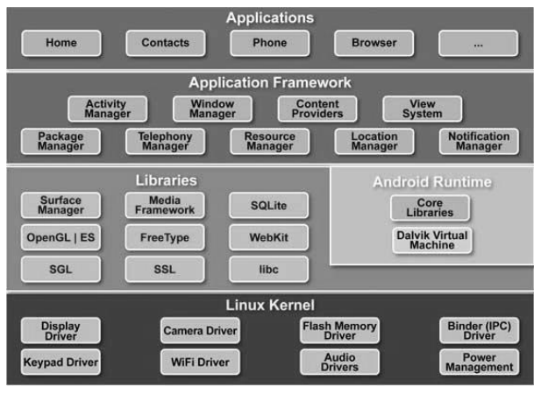

**Open-Source Nature and Impact on Mobile Computing**  
The open-source model of Android has catalyzed its adoption across diverse hardware platforms, making it accessible at various price points. This adaptability has expanded Android’s reach, fostering innovations in areas like IoT and wearables. However, it has also led to fragmentation, complicating updates and security management. Android's deep integration with Google services, such as Google Assistant and Google Play, has established it as a central pillar in mobile computing (Kumar, 2020)​.

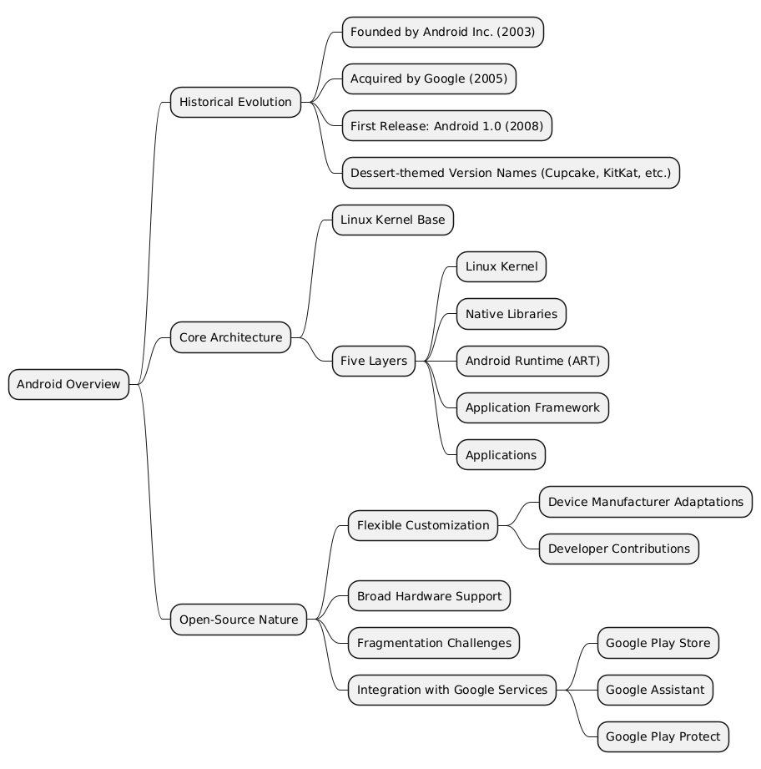

#### **2.3. macOS Overview**

**Evolution from Mac OS to macOS**  
macOS, introduced in 1984 as Mac OS, has consistently been a benchmark for desktop operating systems. Its evolution includes the pivotal adoption of NeXTSTEP in the late 1990s after Apple acquired NeXT, which contributed to macOS’s UNIX-based foundation. The rebranding to "macOS" in 2016 further aligned its naming convention with Apple's ecosystem. Over time, macOS has become a preferred OS for professionals and creatives due to its stability and innovative features (Verma & Sambhav, 2020)​.

**Key Innovations and File Systems**  
A critical milestone in macOS development was the 2017 introduction of APFS (Apple File System), replacing HFS+. APFS brought significant enhancements, including improved performance, space sharing, and robust encryption capabilities, making it ideal for SSD storage. Additionally, macOS's seamless ecosystem integration allows features like Handoff and AirDrop, fostering a cohesive user experience across Apple devices (Verma & Sambhav, 2020; Kumar, 2020)​​.

This overview contextualizes the unique trajectories of iOS, Android, and macOS, setting the stage for a deeper comparative analysis of their core OS concepts.

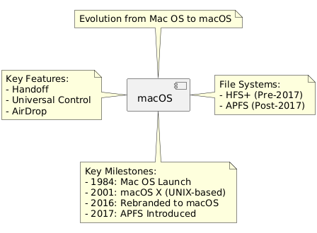

### ****3. Comparison of OS Concepts****

#### **3.1. Process Management**

**Process Creation and Scheduling**  
In iOS, processes are created and managed using a combination of preemptive multitasking and cooperative task scheduling. The system uses a Unix-based kernel to spawn processes with distinct Process IDs (PIDs). Its Grand Central Dispatch (GCD) enables efficient thread management, prioritizing tasks based on system load and resource availability. Android, leveraging the Linux kernel, employs similar process creation techniques but relies on the Android Runtime (ART) to optimize Java-based applications. The kernel facilitates process scheduling via Completely Fair Scheduler (CFS), ensuring fairness across tasks (Kumar, 2020)​.

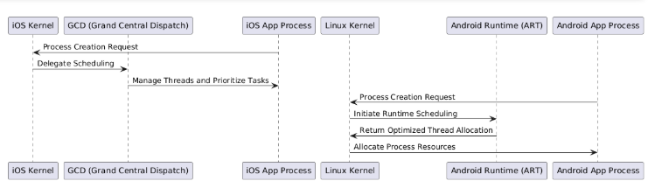

**Multitasking Capabilities**  
Both iOS and Android offer robust multitasking frameworks, but their approaches differ. iOS supports multitasking through background execution modes, allowing apps to perform specific tasks such as audio playback or location updates. This feature prioritizes user experience and battery efficiency by limiting resource-hogging processes (Verma & Sambhav, 2020)​. Android’s multitasking is more extensive due to its open architecture, supporting activities like split-screen operations and picture-in-picture mode. However, this flexibility can strain system resources, especially on lower-end devices (Kumar, 2020)​.

**Inter-Process Communication (IPC) Mechanisms**  
IPC in iOS is achieved using XPC (Cross-Process Communication) and mach messaging, facilitating secure and efficient communication between processes. By isolating applications within their sandbox, iOS minimizes the risk of data breaches. Android employs Binder IPC, a Linux kernel-based mechanism, enabling processes to communicate through shared memory. While Binder offers flexibility, its security largely depends on app permissions and developer practices, making it potentially less secure than iOS’s tightly controlled environment (Kumar, 2020)​​.

#### **3.2. Memory Management**

**Memory Allocation and Deallocation Techniques**  
iOS employs Automatic Reference Counting (ARC), a compile-time feature that eliminates the need for manual memory management. This approach reduces memory leaks by automatically deallocating unused objects. Android, on the other hand, relies on garbage collection (GC) in the Android Runtime (ART). GC periodically clears memory occupied by unused objects, which can cause minor lags but ensures efficient memory recycling in the long term (Verma & Sambhav, 2020; Kumar, 2020)​​.

**Virtual Memory and Caching**  
Virtual memory is central to both systems. iOS leverages a memory-mapped file system to swap inactive processes, optimizing RAM usage without significant performance hits. Similarly, Android uses paging to swap inactive applications to virtual memory, ensuring active processes have sufficient resources. Both systems incorporate caching mechanisms: iOS uses unified memory architecture for efficient GPU and CPU access, while Android employs Dalvik and ART-specific caches to speed up application execution (Kumar, 2020)​.

**Memory Protection Mechanisms**  
iOS isolates application memory spaces, preventing unauthorized access and enhancing security. The system uses Data Execution Prevention (DEP) to prevent code execution in non-executable memory areas. Android’s memory protection includes Address Space Layout Randomization (ASLR), which randomizes memory location allocations to mitigate exploits. Both systems prioritize user and system-level protection, but iOS’s stricter control offers a more robust defense against memory-based vulnerabilities (Verma & Sambhav, 2020)​​.

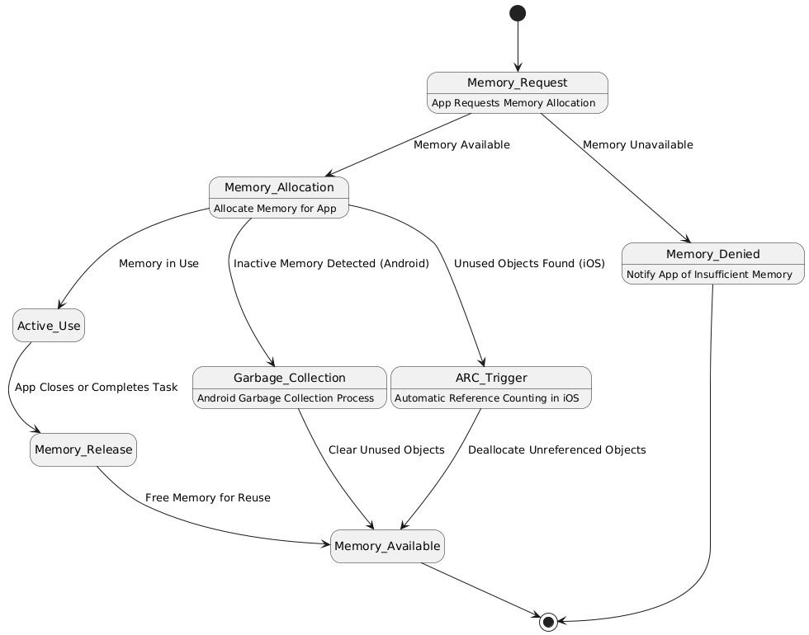

#### **3.3. File System**

**File Organization and Accessibility**  
iOS adopts a sandboxed file system, isolating app data to prevent unauthorized access. Apps interact with the file system via APIs, ensuring security and streamlined access. Android, in contrast, uses a Linux-based file system structure, offering greater flexibility to developers. Users can navigate files directly, an advantage over iOS’s restricted access (Kumar, 2020)​.

**HFS+ and APFS vs. ext4**  
macOS transitioned from HFS+ to APFS in 2017, introducing features like space sharing, snapshot support, and native encryption. APFS’s focus on SSD optimization significantly improves performance. Android’s default ext4 file system, built on Linux, is known for its robustness and journaling capabilities. While ext4 excels in general-purpose storage, APFS offers superior efficiency and encryption tailored for macOS and iOS devices (Verma & Sambhav, 2020)​​.

**Differences in Storage Management**  
iOS uses a hierarchical storage management system, combining app-specific storage with shared spaces for user data. Android, with its open architecture, allows external storage options like SD cards, giving users more control over file management but introducing potential security risks (Kumar, 2020)​.

| **Aspect** | **iOS (APFS)** | **macOS (APFS)** | **Android (ext4)** |
| --- | --- | --- | --- |
| **File System Type** | APFS (Apple File System) | APFS (Apple File System) | ext4 (Fourth Extended File System) |
| **Optimization** | Designed for flash/SSD storage, efficient in handling snapshots and metadata. | Optimized for SSDs with advanced encryption and fast directory sizing. | General-purpose, supports a variety of storage types. |
| **Encryption** | Built-in, full-disk encryption with minimal performance impact. | Advanced encryption and per-file encryption. | Optional encryption; device-dependent. |
| **Journaling** | Uses copy-on-write (COW) rather than traditional journaling. | COW mechanism ensures metadata consistency without performance degradation. | Traditional journaling for metadata and some data changes. |
| **Snapshots** | Supported; enables instant backups and system state restoration. | Comprehensive snapshot support, particularly for Time Machine backups. | Limited or unsupported by default. Some Android devices may use alternatives. |
| **Scalability** | Tailored for small-scale device storage (mobile devices). | Highly scalable, suitable for large volumes. | Scales well for various devices but less optimized for high-end hardware. |
| **Performance** | Prioritizes efficiency for mobile hardware with low latency. | High-performance focus, particularly for macOS apps and multitasking. | Moderate performance for general use; depends on device hardware. |
| **User Access** | Highly restricted; users access files via app-managed directories only. | Moderate user access via Finder with administrator controls. | Full user access to file directories, including external storage. |
| **Flexibility** | Limited to Apple devices and ecosystems. | Tightly integrated with Apple hardware/software. | Open, adaptable to various manufacturers and customizations. |

#### **3.4. Security**

**Permissions, Encryption, and Authentication Mechanisms**  
iOS enforces strict permissions and encryption standards, with apps requiring explicit user consent to access sensitive data. Its end-to-end encryption ensures secure communication, while biometric authentication methods like Face ID and Touch ID provide robust user security. Android also employs permission-based access control but grants developers more flexibility, which can lead to inconsistent implementation. Its encryption protocols, while effective, rely on user activation in some cases (Verma & Sambhav, 2020)​​.

**Unique Security Features**  
iOS stands out with its sandboxing approach, which prevents apps from interfering with one another. It also features a secure enclave for biometric data, ensuring hardware-level protection. Android’s open-source model supports broader hardware compatibility but exposes it to potential vulnerabilities. Its Google Play Protect feature scans apps for malicious content, but its effectiveness can vary across devices (Kumar, 2020)​.

**User and System-Level Security**  
At the user level, iOS ensures privacy through data minimization and on-device processing for features like Siri. System-level security is bolstered by Apple’s proprietary chips, such as the T2 Security Chip. Android offers robust user controls but depends heavily on manufacturers and developers to implement updates, leading to potential inconsistencies. Despite its limitations, Android’s open-source nature allows for rapid patching by the community (Verma & Sambhav, 2020)​​.

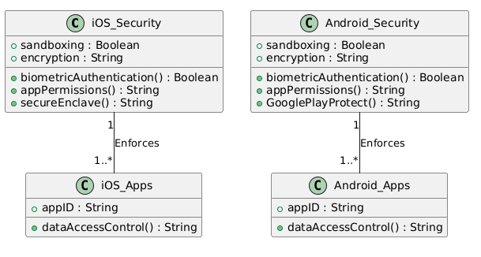

#### **3.5. Scheduling**

**CPU Scheduling Algorithms**  
iOS uses priority-based scheduling, ensuring critical system tasks receive precedence. Android employs the Completely Fair Scheduler (CFS) from the Linux kernel, balancing fairness and efficiency across processes. While both systems handle real-time and multi-user processing effectively, iOS’s tighter control ensures smoother performance, particularly in resource-intensive tasks (Kumar, 2020)​.

By exploring these fundamental OS concepts, it becomes evident that iOS, Android, and macOS offer unique strengths tailored to their respective ecosystems, while also influencing each other in their continuous evolution.

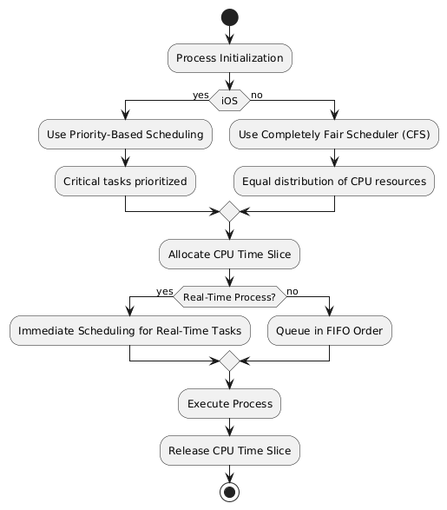

### ****4. Creative Analogy and Insights****

Operating systems can be compared to modes of transportation in a city, each designed to serve distinct needs while sharing common infrastructure. iOS, Android, and macOS align with this analogy, functioning as luxury cars, customizable vehicles, and high-speed trains, respectively.

**iOS: The Luxury Car**  
iOS resembles a high-end luxury car, engineered for a seamless, secure, and exclusive user experience. Its sandboxed apps act as private compartments, ensuring that one passenger’s activities (app’s data) do not intrude on another's. Like luxury cars, iOS prioritizes design, performance, and safety, appealing to those who value a polished, controlled environment over customization.

**Android: The Customizable Vehicle**  
Android is the adaptable SUV, capable of catering to a wide array of terrains (devices) and user preferences. Its open-source nature allows users and developers to modify the system extensively, much like customizing a vehicle for specific needs. However, this flexibility can occasionally compromise performance and safety, akin to retrofitting parts from various manufacturers.

**macOS: The High-Speed Train**  
macOS mirrors the high-speed train—optimized for efficiency, stability, and professional workflows. It connects seamlessly with other "stations" (Apple devices), enabling features like Handoff and Universal Control. However, its tracks are fixed, limiting its flexibility compared to more open ecosystems.

From a user perspective, iOS offers unparalleled security for sensitive tasks, Android provides diversity and affordability, and macOS ensures reliability for creative and professional endeavors. This diversity underscores the importance of selecting the right "transport" based on individual priorities and use cases.

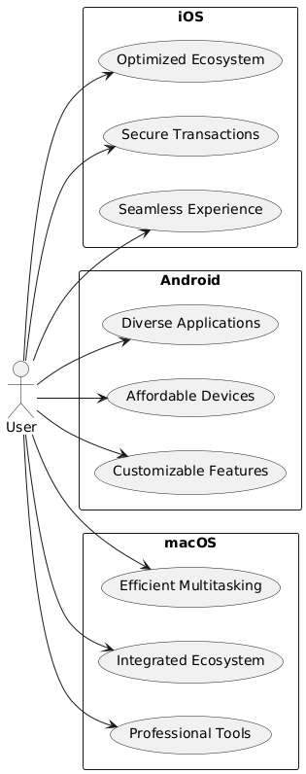

### ****5. Conclusion****

This analysis highlights the unique strengths and approaches of iOS, Android, and macOS. iOS excels in security, seamless integration, and user-centric innovations, while Android’s open-source nature fosters customization and widespread adoption. macOS stands out for its stability, advanced file systems, and ecosystem synergy. These systems, despite their differences, continue to influence one another, driving technological progress.

Looking ahead, advancements in AI, augmented reality, and cross-platform interoperability are likely to shape the future of operating systems. Striking a balance between customization, security, and user experience will remain a priority as these systems evolve to meet diverse user needs.

**🡨----------------------------------------------------------------------🡪**