**National University of Computer and Emerging Sciences**



**Lab Manual 8**

**Object Oriented Programming**

|  |  |
| --- | --- |
| Course Instructor | Ms. Syeda Tayyaba Bukhari |
| Lab Instructor (s) | Ms. Fariha Maqbool  Mr. Muhammad Usama |
| Section | B |
| Semester | Spring 2022 |

Department of Computer Science

FAST-NU, Lahore, Pakistan

## Objectives

After performing this lab, students shall be able to:

* Composition
* Association
* Aggregation

**TASK 1: Composition**

1.Implement a class called **Time**. The **Time** class will have two private data members:

* int hr;
* int min;

You have to implement the following functions for time class

* Time();
* Time(int, int);
* void setTime(int, int);
* void getTime(int&, int&);
* void printTime();
* void incrementHours();
* void incrementMinutes();

2. Implement a class called **Date**. The **Date** class will have three private data members:

* int month;
* int day;
* int year;

You have to implement the following functions for Date class

* Date();
* Date(int, int, int);
* void setDate(int, int, int);
* void getDate(int&, int&, int&);
* void printDate();

3. . Implement a class called **Event**. The **Event** class will have three private data members:

* string eventName;
* Time eventTime;
* Date eventDay;

You have to implement the following functions for Event class

* Event(int hours = 0, int minutes = 0, int m = 1,
  + - int d = 1, int y = 1900, string name = "Christmas");
* void setEventData(int hours, int minutes, int m, int d, int y, string name);
* void printEventData();

Your Main function should be like this

int main()

{

//instantiate an object and set data for Christmas

      Event object;

      object.setEventData(6, 0, 12, 25, 2010, "Christmas");

      //print out the data for object

      object.printEventData();

      //instantiate the second object and set date for the fourth of July

      Event object2;

      object2.setEventData(1, 15, 7, 4, 2010, "Fourth of July");

      //print out the data for the second object

      object2.printEventData();

      return 0;

}

Please define each function outside the class properly.

**TASK 2: Association**

Understand the diagram and write a code for it.

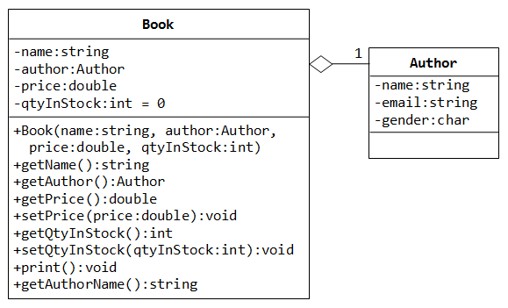

* Implement all functions in book class
* Your Author class must have the following functions
* Author(const string & name, const string & email, char gender);
* string getName() const;
* string getEmail() const;
* void setEmail(const string & email);
* char getGender() const;
* void print() const;

Your driver function must be like this.

int main() {

// Declare and construct an instance of Author

Author peter("Peter Jones", "peter@somewhere.com", 'm');

peter.print(); // Peter Jones (m) at peter@somewhere.com

// Declare and construct an instance of Book

Book book("C++ for Dummies", peter, 19.99);

book.print();

// 'C++ for Dummies' by Peter Jones (m) at peter@somewhere.com

peter.setEmail("peter@xyz.com");

peter.print(); // Peter Jones (m) at peter@xyz.com

book.print();

// 'C++ for Dummies' by Peter Jones (m) at peter@somewhere.com

book.getAuthor().setEmail("peter@abc.com");

book.print();

// 'C++ for Dummies' by Peter Jones (m) at peter@somewhere.com

}