+91 7310970546



1 77777 66666

*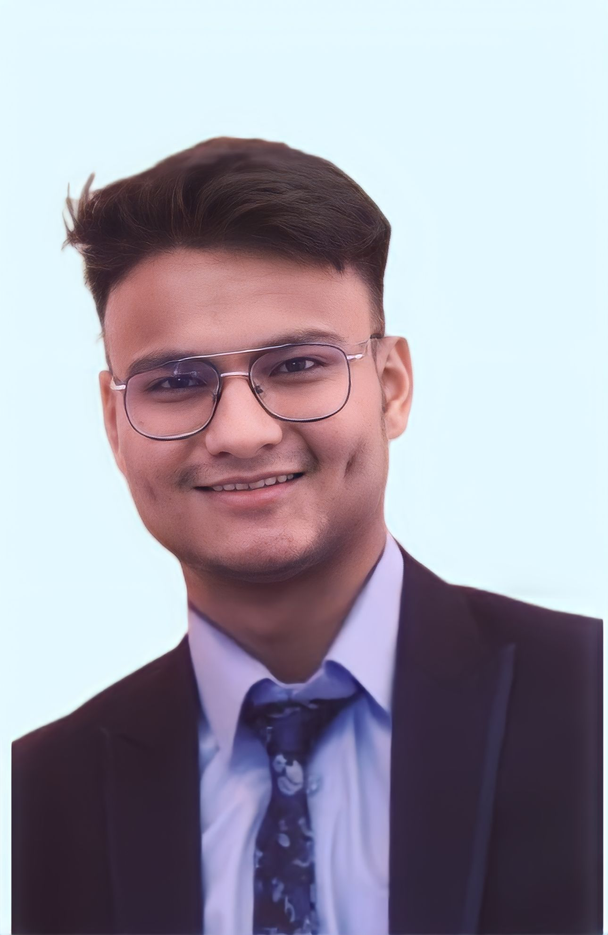*

ARVIND SHAHI

shahi55@gmail.com



www.linkedin.com/in/arvind



SOFTWARE ENGINEER

Phagwara, Punjab



ArvindShahi



S U M M A R Y

* Front-End Web Development|

Free code Camp

* Time Value of Money and Capital Budgeting | Udemy

C E R T I F I C A T I O N S

Programming languages:

Python, C

Web Technologies:

HTML5, CSS

Platform’s: Windows 7,

Windows 10, windows11

T E C H N I C A L S K I L L S

I am currently enrolled in a Bachelor’s degree program in computer science and Engineering, and I posses a strong passion in coding.