CMPG 323

Project 1 - Discovery

Submitted to: Mr. Z. Boonzaaier

Date: 11/10/2021

Author: Zandri Stoltz

Student number: 31614132

Contents

1. Brief introduction to project and general system overview 1

2. ERD diagram 2

Diagram 2.1: ERD 2

3. Use case diagram 2

Diagram 3.1: Use case diagram 2

4. Service Flow diagrams 3

Diagram 4.1: View miles 3

Diagram 4.2: Redeem miles 5

5. How to guide? 5

5.1. Registering as a user 5

5.2. Logging In 5

5.3. View miles 5

5.4. Redeem miles 5

5.5. Help 5

6. Code coverage report 5

# Brief introduction to project and general system overview

The purpose of this project is to teach students how to adapt to making use of various new resources to develop. The project aim is to develop an app for Discovery to have the users track, maintain, add and redeem their Discovery Vitality points using the app.

# ERD diagram

## 

## Diagram 2.1: ERD

# Use case diagram

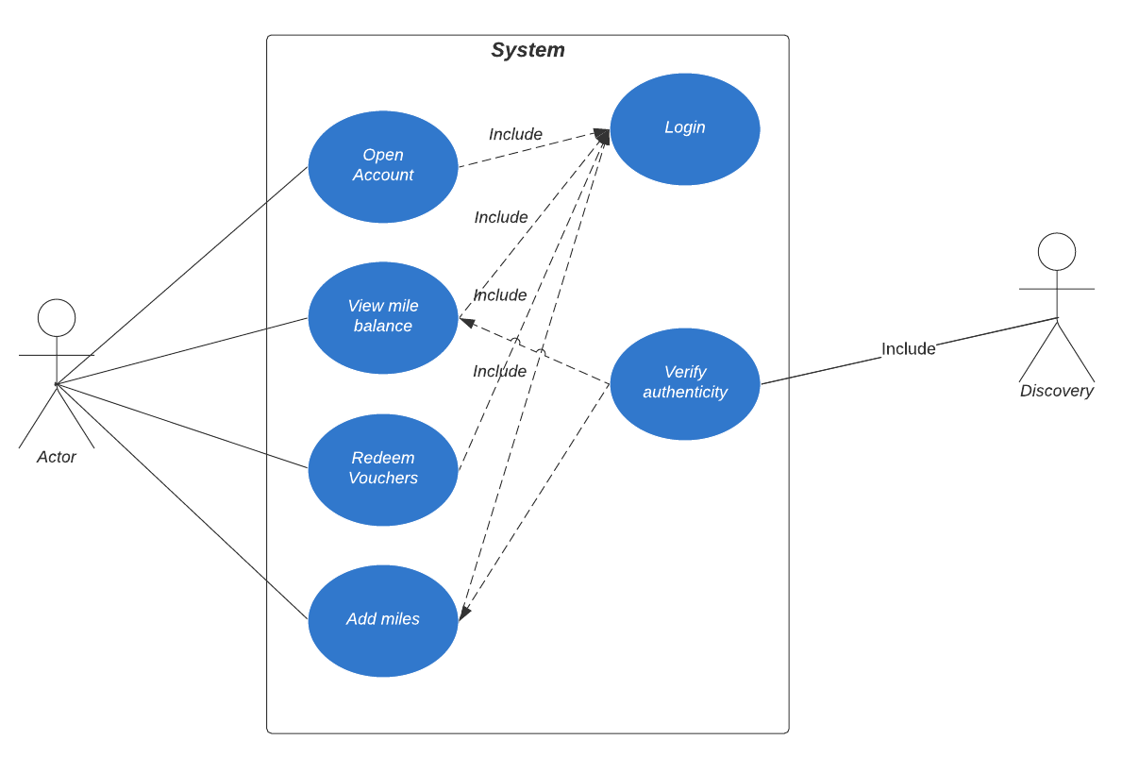

## Diagram 3.1: Use case diagram

# Service Flow diagrams

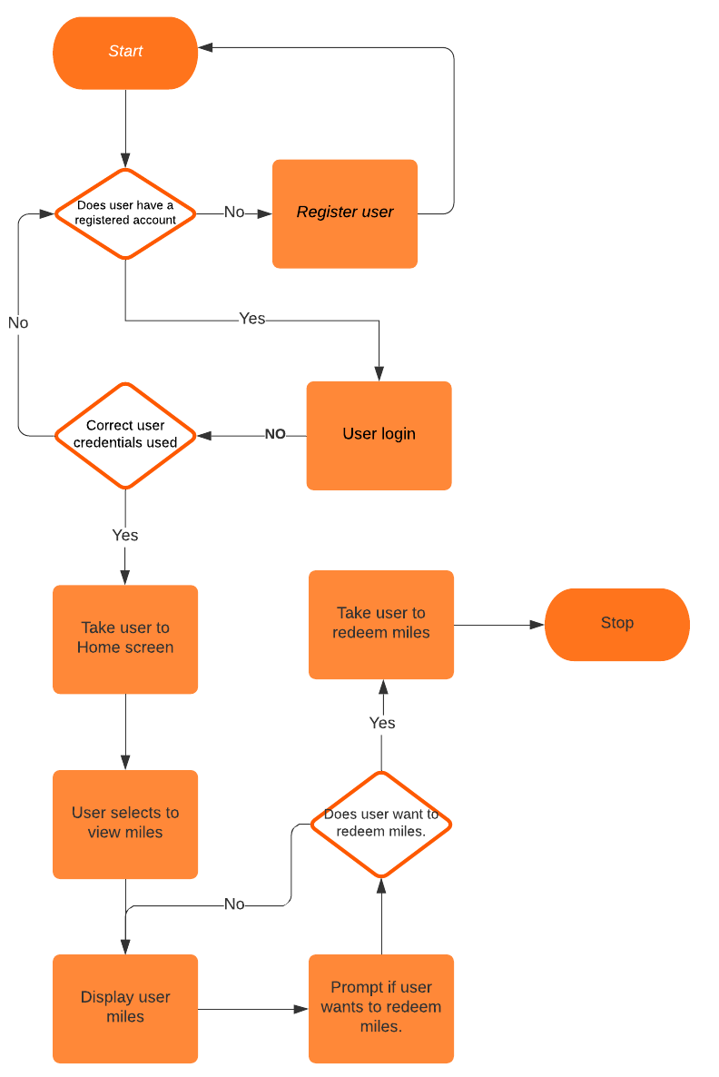

## Diagram 4.1: View miles

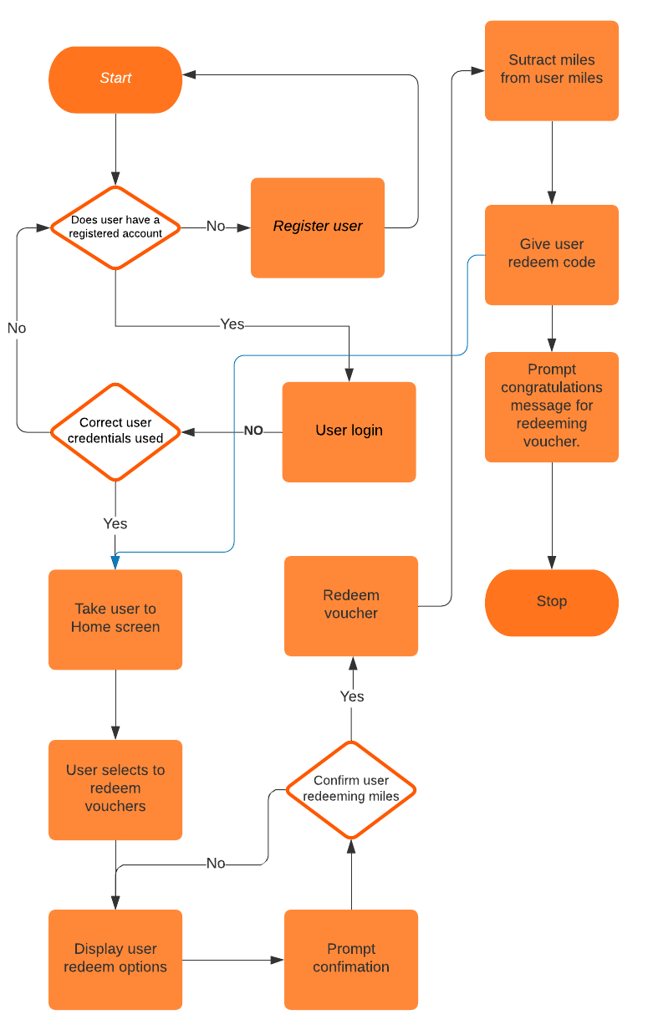

## Diagram 4.2: Redeem miles

# How to guide?

## Registering as a user

1. Open the app
2. Select Register new user
3. Enter information in the given boxes
4. Select “Create Account”
5. Confirm user information correct
6. A new account has been created

## Logging In

*The user will only be able to log in IF they have an existing user account.*

1. Enter user Account number and password associated with that account number
2. Select “Login”  
   If the user has entered incorrect information, the app will prompt them to try again.
3. User is now successfully logged into their account.

## View miles

*User has to be logged in, do this by following* 5.2. Logging In

1. Select “View Miles” option on home screen.
2. User miles will be displayed

*User will then have the option to redeem their miles.*

## Redeem miles

1. Select “Redeem Miles” option on home screen
2. Select place to redeem the miles from

*User miles redeemed will then be subtracted from the total of the user miles.*

## Help

Contact our consumer helpline during office hours : 0800 123 456

# Code coverage report