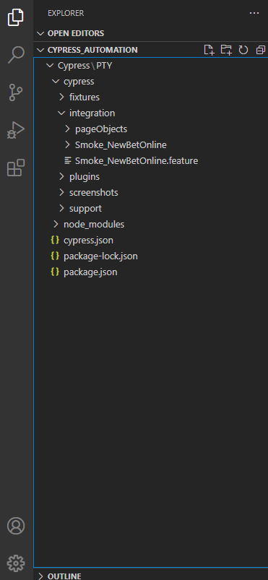

|  |  |  |
| --- | --- | --- |
| **Folders** | **Description** | **More information** |
| **Fixtures** | Fixturesare external pieces of static data that can be used by your tests. |  |
| **Integration** | Integration provides a place that writes out test cases. We can also create our folder under the integration directory and add out test cases under that. |  |
| **Plugins** | Plugins contain the plugins or listeners. By default, Cypress will automatically include the plugins file “cypress/plugins/index.js” before every test it runs |  |
| **Support** | Supportwrites customized commands or reusable methods that are available for usage in all of your spec/test files. This file runs before every single spec file. |  |
| **Node_Modules** | Node_Modules in the default project structure is the heart of the cypress project |  |
| **Cypress.json** | Cypress.json is used to store different configurations. E.g., timeout, base URL, test files, or any other configuration that we want to override for tweaking the behavior of Cypress. |  |
| **package.json** | All NPM packages contain a file; usually, in the project root, called package.json**,** this file holds various metadata and libraries relevant to the project. |  |
| **Screenshots** | Cypress as a tool comes with the in-build capability to take screenshots irrespective of whether you are running in interactive mode using cypress open or cypress run and even in headless mode on the command line or CI as part of your pipeline. |  |
|  |  |  |

