Cucumber Implementation in cypress

Installation
Install the plugin by running:
npm install --save-dev cypress-cucumber-preprocessor
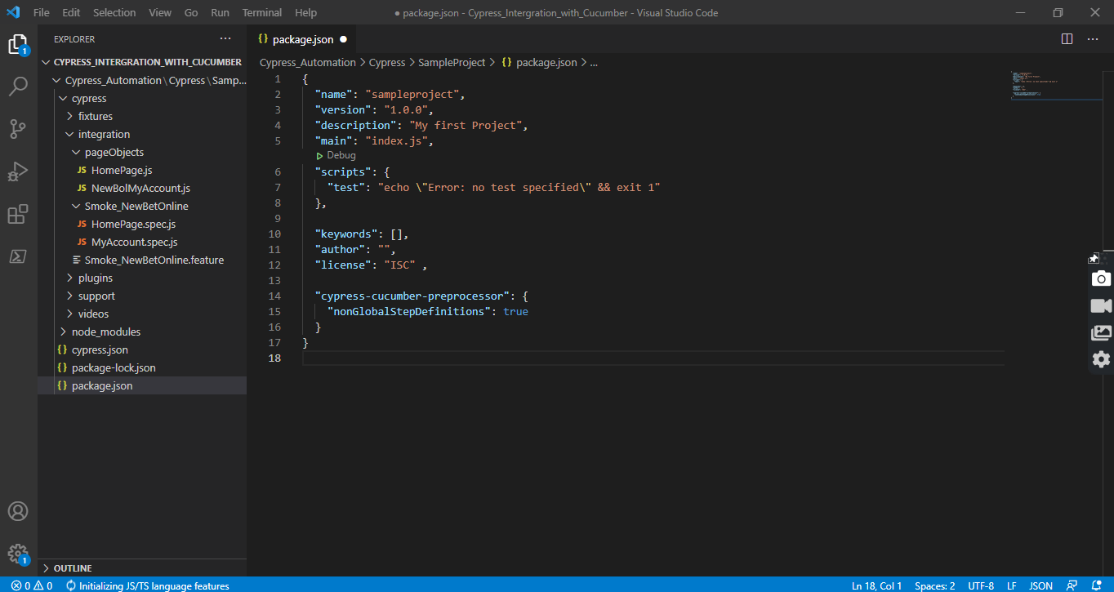
Note: set nonGlobalStepDefinitions : true

Configuration
Add it to your plugins:
cypress/plugins/index.js
const cucumber = require('cypress-cucumber-preprocessor').default
module.exports =(on, config) =>{
on('file:preprocessor', cucumber())
}
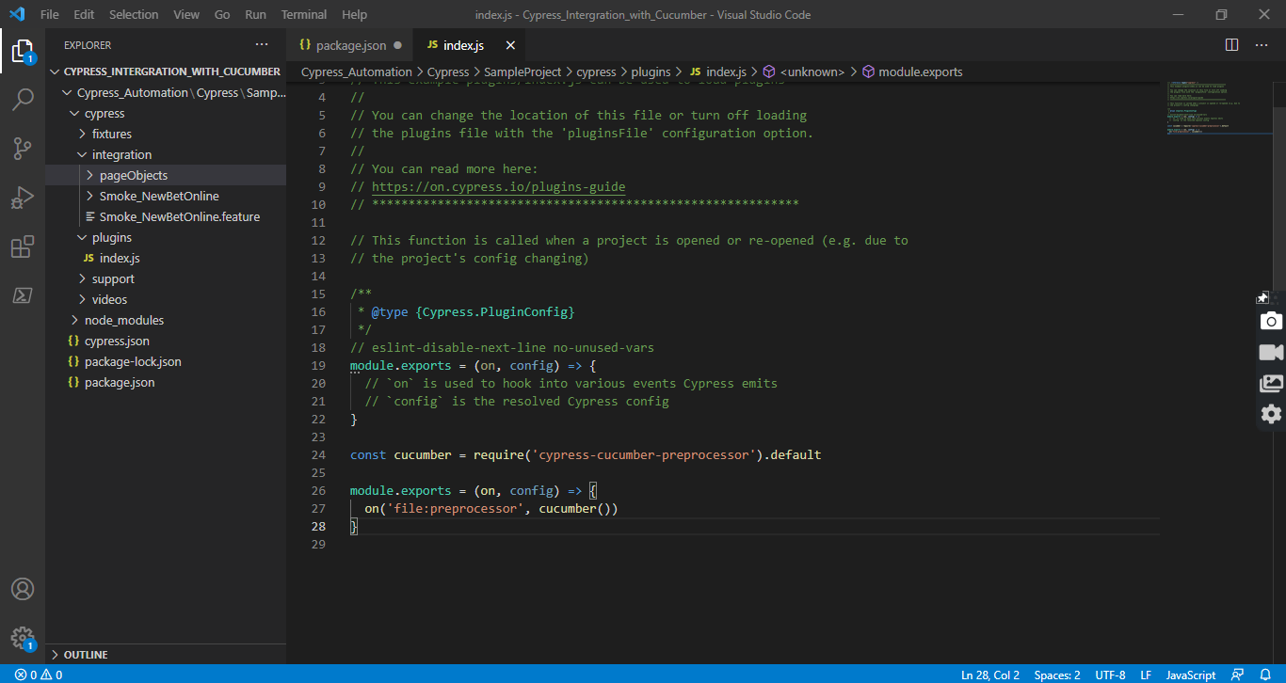
Add support for feature files to your Cypress configuration this make us to see only features files in our cypress test runner
cypress.json
{
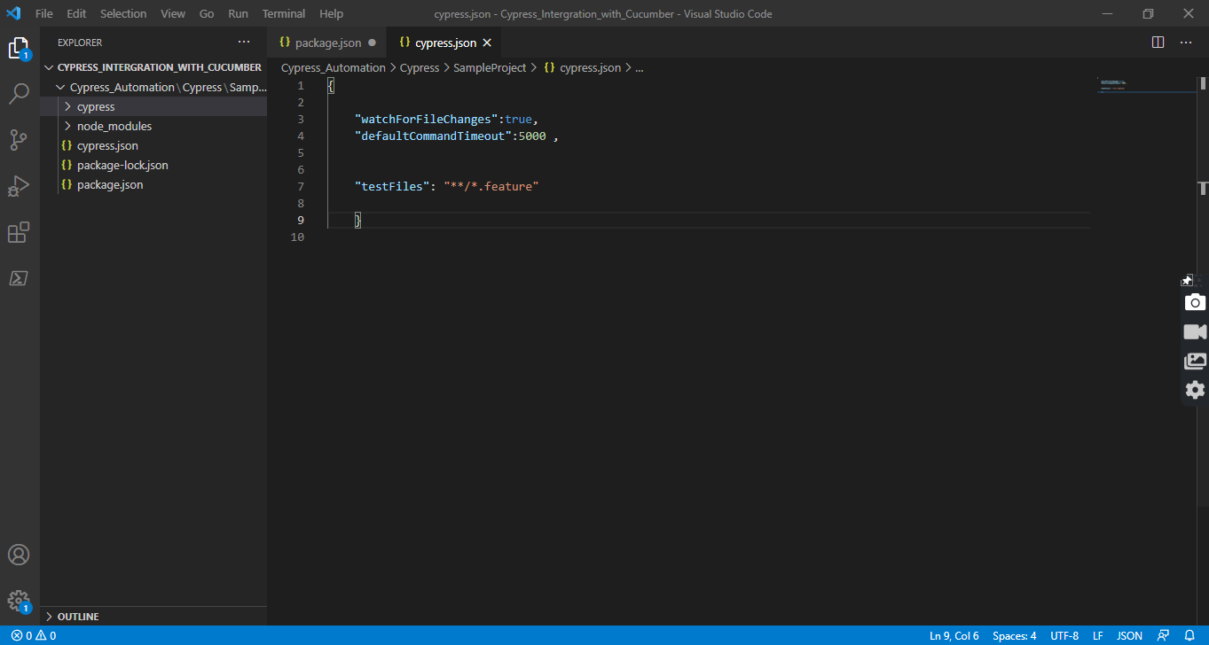
"testFiles":"**/*.feature" }
Feature Files

We can create our .feature files inside cypress/integration/

For Example: cypress/integration/Smoke_NewBetOnline.feature
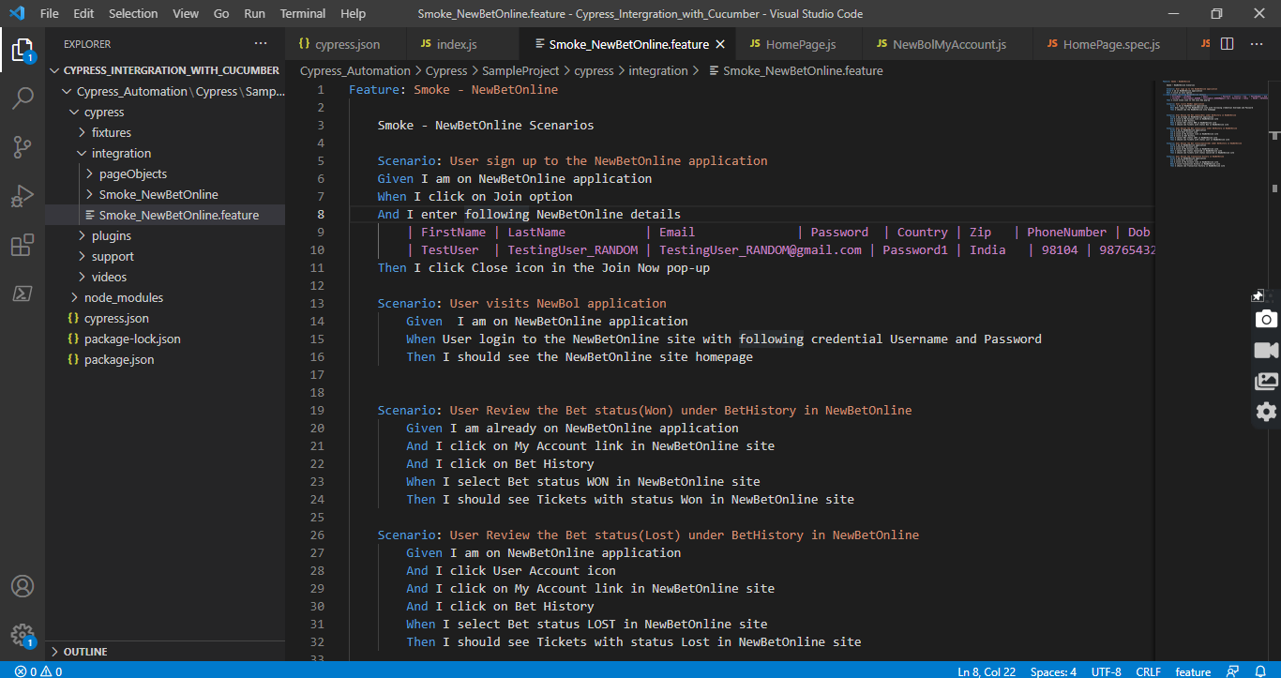

StepDefinitions

The feature file will use the step definitions created inside the same directory with same name as .feature file

The feature file cypress/integration/Smoke_NewBetOnline.feature, will read all the .js files inside cypress/integration/Smoke_NewBetOnline
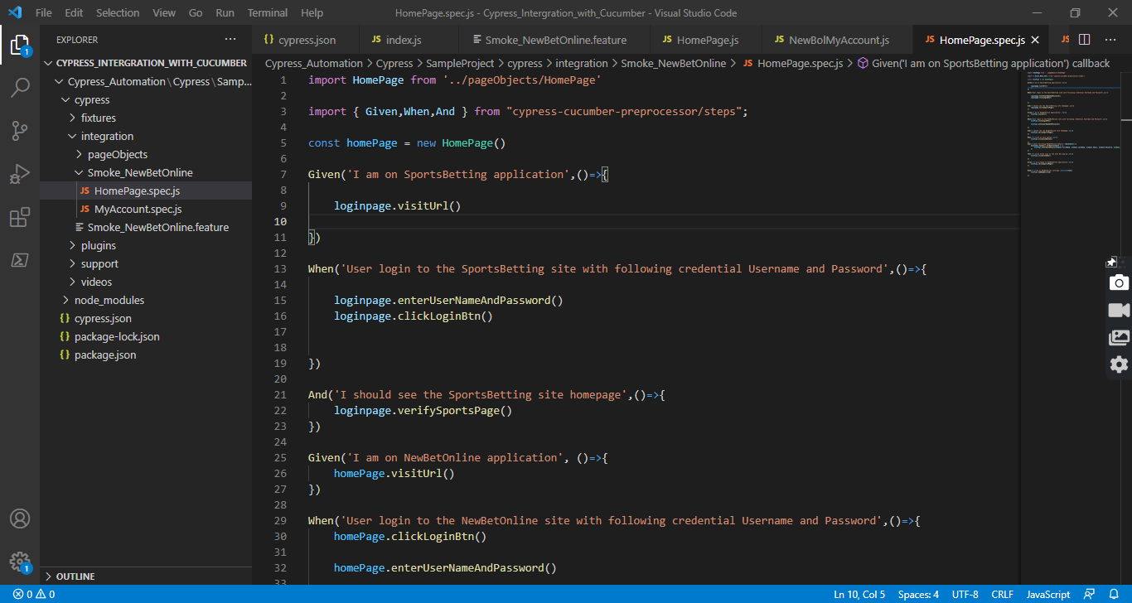

Page Object Pattern

we can create our page class .js files inside cypress/integration

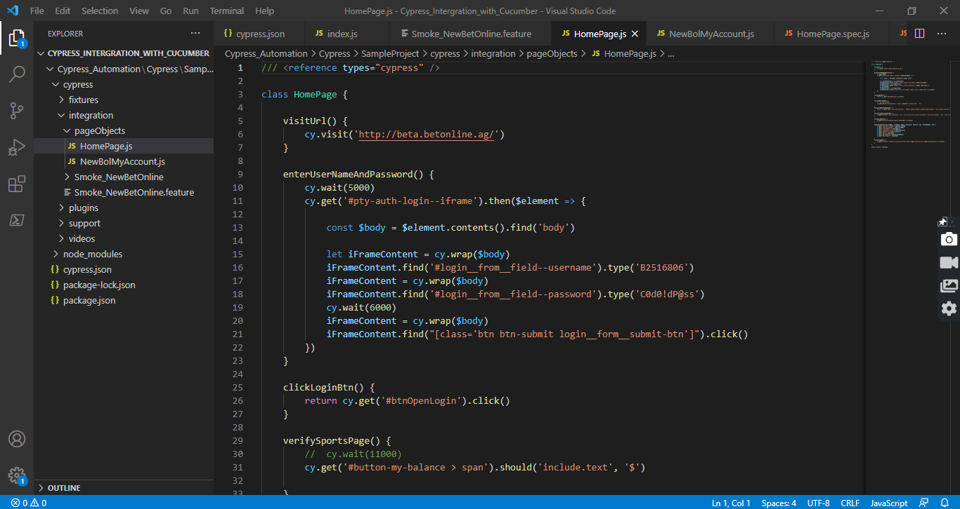
For Example: cypress/integration/pageObjects/HomePage.js
we have set our page class to export default.

/// <reference types="cypress" />

class HomePage {

visitUrl() {
cy.visit('http://beta.betonline.ag/')
}
}

export default HomePage

So we can use methods in stepDefinition files by importing the page class

import HomePage from '../pageObjects/HomePage'

const homePage = new HomePage()

To Run Test

Method 1: Run your test on cypress test runner. Open your cypress test runner with

./node_modules/.bin/cypress open

click on .feature file listed on the test runner

Method 2: Run you test via Terminal with the command

npx cypress run --spec cypress/integration/Smoke_NewBetOnline.feature --browser chrome

