|  |  |
| --- | --- |
| **Course signature** | ZDTESTXYZ1234 |
| **Team members names and surnames** |  |
| **Project title** | Final Project |
| **Link to repository** |  |
| **Project description** (with listed, used technologies, testing plan) | For the final project we tested the website <https://www.example.com> . We were divided into 6 teams and, for 20-30 minutes, we explored the website.  The first task was to found minimum 3 bugs by Exploratory Testing and to report them in Jira.  The User Stories were analyzed and we created the structure of the project based on Epic, Version, Test Cycle and Test Suites. We established the testing environment: Chrome, Safari, IExplorer, Mobile.  We created Test Cases which were classified in folders and subfolders (based on requirements). We executed the test cases and we set up the status per step (passed/failed). The bugs encountered were linked to the test cases and we established the severity for each one. Were added outcomes: test executions, screenshots and comments.  To conclude the project we created a report (based on Test Metrics) which describes the entire project.  You will find bellow the conclusion report. |

**Final Project**

1. **General info:**

**Name project: Final Project**

**Version: Version 1**

**Epic: Group C**

**Environment: Chrome 83 on Windows 10/ Android Samsung Galaxy J5**

**Cycle Summary: Group C Requirements Test Cycle**

**Folders based on Stories:**

* **Add multiple addresses**
* **Add to Favorites Section**
* **Login Page**
* **Order Products**
* **Recently viewed products**

1. **Test Metrics for Final Project**

**In the period 31.05.2020-13.06.2020 were executed 101 test cases, only 5 were failed.**

**The highest number of test cases executed were on 07.06.2020 - 28 passed and 2 failed.**

**There is still one unscheduled test case, but the rest of 100 test cases from Version 1 were done.**

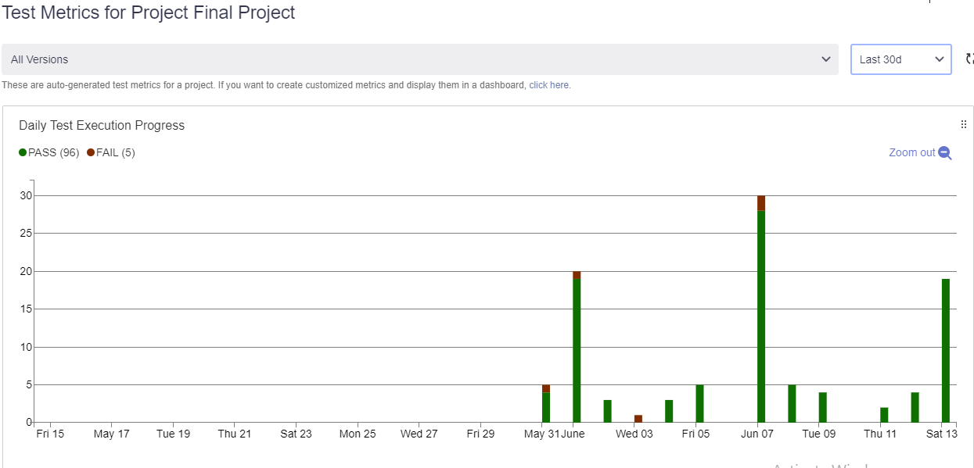

**The distribution of groups is represented by the number of executions on test cases. Group A has the highest number of test cases executed.**

**Group C had executed 12 test cases, representing 11.88% of total TC.**

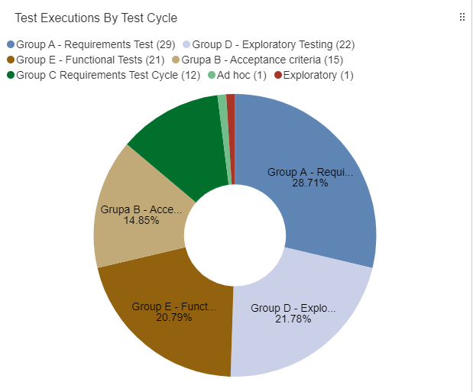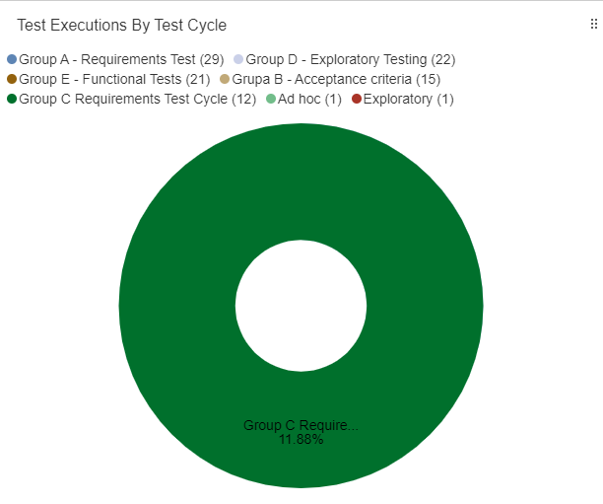

**Filtering by label, 104 tests were created and 32 bugs were discovered.**

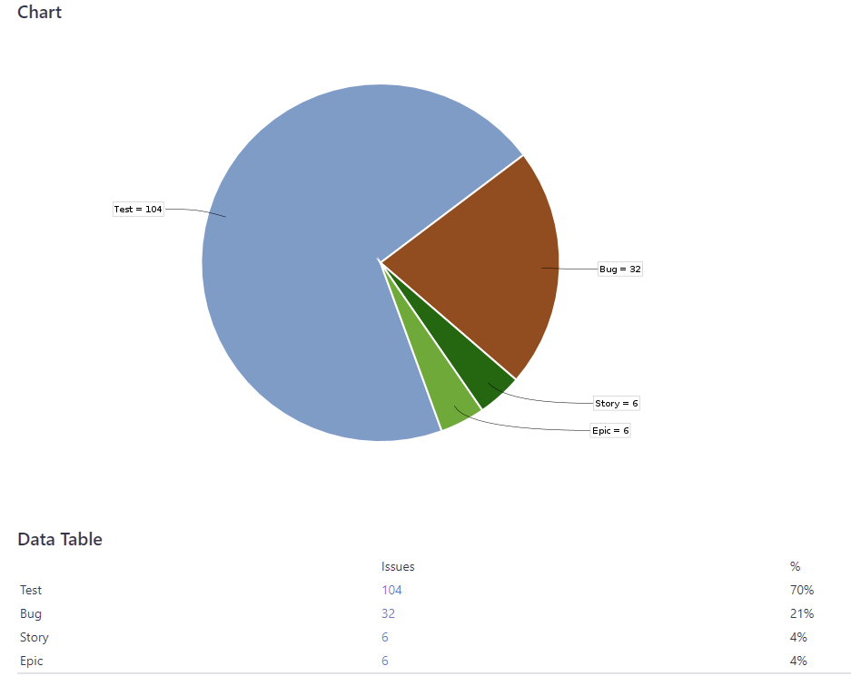

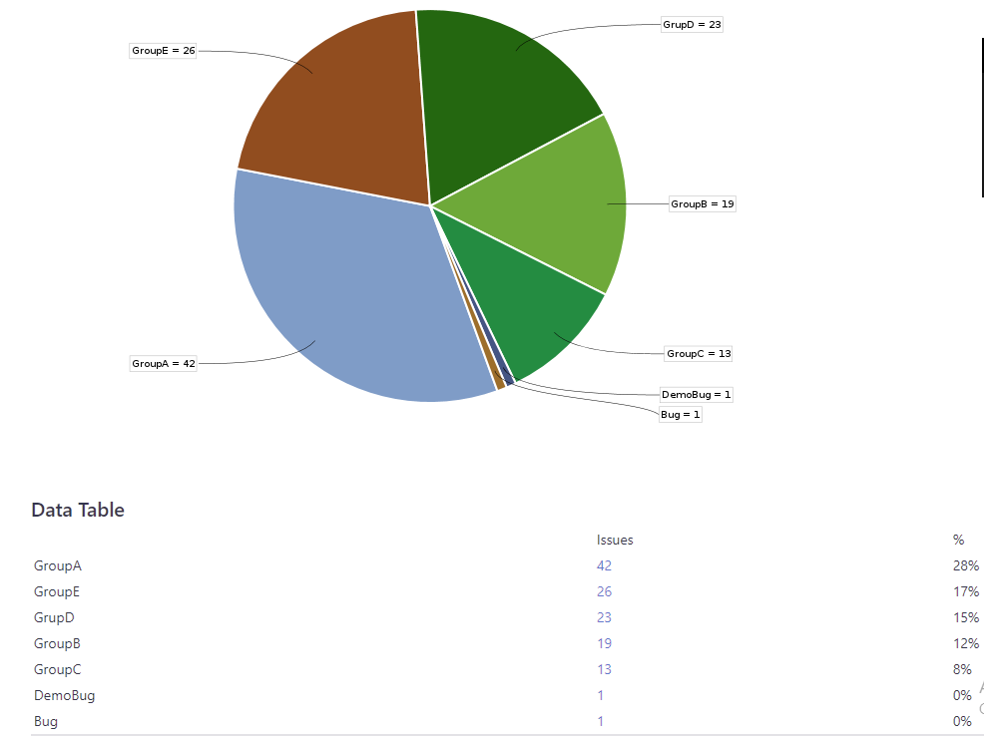

**From the 12 TC executed by Group C, 10 have passed and 2 have failed, and there were found 2 bugs in the requirements area: in the Login page folder and in the Add to favorites folder. Another 3 bugs were founded in Exploratory testing.**



