Basic Commands
- forward(distance) - Moves forward in the direction the turtle is facing the distance that you enter.
- left(degrees), right(degrees) - Rotates the turtle left or right the number of degrees you enter. A turn is based on the direction the turtle is facing.
- seth(degrees) - Sets the direction the turtle is facing based on the coordinate circle directions.
- color(‘color’) - Changes the turtle color to the color you enter. Ex. ‘blue’, ‘black’, ‘light blue’

Advanced Commands
- speed(speed) – Sets the speed that the turtle moves. 1=slowest, 11=fastest.
- circle(radius) - Draws a circle with the radius that you enter.
- setposition(x-coordinate, y-coordinate) - Moves the turtle to the (x,y) coordinate you specify. Envision the canvas is a coordinate plane with the center being (0,0).
- up(), down() - When the turtle is down and moves it draws a line behind it. When the turtle is up nothing will be drawn when it moves.
- pensize(width) – Sets the width of the line drawn by the turtle
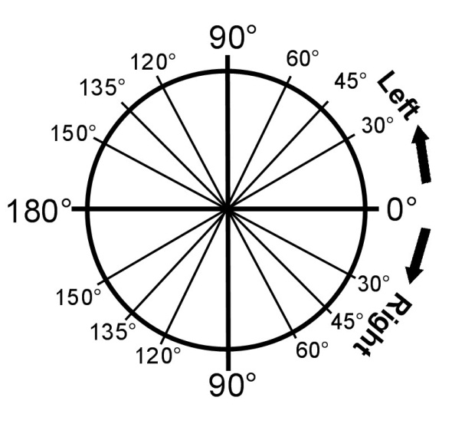
- shape(‘shape’) – Sets the shape of the turtle. Ex. ‘turtle’, ‘classic’, ‘arrow’, ‘square’, ‘circle’

Saving a File
In the Idle window go to File->Save OR hit ctrl+s

Running a File
In the Idle window go to Run->Run Module OR hit F5

