Evaluation of various techniques, and execution times, of different filtering systems against audio files

Alexander O’Callaghan

Abstract

Acknowledgements

# Contents Page

Contents

Contents Page 4

1.0 Introduction 5

1.1 Background 5

1.2 Focus 5

1.3 Value 5

2.0 Literature review 6

2.1 High Level Overview 6

2.2 Filtering Techniques 7

3.0 Methodology 8

3.1 Introduction 8

3.2 Code Breakdown 9

4.0 Findings/Results 10

4.1 Introduction 10

5.0 Discussion 12

5.1 Introduction 12

5.2 Which filtering technique resulted in the best removal of unwanted noise 13

5.3 Which had the quickest execution times 15

5.4 Best overall 16

6.0 Conclusion 17

6.1 To conclude 17

6.2 Future work 17

References 18

Appendix 19

# 1.0 Introduction

## 1.1 Background

Digital signal processing (DSP) is a way of using computer code to make a series of operations on signal data with the intention of creating data that is more useful in some manner, to the user. This can range from <<refrence>>. The main advantage of using software to do this is that designs can be created very easily, cheaply, and more effectively than creating similar designs in hardware. <<compare hardware to software reference>>. This is because modifying design in software can be done very quickly and tested on the fly. Hardware components must be physically altered to change processing aspects and rely on each part working correctly. This introduces more points of failure to the system.

## 1.2 Focus

The focus of this project is to make comparisons between different filtering techniques that can be used to increase correlation between audio samples and their noisy counterparts. The noisy samples will be filtered using different methods and the performance will be examined. While it may be difficult to directly compare the results should indicate certain advantages and disadvantages in certain aspects.

Research Questions

1. Which filtering technique can consistently perform the best removal of unwanted noise from an audio signal?
2. Which filtering technique is the quickest in its execution?
3. Does a filtering technique contain a good mixture of both functionality and speed?

## 1.3 Value

The scope of this project focuses on examples where audio files are used. Though that alone could provide useful, the scope for filtering techniques can extend to a large range of different signal mediums. The results found here can contribute to the wider field of Digital Signal Processing in which the benefits of which can have far reaching effects.

# 2.0 Literature review

## 2.1 High Level Overview

This dissertation is about the effectiveness and performance of different filtering types. While many different media can have filters applied to them, this report will be specifically looking at digital filters acting on audio signals.

To describe a filter on a signal, Steven W. Smith, (1997) puts it well in his book that filters primarily are used to either separate “…signals that have been combined, and (2) restoration of signals that have been distorted in some way.” (p261). To expand on that point, an example could made of a voice recording that contains background noise. A filter, designed to reduce the frequencies that a human voice does not contain, could be used to clear the signal and make hearing the voice easier. The author later goes on to make a comparison of analogue and digital and while “digital is slow; analogue is fast. For example, a personal computer can only filter data at about 10,000 samples per second, using FFT convolution. Even simple op amps can operate at 100 kHz to 1 MHz, 1 to 100 times as fast as the digital system!” (p344), the digital bests analogue in almost all other areas.

## 2.2 Filtering Techniques

Signal filters can either be analogue or digital and while both have their merits, digital versions are what this report will focus on.

Two “families” of digital filters exist, and they are finite impulse response (FIR) and infinite impulse response (IIR). Aiming for the same result they both differ in their application.

FIR filters use a method called “convolution” when applying their filtering to signals. This is fundamentally different to IIR filters as though they employ this method too, they also take the output of the expression for further functions. The two different style produce different characteristics for example, (Burgess, 2014) weighs up some of the advantages and disadvantages of the two, commenting that while FIR has a lower efficiency than that of IIR, it is much more stable. This is due to FIR having no feedback, not matter how it is implemented.

How each filter is applied can also change. The two that this report will use is bandstop and lowpass filter. A bandstop is a filter that reduces the power of frequencies between two points. For example, a bandstop filter could have a range between 300Hz and 400Hz which would reduce the power of the signal between those frequencies, while leaving the rest relatively unaltered. Lowpass is a filter that allows up to a certain frequency to pass through unaltered to a point. An example of that would be setting a lowpass filter at 80Hz to filter all frequencies after 80Hz and leave the rest.

A lot of research has been with the implementation of different filters being used as a tool rather than a focus whereas this report will seek to directly compare them in like for like cases.

# 3.0 Methodology

## 3.1 Introduction

#### Recap of questions

The following methodology was designed with the research questions mentioned earlier in mind. To recap this project aims to assign values of functionality, speed, and an evaluation based on both things.

#### Design

MATLAB was the software chosen to perform all the development of the filtering because of its functionality to easily implement the filters and output the results in a clear and concise way. The speed of development is very similar to prototyping as the language’s syntax lends itself to quick implementation without class structure. The version of MATLAB used was R2019b and was running on a laptop with <<insert specs>>.

<<source control>>

Five audio files were picked from https://www.bensound.com/royalty-free-music to be used as the media in which the filters will be applied to.

## 3.2 Code Breakdown

The work of the project was completed entirely in MATLAB and the following is an overview of the code itself.

The original audio files were cut down to a length of 30 seconds to reduce computational times while in the prototyping phase. The files were then played through the computer’s speakers while a microphone was used to capture the sounds. Both the cut down, and recorded files, were imported into the program in a for loop and placed in separate matrixes. During the import, the two audio channels we combined into a singular value of left and right to make an average. The sampling frequencies were also changed to make both sets the same.

Next a loop ran through each recorded file and found the correlation of it against each of the original files. The method used found at which point the two files were most similar and compared the recorded file against the original at that point. On some files that did not match, this point was at a moment in time that did not allow for a full comparison. As this only happened on files that did not match, marking these comparisons as Null was acceptable and could be dismissed in the analysis.

The matrix was then converted into a table for easier viewing and the file names were added in the columns to further aid analysis. The resulting five by five grid is from then on considered the baseline and these figures could then be used when comparing against the filtered results.

#### Scenarios

With the baseline set, the recorded versions of the files were combined with other signals to create “scenarios” in which an audio signal could realistically exist in real world applications. The scenarios were adding a 1Khz sine wave, adding a 60Hz, and adding the sound of a vacuum cleaner. With each scenario, the filters would have to be set up with different parameters. The only difference in the setup is that the signal with the vacuum cleaner was filtered three times. This is because, unlike the two others, the vacuum cleaner noise spanned multiple frequencies and mostly where the original signal resided. This meant that a filter applied across the same range, that the noise spanned, would also cut out the track that we were trying to restore. So instead, two bandstop filters were applied and one lowpass.

For each track that has had a signal added to it, a multitude of filtering techniques will be applied to it, with the output of each being correlated against the original file, along with the recorded file it originated from and its execution time.

Once complete, the output data will be imported into Microsoft Excel to take advantage of the programs ease of use and ability to apply conditional formatting.

For the filtering, the MATLAB application “Filter Designer” was a useful resource in making the filters.

# 4.0 Findings/Results

### 4.1 Introduction

In this chapter we will look at some of the key result created from the experiments and examine any observations that can be reached at a glance. The deeper look into the results will be discussed in the next chapter and all of the data can be seen in appendix 1-5.

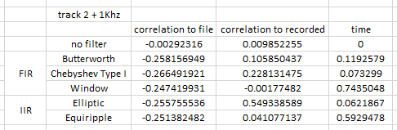

Figure 1. A typical table of results.

Above, figure 1, is the output of the experiments for one of the tests ran. It shows that the recorded version of track 2, with an added frequency of 1KHz, and the results from correlation with the original file, the recorded file and the time it took to perform the filter. To the left, we see that each row represents the type of filter, FIR and IIR, along with the different filter names. The no filter row was included as a reference point and because there was no process being completed, the time is zero.

After taking all the absolute values and averaging, figure 2 shows a graph of the results in a more presentable manner.

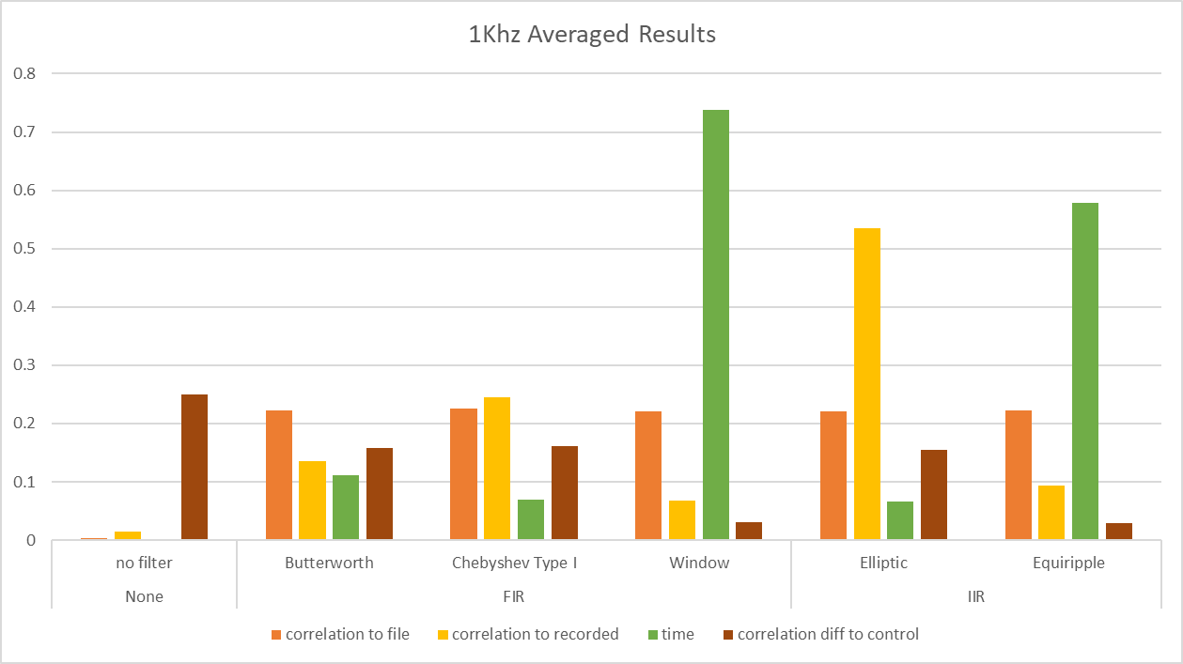

Figure 2.

The results are banded in either no filter applied, a FIR filer, or an IIR filter. We can see, on the whole, very little deviance between filters in correlation to the original file, which we would look for a higher value being a better correlation and therefore a more favourable result.

However, correlation to the recorded file is much more varied.

As acknowledged above, figure one is a typical results table from the experiment which share similar trends as most the other also do. Again, a higher value represents a higher correlation and is favourable. We can see that elliptical is at least double the correlation value compared to any of the other filter types.

The time taken for each filter has perhaps the biggest range with values starting below 0.1 up to heights of over 0.7. This section the favourable value would be the lower number, showing a quicker execution time. The window and equiripple techniques are shown to be many times higher than that of any of the others.

The last value represented on this graph is the correlation difference to the control which in this case is the value that the correlation between the original file and the recorded output. While it is not inherently true that a lower value is more favourable, as we already know that the first value in figure 2 (the correlation between the filtered results and the original file) does not vary much, a lower number does indicate a more favourable result because it shows that filter has been more successful at removing noise from the recorded file.

This chapter has been a brief look at how the results of the experiment can be displayed in a suitable manner. In the next chapter the results will be more closely investigated.

# 5.0 Discussion

## 5.1 Introduction

For the project to use a “base line” of correlation from the signals that have had noise added, there was need to establish a control of the recorded tracks correlated against the original files. Figure 3 shows the results of this.

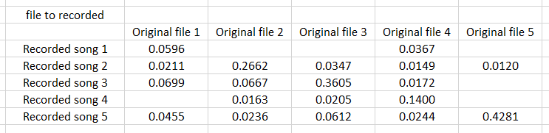

Figure 3. Cells without any values represent very poor correlation. All values are absolute values of results

The values of this table represent the correlation of each track based on a coefficient from 0 to 1, where 0 is least similar and 1 is most similar. In each case, the point at which a song is compared to its similar version, it is the highest scoring correlation coefficient in the column with the exception of the first column. This could be due to the two tracks having similar structures and frequency ranges and the degradation of the signal from being recorded exposes these similarities more. The table shows that the comparison method shown in appendix 7 works. While we cannot be sure to what extent, we can measure against this table to make comparisons later. In some cases in figure 3, the highest scoring value is much higher than the others in the row/column, but in other cases it is only higher by a small amount. WHY THOUGH

With the data we can now aim to apply it to the original 3 research questions.

## 5.2 Which filtering technique resulted in the best removal of unwanted noise

To aid discussion, figure 4 shows a graph of all the results for each scenario, with the data of each track averaged. This can be done in confidence as appendices 2, 4 and 6 shows that filters act consistently as they are being applied, with not much range. In all instances, a higher result is more desirable within figure 4.

Figure 4. Each section shows the results from the recorded track, with added noise, compared to the original recorded track.

One of the most obvious things looking at this chart is that the elliptic filter works much better than the other filters at returning the signal to its original state. We will see later than, in fact, the first two results for elliptic in figure 4 are the highest scoring correlation out of any of the test. This begs the question as to why it was not the case where the vacuum noise was added. In that set of groupings we actually see that not applying a filter at all is more effective than any of the filters tested. Looking closer though after the no filter score, elliptic is then the second highest.

SOMESTUFF

This does not paint the full picture though. Figure 4 shows results when comparing the noisy tracks to the recorded file. What about comparisons to the original file? Figure 5 shows us.

Figure 5. Each section shows the results from the recorded track, with added noise, compared to the original file.

In this graph we see a much more uniform distribution of results, especially with the 1Khz noisy track. The results from the first section are so uniform that its hardly worth comparing them. The same could also be said for the vacuum scenario. The 60Hz ones however show at least some variance. The equiripple and window methods display much lower scores than the rest, though still managing to more effective than no filter.

BEACUASE CLOSE TO START!?

## 5.3 Which had the quickest execution times

For all the different execution times, the type of filter remained consistent throughout the different applications of it. Figure 6 shows the averaged results for each scenario.

Figure 6. Average time taken for each filter to execute.

As noted previously, as no action was being performed for the no filter part, there was no time recorded so it was not included in figure 6. Again, the results are consistent in that equiripple and window both took much longer to compute than any other method, by several orders of magnitude. This is not due to inherent flaws with the type of filter they are, as equiripple is IIR and window is a FIR.

Interestingly, in the vacuum scenario neither Chebyshev nor elliptic seem to increase much compared to the other two scenarios. This is especially significant because for the vacuum scenario the signal was filtered 3 times and the execution time was taken from before the first and after the third.

## 5.4 Best overall

Looking at the two previous sections some of the filters really stand out. We saw that equiripple and window both not only had some of the worst results but also the longest execution time.

The filter that provided the best results for removing unwanted noise was also the fastest working, the elliptic. It is clear that the result of the experiments shows that for these requirements that were set, elliptic is the best filter to use when looking for quick execution and removing of unwanted signals.

5.5 C­ontinuing

We can say that one filter is better or worse than other filters based on our experiments but only within the scope of the parameters that were set. For example, though the two worst performing filters were poor performers in when comparing against the recorded file, they were both met the same average as the rest of the filters when filtering out the 1KHz noise and comparing it against the original file. This could be because the 1Khz signal was more isolated in its frequency range than the other scenarios. Both filters also struggled to filter the 60Hz. This could be because the filer parameters were so close to the start of the signal and the subsequent ripple effect the filter creates distorts when so close to the end of a signal.

# 6.0 Conclusion

## 6.1 To conclude

As is the case in much work, the accuracy of these results can be improved by increasing the number of samples tested against.

## 6.2 Future work

Future work and extensions of this project should look to change the type of data being used. A suitable example would be the medical field of study. Implementing filtering techniques to data such as MRI, ultrasound or other similar signal-based areas could create beneficial tools to medical professionals. By processing MRI data, for example, with filters that specifically determine tumour sizes in a patient could aid a doctor’s decision making prosses.

# References

Burgess, R.C. (2014). Filters, Analog/Digital. *Encyclopedia of the Neurological Sciences*, pp.299–307.

Smith, S. (1997). The Scientist and Engineer’s Guide to Digital Signal Processing.

‌

# Appendix

Appendix 1 – Recorded files, with noise, compared to original file

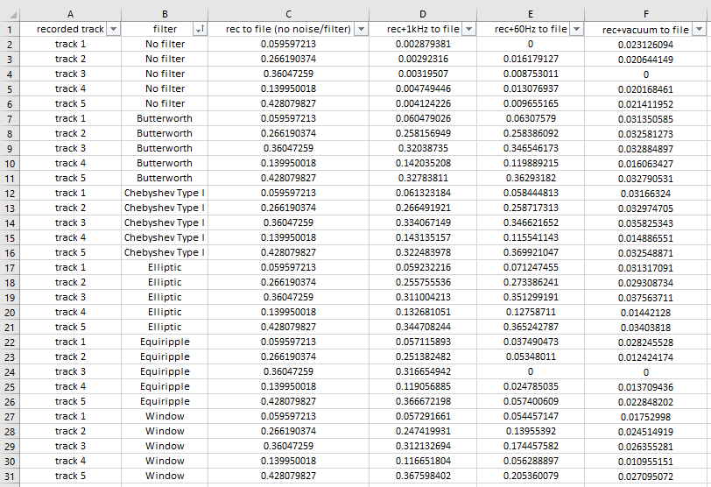

Appendix 2 – Graphs from the above data in appendix 1

Appendix 3 – Recorded files, with noise, compared to recorded file

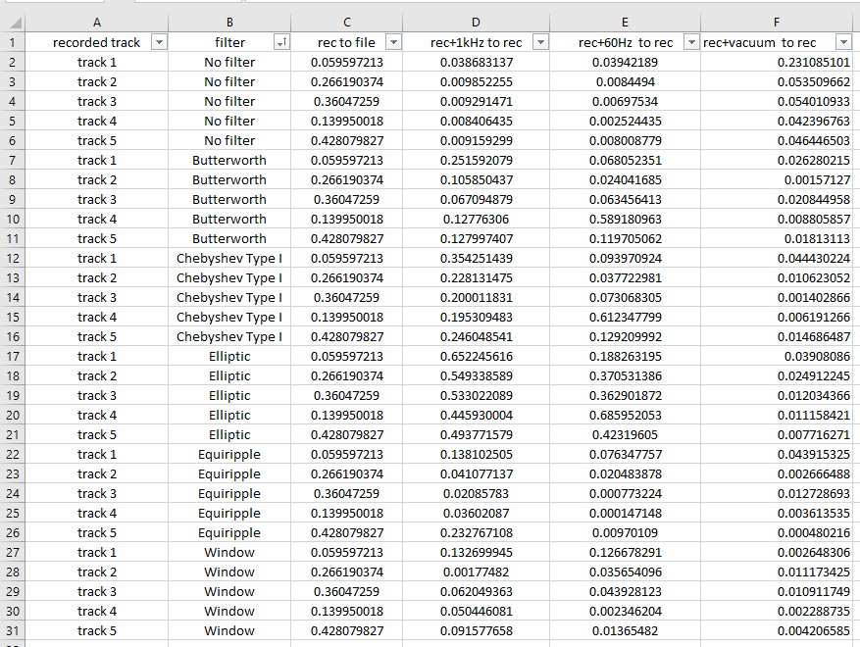

Appendix 4 – Graphs from the above data in appendix 3

Appendix 5 – Data of execution times

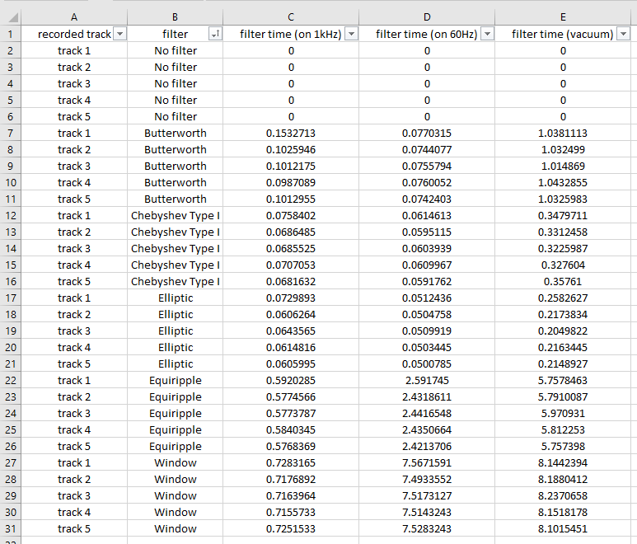

Appendix 6 - Graphs from the above data in appendix 5

Appendix 7 – Code segment of the function used to compare two signal and output the similarity coefficient.

