Predicting wildfire risk in Colorado using spatial embeddings and environmental covariates

Zander Hirman¹, Kai Skowlund²

Department of Geography, University of Colorado Boulder, Boulder, CO, USA
zander.hirman@colorado.edu¹ kai.Skowlund@colorado.edu²

Abstract

Wildfire occurrence in Colorado has increased threefold in frequency, intensity, and proximity. Predicting fire ignition risk is essential for mitigation techniques and early recognition. This project uses data such as burned-area maps, AlphaEarth embeddings, and environmental covariates (NDVI, climate, terrain, etc.). The training area is expanded to include Colorado as well as New Mexico, Utah, and Wyoming. Several models were used to obtain the best F1, AUC, and recall scores, such as a baseline Logistic Regression, Random Forest, XGBoost, LightGBM, and a Neural Network.

Index Terms— Wildfire prediction, AlphaEarth, XGBoost, WUI
1. Introduction

Wildfire risk in urban areas has increased significantly, making prediction models a top priority. Recent research has shown the expansion of fires from Wildland to Urban areas [1]. The expansion of WUI (wildland-urban interface) has increased the risk to infrastructure and human life. Identifying at-risk areas enables governments or municipalities to put in place preventive measures and resource planning before ignition. Machine learning enables combining environmental data and spatial information to build predictive models of fire risk. This project's task is to predict how fire-prone a given location in Colorado is. Data used for fire ignition points came from MTBS [2], and Satellite embeddings came from Google's AlphaEarth engine [3]. Environmental data were derived from multiple sources, including Sentinel-2 imagery (NDVI and NDVI anomaly) [4]. Climate data (Temperature, Dewpoint, RH) came from ERA5 (ECMWF Reanalysis v5) [5]. Elevation, slope, and Aspect were all derived from USGS SRTM (Shuttle Radar Topography Mission) [6]. Landfire Fuel Data came from FBFM40 (Fire Behavior Fuel Model 40) [7]. Landcover came from NLCD 2021 (National Land Cover Database) [8]. Nighttime Lights, Population Density, and Distance to Roads were obtained from NOAA VIIRS DNM [9], GHSL 2020 [10], and the LANDFIRE roads dataset [11], respectively. Finally, the last dataset used was the SPEI (Standardized Precipitation-Evapotranspiration Index) drought index [12].

2. Methods
2.1 Study Area
To accurately predict wildfire risk in Colorado and ensure sufficient samples in the study area for this project, the training area was expanded to include New Mexico, Wyoming, Utah, and Colorado. This helps reduce overfitting and increase the sample size.

2.2 Fire Data Construction
Training samples were split into 3 classes: burned points (positive class), near-fire negatives (hard negatives), and far-field background points (true negatives). Burned points were generated from randomly sampling the inside of burned polygons (label = 1). Near-fire negatives were created by applying a buffer of 5-10km around each burned polygon and then randomly sampling points inside that buffer zone. Far-field negatives were sampled from background points across the entire four-state region. After sampling the dataset was imbalanced at 1:2 (fire to non-fire), this imbalance was addressed through class weighting using scale_pos_weight.

2.3 Feature Extraction & Preprocessing
Using Earth Engine, environmental features were extracted as well as 64-dimensional embeddings. All datasets were combined, and embeddings were renamed to emb_0 – emb_63. Feature scaling was necessary only for the neural network; continuous variables were standardized using z-scores to improve convergence. The train-test split was set to 75/25 using stratified sampling to preserve the 1:2 class ratio. The final feature matrix was 64 embeddings, 14 environmental variables, human influences, and a binary label (1 = burned, 0 = non-burned).

2.4 Models
5 different models were used to determine the best-performing model on the data. Baseline Logistic Regression was used, followed by Random Forest, XGBoost, LightGBM, and finally a Neural Net.

2.5 Model Evaluation
Model performance was evaluated using AUC, Precision, Recall, and F1-Score. Because of the data imbalance, the best way to gauge model performance is through AUC. AUC is insensitive to class imbalance, making it a good metric for rare event predictions like wildfire ignition. To get a grasp of classification behavior, precision, recall and F1 were also noted during the results. However, out of those three, recall was the most important because missing a fire (false negative) is more problematic than predicting too many high-risk areas (false positive). All models were optimized as well, which helped improve them slightly. All models were trained and tested using a 75/25 split, which allowed for direct comparison.

3. Evaluation

This section will be split by model; each model was scored with embeddings only, then with embeddings and environmental covariates. Precision, Recall, and F1 score will be computed from the fire class only.

3.1 Logistic Regression
Logistic regression was used as a baseline for our other models

3.1.1 Logistic Regression EMB
AUC Score = 0.837, Precision = 0.70, Recall = 0.57 and F1 = 0.63. These scores were based solely on embeddings and separated the classes well. However, the model couldn’t identify true fires and struggled to detect actual fires. This is due to the linearity of the model’s decision

3.1.2 Logistic Regression EMB & ENV
AUC Score = 0.837, Precision = 0.60, Recall = 0.78, F1 = 0.68. These scores showed the model benefited from the addition of ENV variables. ENV covariates helped with identifying true fires, as well as a slight bump in F1, the overall fire class performance.

3.2 Random Forest
Random Forest was used because it is good at capturing complex relationships between variables. This helped the model, where EMB & ENV were used together.

3.2.1 Random Forest EMB
AUC Score = 0.854, Precision = 0.75, Recall = 0.53, F1 = 0.62. Precision improved over Log Reg, but Recall is still low, which is our most important metric. Slight bumps in score but nothing super important to note.

3.2.2 Random Forest EMB & ENV
Threshold = 0.350, AUC Score = 0.86, Precision = 0.61, Recall = 0.83, F1 = 0.70. AUC improved slightly when adding embeddings, but precision dropped. Recall improved the most, which is exactly what was needed. Threshold tuning helped our recall out a lot. Before tuning, it was 0.57; after tuning, it was 0.83.

3.3 XGBoost
This model was chosen for its strong performance on tabular data. It also performs well with imbalanced data, which was needed for this project.

3.3.1 XGBoost EMB
Threshold = 0.425, AUC Score = 0.86, Precision = 0.64, Recall = 0.77, F1 = 0.70. XGBoost is doing really well with just embeddings and has a good recall of 0.77. This model has used embeddings the best and been able to get a strong overall F1 Score.

3.3.2 XGBoost EMB & ENV
Threshold = 0.30, AUC Score = 0.86, Precision = 0.61, Recall = 0.83, F1 Score = 0.71. Recall improved to its best level yet, indicating that environmental covariates were useful for this model. With threshold tuning, this model was the top performer.

3.4 LightGBM
LightGBM was used because it’s faster and more efficient than XGBoost. Mainly to see if it could match XGBoost scores.

3.4.1 LightGBM EMB
Threshold = 0.475, AUC Score = 0.85, Precision = 0.66, Recall = 0.72, F1 = 0.69. This model didn’t perform as well with just embeddings as XGBoost did. While it ran faster, XGBoost is still a better option. It is important to note just how well embeddings alone can separate classes.

3.4.2 LightGMB EMB & ENV
Threshold = 0.475, AUC Score = 0.86, Precision = 0.68, Recall = 0.73, F1 = 0.70. LighGBM didn’t perform as well with both EMB & ENV as XGBoost did. Recall was lower as well as overall F1. This model was faster but at a cost to performance.

3.5 Neural Net
The Neural Net used EMB & ENV to see whether a deep learning model could learn more relationships between them. Neural Nets also benefit from large datasets, which is another reason only EMB & ENV were used together, rather than just EMB. The first NN used 2 hidden layers with ReLU activation and dropout to prevent overfitting. It had a total of 76 features inputted (64 EMB 12 ENV) and 7,000 params. The second NN was deeper, with 3 hidden layers (128, 64, 32) and ReLU activations. It also had 76 features and 21,000 params. Batch normalization and dropout were used to reduce overfitting and improve stability. In this NN, early stopping and learning rate scheduling were used for generalizability.

3.5.1 Neural Net V1
Threshold = 0.55, AUC Score = 0.86, Precision = 0.65, Recall = 0.76, F1 = 0.70. The first version of the NN matched XGBoost's AUC score but struggled with Recall and Precision. It handled EMB & ENV well with an F1 of 0.70, almost as good as XGBoost.

3.5.2 Neural Net V2
Threshold = 0.5, AUC Score = 0.862, Precision = 0.61, Recall = 0.83, F1 = 0.70. This version performed the closest to XGBoost in AUC score. Recall was higher in the second version which showed the importance of a deeper network to learn stronger relationships between EMB and ENV. However, Precision decreased, which is why XGBoost is still the better model.

4. Results

4.1 EMB Model Performance
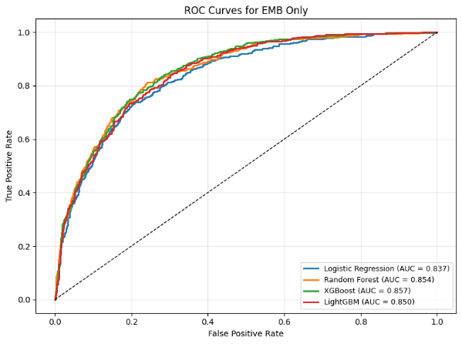
This figure shows the AUC results for models that used only EMB. It's interesting to see how far models can go with only embeddings. Even without primary predictors like land cover and fuel, these models are still able to get respectable scores.

4.2 Feature importance
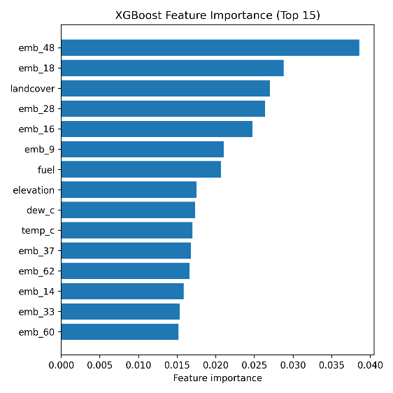
This figure shows the feature importance for XGBoost.

4.3 Key findings
Embeddings are very important for predicting where wildfires will occur. XGBoost was the best overall model. The NN got close on the second version but took longer to run. XGBoost is easier to replicate, making it the best option for future use. Recall was improved through the addition of environmental covariates. This means that while spatial embeddings are impressive, the labeled physical factors add important information about fire risk.

4.4 Summary Table
Model | Features | AUC | Prec | Recall | F1
Log Reg | EMB | 0.837 | 0.70 | 0.57 | 0.63
Log Reg | EMB&ENV | 0.837 | 0.60 | 0.78 | 0.68
RF | EMB | 0.845 | 0.75 | 0.53 | 0.62
RF | EMB&ENV | 0.860 | 0.61 | 0.83 | 0.7
XGB | EMB | 0.860 | 0.64 | 0.77 | 0.7
XGB | EMB&ENV | 0.864 | 0.61 | 0.83 | 0.71
LightGBM | EMB | 0.850 | 0.66 | 0.72 | 0.69
LightGBM | EMB&ENV | 0.857 | 0.68 | 0.73 | 0.7
NN V1 | EMB&ENV | 0.860 | 0.65 | 0.76 | 0.7
NN V2 | EMB&ENV | 0.862 | 0.61 | 0.83 | 0.7

5. Limitations
5.1 Data Limitations
Data limitations in this project came from the fire ignition data. Our dataset contained burned perimeters but not exact ignition points. Data was averaged annually, so seasonality isn’t considered. Class imbalance remains even after weighting.

5.2 Computational Limitations
Extracting embeddings and ENV features from Earth Engine is slow on laptops. Running full cross-validation for every model would have been impractical. The GPU used to run the models hindered the Neural Net's performance, which could have been the best model if it had been built deeper.

5.4 Generalization Limitations
Models were trained on CO, NM, WY, and UT, so generalizing to other regions would require more data. Colorado has landscapes similar to more states than just the training area. More states would have provided more information.
6. Conclusion
6.1 Goal
The goal of this project was to predict wildfire risk in Colorado using a combination of Embeddings and Environmental covariates. Multiple models were used to determine which produced the best results.

6.2 What was accomplished
Created a large fire dataset across four states using burned areas, hard negatives, and fair-field negatives. The extraction of embeddings and environmental variables from different sensors/sources. Trained and evaluated multiple models, which achieved relatively high performance. Showed how useful spatial embeddings can be and how much information can be extracted from them.

6.3 What was best
XGBoost with the combination of EMB and ENV was the best model. The highest recall score came from this model as well as the best overall F1. Threshold tuning helped all models but was the most significant for XGBoost.

6.4 Final Impact
XGBoost is the best option for machine learning-based fire risk mapping. This model can be used to create maps of at-risk areas, which will help with preparedness and mitigation for fires in Colorado. Wildland Urban Interfaces could benefit from predictions from these models.

7. References

[1] T. J. Hawbaker, V. C. Radeloff, S. I. Stewart, R. B. Hammer, N. S. Keuler, and M. K. Clayton, “Climate change and wildfire risk in an expanding wildland–urban interface: A case study from the Colorado Front Range Corridor,” Landscape Ecology, vol. 30, no. 5, pp. 725–740, 2015.
[2] USDA Forest Service and U.S. Geological Survey, “Monitoring Trends in Burn Severity (MTBS) Project: Fire Level Geospatial Data,” MTBS, 2022.
[3] A. R. Kondmann et al., “Satellite Image Embeddings for Scalable Geospatial Machine Learning,” arXiv preprint arXiv:2402.00713, 2024.
[4] European Space Agency (ESA), “Sentinel-2 MSI Level-2A Surface Reflectance,” Copernicus Open Access Hub, 2017.
[5] H. Hersbach et al., “The ERA5 global reanalysis,” Quarterly Journal of the Royal Meteorological Society, vol. 146, no. 730, pp. 1999–2049, 2020.
[6] USGS, “NASA Shuttle Radar Topography Mission (SRTM) 1 Arc-Second Global,” U.S. Geological Survey, 2014.
[7] LANDFIRE, “Fuel Model 40 (FBFM40),” U.S. Department of the Interior, Geological Survey, 2022.
[8] J. Dewitz, “National Land Cover Database (NLCD) 2021 Products,” U.S. Geological Survey, 2023.
[9] C. Elvidge et al., “VIIRS night-time lights,” International Journal of Remote Sensing, vol. 38, no. 21, pp. 5860–5879, 2017.
[10] M. Schiavina, D. Freire, and S. MacManus, “GHS-POP R2023A – GHS population grid multitemporal (1975–2030),” Joint Research Centre (JRC), European Commission, 2023.
[11] LANDFIRE, “Roads Dataset,” U.S. Department of the Interior, Geological Survey, 2022.
[12] J. T. Abatzoglou, “Development of gridded surface meteorological datasets for ecological applications and modeling,” International Journal of Climatology, vol. 33, no. 1, pp. 121–131, 2013.

