**ACTIVITY # 1**

**(A.B)(A+B)**

|  |  |  |  |  |  |
| --- | --- | --- | --- | --- | --- |
| NAME: | Itumay Aldrian P. | | | COURSE, YEAR & SECTION: | BSIT-3A |
|  | *Last name* | *First name* | *M.I.* |  |  |

1. Diagram

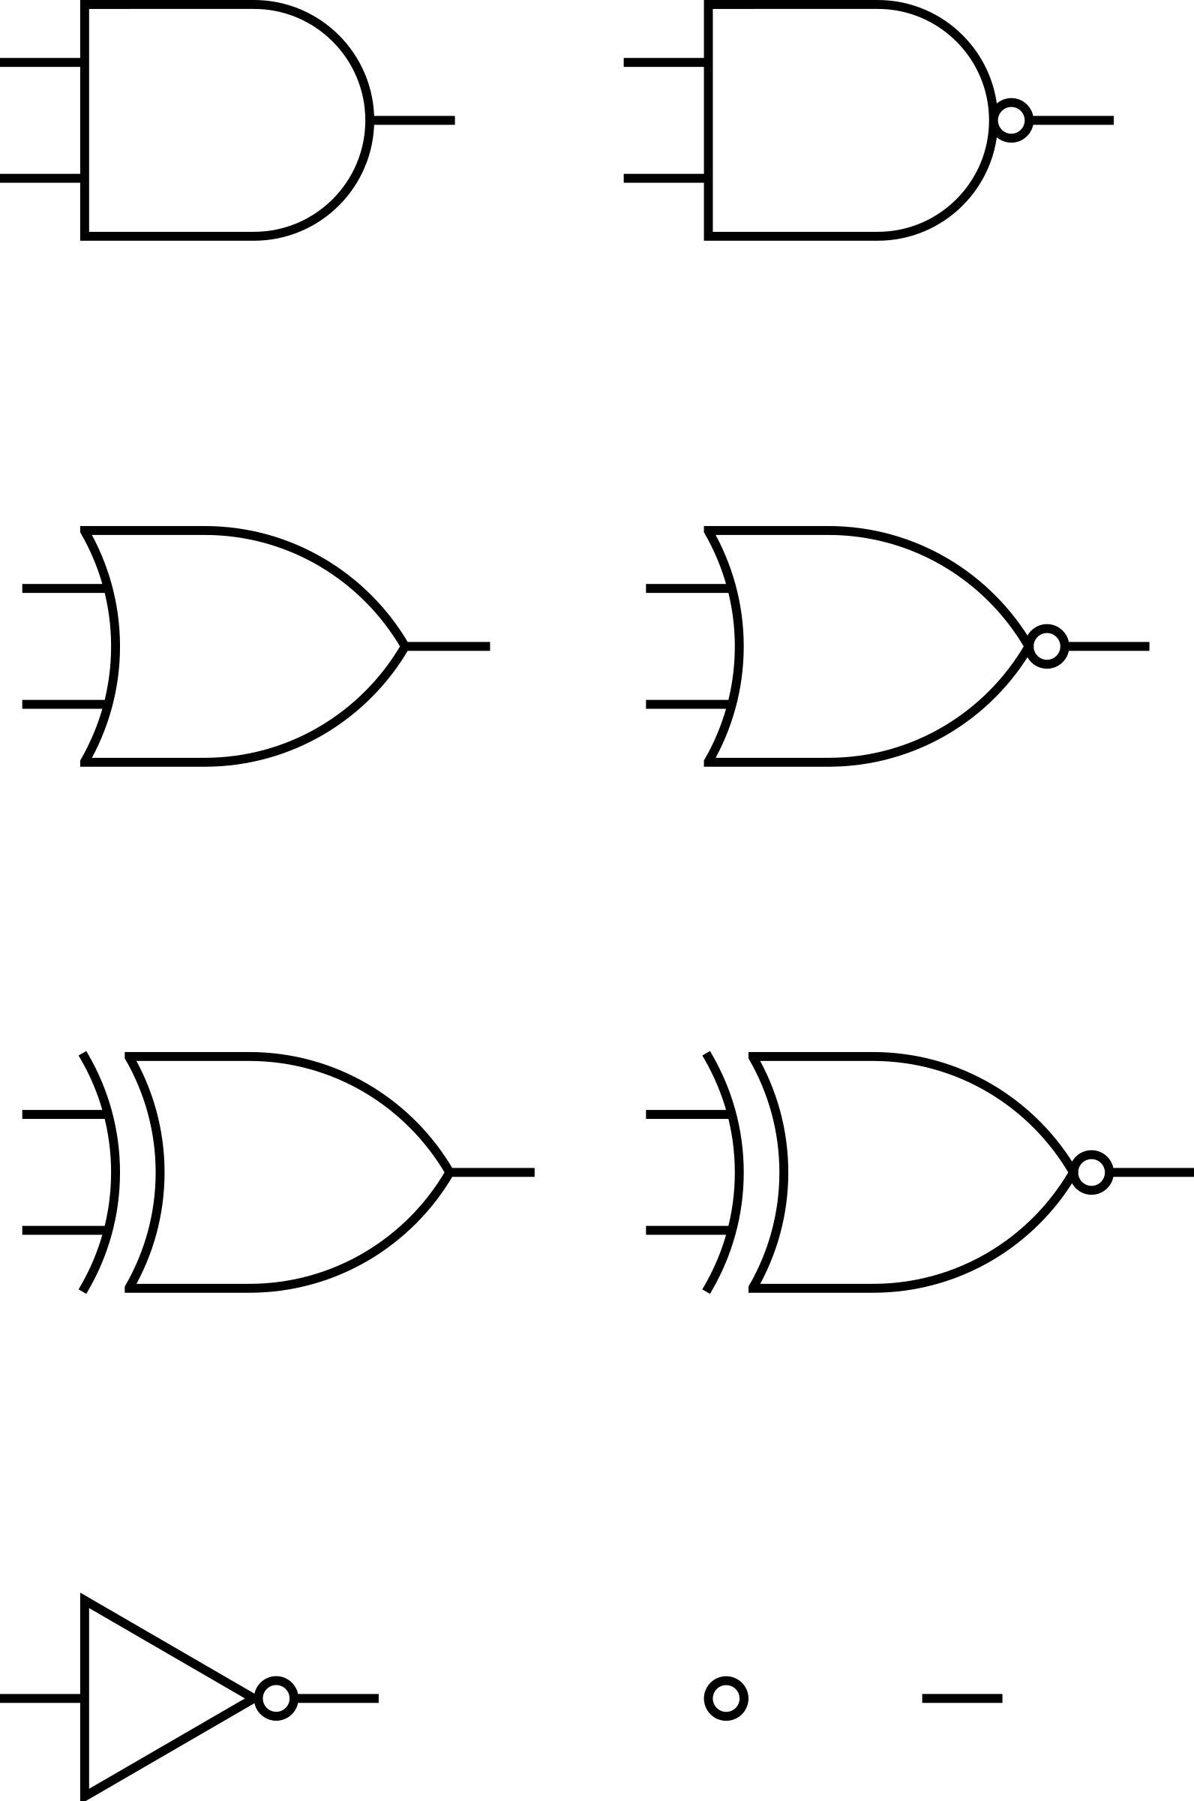

**A**

**A.B**



**(A.B)(A+B)**

**B**



**A+B**

1. Analysis
2. A.B
3. A+B
4. (A.B) (A+B)
5. Truth Table

|  |  |  |  |  |
| --- | --- | --- | --- | --- |
| A | B | A.B | A+B | (A.B) (A+B) |
| 0 | 0 | 0 | 0 | 0 |
| 0 | 1 | 0 | 1 | 0 |
| 1 | 0 | 0 | 1 | 0 |
| 1 | 1 | 1 | 1 | 1 |

1. Breadboard Simulation (Screenshots)
2. 