**Construct a DFA over [false, true] which accepts a string that contains any bad/toxic word in English language.**

Transition Table

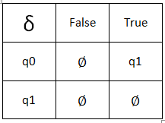Q = [q0, q1]

Sigma = [false, true]

q0 / initial state = q0

F / Final state = q1

Delta: q0, true 🡺 q1

Entry: True

True, False

False

False

True