

Submitted by: **ABM 11-VALENZUELA**

GROUP # **3**

**AZHLEY JIANE BADIOLA**

**AISHE ASHLY MARIANO**

**JEANEL MIRADOR**

**REA COMCOM**

**JARED CLARK BAJEN**



**Business Address:** Ph 1, Bagong Silang, North Caloocan City

**Nature of the business:**

* Our goal is to make tumbler more accessible and affordable with reliable services, and we also have highly skilled workers and high-quality materials. It's the best choice for putting any water and juices. Creating a tumbler is one of the goals of our business. It can help people bring their water from home and not waste plastic bottles. Furthermore, our target in creating our tumbler is to sell it to those who always buy and use plastic bottles every time he/she is going outside. Our materials are made of plastic, glass or stainless steel. It depends on what type of tumbler you're buying from us. We also ensure that the quality of our product is good and safe for children, pregnant women and also for elderly persons.

II. Description of the business

**a. Product Description**

* 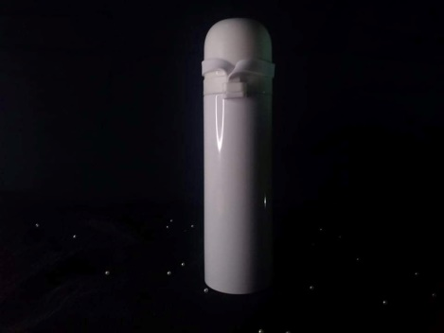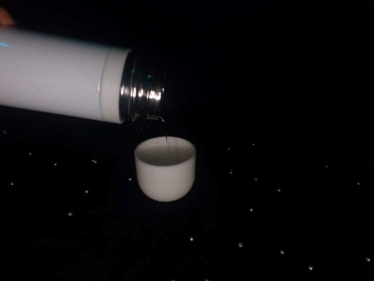Our product is made by double - walled and vacuum insulated to keep your drinks hot or cold. Our tumblers make perfectly for taking your favorite hot or cold drinks on the go. We assure that our product was in a best quality and have affordable price and that's why people buy from us.

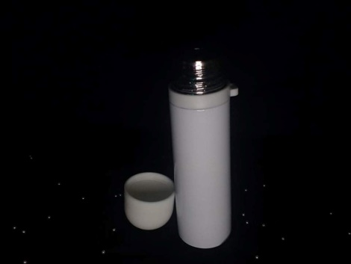

**b. Mission**

* The mission of our business is to make people have fun while drinking their beverage. Enjoying their drinks while using our product is the best feeling for us. And we make sure that our product is unique and have a good quality. Our product is best on the trips because it’s on the go tumblers. And it’s perfectly to the people wants their beverage stay hot or cold.

**c. Vision**

* The vision of our business is to give satisfaction to our dear customers and to be the highest rates for Tumbler market industry.

**e. Core Values**

Satisfaction

* We guarantee that our customers will be delighted with their purchase of a high-quality items from our store.

# Respect

* We value our customers' choices and opinions when it comes to purchasing our products.

# Patience

* We must also be patient with the customers who do not understand how to to use our product, and we must repeat and simplify our explanations to them so that they can fully understand what we are saying.

# III. Organizational Plan

* Because of the shareholders, who are the general, marketing, administrative, and sales managers, the Tumbler Zone is a partnership business. In order to start this type of ownership, the owners must be divided into equal parts and contribute the same amount of money.

## IV. Organizational Chart

**a. Roles and Responsibilities**

### General Manager Azhley Jiane Badiola

* Is in charge of creating and maintaining budgets, managing employees, and other responsibilities.

### Assistant Manager Jared Bajen

### Maintaining a safe and hygienic work environment, as well as monitoring customer and client satisfaction.

### Marketing Manager Jeanel Mirador

#### Is in charge of creating, implementing, and executing strategic marketing plans in order to acquire new customers and keep current ones.

#### Administrative Manager Aishe Ashly Mariano

#### Is in charge of reviewing, monitoring and managing budgets.

#### Sales Manager Rea Comcom

### Is responsible of creating reports to track sales and achieve goals.