DAT602 Database application development
Assignment 1.

By Zandi Galpin.

Table of Contents
Assignment 1 2
Task 1, Description of game, storyboarding and user stories: 2
Task 2, logical entity relationship diagram depicting the planned database: 26
Task 3, CRUD table as part of analysis for the game system: 27
Task 4, DDL SQL script to create tables and relations between tables to support the game: 29
Task 5. Create a prototype C# .net application using Visual Studio: 29
Assignment 2: 30
Task 1, TSQL procedures: 30

Assignment 1

Task 1, Description of game, storyboarding and user stories:
Description:
This game will be titled Ultimate Goose Fighter. It is a semi-top-down (characters are shown from the side, but the environment is top-down) multiplayer combat game in which players play as geese. Each goose has a health bar above it visible to all players. Players will move either with the arrow keys or WASD. The player can attack with the space bar. Attacking causes the goose to extend its neck and peck forwards one tile in the direction they are facing. A goose’s beak must be in contact with another goose to do damage. After being damaged, a goose is invincible for 0.5 seconds. When a goose’s health is depleted, they respawn in a different location on the map, and they are invincible for 5 seconds. While a goose is invincible their sprite flashes. The player who killed them has their score increased by 1.
All geese have 4,000 max health and deal 40 base damage.
Each goose has 1 inventory slot (holding item in mouth). Holdable items can be picked up by coming into contact with the goose’s beak or body (either by using the attack button or walking onto the tile the item is on). Items spawn randomly. While holding an item, use the space bar (attack button) to use the item or attack with it. Press L or G to drop the item.
Holdable items can include the following:
- Baseball bat (+50% attack damage).
- Pellet Gun (-50% attack damage, ranged attack, disappears after ammo is depleted, random amount of ammo from 3 to 10, bullets travel in the direction the goose is facing when shot until they hit something, if a goose picks up another pellet gun while they still have ammo then more ammo is added).
- Shield (-50% incoming damage, -25% outgoing damage).
- Grenade (when activated, is thrown straight forward 3 tiles in the direction the player is facing, explodes after 1 second, doing 500% damage in a square shape of 9 tiles).

When a goose drops an item, that item disappears and cannot be picked back up again. Consumables will also randomly spawn on tiles. A goose cannot eat consumables while it has an item in its mouth (this is why items disappear when dropped and can’t be picked up again. If a player has a powerful item, they should think twice before dropping it to eat consumables). Consumables are picked in the same way as items are picked up (coming into contact with beak or body) and you can either press the space bar to consume them or L or G to drop them.
Consumable items can include the following:
- Peas (when eaten, regain 200 health).
- Banana (spawns less, when eaten, regain 400 health).
- Grapes (spawns rarely, when eaten, the player gains invincibility for the next 5 seconds).
- Watermelon (spawns rarely, when eaten, regain 1,000 health).

Each player will have a home nest that spawns under them when they first spawn (or when they respawn). While a player is standing on their nest, they cannot be attacked (flashing invulnerability) but can still attack others. If a player drops an item or consumable on their nest, it goes into the nests inventory, which has 9 slots. If the nest’s inventory is full, clicking the drop buttons (L or G) will not do anything. While standing on the nest, the nest’s inventory will be open. Items in the nest will be listed with images. Clicking on an item will remove it from the inventory and place it in the goose’s inventory (if there is not already an item in it). If a player’s health is depleted, their nest despawns and all items in the nest are lost. The player respawns and a new nest is spawned under them.
If a player leaves the game, their nest’s position is saved, any items in the nest are saved, their goose’s position on the map is saved, their health is saved, their score is saved, and any item they may be holding is saved.
Items and consumables will not spawn unless there are at least 2 players online.
When a new account is created the default score is 0.
There will be no more than 1 NPC on the map at all times. The NPC will be a grey goose which wanders randomly. It has 1,000 health and a health bar indicating its health. When defeated, it drops an item or consumable completely randomly (ignores spawn rates and instead treats the probability of all items/consumables equally, therefore rare items are more likely to drop). When the NPC dies, a timer of 1 minute begins. After 1 minute another NPC spawns in a random location.
Storyboards:
Login screen, storyboard 1 – requirement 1/2:
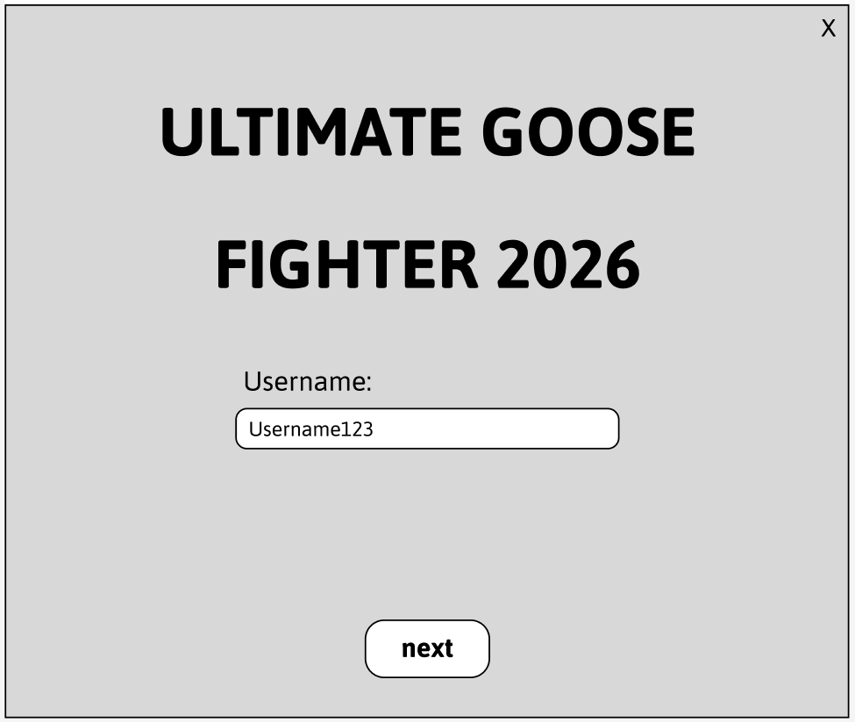
A user first opening the application is brought to this screen with a username field, a “Next” button, an “X” in the top right to close the application, and the title “ULTIMATE GOOSE FIGHTER 2026”. They type in a username and click the “next” button. If the username exists in the database, the screen changes to storyboard 2. Clicking “Next” runs a SELECT against PLAYER on Username to check whether the row exists, which determines whether the user goes to storyboard 2 or 3.
If the username doesn’t exist in the database, the screen changes to storyboard 3.

Login screen (existing user), storyboard 2 – requirement 1:
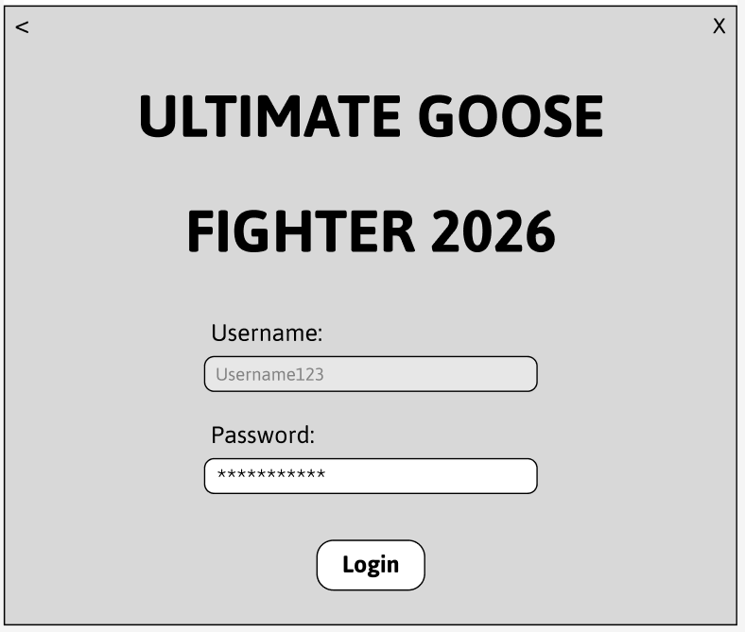
When a user has entered an existing username in storyboard 1, they are brought to here. The username is greyed out and can no longer be changed. A “Login” button appears in place of the “Next” button and a “Password” field appears under the Username field (starting empty until typed in, appears as asterisks), along with a back arrow in the upper left corner. If the back arrow is clicked, this directs the user back to the screen in storyboard 1. The user types a password in and clicks the “Login” button. If the password is correct and the user is a regular user, the screen changes to Storyboard 12. If the password is correct and the user is an admin, the screen changes to Storyboard 17. If the user is a new regular user (created by an admin but hasn’t logged in before), they are taken to storyboard 5. If the password is incorrect, the password field is cleared and the text “Incorrect password” appears under the password field, and they are given a chance to try again. After 5 incorrect attempts, the screen changes to storyboard 4. Password is checked against the stored PLAYER’s username. A failed attempt increases FailedLoginAttempts by 1. A success resets it to 0. If it gets to 5 then IsLockedOut is set to 1.
Registration screen (new user), storyboard 3 – requirement 2:
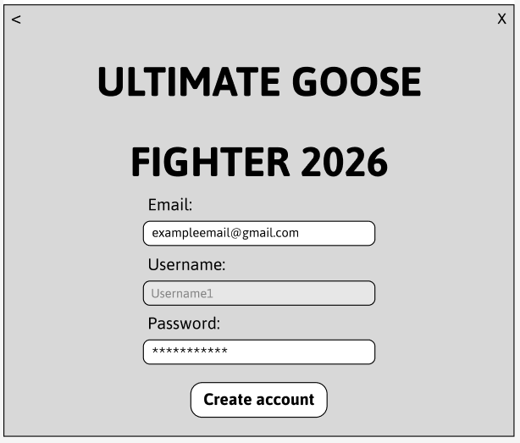
When a user has entered a name that doesn’t currently exist in the database in storyboard 1, they are brought to here. The username is greyed out and can no longer be changed. A “Create account” button appears in place of the “Next” button. An “Email” field appears above the Username field, and a “Password” field appears underneath the Username field (both starting empty until typed in, password text appears as asterisks), along with a back arrow in the upper left corner. If the back arrow is clicked, this directs the user back to the screen in storyboard 1. If the user leaves either of the entries empty, clicking the “Create account" button won’t work. If the user has typed in them, clicking the button will change the screen to storyboard 5. “Create account” inserts a new PLAYER row with the entered email, username and password, a score of 0, IsAdmin set to 0, IsLockedOut set to 0.

Lockout screen (5 incorrect attempts), storyboard 4 – requirement 1:
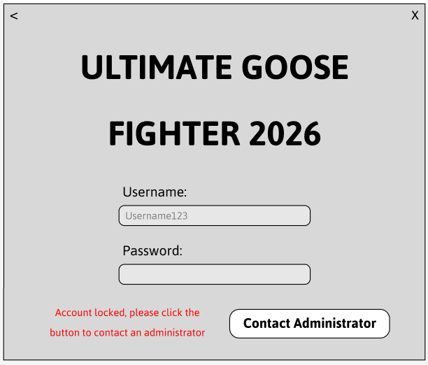
When a user enters an incorrect password 5 times on storyboard 2, the screen changes to this. The password is cleared and the field is greyed out and can no longer be typed in. The text “Account locked, please click the button to contact an administrator” appears underneath in red, and the “Login” button disappears and is replaced with a “Contact Administrator” button. If this button is clicked it displays an admin’s contact info. This screen reflects PLAYER.IsLockedOut = 1. Only an admin unticking “Account locked?” on storyboard 11 can set it back to 0.

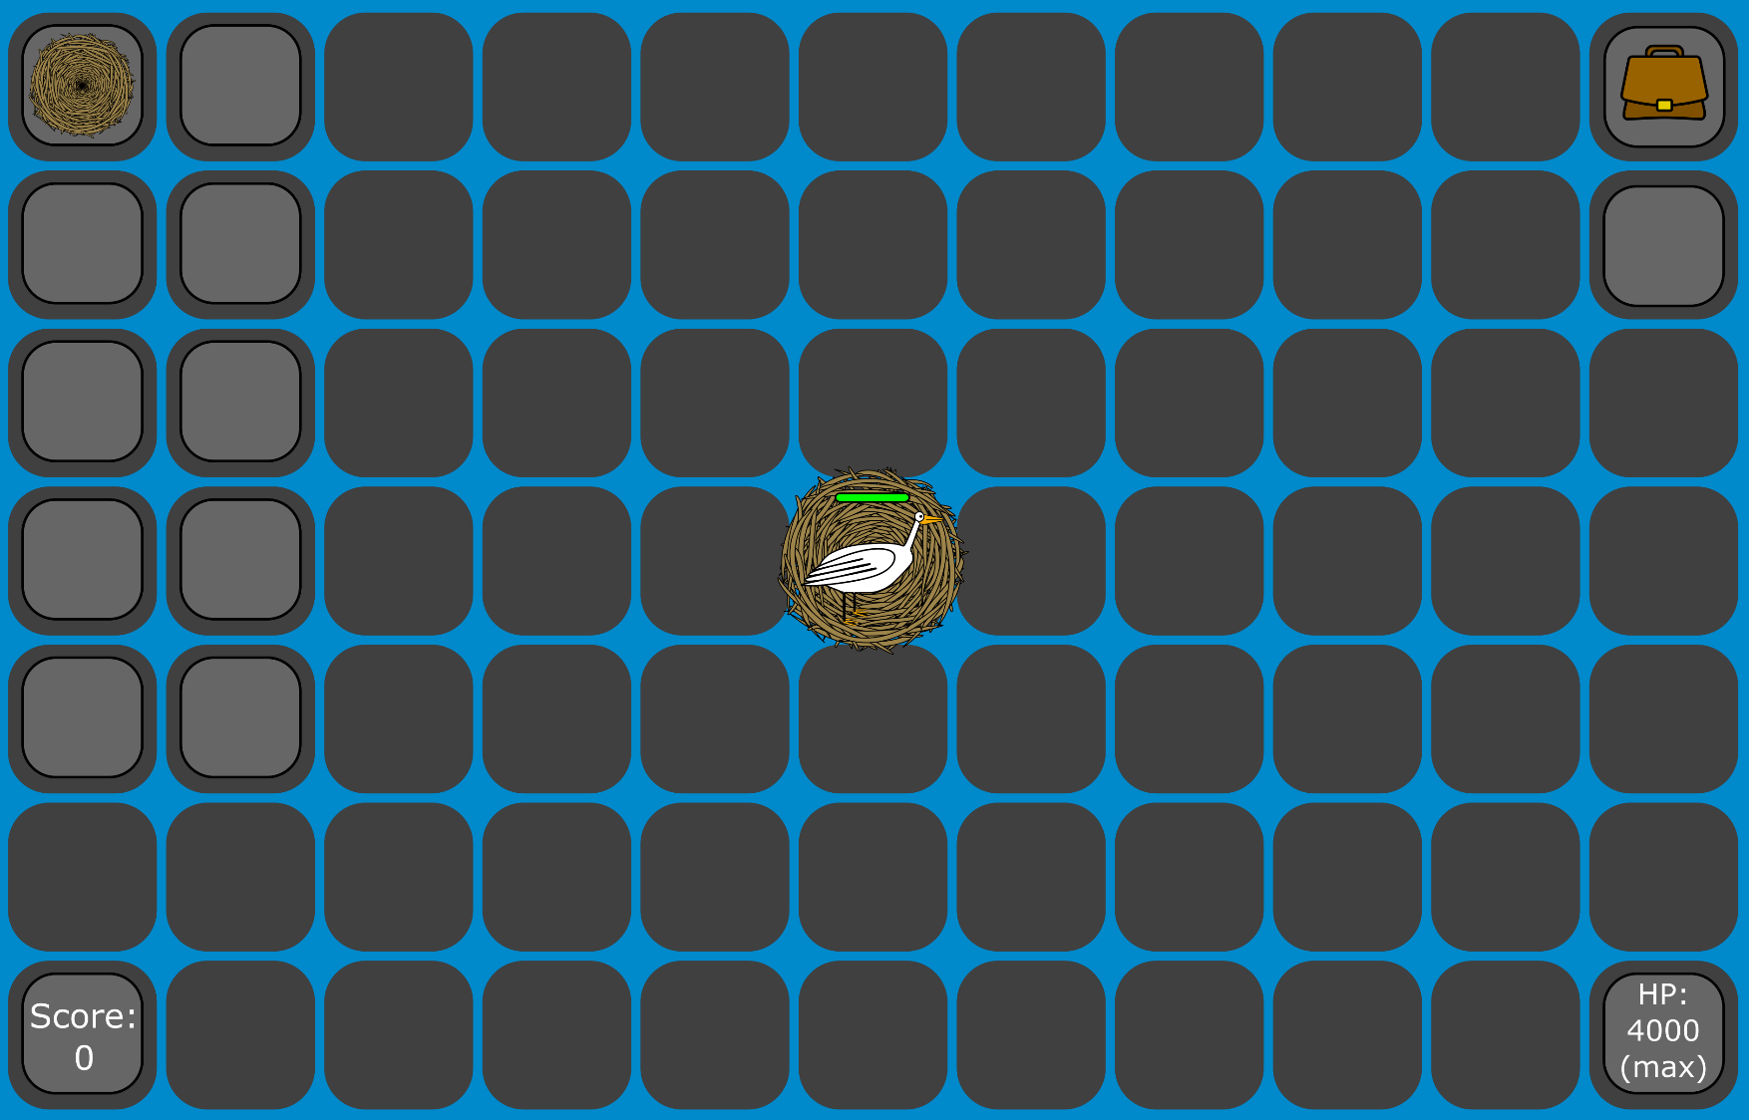
Game start screen for new user, storyboard 5 – requirement 6:
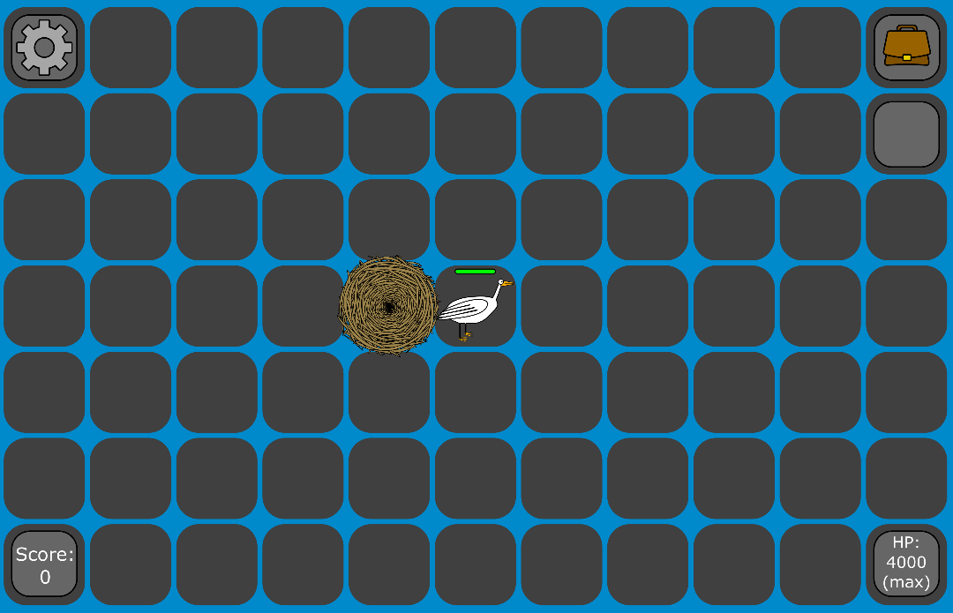
When a user creates a new account (from storyboard 3) they are brought here. They spawn in on a random tile on the map with a nest under them. In this case all tiles on the screen are filled in. This doesn’t have to be the case. A player can spawn with their nest on a tile on the edge of the map. The score, HP and inventory overlay will always be on screen. The nest overlay will only be on screen while standing on the nest. The user then presses the “D” key on their keyboard, moving them to the next tile on the right, as seen here. Also, when the player is not on their nest, the settings icon will appear as an overlay. This stays on screen at all times that the user is not standing on their home nest. The user clicks this icon and is brought to storyboard 7. A NEST row is inserted (linked to the new PlayerID and a randomly chosen TileID). PLAYER.CurrentTileID is updated to that tile.
Settings screen (regular user), storyboard 7 – requirement 3:
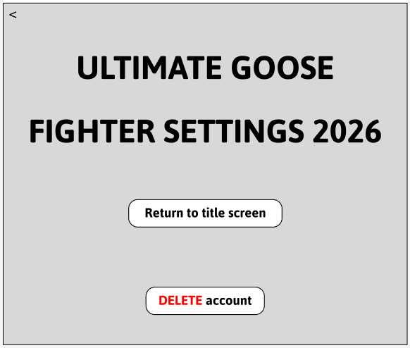
Anytime a regular user (non admin) clicks the settings icon while they are in the game (in this case from storyboard 5 or 12), they will be brought to this screen. While on this screen their goose will be invincible. There will be a “Return to title screen” button which when clicked will send the user back to storyboard 1 (logging them out). There is also a “DELETE account” button. When clicked, it will prompt the user asking them if they are sure they want to delete their account, with “yes” and “no” options. If the user clicks the “yes” button, their account will be deleted and removed from the database, and they will be sent to storyboard 1. Clicking the back arrow on the top left will return them to the game (storyboard 5 or 12) and they will no longer be invincible. “DELETE account” removes the PLAYER row, and deletes their NEST row and any ITEMs they were holding or storing. “Return to title screen” sets IsOnline to 0 for the user’s PLAYER row.

Settings screen (admin), storyboard 8 – requirement 11, segway to requirements 12, 13 and 14:
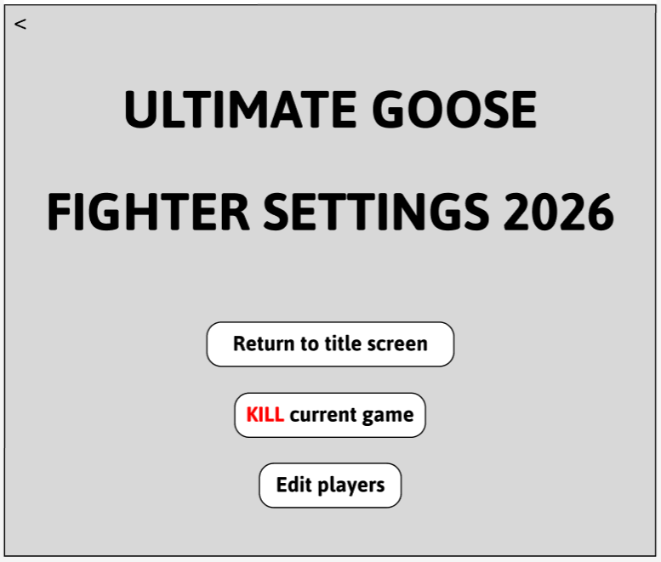
When a user who is an administrator clicks the settings button (in this case from storyboard 17), they will be brought to here. This screen is the same as in storyboard 7 except the “DELETE account” button is replaced with an “Edit players” button, plus there is a new “KILL current game” button. The “Return to title screen” button, when clicked by the user, sends them back to storyboard 1 (logging them out). The user (admin) clicks the “Edit players” button and they are brought to storyboard 9. Clicking the back arrow on the top left will return them to the game (in this case storyboard 17). If the user had instead clicked the “KILL current game” button, they would be prompted with text saying “Are you sure” and given the options “Yes” and No”. If they click no, the text goes away. If they click yes, the current game is killed and all players are kicked offline. Clicking the “Kill current game” button and confirming runs a bulk UPDATE against the PLAYER table. IsOnline is set to 0 for every row that is set to 1. Does not change anything else. “Return to title screen” sets IsOnline to 0 for the user’s PLAYER row.
Edit players screen (admin), storyboard 9 – requirement 14, segway to 12 and 13:
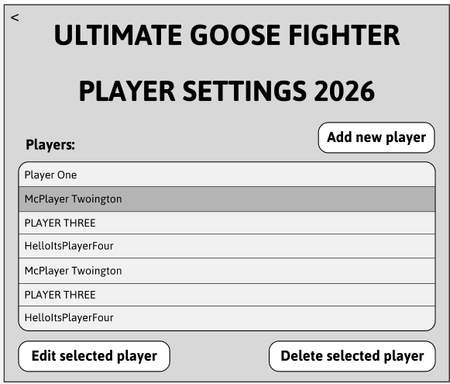
When a user who is an administrator on storyboard 8 clicks the “Edit players” button they are brought to here. There is a back arrow in the same place as before which when the user clicks it, returns to the settings screen (storyboard 8). There is an “Add new player” button which when clicked takes the user to storyboard 10. Under this button is a list of existing players. In this screenshot, the user has selected (clicked) the player “McPlayer Twoington”. Under the list of existing players there are two buttons. A player must be selected for either of them to be clicked. The first button is the “Edit selected player" button, which when clicked brings the user to storyboard 11. The second button is the “Delete selected player” button, which when clicked, removes the selected player and any related player information from the database, along with removing it from the list on screen. The list of players is populated by selecting all usernames from the PLAYER table. “Delete selected player” does the same delete as in storyboard 7.

Add new player screen (admin), storyboard 10 – requirement 12:
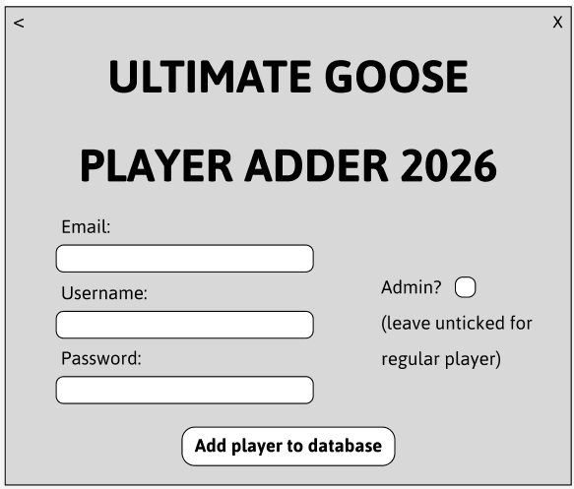
While on storyboard 9, if the user clicks the “Add player” button, they are brought to here. The back arrow, when clicked by the user, returns them to storyboard 9 without saving any details entered. There are “Email”, “Username” and “Password” fields like in storyboard 3, except here the username field is not greyed out as it needs to be entered along with the other info. These fields cannot be left blank before submitting. There is also an “Admin?” tick box which is by default unticked. If the user ticks this and submits, the player will be given administrator privileges. The user submits by clicking the “Add player to database” button at the bottom. This adds the player information to the database, then sends the user back to storyboard 9, where the new player is listed along with the old ones. Same INSERT as storyboard 3, but IsAdmin is set based on the tick box instead of automatically being set to 0.

Edit selected player screen (admin), storyboard 11 – requirement 13:
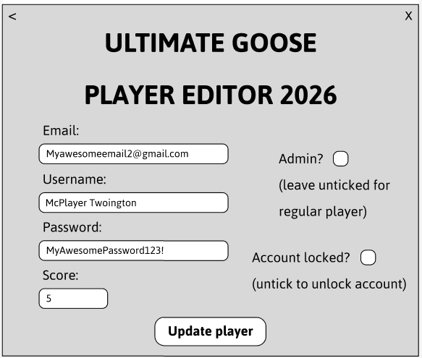
While on storyboard 9, if the user (who had selected McPlayer Twoington) clicks the “Edit selected player” button, they are brought to this screen. This has “Email”, “Username”, “Password” and “Score” fields which are all stored in plaintext, contain the players current information from the database, and are able to be edited. There is also an “Admin?” tick box and “Account locked?” tick box which are either already ticked or unticked depending on the data in the database reflecting each of them (Booleans). The back arrow, when clicked by the user, returns them to storyboard 9 without saving any details which have been altered. The user edits some details about McPlayer Twoington, including changing his username to “Mcplayerington Two”. There is an “Update player” button at the bottom which, when clicked by the user, updates the players information in the database to what has been edited on this screen by the user, then sends the user back to storyboard 9, which appears the same, except instead of “McPlayer Twoington”, “Mcplayerington Two” is now listed (not to be implemented in this project, but a good idea would be to send the player an email about their username and/or password getting changed). “Update player” runs an UPDATE PLAYER SET … WHERE PlayerID = … for all the edited fields, including IsAdmin and IsLockedOut.

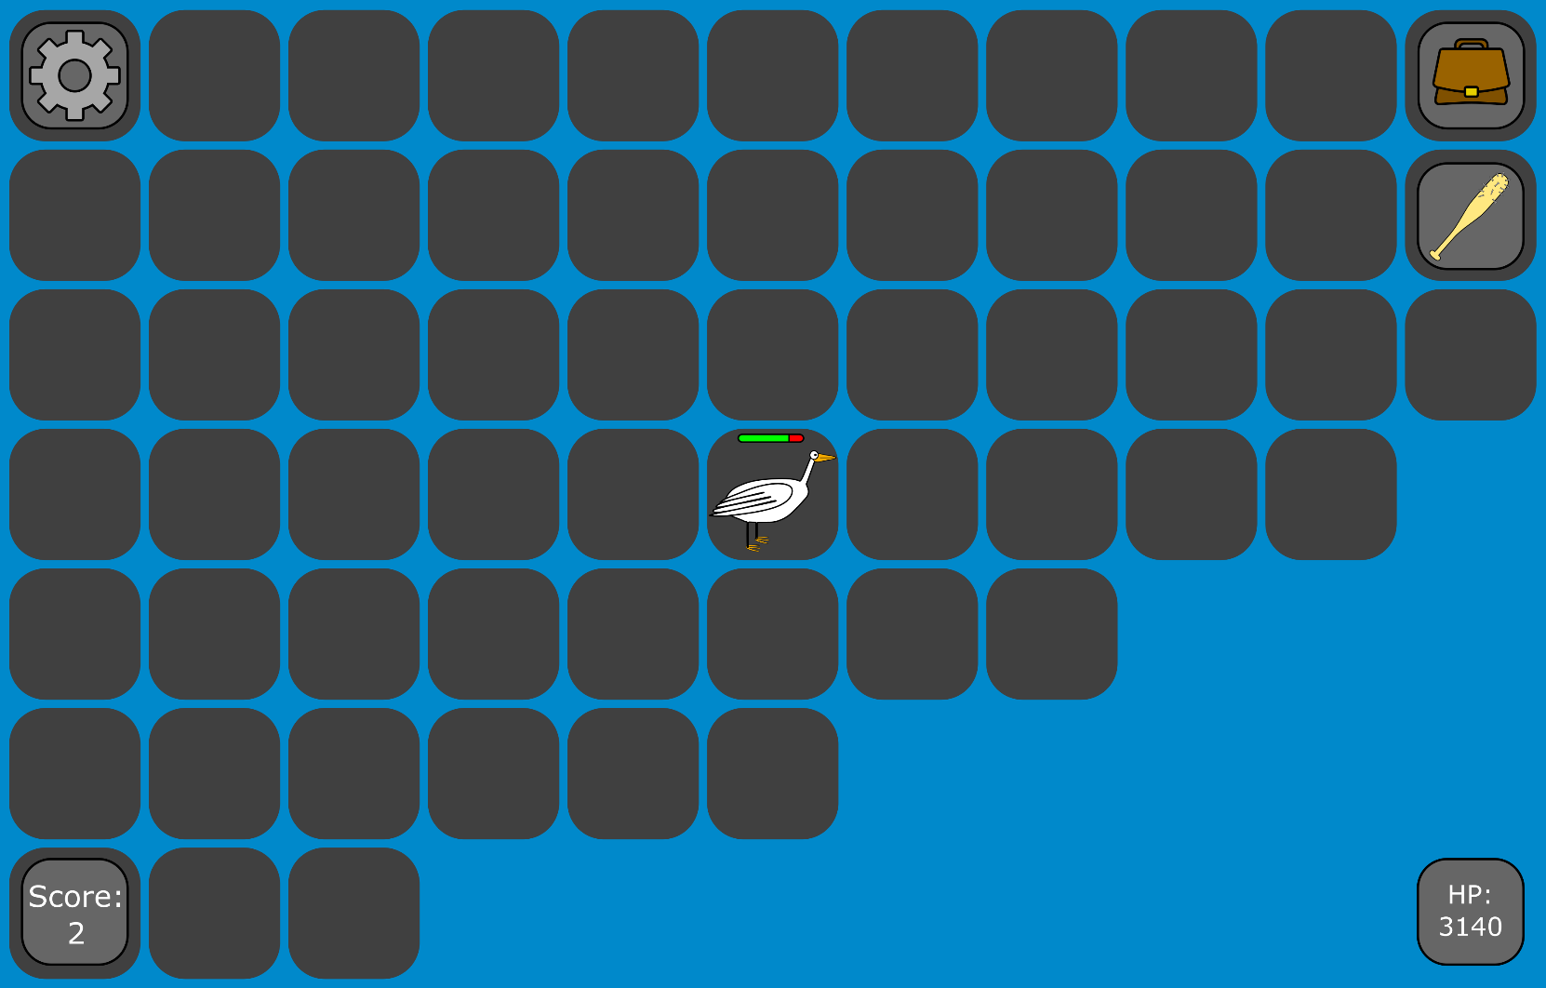
Game start screen for returning user, storyboard 12, segway to requirement 7:
On storyboard 2, if the user clicks the “Login” button with correct credentials, they will be brought to wherever they were when they last left the game, in whatever state they were in with whatever item they had. In this case we can see that the user had 3140 HP, a score of 2 and a baseball bat when they last logged out. If the user clicks the settings icon in the top left, they will be brought to storyboard 7. In this case the user doesn’t click this and continues to storyboard 13. On login, PLAYER’s saved CurrentTileID, Health, Score and HeldItemID are read to restore the state they had when they left, and IsOnline gets set to 1.

User defeating another player and gaining score, storyboard 13, requirement 7:
In this case the user stays still (no inputs) and another player comes on screen and moves across to them until they are 2 tiles away, as seen below.
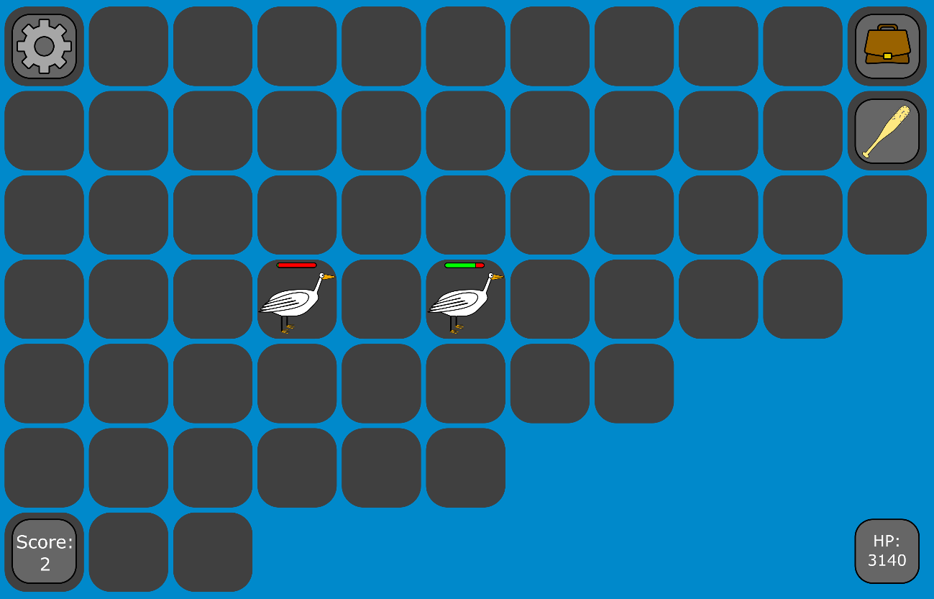
The user then clicks the left arrow key, moving one tile to the left. And the other player clicks the space bar, attacking forward onto the tile the user is on. This decreases the user’s health by 40, as shown below.
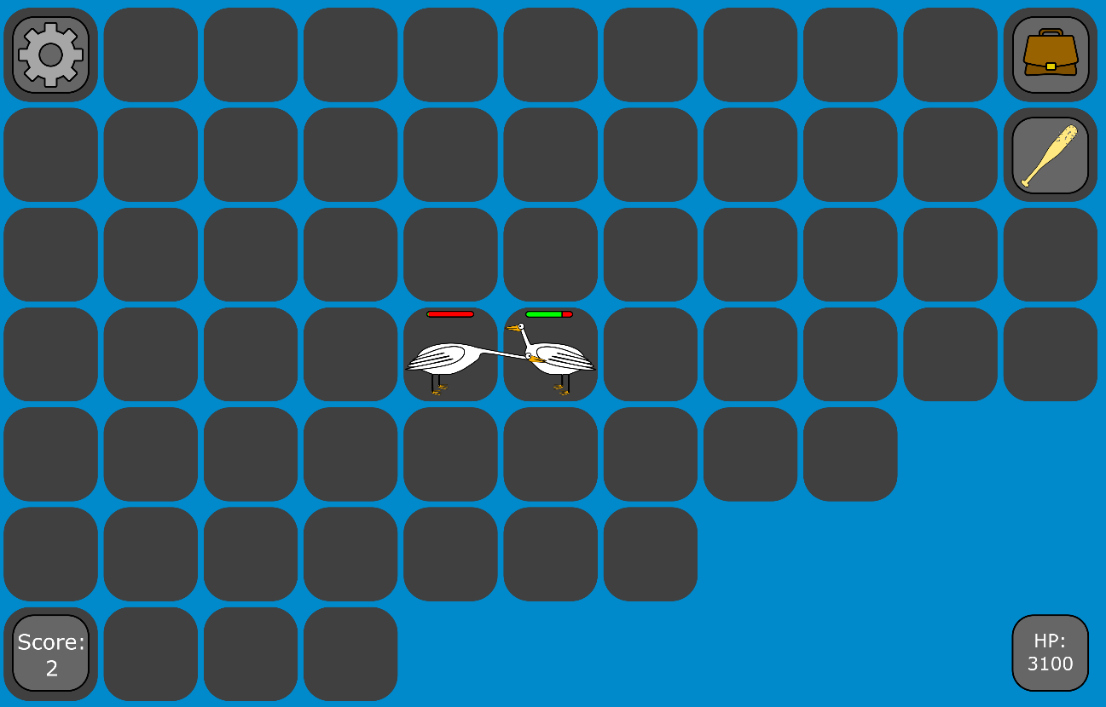
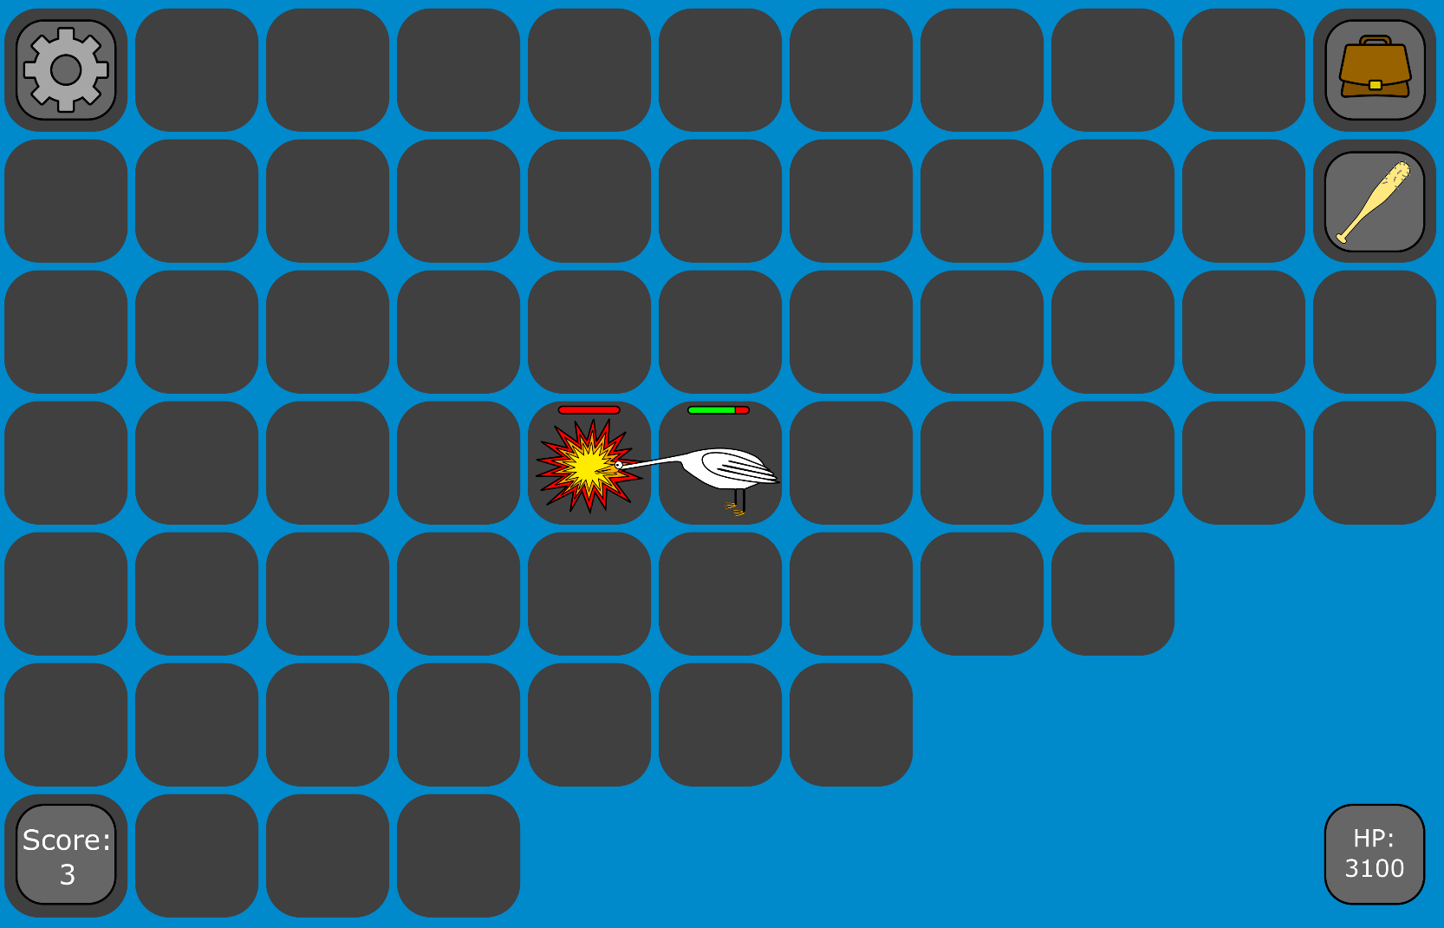
The user then clicks the space button, attacking to the left where the other player is standing. With the baseball bat this deals 60 damage to the player. The player had 50 health before being attacked so upon getting hit they are defeated. The remaining green on their health bar disappears and it turns entirely red, and their goose sprite is replaced by an explosion sprite. The user’s score then increases by 1 as can be seen below. The other player’s home nest is deleted.
The explosion and empty health bar then would disappear, the user’s sprite would change from the attack sprite to the standing left sprite, and the other player would respawn somewhere else on the map with a new nest.
Damage taken updates PLAYER.Health. When defeated, the attackers SCORE is increased by 1. The defeated player’s NEST row is deleted, and their PLAYER row gets a new random CurrentTileID, a new NestID and a new NEST row is added with a random TileID. The player’s HEALTH is reset to 4000 and IsInvincible is set to 1 and InvincibleUntil is set to 5. 5 seconds later IsInvincible is set to 0.
Continue to storyboard 14.

NPC walks on screen and wanders around, storyboard 14, requirement 9:
The user stands still and doesn’t do anything (no input). The grey goose (an NPC with 1000 health, doesn’t attack the player, just wanders randomly) moves on screen (from the left). If defeated he will drop a random item or consumable on the tile he is defeated on (explosion sprite will play like the other storyboard, but the user will not get score).
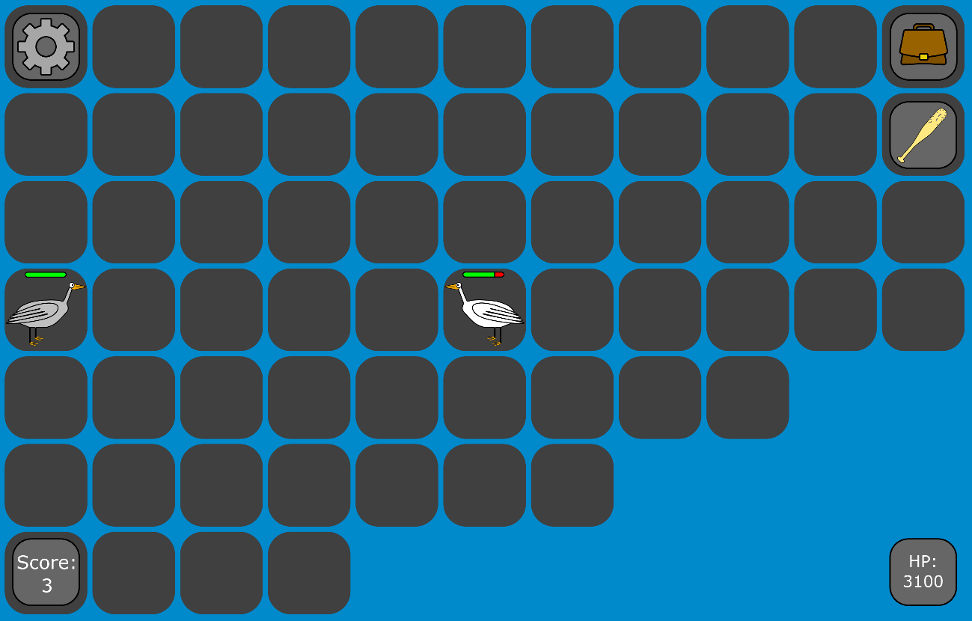
After a random amount of time (between 1 and 5 seconds) the grey goose then moves again one tile in a random direction. In this case it moves down (shown below).
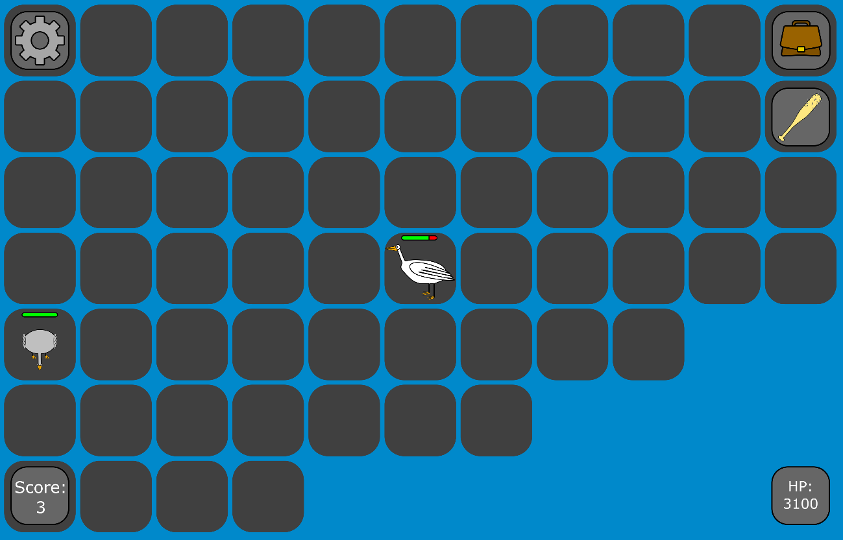
Each random move updates NPC.TileID. When defeated, IsAlive is set to 0 and a new ITEM row is inserted at the last tile the NPC was on with a randomly chosen ItemTypeID. After the 1 minute timer, a new NPC row is placed at a random tile.
Continue to storyboard 15.
User stores current item in nest, collects new item, storyboard 15, requirement 8:
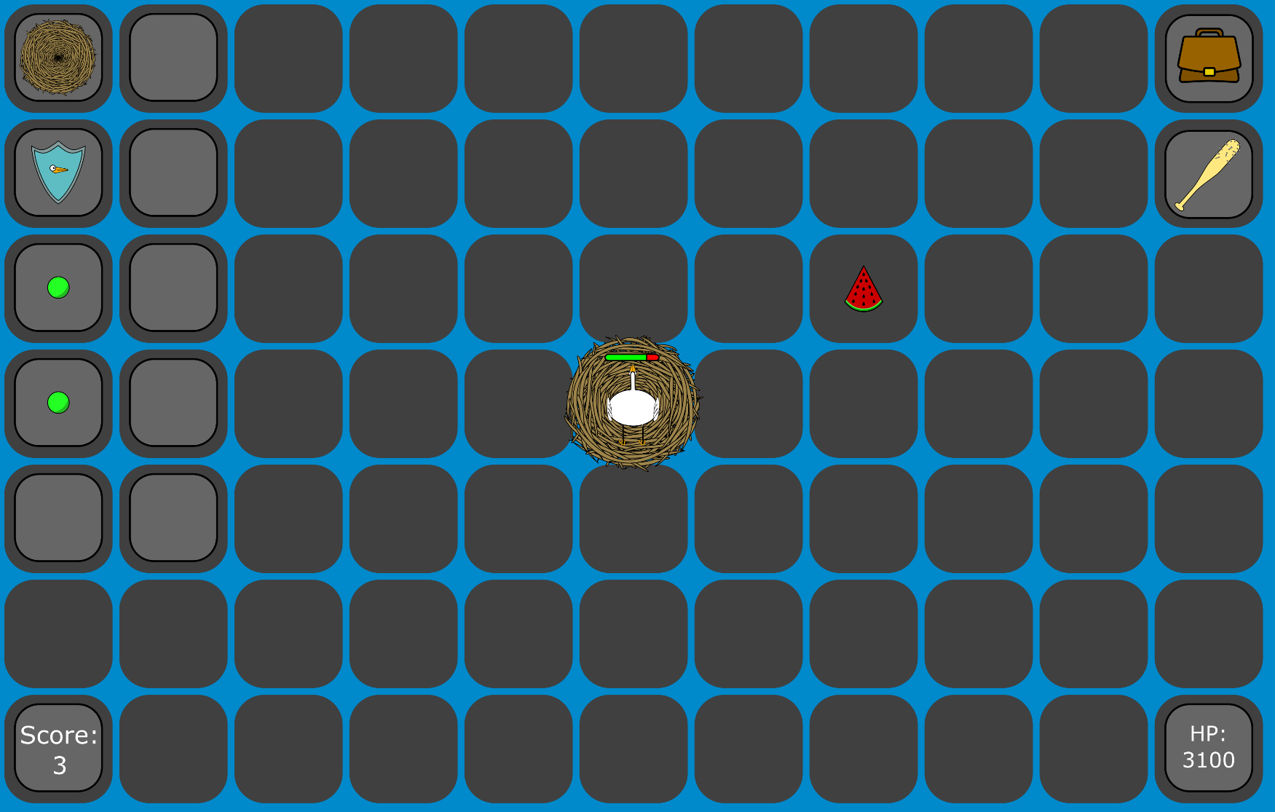
The user walks up towards their nest and notices a watermelon which they want to pick up, but they are currently holding a baseball bat, so they walk onto their nest so that they can store the bat there.

As seen above the user already has a shield and 2 peas which have been saved in the nest’s inventory since before they last logged out. The watermelon they want is also near the nest. They then press the “L” key which transfers the baseball bat from the player’s inventory to the nest’s inventory, as seen below.

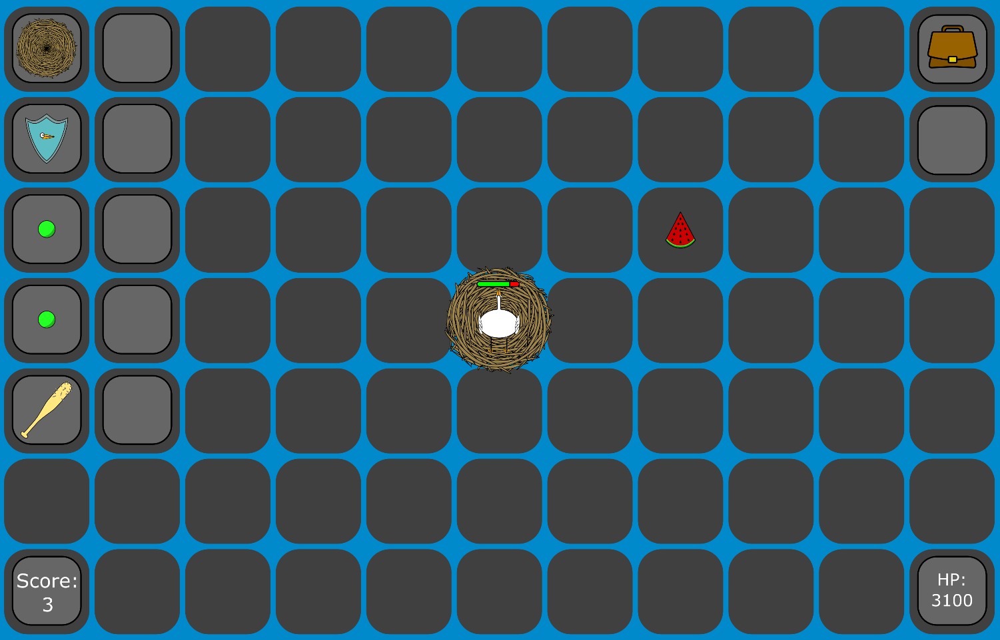
Now that the user’s inventory is empty, they press the right arrow twice, then the up arrow once to move onto the tile that the watermelon is on, collecting it and putting it into their inventory, as seen below.
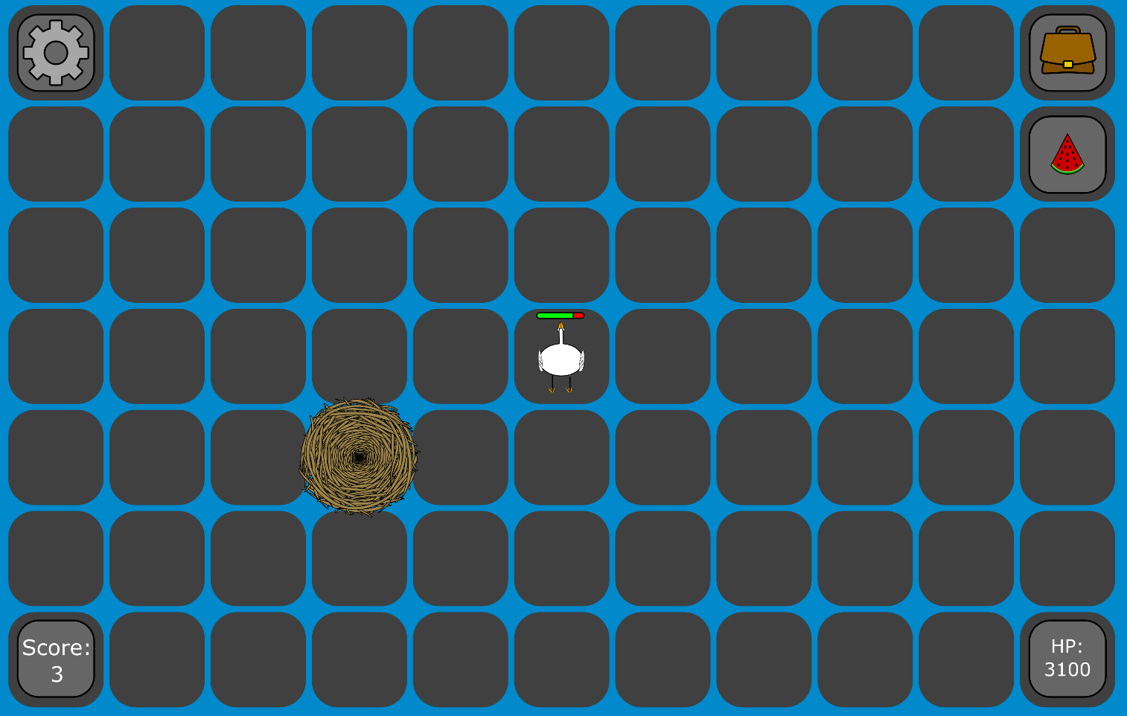
Pressing L moves the held item’s ITEM row from the player to the nest (HolderPlayerID = NULL, NestID = <nest id>). Walking onto an item tile does the reverse (TileID = NULL, HolderPlayerID = <player id>) and HeldItemID is updated to match.
Continue to storyboard 16.
Item spawns, player moves, logs out, logs in, item stays in the same location the whole time, storyboard 16, requirement 10:
A gun spawns on a tile two tiles above the user and one tile to the right.
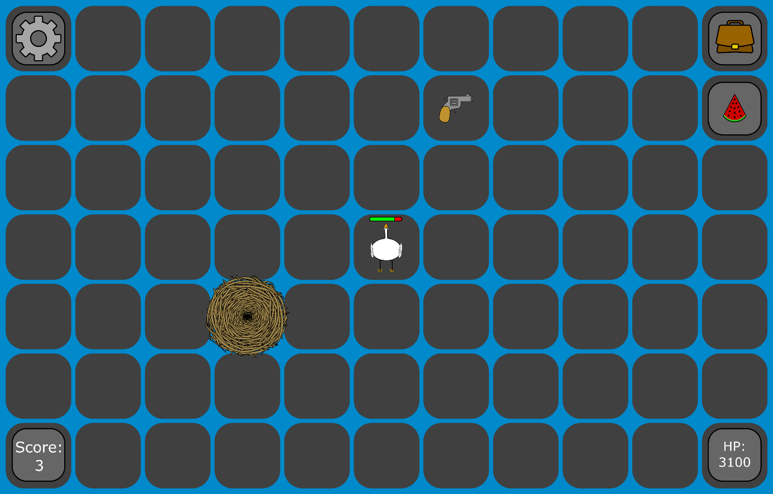
The user then clicks the right arrow once, and the gun is now 2 tiles above them, showing that it has stayed in the same location on the map.
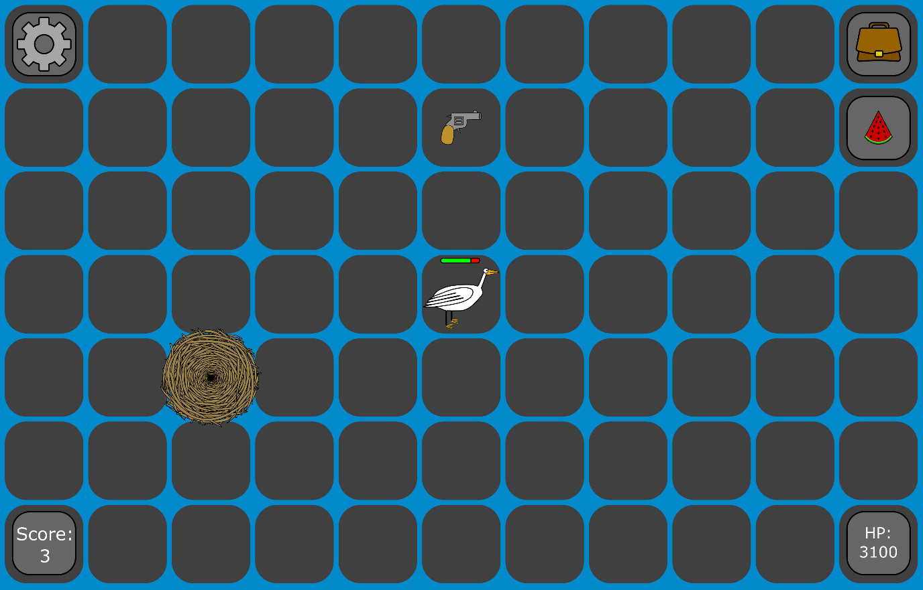
The user then clicks the settings icon, bringing them to the settings screen (storyboard 7). They then click the “Return to title screen” button, returning them to the title screen (storyboard 1). At this point there are no players online. They then close the program. They then re-open the program, bringing them to the title screen (storyboard 1). They then type in their username and click the “next” button, bringing them to the login screen (storyboard 2). They enter their password and click the “Login” button, bringing them back to where they were when they logged out, as seen below. The gun is in the same place as when they logged out, showing that the item location persists even upon all online users logging out.
Item position is in ITEM.TileID, which doesn’t depend on any particular player, so it persists even when all PLAYER rows have IsOnline set to 0.

Admin returning to the game, storyboard 17, segway to requirements 4 and 5:
On storyboard 2 the user logs in. If they are an admin they are brought to here. This is the last place that the user (from now on referred to as admin) logged out. If the admin then clicks the settings icon they will be brought to storyboard 8. The admin is able to move with arrow keys or WASD like a normal user, however their sprite will not change. An admin does not have a home nest (if they log in for the first time one will not spawn). If the admin presses the space bar or L or G nothing happens. Instead of the inventory icon in the top right corner there is a tile icon. Instead of a health icon in the bottom right corner there are 8 item/consumable icons (one for each item and consumable). Instead of a score icon on the bottom left there is a rubbish bin icon. If an admin clicks any of these icons, they will be highlighted in green. If the admin clicks the rubbish bin icon, then clicks on a tile with an item or consumable on it, the item or consumable will be deleted. If they instead click on a tile without anything on it, the tile will be deleted.
If the admin clicks the tile icon in the top right corner, they will be brought to storyboard 18.
If the admin clicks one of the consumable icons (in this case the banana), they will be brought to storyboard 19.
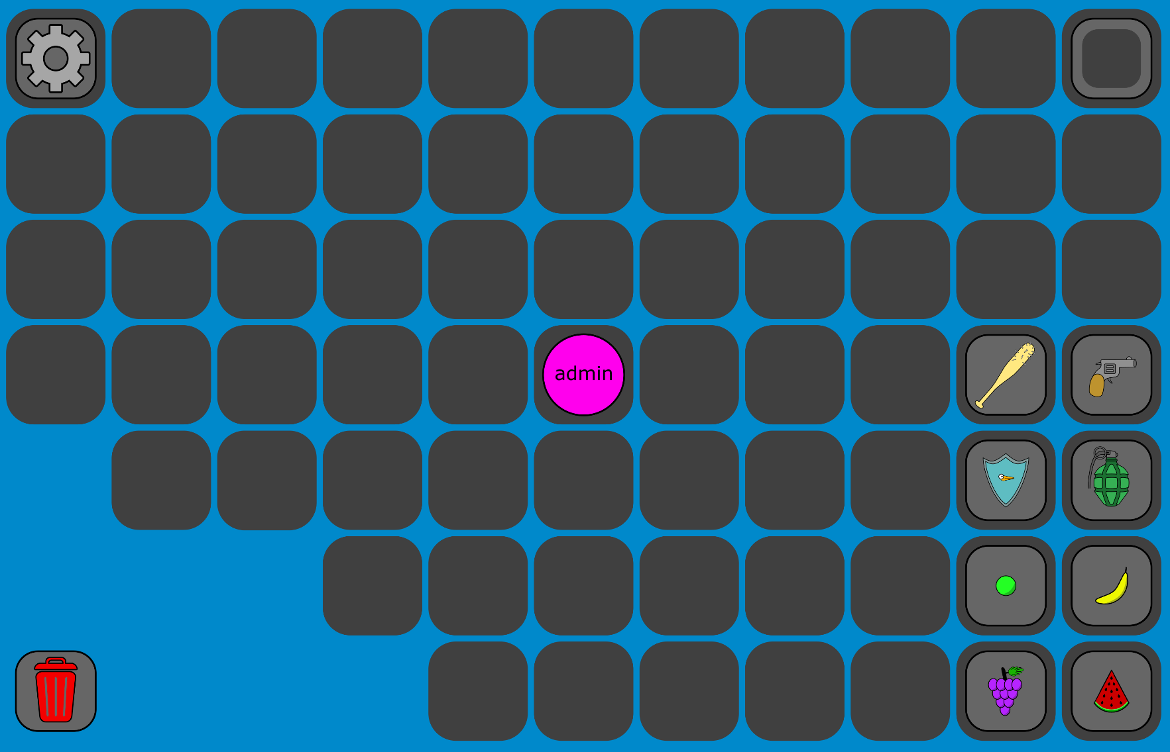
The admin’s PLAYER row has no linked NEST row. The tile/item edit actions write directly to TILE and ITEM.
Admin selecting and placing a tile, storyboard 18, requirement 4:
On storyboard 17, the admin clicks the tile icon in the top right corner to select it. The border turns from black to green to indicate that it is selected as seen below.
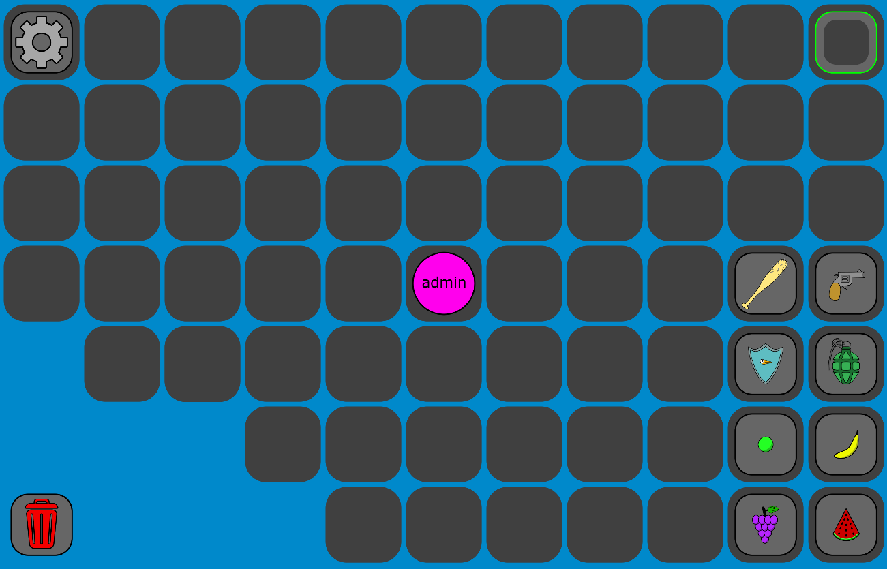
The admin then clicks on the first empty space directly under the settings icon (4 tiles down) to place a tile there. It then appears there for all players and persists even after all players go offline. Tiles can only be placed on empty spaces which are adjacent to another tile (above, below, left or right). The tile placed is shown below.
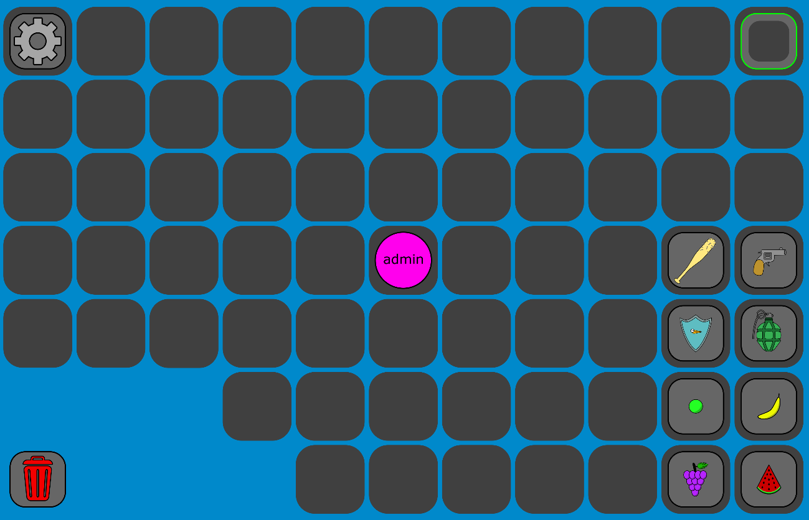
Placing inserts a new TILE row, deleting removes it. Can only do this when no PLAYER, ITEM, or NEST reference the TILE row.
Admin selecting and placing an item on a tile, storyboard 19, requirement 5:
In storyboard 17 the admin selects the banana icon. The border on the icon turns from black to green to indicate that it is selected as seen below.
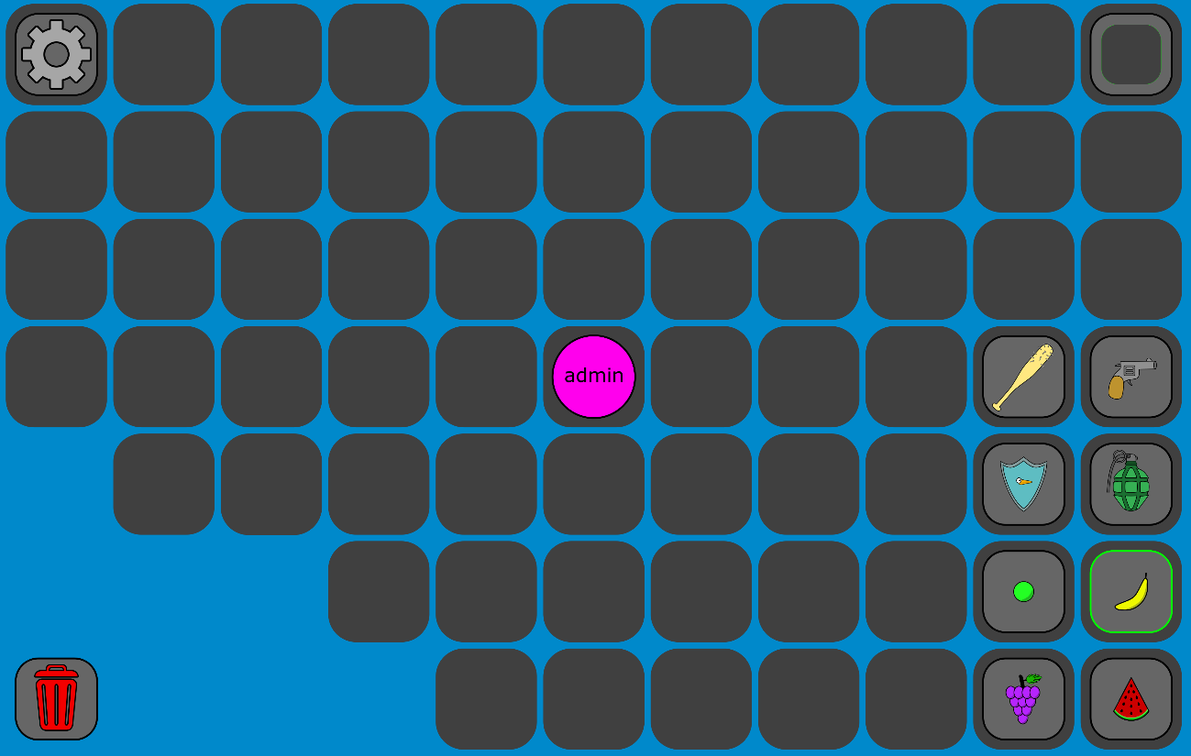
The admin then clicks the empty tile above them (items can only be placed on a tile without an already existing item on it). This places the banana on the tile and it appears for all players. Its location persists even if all players log out. The placed item can be seen below.
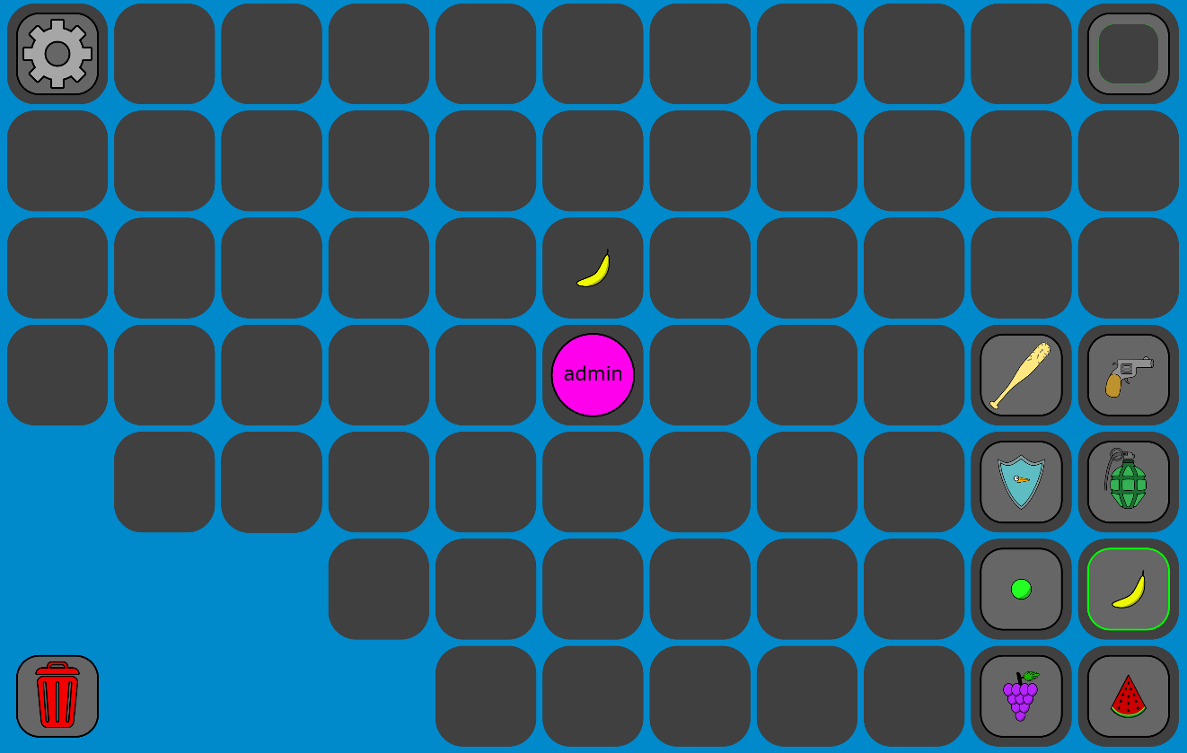

Placing inserts a new ITEM row. The rubbish bin icon deletes an ITEM row for a tile that has one.
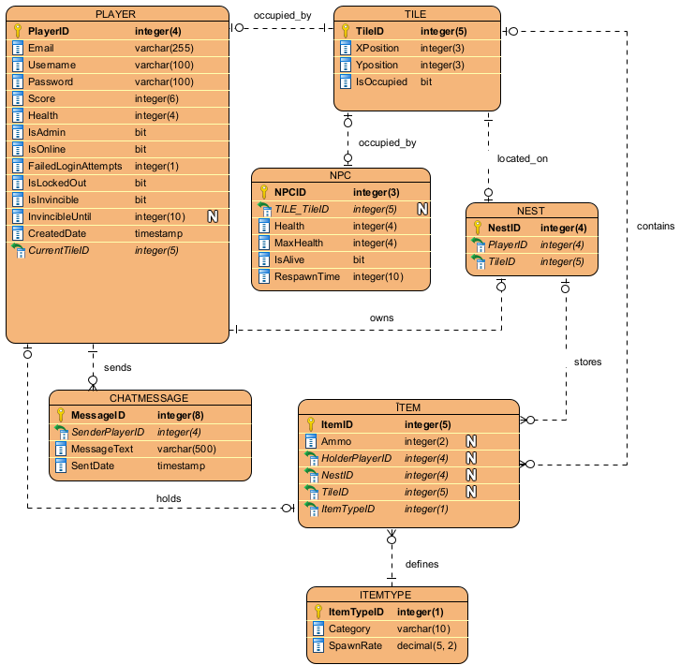

Task 2, logical entity relationship diagram depicting the planned database:

Task 3, CRUD table as part of analysis for the game system:
Number | Process | Tables involved | Key attributes affected | CRUD operation(s) | Description
1 | Player login (including lockout). | PLAYER | Username, Password, FailedLoginAttempts, IsLockedOut, Isoline | Read, Update. | Username/password checked against PLAYER. A failed attempt adds 1 to FailedLoginAttempts. A success resets it to 0. If it gets to 5, IsLockedOut is changed to 1.
2 | Player registration. | PLAYER | Email, Username, Password, Score, IsAdmin, IsLockedOut, FailedLoginAttempts, CreatedDate | Create. | A new row is inserted when a player enters an unused username and submits their details, with Score being set to 0 by default.
3 | Laying out tiles on the board. | TILE | TileID, XPosition, YPosition | Create, delete. | Admin inserts a new tile next to an existing tile to extend the board, or deletes an unoccupied tile.
4 | Placing an item on a tile. | ITEM, ITEMTYPE, TILE | ItemTypeID, TileID | Create, delete. | Either an admin places a new item on an unoccupied tile (adding an ITEM row), or one spawns randomly. The admin bin tool is used to delete an ITEM row from a tile.
5 | Player movement. | PLAYER | CurrentTileID | Update | Moving to an adjacent unoccupied tile updates the player’s CurrentTileID to the destination tile.
6 | Game play scoring. | PLAYER | Score, Health | Update. | Defeating another player increases the attacker’s Score by 1. Taking damage reduces the target’s health, which then resets upon respawning.
7 | Acquiring inventory. | ITEM, NEST | HolderPlayerID, TileID, NestID | Update. | Picking up an item updates its ITEM row so that HolderPlayerID is set and TileID and/or NestID are cleared. Storing it in the nest does the reverse.
8 | Item (NPC) movement. | NPC, ITEM | TileID, Health, IsAlive, RespawnTime | Update, Create. | The NPC’s TileID is updated each time it moves. On defeat, IsAlive is set to 0 and a new ITEM row is inserted at the tile it died on with a randomly chosen type.
9 | Kill running games. | PLAYER | IsOnline | Update | When an admin clicks the “KILL current game” button and confirm, every currently online player’s IsOnline flat is set to 0, logging them out and sending them back to the login screen.
10 | Add new players (admin). | PLAYER | Email, Username, Password, Score, IsAdmin, CreatedDate | Create. | Same as player registration, but done by an admin from the player adder screen with IsAdmin able to be set.
11 | Update data of a player. | PLAYER | Email, Username, Password, Score, IsAdmin, IsLockedOut | Update. | Admin edits an existing player’s fields on the player editor screen (with IsAdmin able to be set, and IsLockedOut turned on or off), updating the corresponding PLAYER row.
12 | Delete a player. | PLAYER, NEST, ITEM, CHATMESSAGE | Whole PLAYER row, related NEST row, related ITEM rows, SenderPlayerID on CHATMESSAGE. | Delete. | Deleting a player, either by themselves or by an admin, removes their PLAYER row along with their NEST and any ITEM rows they hold or store. Their CHATMESSAGE rows are also removed.

Task 4, DDL SQL script to create tables and relations between tables to support the game:
Note: Added “name” and “description” to ITEMTYPE table.
The DDL SQL script itself is provided as a separate file (it is also in the GitHub repository).
The DDL is implemented as a single T-SQL procedure (usp_CreateGooseFighterDatabase), which builds the entire database from scratch, including all 7 tables with constraints and indexes, and some test data which covers everything in the CRUD table. The script can be run repeatedly without error by checking if each part exists (dropping first if it does) before creating it. It kicks anyone connected to it first before doing this. This is good for repeated testing.
Tables were created in dependency order (because foreign keys cant reference something that doesn’t exist). Every table has a primary key, and foreign keys enforce the relationships from the ERD. UNIQUE constraints enforce other rules (e.g. UQ_Tile_Position stops 2 tiles occupying the same space, UQ_Nest_Player ensures there is only one nest per player, CK_Item_OneLocation makes sure that an item is always on a tile, held by a player or in a nest, etc.).
Only 2 relationships cascade when deleting. Deleting a player removes their nest and chatmessage rows. All other foreign keys use NO ACTION. This is because ITEM is reachable from PLAYER through 2 cascading paths (through HolderPlayerID and through NEST.PlayerID -> NEST -> ITEM.NestID). So there isn’t a single order of deletes. Instead, item deletion is done by the application/procedure logic.
Indexes were made on columns that will be queried often during the gameplay.

Task 5. Create a prototype C# .net application using Visual Studio:
Instructions for how to set up and test the application are in the README in the same folder that this word document is in.

Assignment 2:

Task 1, TSQL procedures:
Stored procedures for each of the 12 processes in the CRUD table. These replace the prototype procedures (usp_TestLogin, usp_TestMovePlayer, usp_TestAddPlayer), which only did a single select or update. The new procedures have the real game rules, so the C# app only passes in the parameters and displays what comes back.
The procedures all follow these patterns:
- Validate first, change data last (if any validation fails, data doesn’t get changed).
- Return a status instead of raising an error (each procedure ends by selecting a row result set with a status column. Expected failures are returned as statuses. The caller can read the status and show the appropriate message).
- SET NOCOUNT ON is used in each procedure so only the status result set reaches the caller.
- Test calls are under each procedure. These calls cover the success case and each status it can return.
The gameplay procedures script is to be run after the DDL script (which builds the tables and test data).

Procedures for each CRUD process:

Number: | Process: | Procedures: | Parameters: | Statuses:
1 | Player login and lockout. | usp_LoginPlayer | username, password | SUCCESS, INCORRECT_PASSWORD, LOCKED_OUT, NOT_FOUND
2 | Player registration. | usp_RegisterPlayer | email, username, password | SUCCESS, MISSING_FIELDS, USERNAME_TAKEN, EMAIL_TAKEN
3 | Laying out tiles. | usp_PlaceTile, usp_DeleteTile | x, y / tileId | SUCCESS, TILE_EXISTS, NOT_ADJACENT / SUCCESS, TILE_NOT_FOUND, TILE_IN_USE
4 | Placing an item on a tile. | usp_PlaceItem, usp_RemoveItemFromTile, usp_SpawnRandomItem | itemTypeId, tileId / tileId / none | SUCCESS, ITEMTYPE_NOT_FOUND, TILE_NOT_FOUND, TILE_HAS_ITEM / SUCCESS, NO_ITEM / SUCCESS, NOT_ENOUGH_PLAYERS, ITEM_LIMIT_REACHED, NO_SPAWN_RATES, NO_FREE_TILE
5 | Player movement. | usp_MovePlayer | playerId, direction | SUCCESS, OFF_BOARD, TILE_OCCUPIED, INVALID_DIRECTION, PLAYER_NOT_FOUND, NOT_ONLINE, NO_CURRENT_TILE
6 | Gameplay scoring. | usp_Attack (calls usp_DamageNpc) | attackerId, direction | HIT, KILLED, NPC_HIT, NPC_KILLED, TARGET_INVINCIBLE, TARGET_ON_NEST, NOTHING_THERE, INVALID_DIRECTION, ATTACKER_NOT_FOUND, ATTACKER_IS_ADMIN, NOT_ONLINE, NO_CURRENT_TILE
7 | Acquiring inventory. | usp_PickUpItem, usp_DropItem, usp_TakeFromNest | playerId / playerId / playerId, itemId | SUCCESS, AMMO_ADDED, INVENTORY_FULL, NO_ITEM, etc. / STORED_IN_NEST, DISCARDED, NEST_FULL, NOTHING_HELD, etc. / SUCCESS, NOT_ON_NEST, ITEM_NOT_IN_NEST, INVENTORY_FULL, etc.
8 | Move an item (npc affect). | usp_MoveNpc, usp_DamageNpc, usp_RespawnNpc | npcId / npcId, damage (OUTPUT: health left, killed) / none | SUCCESS, NO_LEGAL_MOVE, NPC_DEAD, NPC_NOT_FOUND / (outputs) / SUCCESS, ALREADY_ALIVE, NOT_READY, NO_FREE_TILE
9 | Kill running games. | usp_KillRunningGame, usp_LogoutPlayer | adminId / playerId | SUCCESS, NOT_ADMIN, ADMIN_NOT_FOUND / SUCCESS, PLAYER_NOT_FOUND
10 | Add new players. | usp_AddPlayer | adminId, email, username, password, isAdmin | SUCCESS, ADMIN_NOT_FOUND, NOT_ADMIN, MISSING_FIELDS, USERNAME_TAKEN, EMAIL_TAKEN
11 | Update data of a player | usp_UpdatePlayer | adminId, playerId, email, username, password, score, IsAdmin, isLockedOut | SUCCESS, ADMIN_NOT_FOUND, NOT_ADMIN, PLAYER_NOT_FOUND, MISSING_FIELDS, INVALID_SCORE, USERNAME_TAKEN, EMAIL_TAKEN
12 | Delete a player | usp_DeletePlayer | requesterId, playerId | SUCCESS, REQUESTER_NOT_FOUND, PLAYER_NOT_FOUND, NOT_AUTHORISED

Design decisions:
- Login and lockout:
The lockout logic from storyboard 2 is in usp_LoginPlayer (not in the form itself). The procedure finds the player based on username (since duplicate usernames cant exist). If the account is locked (IsLockedOut = 1) it returns LOCKED_OUT. If the password is wrong, 1 is added to FailedLoginAttempts. If this reaches 5, it sets IsLockedOut to 1. If the password is correct, FailedLoginAttempts gets reset to 0 and IsOnline gets set to 1. The result also contains IsAdmin (so the app knows which screen to open).
- Registration:
The procedure checks for blank fields, then duplicate usernames, then duplicate emails, so the caller can get a specific reason the registration failed to display it to the user. A successful registration makes a player with a score of 0, IsAdmin of 0 and IsOnline of 1.
- Tiles:
usp_PlaceTile follows the rule from storyboard 18, a new tile must be next to an existing tile (above, below, left or right). The first tile on an empty board is an exception. usp_DeleteTile only deletes a tile if no player, nest, NPC or item references it. This returns a TILE_IN_USE status.
- Items:
An admin can place one item per tile, and the pellet gun gets random ammo amount from 3 to 10. usp_SpawnRandomItem handles the natural spawning based on the following things. Spawning only happens when 2 or more regular players are online. The item type is picked using SpawnRate (a random number is rolled up to the total of all spawn rates, and the first type whose total is past the roll is chosen). The spawn tile is a random tile with nothing on it. There is a cap of 2 items on the map per online player so that the board doesn’t full up.
- Movement:
The player passes a direction as the game is played using the keyboard, and the database figures out the destination tile. The move doesn’t work if the player is offline, if the target tile doesn’t exist, or if another player or npc is on the target tile. Offline players don’t block the movement of other players.
- Scoring:
usp_Attack hits the tile in front of the attacker (based on the direction they are facing, which is based on their last move). Damage has a base of 40 and is multiplied by 1.5 if the player holds a baseball bat, or 0.75 if they hold a shield, or 0.5 if they attack a player with a shield. The rules from storyboard 13 are applied in this order:
- A target on their own nest cant be attacked.
- A target who is invincible cant be attacked.
- If the hit doesn’t kill, health goes down and they victim gets 0.5 seconds of invincibility.
- If the hit kills, the attacker’s score goes up by 1, the victim’s nest and the items in it and in their beak are deleted, and the victim respawns on a random free tile with 4000 health, a new nest and 5 seconds of invincibility.
- If the npc is defeated, no score is given.
- Inventory:
A goose has one slot (the item in its beak) and a nest holding up to 9 items.
usp_PickUpItem takes the item on the player’s tile. If the beak is full, nothing happens unless it is a second pellet gun (adding the ammo to the players current ammo). usp_DropItem stores the item in the nest if the player is standing on it and the nest isnt full. Anywhere else if an item is dropped it disappears. usp_TakeFromNest moves an item from the nest into the beak and only works when standing on the nest. admins have no inventory.
- NPC:
usp_MoveNpc moves the npc one random step to a tile in a random direction (which doesn’t have an online player on it). usp_DamageNpc reduces its health. when it reaches 0 the npc is marked as dead, a 1 minute RespawnTime is set and it drops one random item on its tile/ every item type is equally likely to drop when it dies (ignoring spawn rates). This procedure uses output parameters (health left and whether or not killed) because usp_Attack calls it. usp_RespawnNpc brings it back at full health on a random tile once the timer has run out, and doesn’t run if an npc is already alive.
- Kill running games:
usp_KillRunningGame checks that the caller is an admin, then sets IsOnline to 0 for everyone and clears any invincibility so nobody comes back online as invincible. It returns how many players were logged out. usp_LogoutPlayer does the same for one player and is used by the return to title screen button.
- Also 11 and 12, Player management:
All except deleting checks if the player is an admin, and return specific statuses for each failure. usp_UpdatePlayer checks the username and email are unique. Unlocking an account resets the failed login counter to 0. usp_DeletePlayer deletes the players items first and then the player. This is done like this to avoid multiple cascade paths. The nest and chat messages relating to the player are then cascaded.
Testing:
Every procedure has test calls below it in the script. The tests use the data from the DDL script. If a test needs a different situation, an UPDATE puts the data in the state needed. for example, to test movement into an online player, mcplayer is set online on the tile next to the other player. The tests include the success case for each procedure, each error status, edge cases.
All procedures and test calls ran without errors. This can be tested by running the DDL script then the procedures script both available at the following link:
https://github.com/Zandi-Galpin/DAT602-Ultimate-Goose-Fighter-Assignment
Reflection:
The database makes the decisions so that the C# app doesn’t need to know them. If a rule changes, only one procedure needs updating, and the same rules apply however it is called on the other end.
Statuses are returns in results instead of raising errors, keeping each procedures output the same shape. Real unexpected errors come back as sql exceptions.
Players only gain points, nobody loses score.
The admin who kills the game stays online.
Added cap per player for items laying on the map.

Task 2, C# DAO methods:
For this task I wrote a DAO method for each of the TSQL procedures from task 1. Each method opens a connection, calls a stored procedure with typed parameters, and returns the result as a datatable. The C# code doesn’t contain any SQL logic. Validation, lockout counting, damage calculation and the other rules are all in the procedures. The forms only need to read the status column and decide what to show. To avoid repeating connection code in each method, I made BaseDao that the 3 daos inherit from. It has one method that runs a procedure and fills a datatable, and one that builds a parameter with an explicit sql type instead of using AddWithValue, which guesses the tyope. usp_DamageNpc is an exception. It returns its results through output parameters instead of a result set, so DamageNpc() reads them directly. The methods are grouped by who uses them. LoginDao handles login, registration and logout, GamePlayDao handles movement, attacking, inventory, item spawning and the npc, AdminDao handles the admin tools (tiles, placing items, killing the game, managing players).
DAO methods for each crud process:

Number: | Process: | DAO method: | Stored procedure: | Parameters: | Result columns:
1 | Player login and lockout | LoginDao.Login | usp_LoginPlayer | username, password | PlayerID, IsAdmin, LoginStatus
2 | Player registration | LoginDao.Register | usp_RegisterPlayer | email, username, password | PlayerID, RegisterStatus
3 | Laying out tiles | AdminDao.PlaceTile | usp_PlaceTile | x, y | TileID, PlaceTileStatus
3 |  | AdminDao.DeleteTile | usp_DeleteTile | tileId | DeleteTileStatus
4 | Placing an item on a tile | AdminDao.PlaceItem | usp_PlaceItem | itemTypeId, tileId | ItemID, PlaceItemStatus
4 |  | AdminDao.RemoveItemFromTile | usp_RemoveItemFromTile | tileId | RemoveItemStatus
4 |  | GamePlayDao.SpawnRandomItem | usp_SpawnRandomItem | none | ItemID, TileID, ItemTypeID, SpawnStatus
5 | Player movement | GamePlayDao.MovePlayer | usp_MovePlayer | playerId, direction | NewTileID, NewX, NewY, MoveStatus
6 | Gameplay scoring | GamePlayDao.Attack | usp_Attack | attackerId, direction | AttackStatus, DamageDealt, VictimPlayerID, VictimHealth, AttackerScore
7 | Acquiring inventory | GamePlayDao.PickUpItem | usp_PickUpItem | playerId | PickUpStatus, ItemID, ItemName, Ammo
7 |  | GamePlayDao.DropItem | usp_DropItem | playerId | DropStatus, ItemID
7 |  | GamePlayDao.TakeFromNest | usp_TakeFromNest | playerId, ItemId | TakeStatus, ItemID
8 | Move an item (npc affect) | GamePlayDao.MoveNpc | usp_MoveNpc | npcId | NewTileID, NewX, NewY, MoveNpcStatus
8 |  | GamePlayDao.DamageNpc | usp_DamageNpc | npcId, damage (plus 2 output parameters) | returns killed bool and health left.
8 |  | GamePlayDao.RespawnNpc | usp_RespawnNpc | none | NpcID, TileID, ResapwnStatus
9 | kill running games | AdminDao.KillRunningGame | usp_KillRunningGame | adminId | PlayersLoggedOut, KillStatus
9 |  | LoginDao.Logout | usp_LogoutPlayer | playerId | LogoutStatus
10 | add new players | AdminDao.AddPlayer | usp_AddPlayer | adminId, email, username, password, isAdmin | PlayerID, AddPlayerStatus
11 | update data of a player | AdminDao.UpdatePlayer | usp_UpdatePlayer | adminId, playerId, email, username, password, score, isAdmin, isLockedOut | PlayerID, UpdatePlayerStatus
12 | delete a player | AdminDao.DeletePlayer | usp_DeletePlayer | requesterId, playerId | DeletePlayerStatus

Testing:
I wrote a test class (DaoTests) which calls each DAO method and checks the result. It uses the same scenarios as the sql test calls in task one. It is opened from a developer screen (DaoTestForm) by starting the app with the “--daotests" argument, so that the normal login screen doesn’t need to change.
The tests are split into 13 groups (one for each process, process 4 has 2 groups – placing items and random spawning), before each group, the harness rebuilds the database. this means every group starts from the same test data, so the results don’t change on the order that the tests run in. When a test needs a specific situation that the test data doesn’t cover, a setup statement puts the data in that state. the method being tested is always called through the dao.
For each method I tested the success case and every error status its procedure could return.Some checks go beyond the status, e.g. when a player is deleted, the test queries the database to confirm their nest, items and chat messages are gone.
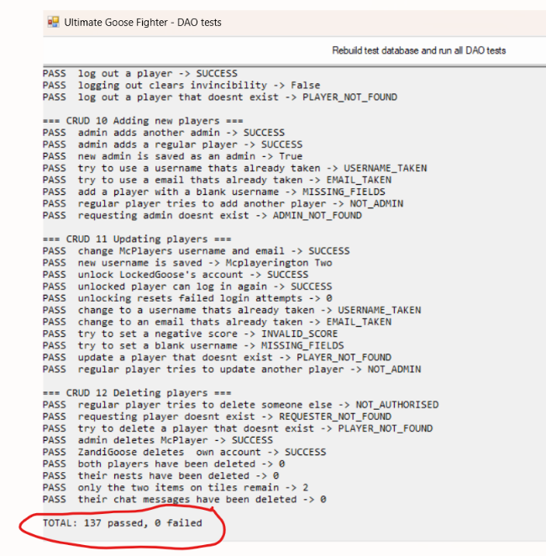

As seen here all the tests pass.

Reflection:
Earlier the prototype daos called test procedures and the form checked IsLockedOut itself. Moving this into the procedures means that the dao methods and now short and similar, so the forms don’t need to know the rules.
The procedures returns a status string for expected failures instead of sql errors. this keeps the dao methods simple, and exceptions are left for real problems.
SCOPE_IDENTITY() returns a decimal, so the new id has to be converted to int before it can be used.
Prototype methods are kept for now, deleted in next task.

Task 3, GUI components that run the DAO methods:
Task 1 put the game rules in tsql procedures and task 2 wrapped these in dao methods. This task connects the forms. The order is form control, then handler, then the dao method, then stored procedure, then result back to the form. The forms don’t have sql or game rules. A form takes what the user typed or clicked, passes it to a dao method, then shows the status the procedure sent back.
The forms match the three display areas from before.

How each requirement is implemented:
Number: | Requirement: | Control on the form: | DAO mentioned: | Stored procedure:
1 | Player login and lockout. | LoginForm: Login button | LoginDao.Login | usp_LoginPlayer
2 | Player registration. | LoginForm: register button. | LoginDao.Register | usp_RegisterPlayer
3 | Laying out tiles. | AdminForm, Board tab: Place tile and Delete selected tile. | AdminDao.PlaceTile, DeleteTile | usp_PlaceTile, usp_DeleteTile
4 | Placing an item on a tile. | AdminForm, Board tab: Place on selected tile and remove item.  GamePlayForm: Spawn random item. | AdminDao.PlaceItem, RemoveItemFromTile, GamePlayDao.SpawnRandomItem | usp_PlaceItem, usp_RemoveItemFromTile, usp_SpawnRandomItem
5 | Player movement. | GamePlayForm: up,left,right,down | GamePlayDao.MovePlayer | usp_MovePlayer
6 | Gameplay scoring. | GamePlayForm: facing dropdown and attack | GamePlayDao.Attack | usp_Attack
7 | Acquiring inventory. | GamePlayForm:pick up item, drop item, take selected item from nest | GamePlayDao.PickUpItem, DropItem, TakeFromNest | usp_PickUpItem, usp_DropItem, usp_TakeFromNest
8 | Move an item (npc affect). | GamePlayForm: move the npc, respawn the npc and attack for npc damage | GamePlayDao.MoveNpc, RespawnNpc | usp_MoveNpc, usp_RespawnNpc, usp_DamageNpc (called by usp_Attack).
9 | Kill running games. | adminForm: game tab: kill current game, both game forms: back to login | AdminDao.KillRunningGame, LoginDao.Logout | usp_KillRunningGame, usp_LogoutPlayer
10 | Add new players. | AdminForm: Players tab: add as new player | AdminDao.AddPlayer | usp_AddPlayer
11 | Update data of a player | AdminForm: players tab: update selected player | AdminDao.UpdatePlayer | usp_UpdatePlayer
12 | Delete a player | AdminFOrm: delete selected player. GamePlayForm: Delete my account | AdminDao.DeletePlayer | usp_DeletePlayer

Design decisions:
Every handler follows the same pattern, each button reads its inputs, calls a dao method and passes the result to a shared helper. This keeps the forms short and makes each button behave the same, which makes testing simpler.
The DAO returns a DataTable and the form reads the status column. Each procedure returns a one row result with a status. A helper class (ResultHelper) reads the status and makes a line of text shown in the bottom left. Successful statuses are shown in green. Others in red.
The screen is reloaded from the database after each action.
The 12 requirements only describe changes to the data, but the screens have to display data, so read only procedures were added with matching dao methods, so there is no sql in the C# code.
Testing:
Registration:
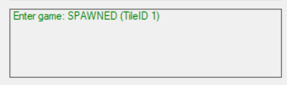
Login:
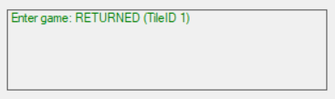
Lockout (wrong password 5 times:
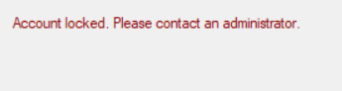
Movement:
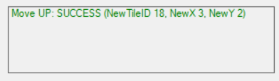

npc attacked:
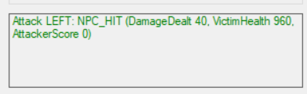
pick up item:
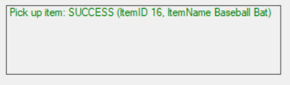
Kill current game:
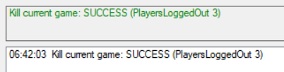
Place tile:
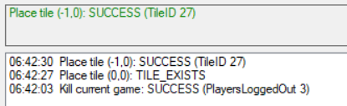
Killing another player was confirmed to work but not shown here due to time constraints.

