**Project #9: Cloud DevOps - Deploy an App with AWS CodeDeploy**

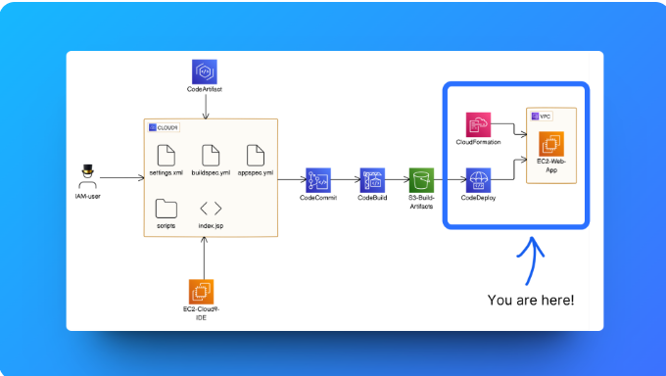

**Let's get ready to:**

1. Create an **EC2 instance** and **VPC** with AWS CloudFormation.
2. Create **deployment scripts** in your project to automate deployment commands.
3. Direct CodeDeploy with a new **appspec.yml** file.
4. Build and deploy your **CodeDeploy application!**

