**Basic scanning**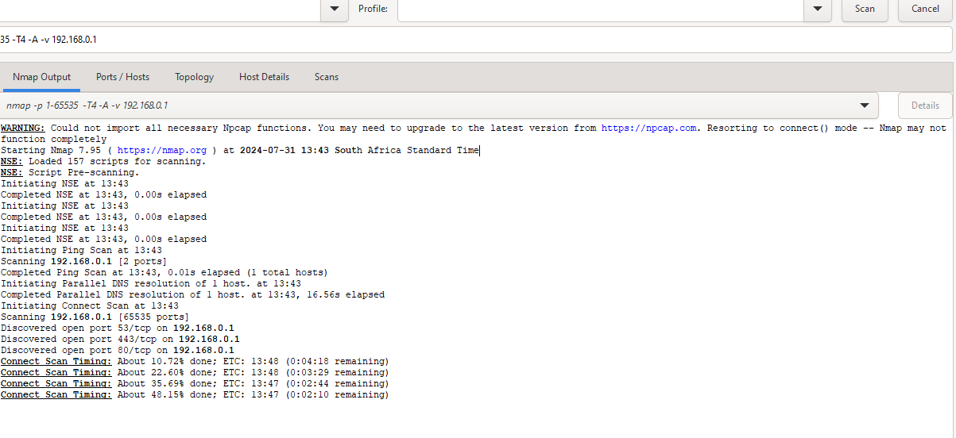

**Scan for open ports:**

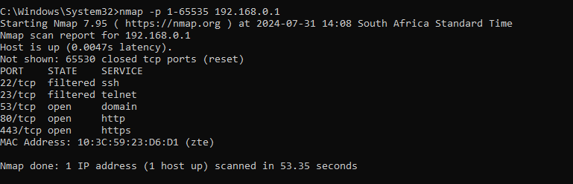

**Service and Version Detection:**

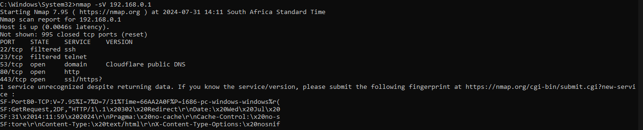

**Advanced Nmap Scanning:**

Operating System Detection

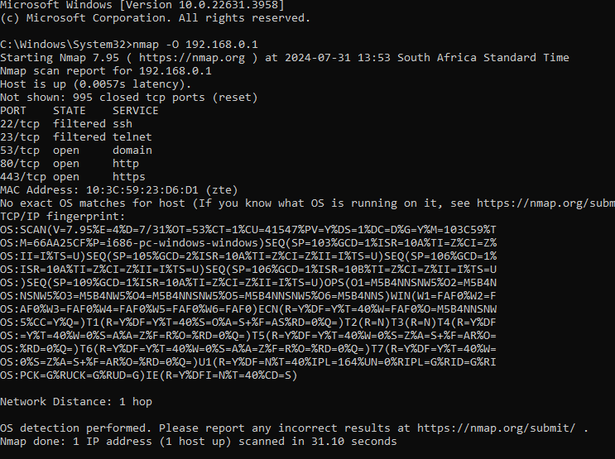

**Vulnerability tests:**

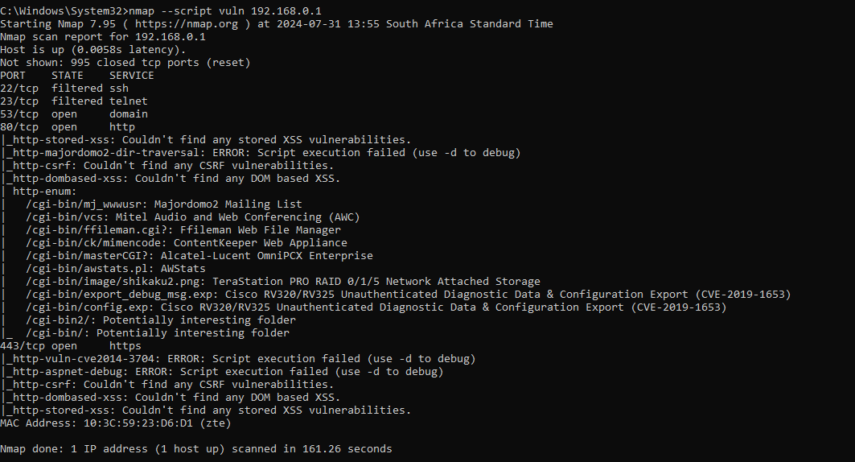

**Aggressive Scan**:

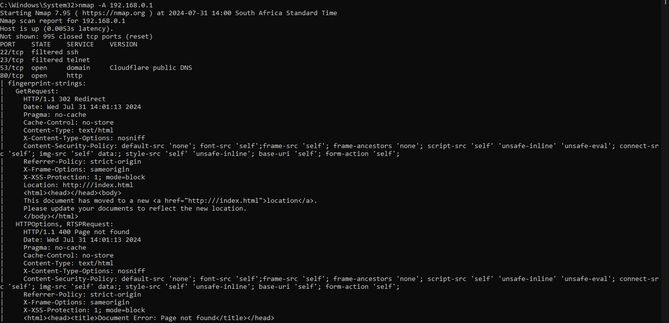

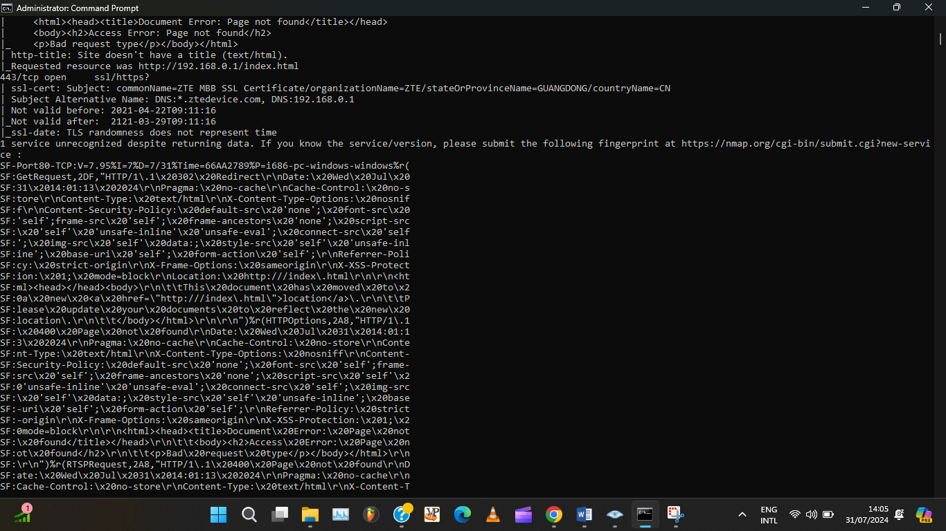

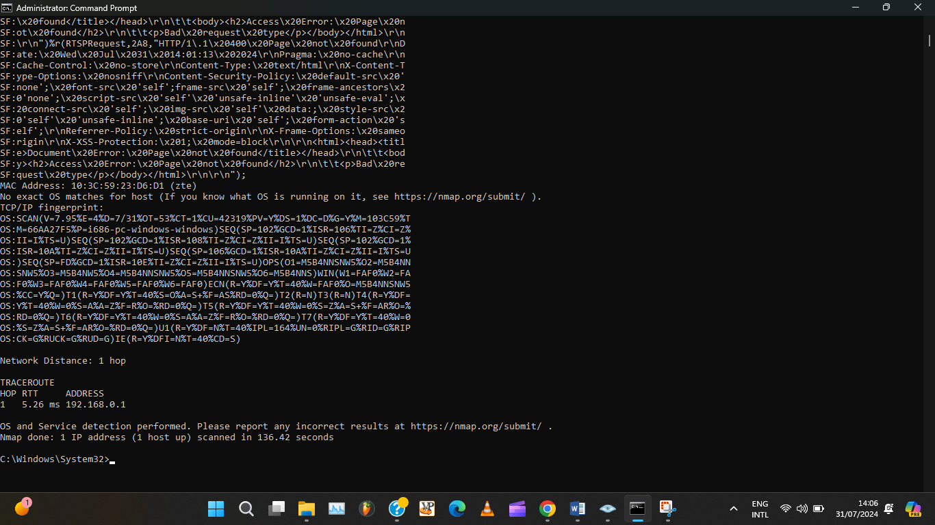

**Automating Nmap Scans with Python**

import nmap

import json

def scan_network(target):

nm = nmap.PortScanner()

scan_data = nm.scan(hosts=target, arguments='-A')

return scan_data

def save_results(results, filename):

with open(filename, 'w') as file:

json.dump(results, file, indent=4)

if __name__ == '__main__':

target = '192.168.0.1' # target network

results = scan_network(target)

save_results(results, 'nmap_scan_results.json')

print(f'Scan results saved to nmap_scan_results.json')