# DOG SKIN DISEASE RECOGNITION USING IMAGE SEGMENTATION AND GPU ENHANCED CONVOLUTIONAL NEURAL NETWORK (CNN)

by

Amarga, Marc Renzo S.

Balen, Mark Johnnel A.

Juco, Leslee L.

Pasatiempo, Jim Ryan D.

See Tiong, Pierre Edwin L.

Submitted in Partial Fulfillment of the Requirements for the Degree of

Bachelor of Science in Computer Science

at

FEU Institute of Technology

March/2021

Ms. Beau Gray Habal

©2021 Amarga, Marc Renzo S., Balen, Mark Johnnel A., Juco, Leslee L.,

Pasatiempo, Jim Ryan D., See Tiong, Pierre Edwin L.

All Rights Reserved

The author/s grant FEU Institute of Technology permission to reproduce and distribute the contents of this document in whole or in part.

# APPROVAL AND ACCEPTANCE SHEET

The thesis entitled **“Dog Skin Disease Recognition using Image Segmentation and GPU Enhanced Convolutional Neural Network (CNN)”** prepared and submitted by:

Amarga, Marc Renzo S.

Balen, Mark Johnnel A.

Juco, Leslee L.

Pasatiempo, Jim Ryan D.

See Tiong, Pierre Edwin L.

In partial fulfillment of the course of requirement for the Degree of Bachelor of Science in Computer Science with Specialization in Software Engineering has been examined and is hereby recommended for approval.

_____ _____ _______ _

Ms. Rossana Adao Ms. Elisa Malasaga

Panelist 1 Panelist 2

____ ____

Dr. Shaneth Ambat

Head Panelist

Accepted as partial fulfillment of the requirements for the **Degree of Bachelor of Science in Computer Science.**

_ _____ _______ ___

Dr. Hadji Javier Tejuco Ms. Beau Gray Habal

Thesis Adviser Thesis Mentor

_______________________

Dr. Shaneth Ambat

Program Director

March , 2021

# TABLE OF CONTENTS

DOG SKIN DISEASE RECOGNITION USING IMAGE SEGMENTATION AND GPU ENHANCED CONVOLUTIONAL NEURAL NETWORK (CNN) i

APPROVAL AND ACCEPTANCE SHEET iii

TABLE OF CONTENTS iv

LIST OF TABLES ix

LIST OF FIGURES x

LIST OF ABBREVIATIONS xii

INTRODUCTION 1

1.1. Introduction and Background of the Study 2

1.2. Theoretical Framework of the Study 3

1.2.1. Image Processing 3

1.2.2. Convolutional Neural Network 3

1.2.3. Graphics Processing Unit 4

1.2.4. Image Segmentation 5

1.2.5. TensorFlow 6

1.3. Conceptual Framework of the Study 7

1.4. Objectives of the Study 8

1.4.1. General Objective 8

1.4.2. Specific Objective 8

1.5. Scope and Limitations of the Study 9

1.6. Significance of the Study 10

1.7. Definition of Terms 10

1.7.1. Technical 10

1.7.2. Operational 11

REVIEW OF RELATED LITERATURE AND STUDIES 12

2.1. Related Literature 12

2.1.1. Dog Skin Disease 12

2.1.1.1. Yeast Infection 12

2.1.1.2. Folliculitis 13

2.1.1.3. Impetigo 14

2.1.1.4. Seborrhea 16

2.1.1.5. Ringworm 17

2.1.1.6. Alopecia 18

2.1.1.7. Allergic Dermatitis 19

2.1.1.8. Mange (Mites) 20

2.1.1.9. Color or Texture Change 21

2.1.1.10. Skin Tumor 22

2.1.1.11. Hot Spots 23

2.1.1.12. Anal Sac Disease 24

2.1.2. Convolutional Neural Network in Medical Diagnosis 25

2.1.3. Graphics Processing Unit based Convolutional Neural Networks 25

2.2. Related Studies 25

2.2.1. Performance Analysis of CNN Framework for GPU 25

2.2.2. Identification using CNN 26

2.2.3. An Intelligent System for Monitoring Dog Skin Disease 27

2.2.4. Performance and Scalability of GPU-based CNN 27

2.2.5. Automating Skin Disease Diagnosis Using Image Classification 28

2.2.6. Flexible, High Performance Convolutional Neural Networks for Image Classification 28

2.2.7. Dermatology in Dogs and Cats 29

2.2.8. Deep Learning Implementation in Convolutional Neural Network 29

2.2.9. CPU vs GPU in Deep Learning Performance 30

2.2.10. The Importance of Image Processing and its Applications 31

METHODOLOGY 32

3.1. Type of Research 32

3.2. Project Design 33

3.2.1. Use Case Diagram for WebApp 33

3.2.2. Use Case Diagram for Mobile App 36

3.2.3. Activity Diagram 40

3.2.4. Sequence Diagram 44

3.3. Hardware and Software Specifications 45

3.3.1. Hardware Specification 45

3.3.2. Software Specification 45

3.4. Method in Developing the Software Product 46

3.4.1. Algorithms in Developing the Software Product 47

3.4.1.1. Otsu’s Algorithm Thresholding 47

3.4.1.2. Convolutional Neural Network 48

3.4.1.3. Image Segmentation 49

3.5. Method in Evaluating the Software Product 49

3.5.1. Alpha Testing 50

3.5.2. Beta Testing 50

3.5.3. White Box Testing 50

3.5.4. Reliability Testing 51

3.6. Data Gathering Procedure 51

3.6.1. Survey 52

3.6.2. Interview 52

3.6.3. Data Set 52

3.7. Respondents of the Study and Sampling Technique 53

3.8. Statistical Treatment of Data 54

3.8.1. Likert Scale 54

3.8.2. Percentage 55

3.8.3. Weighted Mean 56

3.8.4. Precision 56

3.8.5. Accuracy 57

Results and Discussion 58

4.1. Presentation of Results 58

4.1.1. Reliability Testing Results 58

4.1.2. Survey Questionnaire Results 59

4.2. Interpretation of Results 63

CONCLUSION 64

RECOMMENDATION 65

BIBLIOGRAPHY 66

APPENDIX A 66

APPENDIX B 71

# LIST OF TABLES

Table 1. Respondents of the Study and their Qualifications 53

Table 2. The Likert Scale 55

Table 3. Responses for the Functionality of Petment Scanner 60

Table 4. Response for Efficiency of Petment Scanner 61

Table 5. Response in Usability of Petment Scanner 62

Table 6. Summary of Findings 63

# LIST OF FIGURES

Figure 1. Convolutional Neural Network Diagram 4

Figure 2. Difference between GPU and CPU application 5

Figure 3. Types of Image Segmentation 6

Figure 3. Conceptual Framework 7

Figure 4. An image of Yeast Infection 13

Figure 5. An image of Folliculitis 14

Figure 6. An image of Impetigo 15

Figure 7. An image of Seborrhea 16

Figure 8. An image of Ringworm 17

Figure 9. An Image of Alopecia 19

Figure 10. An Image of Allergic Dermatitis 19

Figure 11. An Image of Mange (Mites) 20

Figure 12. An Image of Color or Texture Change 21

Figure 13. An Image of Skin Tumor 22

Figure 14. An Image of Hot Spots 23

Figure 15. An Image of Anal Sac Disease 24

Figure 16. Use Case Diagram for WebApp 33

Figure 17. Use Case Diagram for Mobile App 37

Figure 17. Activity Diagram for Mobile App User 41

Figure 18. Activity Diagram for Web App User 43

Figure 19. Sequence Diagram for User 45

Figure 21. Otsu’s Thresholding foreground and backgoung separation. 48

Figure 23. CNN output per proccess of Rectified Linear Unit (ReLU) 49

Figure 24. Different kind of Image Segmentation 49

Figure 21. White Box Process 51

# LIST OF ABBREVIATIONS

CNN - Convolutional Neural Network

GPU - Graphics Processing Unit

ANN - Artificial Neural Network

FFT - Fast Fourier Transform

R-FCN - Region-based Fully Convolutional Network

Faster R-CNN - Faster Region-based Convolutional Neural Network

SSD - Single Shot Multibox Detector

CUDA - Compute Unified Device Architecture

API - Application Programming Interface

Chapter 1

# INTRODUCTION

Dogs are one of the most common animals that we can see everywhere, in households, police, military, and even doing some tricks for shows. They provide protection to our households, and sometimes even help people with disabilities to perform a task that will help their human companion, that is why they are called “*man’s best friend”*. However, like any other animal and human, dogs are not immune to a skin disease. Where many of their skin disease are caused by allergies, irritants, immune system-related problem and other factor such as mites. If these diseases are not identified and treated correctly, it can affect how the dogs will behave and its health negatively and may even spread to other dogs or worst to have a human transmission of disease.

As technology evolves different kind of application and system are already been developed especially for medical approached such as Skin Disease Checker for Human. However, this systems and applications are most available for human health purpose only, in which animals are still being sent to a veterinary doctor for checkup where not all the time there is an available veterinary clinic and doctors to cater them.

This study will focus in creating an application which will prioritize animals such as dogs for quick and reliable diagnosis. It will also mainly benefit the volunteers in animal shelter organizations who caters stray, abused, abandoned, and senior dogs that are most suspectable in skin diseases, to pre-examine the situation of the dog specially to a newly rescued dogs where there might not be available veterinary doctor volunteer to check the dog condition. It can also be beneficial to veterinary doctors to have an additional information of the dog condition after the volunteer uses the application for an on-site check.

## Introduction and Background of the Study

Animal shelter organizations such as The Philippine Animal Welfare Society (PAWS) and Phoenix Legacy of Compassion are just one of other animal shelters organizations that provides a proper shelter for rescued dogs, which are being organized by volunteers and being funded through donations. This animal shelters caters almost 700 different kind of animals daily by giving them proper shelter, foods and medical treatments and there are times that a veterinary doctor is not available especially when in a rescue mission and the dog needs to have an onsite checkup where most of the time dogs skin is the most visual available disease, this skin diseases are usually not being recorded for a daily and monthly record of infected dogs.

However, even with this kind of organizations, dog cruelty, abandonment and being neglected is still common especially to some home owned dogs and street dogs, which this kind of dogs usually dies or euthanized due to diseases that it has which can also be a reason for not being adopted by other people.

In the Philippines, these are common especially to a low-income household because they usually adopt a dog just to have a guard in their gates or entrance of their house. According to *Republic Act No. 8485* *Sec. 6.* (1998), “It shall be unlawful for any person to torture any animal, to neglect to provide adequate care, sustenance of shelter, or maltreat any animal or to subject any dog or horse to dogfights or horse fights, kill or cause or procure to be tortured or deprived of adequate care, sustenance or shelter, or maltreat or use the same in research or experiments not expressly authorized by the Committee on Animal Welfare”.

## Theoretical Framework of the Study

## Image Processing

Image processing is a method to perform operations on an image by capturing a photo and frame of a video. When different algorithms are applied it is called Digital Image Processing. Digital Image Processing focuses on developing a computer system that can perform processing on an image.

Image pre-processing aims for improvement of image data that suppresses distortions or enhances some image features.

## Convolutional Neural Network

Convolutional Neural Network (ConvNet or CNN) is a special type of Neural Network used effectively for image recognition and classification. They are highly proficient in areas like identification of objects, faces, and traffic signs apart from generating vision in self-driving cars and robots too. CNN is similar to the traditional Artificial Neural Network (ANN) but the difference between these two are; CNN accepts raw images as inputs and a class core as an output. The only significant difference between CNN and ANN is that CNNs are primarily used for pattern recognition within images (O’Shea, Keiron & Nash, Ryan, 2015). O’Shea, et. al. also mentioned that one of the key differences of CNN is that each neuron is organized into three dimensions: depth, width, and image height, in which allows CNN to be more suitable for image-related tasks such as identification and recognition.

Figure 1. Convolutional Neural Network Diagram

## Graphics Processing Unit

Graphics Processing Unit (GPU) is a specialized processor with dedicated memory that is required for rendering graphics. GPU computing is already considered necessary for Deep Learning Models where it actually enhancing the speed of the training of the models that focuses in image processing that uses the implementation of Matrix multiplication, that is common algorithm to be implemented on GPU (Faizan, S., 2017).

Figure 2. Difference between GPU and CPU application

## Image Segmentation

Before detecting or identifying the objects or even classifying the image it a must to understand first what is in the image, this where Image Segmentation works. Image segmentation is used in order to train a neural network to output a pixel-wise of an image, which it groups together the set or collection of different pixels that have similar attributes in order to identify or use this training for the classification of the objects in an image. Image segmentation is generally considered an intermediate step of some pattern-recognition applications (Comaniciu, Meer & Member, 2002).

Figure 3. Types of Image Segmentation

## TensorFlow

It is an end-to-end open-source platform mainly for machine learning, which it has a comprehensive and flexible tool, and libraries that helps researchers and developers in building and deploying Machine Learning powered applications. Mostly of social media, telecom and handset manufacturers which uses face recognition, image search, machine vision, photo clustering and other image processing approach uses TensorFlow algorithm in order to classify and identify an object from a cluster of objects in an image. It is also already expanded in the Healthcare Industry which TensorFlow algorithms can process more information than the human counterparts.

## Conceptual Framework of the Study

**INPUT**

* Image of dog’s skin disease

**PROCESS**

**Application Design**

* Simple dashboard with statistical record of identified diseases
* View feature of uploaded image

**Image Processing**

* Convert image to grayscale

**Image Segmentation**

* Resize the image to 224x224 dimensions
* Thresholding using Otsu’s Algorithm

**Classification**

* Classify images using GPU enhanced Convolutional Neural Network via TensorFlow

**OUTPUT**

* Web and mobile Information about the identified skin disease
* Differential diagnosis for other similar skin disease

Figure 3. Conceptual Framework

**INPUT**. The application will start by capturing a photo of dog skin or importing a photo from the phone’s gallery.

**PROCESS.** The input image undergoes preprocessing, which includes converting into a grayscale in preparation for the segmentation process. The image will go through different image processing techniques in which Otsu’s algorithm will be implemented for its thresholding that will be applied onto the image to isolate the diseased skin. This image will be resized to a certain dimension, in which this dimension will be used for inputting the image into the classification model.

Convolutional Neural Network (CNN) will be used as the classification model together with GPU in order to enhance the training time of the system, wherein the height, width and depth of the captured or imported data will be inputted.

**OUTPUT.** The output displays information about the identified skin disease, such as possible other symptoms, treatments and differential diagnoses, which shows the likelihood of other diseases.

For each listed disease results, there will be an information on what the volunteer will do for prevention of infections and other possible treatment. It will only include the possible behavior of the dog, treatment such as cleaning the diseased part if it’s necessary in cases and will exclude prescribing other medical products.

## Objectives of the Study

## General Objective

The researchers aim to develop a web and mobile application for veterinary clinic in identifying the 12 dog skin diseases through the use of image processing and classification techniques.

## Specific Objective

1. Design and develop an interface that will identify the 12 dogs skin disease that the dog can have using TensorFlow’s implementation of Convolutional Neural Network (CNN) and Graphics Processing Unit (GPU) support.
2. Creating a dashboard that generates a numerical result of identified dog skin diseases.
3. Validating and testing of the application for the accuracy of the trained model
4. Implement a system that will help a veterinary clinic to cater dogs in case of unavailability of veterinary doctor for simple, fast, and reliable dog skin disease diagnosis.

## Scope and Limitations of the Study

Veterinary clinics tend to have a numerous client for checkup, treatment, vaccine, and other pet care that they provide. This usually takes a lot of time where some of the patients will need to comeback in another day. This study will help the veterinary clinics for a pre-examination of their dog patients especially for the cases of dog skin diseases. This application will focus in processing an image of dog skin diseases such as Allergic Dermatitis, Yeast Infection, Folliculitis, Impetigo, Seborrhea, Alopecia, Acral Lick Granuloma, Skin Tumors, Hot Spots, Anal Sac Disease, Ringworm.

The system will accept image inputs via mobile phone camera and web application upload function, where the image process will take place. The system will focus only on the specified dog skin disease and does not include another dog skin disease

After the image is processed, it will show the results of classifications which are the identified skin disease, information of the dog skin disease such as the possible cause, symptoms, and its similarity to other diseases. The system will also show some recommendations to prevent and/or first aid a certain skin disease and will also recommend visiting a veterinary doctor in case of serious cases.

This application is not and will not be a substitute for a professional diagnosis but only to inform the organization and volunteers the potential diagnosis and first aid treatment to the dog skin disease, in which will also serve as additional information to the decision factor of veterinary doctors in making a diagnosis.

## Significance of the Study

**Veterinary Clinic.** The application aims to be beneficial to veterinary clinics which will help them to pre-examine the situation of the dogs and reduce the time it takes in examining the dog patients.

**Veterinary Doctors.** The application aims to be beneficial to veterinary doctors for advance pre-examined information of the dog skin situation, since the application will provide a complete information of possible disease of the captured dog skin image.

**Future researches.** This study aims to be used as a basis to enhance the methods using Image Processing with Convolutional Neural Network (CNN) together with Graphics Processing Unit (GPU) for faster process and to provide a reliable and accurate results.

## Definition of Terms

## Technical

Algorithm – is a set of rules or instructions designed to perform a specific task based on conducting a sequence of specified actions.

Convolutional Neural Network – is a type of artificial neural network that is used for simulations such as classification, clustering, and pattern recognition using image as inputs.

Database – is a collection of data that stores and organized information on the computer.

Mobile Application – is a type of software application designed to run on a mobile device, such as smartphone or tablet.

Web Application – is a type of software application designed to run on a web server which can be accessed through a web browser with an active internet connection.

## Operational

Image Processing – is a method to perform some operations on an image, to extract some useful information from the enhanced image.

Differential Diagnosis – the process of weighing the probability of one disease to other disease.

Chapter 2

# REVIEW OF RELATED LITERATURE AND STUDIES



## Related Literature

## Dog Skin Disease

Dog skin diseases like skin allergies many of these dog skin diseases can lead to a very dangerous situation if not treated as early as possible. Sometimes most of the people do not give much attention to their dog skin problems and treat using their own method and not aware how dangerous their skin diseases are. Treating dog skin diseases at its initial stage is important to prevent it from spreading.

The mobile application will help the users to identify twelve dog skin diseases yeast infection, folliculitis, impetigo, seborrhea, ringworm, alopecia, mange, fleas, color or texture changes, acral lick/granuloma, skin tumor, hot spots and anal sac diseases each subtype which will be discussed.

## Yeast Infection

Yeast is a fungus that lives on the skin and inside the gut of your dog without causing any harm, most of the time. However, there are certain triggers that when activated can lead to an overpopulation of yeast. The body will then try to get the yeast population back to its normal levels which causes the symptoms of yeast infection in dogs to flare up. The symptoms of yeast Infection in dogs are scratching the skin, hair loss, change in skin color , odor and licking. (Veterinary Medicine, DVM, 2018).

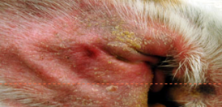

Figure 4. An image of Yeast Infection

If the dog can't seem to stop scratching an ear or licking and chewing their toes, ask your veterinarian to check for a yeast infection. Symptoms include irritated, itchy, or discolored skin. The infection usually strikes the paws or ears, where yeast have a cozy space to grow. Yeast infections are easy to diagnose and often respond well to a topical cream. In some cases, your veterinarian may prescribe oral drugs or medicated baths. (American Society for the prevention of cruelty to animals,” Dog care- skin problem”, 2018).

## Folliculitis

Folliculitis is a term that refers to the inflammation of one or more hair follicles. In veterinary medicine, it’s most commonly discussed as bacterial folliculitis, a condition which involves the infection of hair follicles with bacteria and is widely considered the most common kind of canine skin infection. The bacteria that infect the hair follicles of pets who suffer this condition typically resides on the surface of normal dog and cat skin. As such, bacterial folliculitis tends to occur when a healthy hair follicle is compromised, either by an underlying systemic disease, local trauma, or a specific disorder of the skin. Systemic diseases that can lead to bacterial folliculitis include endocrine disorders (such as hypothyroidism and Cushing’s disease in dogs) and disorders of the immune system. (Dr.Patty Khuly,VMD,MBA, 2015-2020).

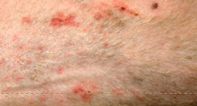

Figure 5. An image of Folliculitis

Skin disorders causing bacterial folliculitis in dogs include canine acne, acral lick granuloma, skin fold pyoderma, interdigital pododermatitis (interdigital cysts), idiopathic furunculosis of German Shepherd Dogs, pyotraumatic folliculitis, and callus dermatitis, among others. .(Dr.Patty Khuly,VMD,MBA, 2015-2020) In both dogs and cats, allergic skin disease is perhaps the most common cause of bacterial folliculitis. Parasitism and fungal infection of the skin are also common causes.

## Impetigo

Impetigo is a benign, non-contagious, non-zoonotic superficial bacterial infection of skin that does not involve hair follicles (Scott et al., 2001)and contributes to 0.5% of all the canine dermatology cases (Scott and Miller, 2008). It is recognized in two forms i.e. juvenile and bullous form, former affects young dogs before puberty(Codner, 1988), while bullous form is common in adults to older dogs that have concurrent metabolic and/or immunologic disorders.

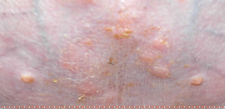

Figure 6. An image of Impetigo

Juvenile impetigo has also been called milk rash or juvenile pustular dermatitis or puppy pyoderma (White et al., 1987) and characterized by non-follicular subcorneal pustules located on the glabrous areas particularly axillae, groin and ventral abdomen (Medleau and Hnilica, 2001). Recent literature indicates Staphylococcus intermedius as primary pathogen (Gross et al., 2005) but Staphylococcus Aureus and Streptococcus spp. has also been reported (Kunkle, 1988). In the majority of dogs spontaneous resolution occurs (Baker, 1987), buttopical and/or systemic antibacterial therapy proven to hasten the recovery (Nesbitt andAckerman, 1998).

## Seborrhea

Seborrheic Dermatitis (SD) of the scalp is characterized by scaly, reddish lesions. The aetiological role of Pityrosporum ovale (Malassezia furfur) in seborrheic dermatitis is now supported by results from several studies. Several shampoos and lotions have been developed and marketed as active against dandruff. (luis J. borda & Tongyu , “A comprehensive review”2020).

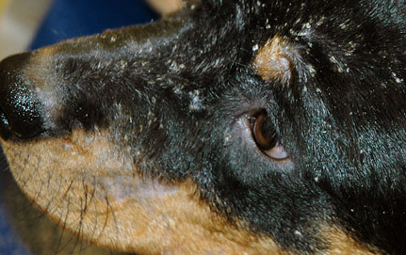

Figure 7. An image of Seborrhea

It is estimated that SD and dandruff combined affect half of the adult population. Despite such high prevalence, their etiology is not well understood. Various intrinsic and environmental factors, such as sebaceous secretions, skin surface fungal colonization, individual susceptibility, and interactions between these factors, all contribute to pathogenesis. Genetic, biochemical studies and investigations in animal models further provided insight on the pathophysiology and strategies for better treatment. In this comprehensive review, we summarize the current knowledge on SD and dandruff, and attempt to provide directions for future investigations and treatments. (J Am Acad Dermatol. 2006).

## Ringworm

Despite its name, it is not an actual worm but a fungus that is highly contagious to other animals and humans as well. This fungal infection appears circular, crusty bald patches and is often found on the dog’s head, paws, ears and front legs. This can make your dog skin appear inflamed and red which have an irritated area from scratching.

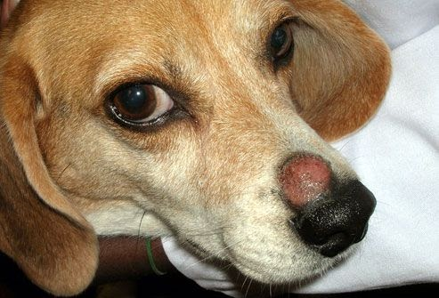

Figure 8. An image of Ringworm

It is advised to contact your vet doctor straight away if you spot any signs of irritation, who can prescribe a treatment to kill the fungus and prevent it from spreading. (Amy Shojai, 2019).

## Alopecia

Alopecia can affect dogs in all breeds and genders at any stage of their life. It is a common condition and can display either partial or complete hair loss, but it can also affect the dog skin, endocrine, lymphatic and immune system of the dog. It can be alarming since this is very noticeable especially if you have a long furred pet who typically has a silky-smooth coat. Alopecia happens when a certain skin condition affects the dogs which can range from gradual to acute. Such as Mange, allergic reactions, parasites or fleas, hot spots, and ringworm, it can also be inherited from the dogs mother. Luckily alopecia is usually treatable, all dogs should be given regular flea control treatments, but if the cause of it is another disease, it is better to have a proper treatment for the other skin condition that causes alopecia. (Purina, n.d.).

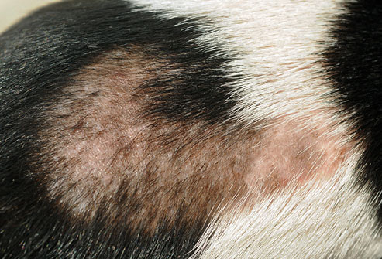

Figure 9. An Image of Alopecia

## Allergic Dermatitis

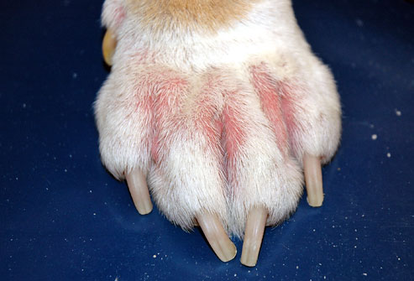

Figure 10. An Image of Allergic Dermatitis

Dogs can have allergic reactions to grooming products, food, and environmental irritants, such as pollen or insect bites. A dog with allergies may scratch relentlessly, and a peek at the skin often reveals an ugly rash. Corticosteroids or other, newer medicines can help with itchy rashes. But the most effective treatment is to identify and avoid exposure to the allergens

## Mange (Mites)

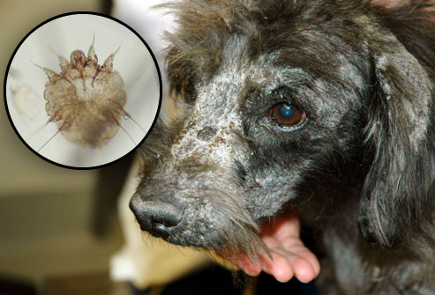

Figure 11. An Image of Mange (Mites)

Mange is a skin disorder caused by tiny parasites called mites. Sarcoptic mange, also known as canine scabies, spreads easily among dogs and can also be transmitted to people, but the parasites don't survive on humans. The symptoms are intense itching, red skin, sores, and hair loss. A dog's ears, face and legs are most commonly affected. Demodectic mange can cause bald spots, scabbing, and sores, but it is not contagious between animals or people. Treatment depends on the type of mange.

## Color or Texture Change

Figure 12. An Image of Color or Texture Change

Changes in a dog's skin color or coat texture can be a warning sign of several common metabolic or hormone problems. They can also result from an infection or other skin disorder. Usually a simple blood test can identify the underlying cause. Be sure to ask your veterinarian about any significant changes to your dog’s coat.

## Skin Tumor

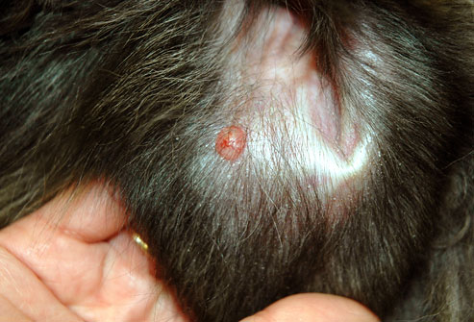

Figure 13. An Image of Skin Tumor

If you notice a hard lump on your dog's skin, point it out to your vet as soon as possible. Dogs can develop cancerous tumors in their skin. The only way to confirm a diagnosis of cancer is to biopsy the tumor. If the lump is small enough, your veterinarian may recommend removing it entirely. This can yield a diagnosis and treatment with a single procedure. For tumors that have not spread, this may be the only treatment needed.

## Hot Spots

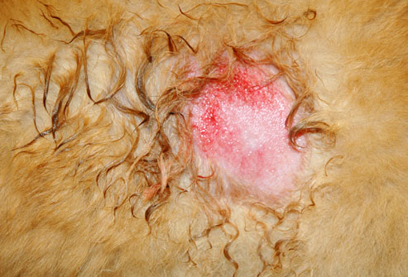

Figure 14. An Image of Hot Spots

Hot spots, also called acute moist dermatitis, are small areas that appear red, irritated, and inflamed. They are most commonly found on a dog's head, hips, or chest, and often feel hot to the touch. Hot spots can result from a wide range of conditions, including infections, allergies, insect bites, or excessive licking and chewing. Treatment consists of cleansing the hot spot and addressing the underlying condition.

## Anal Sac Disease

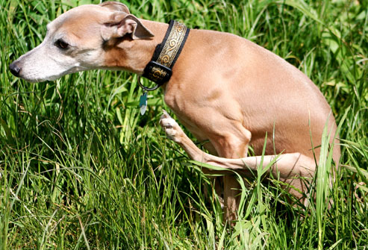

Figure 15. An Image of Anal Sac Disease

As if dog poop weren't smelly enough, dogs release a foul-smelling substance when they do their business. The substance comes from small anal sacs, which can become impacted if they don't empty properly. The hallmark of impacted anal sacs is a dog scooting their bottom along the ground. Other symptoms include biting or licking the anal area. A vet can manually express full anal sacs, but in severe cases, the sacs may be surgically removed.

## Convolutional Neural Network in Medical Diagnosis

Convolutional Neural Network (CNN) dominates with the best results on varying image classification tasks. According to Bakator and Radosav (2018), they reviewed more than 300 research articles, which has been narrowed down to 46 studies. In these 46 studies, the result indicates that CNN is the most widely used when it comes to deep learning and medical image analysis.

## Graphics Processing Unit based Convolutional Neural Networks

Image classification or processing is usually performed using CNN especially in medical, education and security, which is the most used in deep learning. A. Krizhevsky et al. (2012), made the ImageNet classification with CNN. A deep CNN has been trained, dividing the object into 1000 different classes from 1.2 million images with high resolution. To accelerate learning, unsaturated neurons and convolutional operation have used a very effective Graphics Processing Unit (GPU) application.

## Related Studies

## Performance Analysis of CNN Framework for GPU

The most popular deep learning library for such frameworks is cuDNN developed by NVIDIA, and most of the popular deep learning frameworks use it as the backend for GPUs. An approach to speed up CNNs is reducing the time complexity of convolution algorithms. Fast Fourier Transform (FFT) algorithms and Winograd’s   minimal   filtering   algorithm   successfully   reduce   the algorithm complexity of  the  convolution  computation  in  a  CNN.  However, while the efficiency of a CNN on a single GPU has been improved a lot, its efficiency on multiple GPUs still shows poor scalability .(K. Heehoon, N. Hyung Wook, J. Wookeun, and L. Jaejin, N.D) this study chooses a deep learning framework to build their CNN models based on language interfaces, operating system support, performance of use for the dog skin diseases of a execution time of the same CNN model should be the same across all the frameworks when the input is the same. However, in reality, a CNN model built with a framework delivers more than twice the performance compared to the same model with a different framework.

## Identification using CNN

Dog Diseases detection has been a long research topic for the past few decades. In order to improve the recognition rate of disease diagnosis, researchers have studied many techniques using machine learning and pattern recognition. The techniques include machine learning techniques such as Convolutional Neural Network, Artificial Neural Network, Back Propagation Neural Network , Support Vector Machine and other image processing methods. . (Arivazhagan,S.,Vineth,S.,2018) .The techniques in Convolutional Neural Network performs both feature extraction and classification itself. However, the other methods use Color Co-occurrence matrix , Angle Code Histogram , Zooming algorithm , Canny edge detector and various other algorithms for feature extraction. (Arivazhagan,S.,Vineth,S.,2018) This study works have been carried out to classify a single disease in multiple dog diseases. This will be an automated diagnosis of the dog diseases that have been conducted using deep learning techniques. This work was able to classify the 15 classes consisting of diseases varieties using data sets of Dog diseases images. This study aims at identifying fourteen different Dog skin diseases such as yeast infection, folliculitis, impetigo, seborrhea, ringworm, alopecia, mange, fleas, color or texture changes, acral lick/granuloma, skin tumor, hot spots and anal sac diseases. The CNN performs automated feature extraction from the raw input in an analytical way.

## An Intelligent System for Monitoring Dog Skin Disease

Detection of dog skin diseases from the processing of images is an important topic both for sensors and sensing methods but also for Computational Intelligence image processing and Computational Intelligence. The authors presented how the antigens inﬂuence skin characterization for serological diagnosis. (dawid polap, MDPI, 2018). In this study we can find an up to date review over various machine learning methods applied to dog skin diagnosis and diseases detection. We propose a detection of skin dog diseases resulting from changes in over body area. The proposal is in efﬁcient detection and estimation of the analyzed the different kind of diseases of a dog. The method ﬁrst searches over the image for any potentially dangerous skin changes using key point search algorithms. After the image is clustered according to locations.

## Performance and Scalability of GPU-based CNN

The performance enhanced of the classification part of a neural network using the vertex and pixel shader of a GPU, one of latter also accelerated the training of a neural network. It was limited to the network proposed in using the outdated architecture of vertex and pixel shader and implemented through the DirectX API. One of the first neural networks for the new unified shader architecture using CUDA was implemented. A GPU implementation called Neocognitron neural network, which is quite similar to a CNN . (Daniel Strigl,Gpu- Based,2009).This study focuses on the improvement of the recognition part on the GPU, not considered of this training network. However, there’s no prior effort was made to build a complete framework for accelerating training and the classification of arbitrary CNNs on modern GPUs.In fact of the ideal parameters of a neural network (network structure, initial value range, learning method, learning rate, etc.) can only be determined by testing and evaluating, shortening the training time often leads to better results.(Klaus Kofler,2009).

## Automating Skin Disease Diagnosis Using Image Classification

During the last few years, telemedicine with remote image viewing and analysis has emerged as a highly valuable and versatile tool, particularly suited to places where local medical expertise is limited. Granot et al., (2008). Their study is related in a way that images captured undergo image processing techniques such as Image Preprocessing, Image Segmentation, and Feature Extraction.

## Flexible, High Performance Convolutional Neural Networks for Image Classification

The GPU code scales well with network size. For small nets the speedup is small (but still over 10) since they fit better inside the CPU cache, and GPU resources are underutilized. For huge nets the GPU implementation is more than 60 times faster than a compiler-optimized CPU version. Given the flexibility of our GPU version, this is a significant speedup. One epoch takes 35 GPU minutes but more than 35 CPU hours. Dan C. et al., (2011). Their research is similar to the proposed method using Convolutional Neural Network (CNN), Image Processing and GPU Implementation. The proposed system will use these methods to classify dog skin disease by using mobile application and improve the system speed by implementing GPU enhancement.

## Dermatology in Dogs and Cats

The skin is the largest organ of the body with many different functions such as thermoregulation, immune protection, sensory perception, vitamin D production and it acts as a barrier be‐ tween the animal and the environment. (Elisa B. et al, 2012). This research concentrated on the diseases of the skin of dogs and cats. This study includes a variety of different causes of skin diseases and includes a diagnosis of such diseases. Such as Bacterial Skin diseases, Fungal diseases, Parasitic Skin diseases, Allergic diseases, Immunologic Skin diseases, Metabolic and endocrine diseases, Acquired alopecia, Keratinization disorders, Psychogenic diseases, Nutritional skin diseases.

## Deep Learning Implementation in Convolutional Neural Network

Convolutional neural networks is currently one of the most prominent algorithms for deep learning with image data. Whereas for traditional machine learning relevant features have to be extracted manually, deep learning uses raw images as input to learn certain features. CNNs consist of an input- and output layer, and several hidden layers between the input and output. Examples in between layers are convolutional layers, max-pooling layers and fully connected layers. CNN architectures vary in the number and type of layers implemented for its specific application. (Tahmina, Z., Scully, P. Peek, N., Casson, A., Ozanyan, K. 2019) In this study comprised of one or more convolutional and pooling layers followed by one or more connected layers that gained popularity due to the ability to learn unique representation for images, capturing local dependency and distortion invariance. Also, in Dog skin diseases we classified 14 skin diseases and show the diseases and how its treatment for these diseases.

## CPU vs GPU in Deep Learning Performance

CPUs have larger instruction sets than GPUs making GPUs less ﬂexible, however GPUs are said to be dedicated for parallel computing even for the same instructions. Deep Neural Networks (DNN) are structured in a very uniform manner such that at each layer of the network thousands of identical artiﬁcial neurons perform the same computation. (Kayid & Khaled,2018) Therefore, its way of computation is quite similar to how GPU computes instructions. Image processing is an expensive task that requires many calculations and since GPUs have more computational units and have a higher bandwidth to retrieve from memory, GPUs perform quite well in that task with high speed as well, deep learning includes massive image processing operationswith large datasets making parallelism a needed feature in deep learning computing.

## The Importance of Image Processing and its Applications

An image contains sub-images often referred as regions or regions of interest. Images regularly contain groups of objects each of which is the basis for a region. Most generally, image processing requires the images to be available in digitized form. For digitization process, the input image is sampled on a separate lattice and every sample or pixel is quantized by a fixed number of bits. (Basavaprasad and Ravi, 2002). Image processing is very closely related to computer vision and computer graphics. Within the computer graphics, images are physically prepared from environments, physical models of objects and lighting, also an alternative of being acquired through imaging devices from natural scenes, as in most animations. Computer vision is frequently measured good quality image processing by which computer or software means to interpret the objective contents of an image, a sequence of images. (Basavaprasad and Ravi, 2002). In this study we particularly give the importance to medical imaging as the signification application of image processing.  Dog skin diseases process used to determine the image of the dog body. Althoughtoimaging of what kind of diseases and detect what are the possible treatments.

Chapter 3

# METHODOLOGY



## Type of Research

This research will utilize a quantitative type of applied research, which all data will be coming from the mentioned organization. Quantitative research is typically concerned with gathering data through statistical analysis, which is useful to the researchers since the part of data gathering includes conducting a survey and testing of the system to the respondents of the study. The result of the survey were analyzed for information about the respondents which will be used in the development of the system.

## Project Design

## Use Case Diagram for WebApp

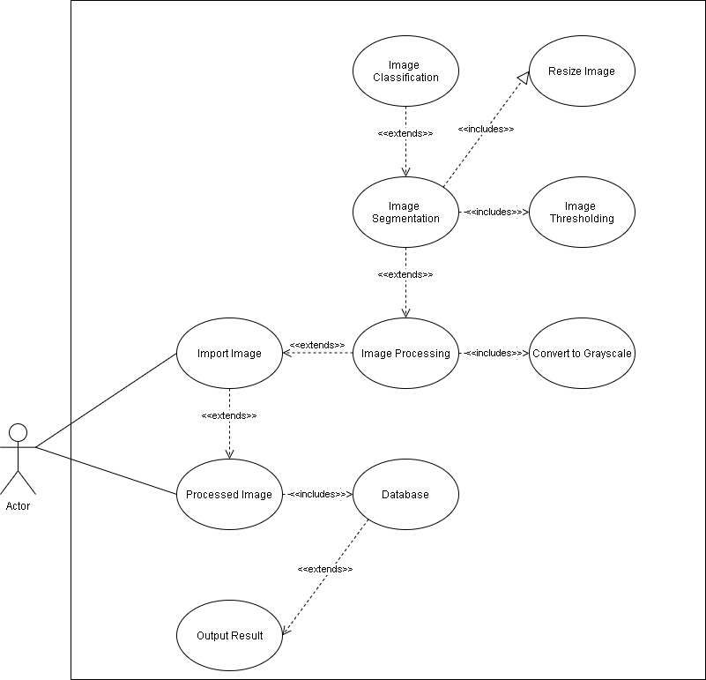

Figure 16. Use Case Diagram for WebApp

**1. Use Case: Import Image**

Introduction. The user/volunteer is required to import an available image of dog skin disease to the application.

Actor. The actor for this use-case is the user.

Pre-condition. The user should capture an identified dog skin disease or import an image from their mobile phone gallery to their computer gallery.

Post-condition. None

Basic flow.

1. The user will click Upload button from the WebApp and choose his/her desired photo.

2. The user will have a send button available after uploading/importing an image in order for the WebApp to process the image and output an result.

**2. Use Case: Image Processing**

Introduction. The input image will undergo an image processing method to obtain the expected output by the user.

Actor. None

Pre-condition. The user should have done capturing or importing the image to the mobile application.

Post-condition. None.

Basic Flow.

1. The inputted image will be turned into a grayscale.

2. The converted grayscale image will undergo to an image segmentation process that includes image thresholding and image resizing.

3. Upon finishing the image segmentation process, image data will proceed to a image classification.

**3. Use Case: Data Base**

Introduction. The finished product of image that undergo to image processing, segmentation and classification will be stored into the database.

Actor. None

Pre-condition. The user should have done capturing or importing an image to process.

Post-condition. None

Basic Flow.

1. Processed image will be stored in the database for output results.

**4. Use Case: Output Result**

Introduction. The user will have an option to view the result of the imported image.

Actor. The actor for this is the user.

Pre-condition. The user should have an active list of captured or imported and uploaded images.

Post-condition. The user will have an option to delete the image and its output result if desired.

Basic Flow.

1. The user will view the output result of the processed image.

2. Output result will show the copy of the image and details such as the identified disease.

## Use Case Diagram for Mobile App

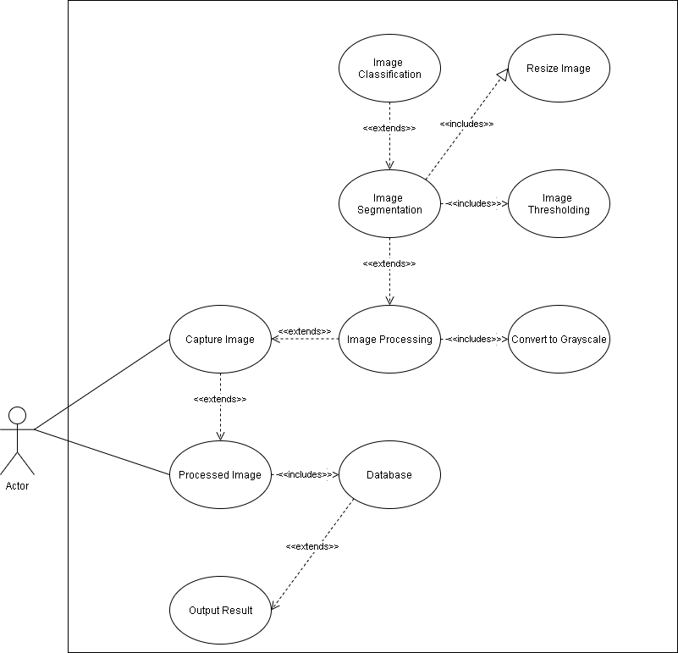

Figure 17. Use Case Diagram for Mobile App

**1. Use Case: Import Image**

Introduction. The user/volunteer is required to import an available image of dog skin disease to the application.

Actor. The actor for this use-case is the user.

Pre-condition. The user should capture an identified dog skin disease or import an image from their mobile phone gallery to their computer gallery.

Post-condition. None

Basic flow.

1. The user will click Upload button from the WebApp and choose his/her desired photo.

2. The user will have a send button available after uploading/importing an image in order for the WebApp to process the image and output an result.

**2. Use Case: Image Processing**

Introduction. The input image will undergo an image processing method to obtain the expected output by the user.

Actor. None

Pre-condition. The user should have done capturing or importing the image to the mobile application.

Post-condition. None.

Basic Flow.

1. The inputted image will be turned into a grayscale.

2. The converted grayscale image will undergo to an image segmentation process that includes image thresholding and image resizing.

3. Upon finishing the image segmentation process, image data will proceed to a image classification.

**3. Use Case: Data Base**

Introduction. The finished product of image that undergo to image processing, segmentation and classification will be stored into the database.

Actor. None

Pre-condition. The user should have done capturing or importing an image to process.

Post-condition. None

Basic Flow.

1. Processed image will be stored in the database for output results.

**4. Use Case: Output Result**

Introduction. The user will have an option to view the result of the imported image.

Actor. The actor for this is the user.

Pre-condition. The user should have an active list of captured or imported and uploaded images.

Post-condition. The user will have an option to delete the image and its output result if desired.

Basic Flow.

1. The user will view the output result of the processed image.

2. Output result will show the copy of the image and details such as the identified disease.

## Activity Diagram

Figure 17. Activity Diagram for Mobile App User

The application can only be used by users who have an account. Users can utilize the function of the mobile application such as editing user profile, change password, and review the uploaded images. Upon clicking the sign up button for the users who wish to create an account, the user must fill up the registration form and after signing up, a verification code will be sent to the user’s email address and go back to the starting page to login. Once the user logged in, the application will direct the user to the Main Page. Users can check their user profile and if they want to edit some information, they can use the edit profile button to change their information and save it, all changes will be saved on our database. They can also change passwords, which can be seen on account settings. As for the main feature of the application, they needed to capture or import and upload a photo of the dog skin disease to the web app server to determine the dog skin health problem, causes and some self-medication method to prevent the disease becoming worse. The user can also log out if they want to login another account.

Figure 18. Activity Diagram for Web App User

The application can only be used by users who have an account. Users can utilize the function of the web application such as editing user profile, change password, review the uploaded images, and view the available timeline. Upon clicking the sign-up button for the users who wish to create an account, the user must fill up the registration form and after signing up, a verification code will be sent to the user’s email address and go back to the starting page to login. Once the user logged in, the application will direct the user to the Main Page. Users can check their user profile and if they want to edit some information, they can use the edit profile button to change their information and save it, all changes will be saved on our database. They can also change passwords, which can be seen on account settings. As for the main feature of the application, they can view the uploaded images by the mobile application to view the diagnosis result from the uploaded image. The result will contain the information about the causes, possibility of other disease and some first aid medication method to prevent the disease becoming worse.

## Sequence Diagram

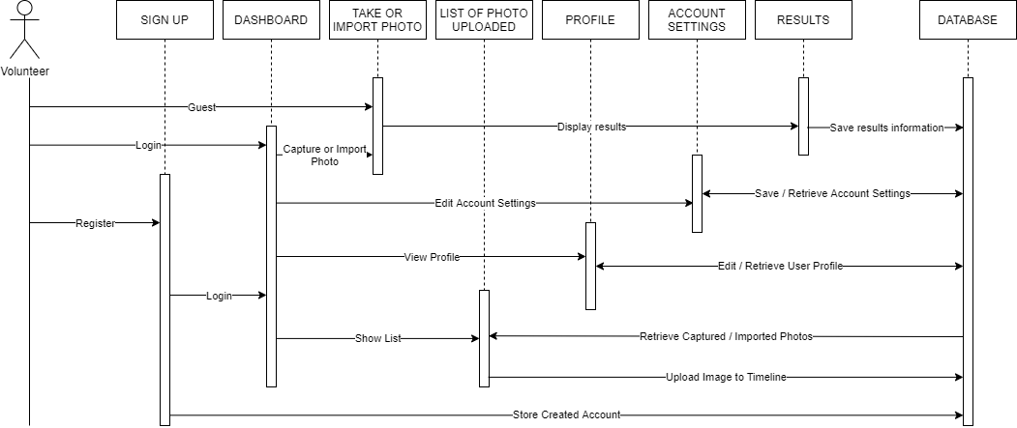

Figure 19. Sequence Diagram for User

Users are classified as registered, where all registered user can login using their credentials. Once the login process is verified, it will display the dashboard. The main function of the application is to capture or import an image of the dog skin disease to identify the appropriate skin disease. Once the user confirmed the captured or imported image the application will process the image to identify the appropriate disease information with differential diagnosis. Registered user will have access to view all imported image together with its diagnosis.

## Hardware and Software Specifications

## Hardware Specification

The hardware requirements for the development of the application are at least 4GB RAM, with 8GB RAM as the recommended amount for optimal use of Android Studio. An Intel® Core i5 is recommended processor and minimum of Nvidia GTX 1050ti is recommended for GPU when developing the application.

## Software Specification

Software requirements for the development of the application should have a Windows 7 or higher OS version. Java programming language will be used via Android Studio which serves as the IDE for the development of mobile application. A combination of JavaScript, PHP and HTML and Springboot Framework will be used in creating the web application where the Convolutional Neural Networks will be develop using Python programming language. Amazon Web Services has been used for both deployment of the webapp system and linking the trained model to the webapp system.

The software requirements to run the mobile application is to have an internet connection via Wi-Fi or Mobile Data and the Android OS version should be 5 Lollipop or higher.

## Method in Developing the Software Product

Modified Waterfall methodology was utilized by the researchers in developing both mobile and web application. The modified waterfall is a linear application development model where it uses a rigid phase, which when one phase ends, the next begins. These steps occur in a sequence approach, however unlike the waterfall model, the modified waterfall allows a return to the previous phase for the verification and validation.

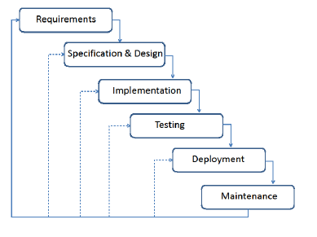

Figure 22. Modified Waterfall Model Structure

## Algorithms in Developing the Software Product

## Otsu’s Algorithm Thresholding

Otsu’s Algorithm Thresholding is used to perform an automatic and simplest form of image thresholding, where the algorithm returns a single intensity threshold that separate pixels into two classes, foreground and background.

Figure 21. Otsu’s Thresholding foreground and backgoung separation.

## Convolutional Neural Network

In order to classify the targeted skin diseased, CNN will be implemented using its classic architecture of layers.

Input -> Convolution -> ReLU -> Convolution -> ReLU –> Pooling -> ReLU -> Convolution -> ReLU -> Pooling -> Fully Connected

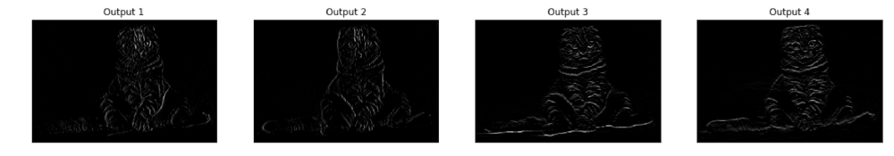This process is used in order to separate the non-linearity in the image and removes the negative values from the activation map to obtain the targeted data in the image.

Figure 23. CNN output per proccess of Rectified Linear Unit (ReLU)

## Image Segmentation

The goal of image segmentation is to simplify or convert the representation of an image into something meaningful and easier to analyze. The simplest method of image segmentation is to called thresholding method where it converts the gray-scale image into a binary image. The result of an image segmentation process is a set of segments that covers the entire image, which each identified pixels has an characteristics or computed property such as the color, intensity, or texture.

Figure 24. Different kind of Image Segmentation

## Method in Evaluating the Software Product

Software testing is an important component of software quality assurance. The basic purpose of software testing is to verify if the application behaves as specified and detects the possible errors and bugs that has been made during the development process. It is also the process to check whether the application meets the specified functions for the project.

## Alpha Testing

Alpha Testing is done on early as the initial stage of software evaluation, it is performed to ensure that the application or system runs as planned and refining the application through finding and fixing the bugs that are not discovered through other tests.

## Beta Testing

Beta Testing is usually done on as the final testing phase of the software. It is performed to ensure and validates the functionality, usability, reliability and compatibility of the application or software. The inputs of end-users or customer will be used in improving the quality of the system before the initial release of the application.

## White Box Testing

White Box Testing is a software testing method wherein the tester knows the internal implementation, structure and design of the software. It is for testing all internal coding and infrastructure of the software. It is also to validates the internal components, framework and object of the application. White box tester should have some knowledge about programming to detect and determine the possible anomalies.

Figure 25. White Box Process

## Reliability Testing

Reliability Testing process is done to discover the issues in the software design and its functionality. Its main purpose is to ensure that the software is bug free and reliable enough for its expected purpose.

## Data Gathering Procedure

Data must first be gathered from reputable sources in order to develop the system. The gathered data will be interpreted to be used to the researcher’s study. This information can be used to improved or make necessary changes to the project.

## Survey

A survey to the respondents of the study will be used in order to gather the information about the system after the testing phase. Veterinary Doctors are essential due to their extensive experience in the field, while the volunteers of the animal shelter organization are needed as for their experiences as people who also always in daily interactions in the dogs.

## Interview

A one-on-one interview will be utilized between the researchers and veterinary doctor, so that they may offer his/her opinion and insights on the proposed application, as well as for the researchers to question about their field so that they may properly take some consideration when developing the application. Multiple veterinary doctor and animal shelter volunteer may be consulted during the time of the research to broader the understanding of the needs of dogs.

## Data Set

Data sets will be utilized in the development of the system in order to train the classification model. The images of the scoped output, which are Yeast Infection, Folliculitis, Impetigo, Seborrhea, Ringworm, Alopecia, Allergic Dermatitis, Acral Lick Granuloma, Skin Tumors, Hot Spots, and Anal Sac Disease, Skin and Nonskin, were gathered to train the model to identify the skin disease after undergoing image processing techniques.

The researchers will use a 1000 images per skin disease, this will be gather using online database of the dog skin diseases which uploaded by veterinary doctors around the world. These gathered data sets are used for the purpose of the study, wherein the images are free to use for non-commercial purpose and the websites are cited and given the appropriate credits.

The information about the fourteen dog skin diseases, such as the cause, symptoms are gathered from reputable veterinary health websites.

## Respondents of the Study and Sampling Technique

The researches utilized a combination of convenience and purposive sampling, due to the availability of the volunteers and veterinary doctors of Phoenix Legacy of Companion.

The respondents will be required to answer a survey after giving the prototype of the application to use, to gather the data about their opinion on the application, whether improvements or changes are necessary.

Table 1. Respondents of the Study and their Qualifications

|  |  |  |
| --- | --- | --- |
| Respondents | Number of Respondents | Qualifications |
| CS/IT Professionals | 5 | Developers / Instructors |
| Veterinary Doctor | 5 | Registered Veterinary Doctor |
| Household Dog owner | 13 | Dog Owner |
| Veterinary clinic personnel | 7 | Experienced Clinic Personnel |

## Statistical Treatment of Data

For effective and precise interpretation of the gathered data, the researchers will utilize a statistical technique such as Likert Scale and Percentage. As for the treatment of datasets, Precision, Accuracy will be utilized.

## Likert Scale

The Likert Scale will be used in the survey to measure the degree of agreement towards the given statements. It ranges from 1 to 5 with 1 being Poor and 5 being Outstanding. Each number has a weighted mean associated with it.

Table 2. The Likert Scale

|  |  |  |
| --- | --- | --- |
| **Rate** | **Description** | **Weighted Mean** |
| 1 | Poor | 1.0 – 1.5 |
| 2 | Below Average | 1.6 – 2.5 |
| 3 | Average | 2.6 – 3.5 |
| 4 | Above Average | 3.6 – 4.5 |
| 5 | Outstanding | 4.6 – 5.0 |

## Percentage

Percentage is to determine how much of the respondents have the similar answers, particularly in the survey. This is to distinguish the majority from the minority, or the different percentages with the respondent. The formula below will be used to discover the different percentages in the data:

Where the *P* is the percentage, *F* is the frequency of a certain response, and *N* is the total number of respondents.

## Weighted Mean

Weighted mean corresponds to the relative importance of each quantity in each data set. The formula bellow will be used to calculate the weighted mean of the data:

Where X is the weighted mean, is the summation, *x* is the sum of scores in distribution, and *N* is the total number of respondents.

## Precision

Precision is how close a measurement comes from another measurement; it is determined by a statistical method of standard deviation on how much average measurements differ from other. High standard deviations indicate low precision, while the low standard deviations indicate high precision.

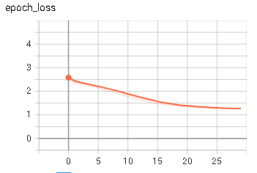

Figure 26. Precision graph of the trained model

## Accuracy

It is used to measure how close the computation comes to the truth. It is determined by how close a measurement comes to an existing value that has been measured by other processes.

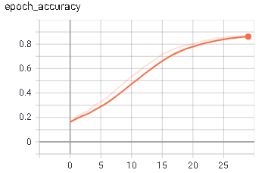

Figure 27. Accuracy graph of the trained model

Chapter 4

# Results and Discussion

## 4.1. Presentation of Results

## 4.1.1. Reliability Testing Results

The software’s reliability was evaluated through a series of test case with at least ten trials per run. The first test evaluates the application to detect healthy skin only. The second test is for the ability to detect the scoped skin diseases. Third test is a combination for first and second, finally the fourth and last test was to evaluate the application’s ability to detect non-skin objects.

## 4.1.2. Survey Questionnaire Results

The researchers conducted the software evaluation through online survey questionnaires to determine the mobile application’s strength and weaknesses. The process on how the application works were discussed and demonstrated to the respondents beforehand.

The survey questionnaires consist of [number] questions to assess the application functionality, reliability, useability, efficiency.

Legend:

**E -** Evaluation

**O** – Outstanding

**BA** – Below Average

**A** – Average

**AA** – Above Average

**O** – Outstanding

**Functionality:** The ability of the application to serve its purpose.

Table 3. Responses for the Functionality of Petment Scanner

|  |  |  |  |  |  |  |  |  |
| --- | --- | --- | --- | --- | --- | --- | --- | --- |
| **Item** | **CS / IT Professional** | **E** | **Veterinary Doctor** | **E** | **Household Dog Owner** | **E** | **Veterinary Clinic Personnel** | **E** |
| The application can diagnose and provide the appropriate skin disease. | 4.4 | AA | 5 | O | 4.7 | O | 4.6 | O |
| The application can display a statistical record of the diagnosed dog skin disease. | 4.4 | AA | 4.2 | AA | 4.5 | AA | 4.5 | AA |
| The application can provide a temporary care measures for the diagnosed dog skin disease. | 4.0 | AA | 4.8 | O | 4.7 | O | 4.6 | O |
| **Average** | 4.3 | AA | 4.7 | AA | 4.6 | O | 4.6 | O |
| **Total Average** | **4.6** | | **Above Average** | | | | | |

The functionality of both web and mobile application was assessed through responses from CS / IT Professionals with an average of 4.3, Veterinary Doctor with 4.7, Household Dog Owner with 4.6 and Veterinary Clinic Personnel with 4.5. Weighted Mean formula was used to get the average of each item, while the Total Average was calculated through summation of all average over its total number of items. The total average functionality score is 4.5 which gives an Above Average.

Table 4. Response for Efficiency of Petment Scanner

|  |  |  |  |  |  |  |  |  |
| --- | --- | --- | --- | --- | --- | --- | --- | --- |
| **Item** | **CS / IT Professional** | **E** | **Veterinary Doctor** | **E** | **Household Dog Owner** | **E** | **Veterinary Clinic Personnel** | **E** |
| The application can load and respond quickly with the necessary data. | 4.8 | O | 4.6 | O | 4.7 | O | 4.7 | O |
| The application can provide the diagnosed dog skin disease in less than five minutes. | 4.6 | O | 4.8 | O | 4.6 | O | 4.6 | O |
| The application can process the captured or imported image in less than a minute. | 4.2 | AA | 4.4 | AA | 4.8 | O | 4.9 | O |
| **Average** | 4.5 | AA | 4.6 | O | 4.7 | AA | 4.7 | AA |
| **Total Average** | **4.6** | | **Outstanding** | | | | | |

The efficiency of both web and mobile application was assessed through responses from CS / IT Professionals with an average of 4.5, Veterinary Doctor with 4.6, Household Dog Owner with 4.7 and Veterinary Clinic Personnel with 4.7. Weighted Mean formula was used to get the average of each item, while the Total Average was calculated through summation of all average over its total number of items. The total average functionality score is 4.6 which gives an Outstanding.

Table 5. Response in Usability of Petment Scanner

|  |  |  |  |  |  |  |  |  |
| --- | --- | --- | --- | --- | --- | --- | --- | --- |
| **Item** | **CS / IT Professional** | **E** | **Veterinary Doctor** | **E** | **Household Dog Owner** | **E** | **Veterinary Clinic Personnel** | **E** |
| The application has an easy to use and understand interface. | 4.4 | AA | 4.6 | O | 4.2 | AA | 4.2 | AA |
| The user can import an image for diagnosis. | 4.6 | O | 4.2 | AA | 4.8 | O | 4.9 | O |
| The user can sign-up for a new account. | 4.6 | O | 4.8 | O | 4.5 | AA | 5.0 | AA |
| **Average** | 4.5 | AA | 4.5 | AA | 4.5 | AA | 4.7 | O |
| **Total Average** | **4.5** | | **Above Average** | | | | | |

The useability of both web and mobile application was assessed through responses from CS / IT Professionals with an average of 4.5, Veterinary Doctor with 4.5, Household Dog Owner with 4.5 and Veterinary Clinic Personnel with 4.7. Weighted Mean formula was used to get the average of each item, while the Total Average was calculated through summation of all average over its total number of items. The total average functionality score is 4.5 which gives an Above Average.

## 4.2. Interpretation of Results

Table 6. Summary of Findings

|  |  |  |
| --- | --- | --- |
| **Category** | **Weight Mean** | **Interpretation** |
| 1. Functionality | 4.6 | Outstanding |
| 1. Efficiency | 4.6 | Outstanding |
| 1. Usability | 4.5 | Above Average |
| **Total Average** | 4.5 | Above Average |

The overall functionality has an average score of 4.5 (90%) which means that the application’s ability to serve its purpose was above average. The system is evaluated with an overall score of 4.6 (92%) for its efficiency, meaning that the application is stable enough to response efficiently. The application scored a 4.5 (90%) for its usability where it is easy to learn and use. The total average of Petment Scanner weighted score was 4.5 (90%), functioning and delivering its main objective of detecting and diagnosing image of diseased dog skin in above average.

Chapter 5

# CONCLUSION

Based on the findings of the study, the following conclusions were drawn:

1. The researchers have developed a system for detection and diagnosis of dog skin diseases using image processing techniques and achieved in creating a model with the application of Convolutional Neural Network (CNN) enhanced by Graphics Processing Unit (GPU) for an enhanced maximum speed of training.
2. The speed of training with the use of Nvidia GTX 1050ti GPU as the core of CNN is at the optimized rate than the usual CPU core CNN, however it can still be enhanced by using the latest version of CUDA supported GPU that have a higher score level.
3. The application Petment Scanner has achieved its goal of utilizing the trained model of neural network in classifying different dog skin diseases after undergone an image processing. If applicable, differential diagnoses are shown to show the user of other possible diagnoses.
4. To further help the veterinary clinic in keeping a record, a dashboard featuring the tally of detected dog skin diseases has been added. The diagnosed image can be saved in the user’s local memory in mobile phone and through online database server.

# RECOMMENDATION

Based on the conclusion, the following recommendation are offered:

1. For future researchers, the researchers recommend that the study can be improved by including different breed of the dogs that can be added to be classified in neural network, as well as more images in the training and test model for more accuracy.
2. Using a higher version of Graphics Processing Unit (GPU) that supports a higher score rate of Compute Unified Device Architecture (CUDA) may be used to achieve a different result in speed of the training process.
3. Different type of classification model such as Artificial Neural Network (ANN), may be used together with CUDA, for different result and accuracy.
4. Alternative or additional image processing techniques such as OpenCV for realtime detection are recommended to be implemented, but the efficiency of the algorithms should not be neglected.

# BIBLIOGRAPHY

[1] A,Kayid and Y.Khaled “Performance of CPUS/GPUs for Deep Learning Workloads”, May 2018

[2] A. Lager, “Electronics Engineering 101,” unpublished

[3]    B. Lightyear. (1986). *To Infinity* [Online]. Available: <http://www.nasa.dl>

[4] Basavaprasad and  Ravi , “ A Study on the importance of image processing”, Publication of pearson, Second Edition, 2002.

[5] B.M. Singh, A. Mittal, D.Ghosh. (2011) “Parallel Implementation of Otsu’s Binarization Approach on GPU”. International Journal of Computer Applications 1975 – 8887.

[5] D. C. Ciresan, U. Meier, J. Masci, L. M. Gambardella, and J. Schmidhuber, “Flexible, High Performance Convolutional Neural Networks for Image Classification”. (2011).

[6] E. Bourguignon, Elisa & Matos, Luciana & Ferreira, Tássia & Favarato, Evandro. (2012). Dermatology in Dogs and Cats. 10.5772/53660.

[7] Fetch by WebMD, “Skin Problems in Dogs” Medically Reviews by Amy Flowers, DVM, Retrieved from https://pets.webmd.com/dogs/ss/slideshow-skin-problems-in-dogs

[7]   J. Delima et.al., “Utilization of Crumb Rubber from Scrap Rubber Tires as Partial Substitute to Fine Aggregates on Asphalt Mix,” B.S. thesis, Dept. Civ. Eng., FEU Institute of Technology, Manila, Philippines, 2014.

[8]    K. H. Recto, private communication, Jun 2015.

[9]  M. Black and A. Rashi, “Nanomaterials Applications,” in *IEEE Intelligent Nanomaterials Symp. Proc.*, Detroit, MI, USA, 2009, pp. 15-22.

[10]    M.G. Fung and J. Wang, “Page interleaved memory access,” U.S. Patent 4 924 375, May 8, 1990.

[11]    *Mark’s Standard Handbook for Mechanical Engineers*, 11th ed., McGraw-Hill, NY, 2006, pp. 1700 – 1710.

[12]   N. de Nevers, “Air Pollutant Concentration Models,” in *Air Pollution Control Engineering International Edition*, 2nd ed. Singapore: McGraw-Hill, 2000, pp. 119 -152.

[13] N.E Sahla, “A Deep learning Prediction Model for Object Classification”, February 2018.

[15] Okuboyejo, D., Oludayo, O., Solomon, A.. “Automating skin disease diagnosis using image classification.” *OMICS journal of radiology* (2013): n. Pag.

[16] Towards Data Science. 2019. The Complete Beginner’s Guide to Deep Learning: Convolutional Neural Networks and Image Classification. Retrieved from https://towardsdatascience.com/wtf-is-image-classification-8e78a8235acb#:~:text=In%20a%20convolutional%20layer%2C%20neurons,by%20extracting%20features%20from%20images.&text=CNNs%20learn%20feature%20detection%20through%20tens%20or%20hundreds%20of%20hidden%20layers.

[16] Exastax. 2017. Top Five Use Case of Tensorflow. Retrieved from https://www.exastax.com/deep-learning/top-five-use-cases-of-tensorflow/

[17] B. M. Singh, R. Sharma, A. Mittal, and D. Ghosh “Parallel Implementation of Otsu’s Binarization Approach on GPU” in *International Journal of Computer Applications*, Vol. 32, No. 2, October 2011

[18]   Z. M. Ali et al., “Bayesian model-based approach for developing a river water quality index,” in *Statistics and Operational Research Int. Conf.,* 2014 © AIP Publishing LLC. doi: 10.1063/1.4894330.

# APPENDIX A

Recommendation Letter from Greenwoods Pet Hospital

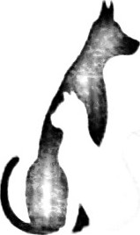Greenwoods Pet Hospital

Dee Dee & Lou Building, Lot 3 Block 2 Greenwoods Avenue,

Greenwoods Executive Village, Cainta, Rizal Contact number: (02)571-1130

Emergency Contact number: (02) 925-3310

Recommendation Letter

May 23, 2021

Good day!

GPH recommends the implementation of the software system Dog Skin Disease Recognition using Image Segmentation. This would further improve the diagnosis and treatment of skin problem in our patients.

Thank you and more power

Sincerely,



Geoffre Marl Carullo, DVM

Lic. No. 6219

Veterinarian

# APPENDIX B

Survey Questionnaire and Response Result

