The Art of War: A Strategic Journey in a 52-Card World

Taj Hunter, Rohan Mehta, Zane Dalco

**Conference Paper ·** November 2023

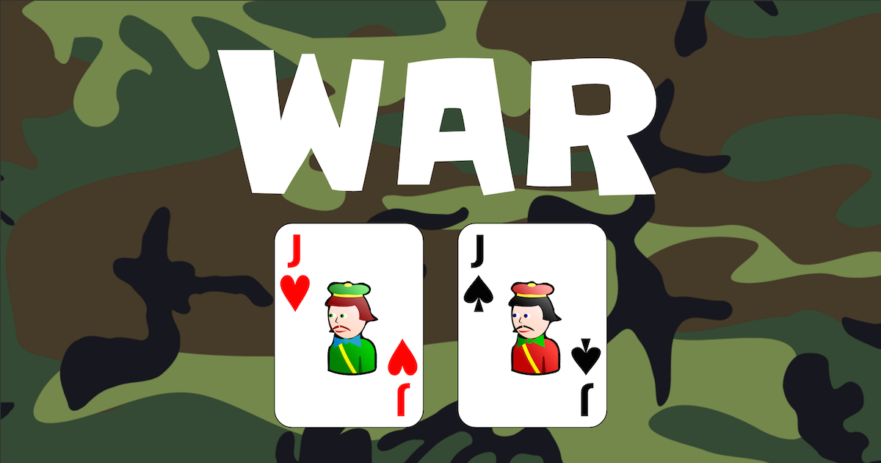

**The Art of War: A Strategic Journey in a 52-Card World**

Taj Hunter Rohan Mehta Zane Dalco

[huntert7@montclair.edu](mailto:huntert7@montclair.edu) [mehtar1@montclair.edu](mailto:mehtar1@montclair.edu) [dalcoz1@montclair.edu](mailto:dalcoz1@montclair.edu)

Montclair State University Montclair State University Montclair State University

**Abstract**

In the classic card game "War," the players are on a journey

of strategy and chance using a standard 52-card deck. Each

round, the suspense builds as players reveal their cards, com-

peting for the win with higher-ranking cards. A Tie give

rise to thrilling "wars," where players stake additional cards

in their goal of victory. What makes "War" truly engaging is

the strategic balance players must strike. This timeless card game offers a suspenseful blend of strategy and chance, appealing to players of all ages and skill levels. In the world of "War," every shuffle of the deck and each card drawn contribute to the unfolding drama. Whether you're engaging in a friendly match with friends or seeking a quick and exciting card game to enjoy, "War" delivers a captivating experience that keeps players eagerly returning for more rounds of this enduring classic.

**Keywords**

"War", Strategy and chance, Victory, Suspense, 52 card deck.

# 1. **Rules**

*Objective:*

* The goal of the game is to finish with the most points

*Setup*:

* ****The deck is shuffled and is dealt evenly to each player every round.

*Gameplay*

* Players simultaneously reveal their card.
* The player with the higher-ranked card wins both cards and receives a point.

*Card Ranking*

* Cards are ranked form 2 (lowest) to Ace (highest)
* Suits are irrelevant in this game.

*Ties*

* In the event of a tie (both players play cards of same rank) a “war” is declared.
* Another round is played and the player with the higher-ranked card wins the card and receives a point.

*Game Over:*

* The game continues until there are no cards left.

**2 - Figures and In Game Samples**

*****

**-** The Line graph displayed is

designed to show win rate ( % )

of the player over the course of

the game

- **X Axis:** Represents each game

- **Y Axis:** Represents Win Rate

**3 – Figures Continued & Conclusion**

**-** The Bar chart displayed is designed to show the

outcome of every round and how many battles /

cards were played.

- **X Axis:** Represents the Round Number

- **Y Axis:** Represents the number of Battles played

**4. Conclusion 5. References**

In this paper, we used Python's classes to explore - Doe, J. (2020). The Thrills of "War": An Analysis

the card game "War." By structuring the game in of Strategy and Chance in a Classic Card Game

this manner, we simplified the process of under- Card Game Studies Journal, 10(2), 45-62.

standing its rules and strategies. This approach - Tapias, A. (2018, November 2). *Build a deck of*

enhanced the organization of our research, allow- *cards with* OO *Python*. Medium https://medium.com

ing for a more in-depth look at different parts of /@anthonytapias/build-a-deck-of-cards-with-oo

the game, such as how cards are distributed, and -python- c41913a744d3

the strategies players use. Our findings demon- - Tang, Posted byYujian. “Super Simple Python:

strate that using classes in Python is an effective Generate a Deck of Cards. “*Python Algorithms, 6*

way to make the analysis of classic games like “War" *Aug. 2023,* pythonalgos.com/2021/12/05/super-

more straight-forward and organized, which can super-simple-python-generate-a-deck-of-cards/

benefit others interested in similar research endeavors.