Tiger’s Shadow of Yserbius Walkthrough
All Keys, Quest Items, and Quests

Tiger wrote this straightforward guide to collecting every quest item and completing every quest in the deeper reaches of the Volcano. It is the most simple guide to completing the game. Tiger is an outstanding member of the Yserbius diaspora, and a frequent commenter on Yserbius.org.

Table of Contents
The World of Yserbius & Twinion 2
Keys and Lockpicks 4
King Cleowyn's Key & Lockpick 5
Palace Key 6
Lava Key 7
Domicile Key 8
Thieves' Key 9
Wind Knights' Key 10
Voranti's Key 11
Back Alley Key 12
Sunbeam Key 13
Elfin Cave Key 14
Cyclop's Mine Key 15
Hidden Mine Key 16
Dwarf Mine Key 17
Quest Items 18
King's Ring 19
Chess Piece 20
Harvest Horn 21
Flex Metal 22
Ace of Spades 23
Blue Metal 24
Moonprism 25
Nature's Robe & Infinite Armor 26
Flex Sword 28
Golden Boat 29
Quests 30
King Cleowyn's Quest 31
Thieves' Den 34
Castle Gate 35
War Hammer of Doom & Kite Shield 37
Wolf Helm 38
Yellow Gem Quest & Kings Bones 39
Arnakkian's Quest & Blue Gem Quest 40
Seasons Quest 42
Green Gem Quest 43
Red Gem Quest & Barbarian's Axe 44
Phoenix Quest 45
Card Quest 46
Final Quest 48

The World of Yserbius & Twinion
Taken from the Yserbius Game Manual
Centuries ago, Twinion was a thriving and prosperous port city, ruled by the human Galabryan dynasty. The Galabryan kings welcomed all races and Guilds to the island, and the people lived in peace under the benevolent protection of the court. A great and ancient wizard, Arnakkian Slowfoot, was lured by the Galabryan kings to the island. In exchange for his use of magic to benefit the royal line, Arnakkian was offered a great castle near the sea. At first, all was well and Twinion flourished and gained world renown.
Then the evils began. Strange, misshapen beasts were spotted on the island and it became dangerous to wander outside the city after nightfall. Arnakkian began recruiting his own troops from among the distant Snow Elves and soon had an elite palace guard who frequently clashed with the king's soldiers. The good king Leowyn Galabryan was assassinated and his weak- minded son Theowayen became king. The wizard Arnakkian soon gained complete control over the profligate Theowayen and became the real ruler of the island in all but name.
Twinion might have disappeared from the annals of history under the cruel reign of Theowayen and Arnakkian, but nature intervened. No one knows quite what happened that fateful night, but the legend says that Arnakkian's eldritch magics caused the volcano eruption that almost engulfed Twinion in lava. The wizard's relentless search for immortality, it is said, led him to test the preternatural powers of the Elementals.
On the night of the catastrophe, Arnakkian threw a great feast, inviting all the most important citizens of the island to his castle. He enchanted his guests with intriguing games (for the wizard had a passion for such intellectual challenges) and with magic feats. His boast was that he had defeated Time itself and was about to become immortal.
No one knows quite what happened that night because no guest returned to report what happened. It is rumored that Arnakkian had trapped an Elemental and tried to force it to obey his will. Somehow the Elemental broke free and unleashed fountains of hot magma, burying Arnakkian 's palace and in the process almost destroying the rest of Twinion.
The volcano Yserbius remains active to the present, and its relentless furies (most of them subterranean, thankfully) make the roiling waters around Twinion almost unnavigable. The island is all but cut off from the mainland. The residents still manage to eke out a living on the island, but life is very difficult.
Twinion might have sunk into oblivion had it not been for the last of the Galabryan kings, Cleowyn the Cruel. Cleowyn had visions of restoring the island to its glory and set about investigating the secrets of the great volcano. He recruited the "earth wise" Dwarfs to mine the riches of gold, silver and jewels in the volcano and he had them carve out a palace for himself in the top section of the volcano. As his personal riches grew, so too did Cleowyn's paranoia and cruelty. He distrusted all peoples and filled his palace with pitfalls and traps to catch any intruders. He tortured people relentlessly as he tried to worm out the last bits of information he could learn about Arnakkian.
One night, Cleowyn's wail of despair was heard across the island, and the people rushed to the palace to see what had happened. It was empty. The king, his court, his guards, the Dwarf miners, and his prisoners were all gone. Some say Cleowyn had managed to open a passage to the buried remains of Arnakkian's castle and had unleashed the dead spirit of the wizard or perhaps even the Elemental.
Rumors of the vast riches accumulated by Cleowyn and the arcane magics of Arnakkian lure the natives of Twinion to try their luck in unraveling the secrets of the volcano. Few return from the quest alive. Most die in the convoluted mazes of the volcano and some... Well, the islanders say, some have managed to survive the rigors of the volcano and are never seen again. Where these few wind up nobody knows
Eventually, Heroes of Yserbius reached the depths of the volcano and conquered the evil time Elemental En-Li-Kil. This ended the vile, writhing volcano's fury, and allowed adventurers ways to new explorations.
Time passed quickly after En-Li-Kil's demise. Many of Twinion's inhabitants still traversed the dungeons of Yserbius, searching for some way off the isolated island. One day, in a flash of magic, a sorceress appeared in the midst of the townspeople. So was marked the return of Aeowyn, daughter and sole offspring of the late King Cleowyn, who had come to reclaim the Galabryan throne.
Long had she been away from Twinion, off on distant mainlands learning arcane magics and arts. She had returned only to find her father's tomb, and the volcano Yserbius dominating the islanders’ beliefs and fears. Mter being told the history of Twinion in her absence, the death of her father, the battle of En-Li-Kil and Arnakkian, and En-Li-Kil's ultimate destruction, she felt a certain responsibility for the inhabitants' woes. It was then that she proclaimed herself Queen Aeowyn of Twinion and began using her powers to build her own palace alongside her father's in the great volcano.
During her magical enchantments to carve out this palace, Aeowyn uncovered two ancient scrolls signed by Arnakkian Slowfoot on which he recorded his experiments and his search for immortality. The scrolls detailed his efforts in trapping the Time Elemental, EnLi-Kil, and how he tortured the Elemental into revealing secret ways into the lower depths under Twinion. There were mentions in the scrolls of how En-Li-Kil was servant for the Dralkarians, five guardians who protect a magical gateway - described as the Portal of Time - deep under Twinion. The last entry on the scrolls revealed Arnakkian's proud claim that he had found a way into this area. Unfortunately, the wizard never enjoyed his success, for the Dralkarians freed En-Li-Kil from his bonds to wreak havoc and revenge upon his captor and all those who dared seek this mystic Portal.
From these scrolls, Aeowyn learned that Yserbius was merely the pinnacle of a great underground maze leading to the gateway which opened a multiverse of dimensions. Aeowyn's own searches led her through an elaborate system of dungeons and labyrinths that none had known existed. During her explorations she encountered an ancient race of elves who dwelled in these dark places of the earth. From them, she came to understand the full meaning of Arnakkian's scrolls and the immense power she could acquire.
These dark elves, who Aeowyn came to know as the Night Elves, warned her that any would-be heroes, even those who had dared to destroy En-Li-Kil, would suffer dire consequences if they attempted to face the Dralkarians. The eldest leaders of the dark elves told Aeowyn about the many traps and evil monsters that had been set up to keep outsiders away from the Portal far below. These Night Elves imparted some of their ancient prophecies and beliefs to Aeowyn, which she was able to piece together as the method for getting past the Dralkarians and reaching the Portal of Time.
To acquire possession of the Portal of Time, Aeowyn designed areas inside Yserbius where she could test new adventurers and find the Champions who would, unknowingly, help her. Aeowyn sent out a charter requesting any who sought adventure to come and face her tests. Those who pass her tests, she said, will become her Champions and will be richly rewarded for their services. Who knows what reward awaits the Champions if they succeed ...

Tiger’s Shadow of Yserbius Walkthrough

Keys and Lockpicks

King Cleowyn's Key & Lockpick
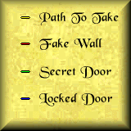

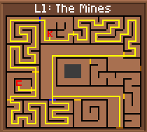

Prerequisites: None
Cleowyn's Key Used For:
1.) Opening locked door in NW section of the mines. (Marked in Blue)
2.) A quest item that will be needed for the red gem quest
Cleowyn's Lockpick used for:
1.) Open a series of doors in the Vestibule and the Great Corridor.
To get King Cleowyn's Lockpick, first go to The Mines. You may then take one of two paths; either go north, which is the longer way, or you can go through a locked door that is closer to the entrance. Since the door is locked, you will need the lockpick skill or a good lockpick to open it. If you do not have either, you will have to take the northern path, and pick up King Cleowyn's Key along the way (it is needed to open the locked door that you will encounter while taking the northern path, marked in blue). The key itself is marked by a red "K". Follow the yellow path, picking a path when it branches off, to get to the King Cleowyn's Lockpick, which is indicated by a red C.

Palace Key

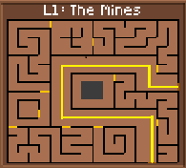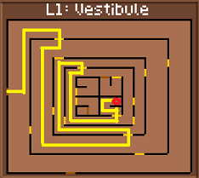

Prerequisites: Kings Lockpick
Palace Key used for: The palace key is used to navigate the Palace Corridor
Follow the yellow path through The Mines to the Vestibule. You will need the Kings Lockpick to pass through the doors in the vestibule. The Palace Key is the reward for the fight at the red circle.

Lava Key

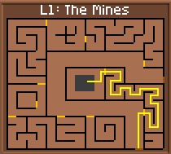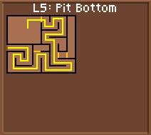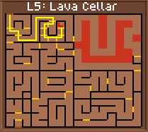

Prerequisites: Must be level 15 to be able to jump into pit
Lava Key used for: Travel through Lava Cellar and also to open doors in the Pit Bottom and a door in the Great Corridor.
To get the Lava Key, you must first go to The Mines, and follow the path indicated by the yellow line. It will lead you to a pit. Jump into it, and you will land in the Pit Bottom. Once you are in the Pit Bottom, follow the path indicated by the yellow line once again to a teleporter that takes you to the Lava Cellar. Once you are there, follow the path indicated on the map to get to the square marked L. There you will fight the battle to gain the Lava Key. Once you have it, it can be used in several places at the Lava Cellar.

Domicile Key

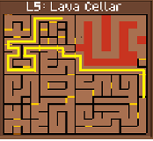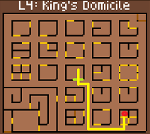

Prerequisites: Lava Key
Domicile Key used for: Faster entry into Kings Domicile and leads to Thieves Den access from Kings Domicile before reaching Level 20
After obtaining the Lava Key, follow the yellow line through the Lava Cellar. The Lava Key will be needed to open two doors on the way. Be mindful that walking past the lava will cause damage. Once in the King's Domicile, take one step forward and cast detect to find a hidden door. Follow the yellow line to the red circle where you will find the Domicile Key. The key opens the door in the lower left portion of the map.

Thieves' Key

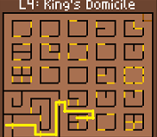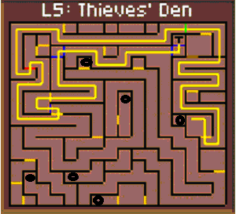

Prerequisites: Have the Domicile Key

The Thieves key will allow you to reach the Labyrinth before reaching level 20. It will also open the shortcut to the Labyrinth from the dungeon entrance once you reach L20

To get the Thieves' key and explore the Thieves Den before reaching level 20, follow the first two maps from the King's Ring Quest. Once you reach the Kings Domicile, follow the highlighted path on the Map. This will take you to the Thieves Den. The walls that you have to go through (fake walls) are colored in red. To go through them, just go up to them and go through as you would through a door. Also, you will encounter walls that you have to detect secret doors in. These are highlighted in green. On these walls, you may also use the Omniscient Prism. Some will required to be detected AND opened via a lockpick or the Lockpick skill. These are highlighted in blue. The Thieves Key (and several treasures) are located at the spot marked "T". The thieves key can be used on the door 2 squares to the left of where you obtain the key. The teleport on the SW corner of the room takes you to the Labyrinth. Its worth exploring the rest of the Thieves Den to gain levels. Each black circle on the Thieves Den map shows where you can learn a new skill.
Once you reach level 20, you can access the thieves den more easily from the mines. From the Dungeon Entrance, go to The Mines. From the entrance of the mines, go 1 step north as shown on the map. Turn east and detect the wall there. A secret door will appear. Go through it and go 1 step east, 1 step south, and 1 step west. If you are level 20 or above, a teleport will appear. Go through it. You will now be at the Thieves Den.

Wind Knights' Key

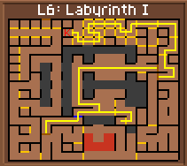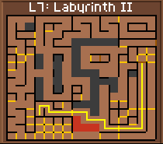

Prerequisites: You will need to be at least level 20 and have possession of the Thieves' Key if you have not been to Labyrinth 1 yet.

The Wind Knights Key is needed to open the door at the bottom left side of L6 Labyrinth I

To get to the Wind Knights' Key, you must first go to Labyrinth 1, accessible from the Dungeon Entrance. From there, go to Sirocco's Door, indicated blue on the map. If you have defeated Sirocco, you may go through this door, and go through the teleport beyond. If you have not, the door will be locked, and you will have to follow the branched-off path to defeat him (the exact spot is marked with a red S). Once you have done all this, and proceeded through the teleport to Labyrinth 2, follow the yellow path to another teleport (be cautious of the Zephyr Wind here), which will take you to the northern area of Labyrinth one, a thieves hideout. Here, go back to the first map and follow the yellow path to get to get the Wind Knights' Key, indicated with a red K on the map.

Voranti's Key

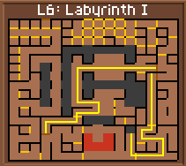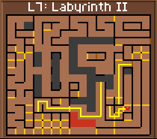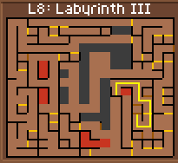

Prerequisites: None
Voranti's Key is used to get past a door and get to the Back Alley.
To get Voranti's Key, first go to Labyrinth 1 from the Dungeon Entrance. Then, go through Sirocco's Door (if it refuses to open check the Wind Knights' Key map to know how to defeat Sirocco. Follow the yellow line to the teleport beyond. Go through it to get to Labyrinth 2. Follow the yellow path once again to a pit which will take you to Labyrinth 3. Follow the yellow path once again back to another section of Labyrinth 2. Once there, referring back to the second map, follow the yellow line to get to a teleport which takes you back to Wyn Sanctuary in Labyrinth 1. Refer back to the first map and follow the bottom yellow line to a pit. This will take you back to another portion of Labyrinth 2. Follow the yellow path to a very tough battle with many dragons and Voranti's Key, marked with a red V.

Back Alley Key

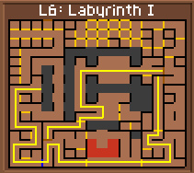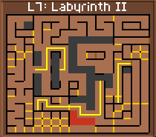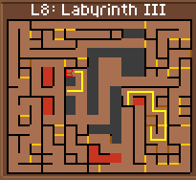
Prerequisites: None

The Back Alley Key is used to get to the Labyrinth Back Alley, where you can get the Wolf Helmet and Kite Shield

To get the Back Alley Key, first go to Labyrinth 1 and follow the yellow path through Sirocco's Door (refer to the Wind Knights' Key maps to know how to defeat him) and through the teleport to get to Labyrinth 2. Follow the path to a pit that takes you to Labyrinth 3, and from there follow the line to a teleport taking you back to another part of Labyrinth 2. From there, follow the yellow path to a teleport back to Labyrinth 1. Refer back to the first map and follow the yellow path to the blue locked door. Here you will need to use the Wind Knights' Key to unlock the door. Once you have done so, go to the pit indicated by the yellow path. This will take you back to Labyrinth 2. From there, follow the yellow path and drop into another pit that leads you back to Labyrinth 3. Here, finally follow the yellow path to the battle for the Back Alley key, marked with a red B.

Sunbeam Key

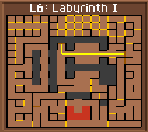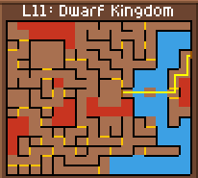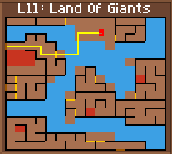

Prerequisites: The Blue Metal (see section for Blue Metal)
The Sunbeam Key is used used to gain access into the western part of the Dwarf Kingdom.
Go to the Dwarf Kingdom (refer to the Cyclops' Mine Key to find out how to get there). From the Dwarf Kingdom, follow the yellow path to the Land of Giants. Once there, follow the path once again, across the waters of the River of Eternity (be sure to take no more than three steps without going out on dry land and healing first) to the spot marked with a red S on the map. There you will meet a Dwarf Knight who will exchange the Blue Metal for the Sunbeam Key.

Elfin Cave Key

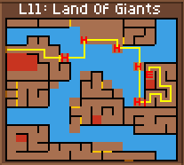
Prerequisites: None

The Elvin Cave Key is used in the Elf Villages to open the door behind which lie King Cleowyn's Bones and the Yellow Gem.

To get the Elfin Cave key, you must first go to the Land of Giants (look at the instructions for the Cyclops' Mine Key to see how to get to the Dwarf Kingdom, from which you can get to the Land of Giants). Once you are there, follow the yellow path. You will need to cross the dangerous River of Eternity several times to get to the secret door behind which lies the path to the Elfin Cave Key. Be sure that you heal yourself at the squares marked with a red H on the map. Follow the yellow line, healing as necessary, until you reach the section of wall highlighted red on the map. Face it and use the Detect skill or an Omniscient Prism and you will open a secret door. Follow the yellow path behind it until you reach the battle for the Elfin Cave Key, marked with a red E on the map.

Cyclop's Mine Key

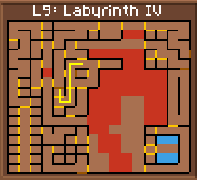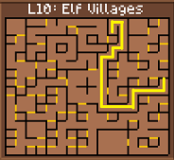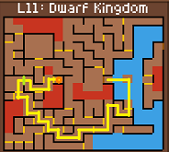

Prerequisites: Sunbeam Key
The Cyclops Mine Key is used in the Land of Giants on the way to the Final Quest.
Now, go to Level 11, the Dwarf Kingdom (A series of maps explains how to get there from Labyrinth 1, assuming you have the CastleGate teleport open). Once there, follow the path marked by the yellow line. You will have to cross the dangerous River of Eternity more than once in this fashion, so cross carefully and heal at the spots marked with a green H. Once you have crossed the stream to the blue locked door, use the Sunbeam Key there (assuming you have not yet done so), and it will unlock the door. From there, follow the yellow path to the western portion of the map. Once you have gotten to the wall marked green on the map, face it and use the Detect skill or an Omniscient Prism to detect a secret door. Go through it and follow the path to the Cyclops' Mine Key, marked with an orange circle the map.

Hidden Mine Key

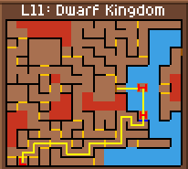

Prerequisites: Sunbeam Key
The Hidden Mine Key is used on the way to the Final Quest.
To get the Hidden Mine Key, first go to the Dwarf Kingdom (for directions on how, see the Cyclops' Mine Key). From the entrance, follow the yellow path across the River of Eternity (be sure to heal at the spots marked with a red H). The blue locked door requires the Sunbeam Key to open, so unless you've opened the door already, see the key list for information on the Sunbeam Key. After you've opened the door, simply follow the yellow path to a dwarf that will give you the Hidden Mine Key, marked with a red L on the map.

Dwarf Mine Key

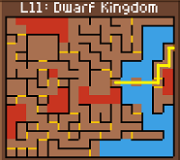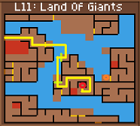

Prerequisites: Sunbeam Key, Cyclops Mine Key
The Dwarf Mine Key raise a platform in the Land of Giants
To get the Dwarf Mine Key, follow the maps for the Cyclops Mine key to the Dwarf Kingdom. follow the path to the Land of the Giants. In the Land of Giants, follow the yellow path through the waters to the first platform BE SURE to heal there completely. After you do that, turn to face the wall marked green. The Cyclops Mine Key will disappear and you will be able to pass through the wall. Do so and follow the yellow path to the second platform Heal there completely and face the green-colored wall. Use and Omniscient Prism or the Detect Spell on it and it will turn into a hidden door. The Dwarf Mine Key is on the room marked with a red circle. It is used to raise a platform in the square marked with an orange circle.

Tiger’s Shadow of Yserbius Walkthrough

Quest Items

King's Ring

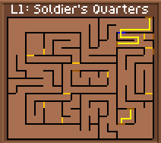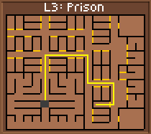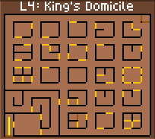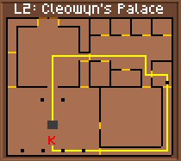
Prerequisites: Lockpick to open door in Soldiers Quarters
The King's Ring is necessary to complete the King's Quest and needed for the Chess Piece.
First go to the Soldiers' Quarters from the Dungeon Entrance. Follow the yellow path to the blue locked door. Use a lockpick or the Lockpick skill to open it, and proceed to the teleport. It will take you to another part of the level, where a teleporter takes you to the Prison. Follow the yellow path to the pit and jump into it. You will be at the King's Domicile. Follow the yellow path 2 steps north and you will step on a platform that takes you to Cleowyn's Palace. Follow the yellow path through a series of doors and up to a column, marked as a black dot on the map. Face it and it will move away, revealing a passage. Follow the path through two doors and to another series of columns which will slide away before you. Follow the path to a point marked K and there you will fight the battle for the King's Ring.

Chess Piece
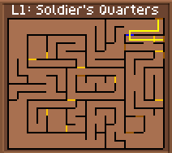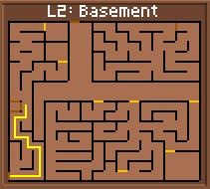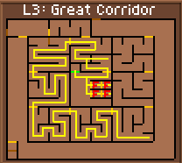
Prerequisites: Cleowyn's Key, Cleowyn's Lockpick, and the King's Ring
The Chess Piece is used in the Cards' Quest to gain access to Arnakkian's Chessboard.
To get the Chess Piece, first go to the Soldiers' Quarters from the Dungeon Entrance. Before you start, you will need Cleowyn's Key, Cleowyn's Lockpick, and the King's Ring. Once you are in the Soldiers' Quarters, follow the yellow path through the blue locked door (use a lockpick or the Lockpick skill to open it) and through the teleport beyond to the Basement. There, follow the yellow path to a teleport that will take you to the Great Corridor. From there, follow the yellow path through the doors; some will require Cleowyn's Key to open, some require Cleowyn's Lockpick, and some require the King's Ring. Follow the yellow path through the doors and after a while, you will run into a spot where the yellow path branches and goes through two doors. Here you must make a choice: if you are of the Chaos alignment, go through the south door. If you are of the Harmony alignment, go through the north door. WARNING: Do NOT go through the door of the other alignment or your statistics will suffer heavy losses, particularly your Strength. Once you have gone through the door of your alignment, and fought both of the battles marked F, go back and take the yellow path to the green secret door. If you have fought both of the battles, the door will appear with no need for detection. Fight and win the battle, and you will receive the Chess Piece.

Harvest Horn

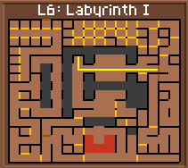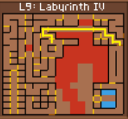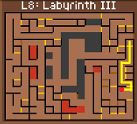

Prerequisites: Castlegate Quest
The Harvest Horn is used in the Season's Quest, Arnakkians Quest & the Blue Gem and in getting the Flex Sword; it will also protect you from the Tempest Winds.
To get the Harvest Horn, first go to CastleGate If you have not opened the CastleGate teleport yet, refer to the CastleGate Quest. Once there, follow the yellow path to a teleport to Labyrinth III. Once there, follow the yellow path to the Harvest Horn, marked with an Red Circle on the map (be very cautious of the Tempest Wind here).

Flex Metal

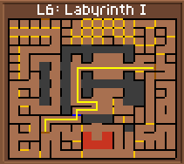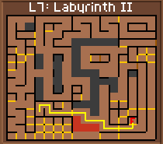

Prerequisites: Harvest Horn
The Flex Metal is required on the Flex Sword Quest.
To get the Flex Metal, you must first have the Harvest Horn. Once you have it, go to Labyrinth 1 from the Dungeon Entrance. Once you are there, follow the yellow path on the map to Sirocco's Door. If you have not defeated Sirocco yet, you will not be able to pass through this door; refer to the Wind Knights' Key map for reference on how to defeat him. Go through the door (marked in blue) and go through the teleport beyond. This will take you to Labyrinth 2. Follow the yellow path here (be cautious of the Zephyr Wind) to a battle marked F. There you will trade the Harvest Horn for the Flex Metal after you win the battle (this will be done automatically).

Ace of Spades

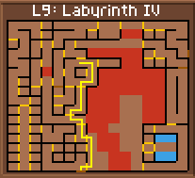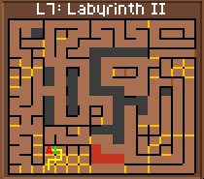

Prerequisites: Castlegate and Voranti's Key
The Ace of Spades is necessary for the Cards' Quest.

To get the Ace of Spades, first go to CastleGate from Labyrinth 1 (refer to the first map of the Harvest Horn for information on how to get there). If you have not opened the teleport there, see the CastleGate Quest. Once there, follow the yellow path to a teleport to Labyrinth 3. There, follow the yellow path to a blue locked door. Use Voranti's Key to open it and proceed to the teleport beyond. Once there, follow the yellow path to a secret door marked green on the map. Use the Detect Spell on it and go through to fight the battle beyond, marked with a red A on the map. Once you defeat the monsters, you will receive the Ace of Spades.

Blue Metal

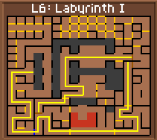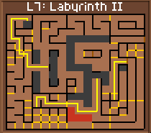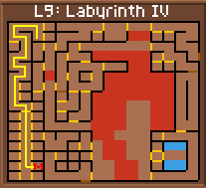
Prerequisites: Wind Knight Key
The Blue Metal is exchanged for the Sunbeam Key at the Land of Giants.
To get the Blue Metal, first go to Labyrinth 1 from the Dungeon Entrance. Then, follow the yellow path to Sirrocco's Door (if it refuses to open for you, refer back to the map of the Wind Knight's Key and see where the path branches off). Go through the teleport beyond to Labyrinth 2 and follow the yellow path to jump into the pit it leads to. You will be now at Labyrinth 3. Take the yellow path again to a teleport back to another section of Labyrinth 2. Once there, follow the yellow path to yet another teleport that takes you back to the bottom of Labyrinth 1 refer back to the first map and take the yellow path there until you reach a locked door. Use the Wind Knight's Key there (refer back to the Wind Knight's Key section to know where to get it) and follow the path to a pit, which you must jump into to go back to yet another section of Labyrinth Two where you will follow another path, referring back to the second map, to jump into another pit that takes you into the western section of Labyrinth 4. Follow the yellow path to the southwestern section of Labyrinth 4 to a battle where you will get the Blue Metal, marked with a red M on the map.

Moonprism
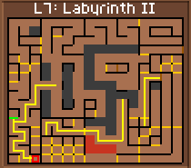
Prerequisites: Wind Knights Key
The Moon Prism is necessary for the Final Quest.
Go to Labyrinth 1 from the Dungeon Entrance. Then, follow the yellow path to Sirocco's Door (if it refuses to open for you, refer back to the map of the Wind Knights' Key and see where the path branches off). Go through the teleport beyond to Labyrinth 2, and follow the yellow path to jump into the pit it leads to. You will be now at Labyrinth 3. Take the yellow path again to a teleport back to another section of Labyrinth 2. Once there, referring back to the second map, follow the yellow path to yet another teleport that takes you back to the bottom of Labyrinth 1. Refer back to the first map and take the yellow path there until you reach a locked door. Use the Wind Knights' Key to open the door and follow the path to a pit, which you must jump into to go back to yet another section of Labyrinth Two. Refer back to the second map and follow the yellow path to the point marked O on the map. There, fight the battle and you will receive an Omniscient Prism. Keep it and follow the yellow path to the green portion of wall. Face it and use the Omniscient Prism; a Detect skill will not work. Once you have discovered the secret door, step through to the point marked P on the map and you will discover a Moon Prism.

Nature's Robe & Infinite Armor
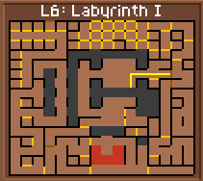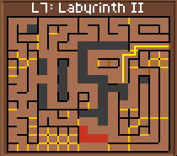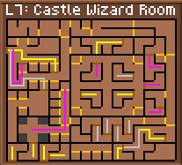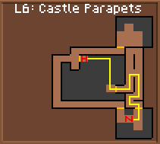

Prerequisites: Harvest Horn and Yellow Gem
Nature Robe is needed for the Seasons Quest
To get the Nature's Robe & Infinite Armor, first go to Labyrinth 1. Follow the yellow path to a pit which will take you down to Labyrinth 2. Follow the path there to a teleport that takes you to the Castle Wizards' Room. There, follow the yellow path to a series of magic walls that take you each to a different place. You may notice that they spell out Arnakkian with the first letter of every word. Follow the yellow path closely on the map and it will take you full circle, bringing you back to the entrance of the Castle Wizards' Room after you spell out Arnakkian (notice that the magical walls are marked in the same color as teleports to avoid confusion). Once you are done, notice that there is another path, colored gray to avoid confusion, that will take you through yet another series of magic walls that will spell out En-Li-Kil (Ignore the dashes). This path, too, will take you full circle to the start of the map.
Once you are finish the En-Li-Kil path, there is another path, colored purple, that will take you to another series of magic walls that spell out Ghost. Once you finish spelling Ghost, you will be near the western edge of the map, surrounded by four pits. Follow the purple path through a door that, when gone through, will take you to the Castle Parapets. Here, follow the yellow path to a point marked with a red H on the map. Here, you must have both the Harvest Horn and the Yellow Gem. Face east and use the Yellow Gem, then the Harvest Horn to form a solid floor, which allows you to traverse the pit. Cross the pit, following the yellow path, and follow it to the battle marked with an N where you will get the Nature's Robe and the Infinite Armor. (Please note that once you have spelled all three words; Arnakkian, En-Li-Kil, and Ghost it is no longer required to spell the first to words; Arnakkian, and En-Li-Kil you can simply spell Ghost and reach the Parapets. After completing this quest, consider going directly to Arnakkian's Quest and the Blue Gem

Flex Sword

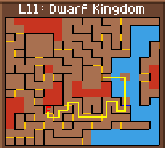

Prerequisites: Flex Metal, Sunbeam Key
The Flex Sword is needed for the Final Quest
Go to the Dwarf Kingdom (Refer to Cyclops' Mine Key for the directions). Once there, you will need the Sunbeam Key to pass through the first locked door, marked blue on the map. There, follow the yellow path to the spot marked F on the map. There, the Flex Metal will be made into the Flex Sword. It is not only the 3rd best weapon (also, every guild can use it) but it is also the only weapon that does not break against the Wind Elemental on the Final Quest.

Golden Boat

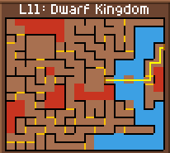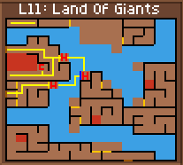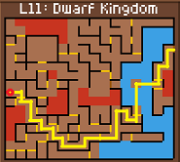

Prerequisites: Cyclops Mine Key, SunBeam Key
The Golden Boat is essential to the completion of the Final Quest.
Go to the Dwarf Kingdom (refer to the Cyclops' Mine Key maps if you do not know how to get there). Once there, follow the yellow path across the water to the teleport to the Land of Giants. Once in the Land of Giants, follow the yellow path through the water (be sure to heal fully at the spots marked with a red H) and to the wall marked in blue. Face it and it will become transparent if you have the Cyclops' Mine Key. Follow the yellow path through the water to another dry square, where you will need to heal. Once you have done so, follow the yellow path to a series of teleports that eventually take you to a battle marked C where you will receive the Cyclops's Head. Take it and follow the yellow path back to the Dwarf Kingdom. There, follow the yellow path south to a locked door (be sure to heal at the spots marked H) and open the door with the Sunbeam Key. Pass through it and follow the path to the spot marked with a red circle where you will trade the Cyclops's Head for the Golden Boat.

Tiger’s Shadow of Yserbius Walkthrough

Quests

King Cleowyn's Quest

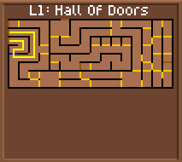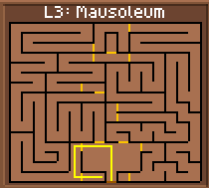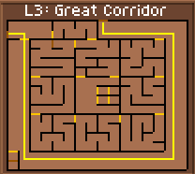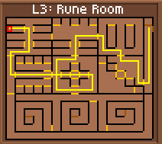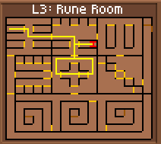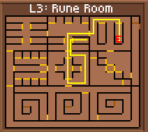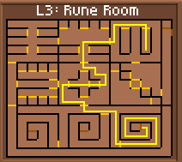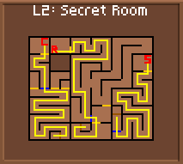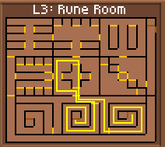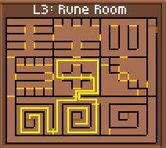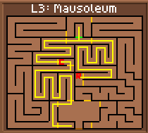

Prerequisites: Kings Ring
Completion of the Kings quest will provide 750,000 Exp Points
First go to the Hall of Doors from the Dungeon Entrance. Follow the yellow path through the blue locked door, which you will need to pick open, to the teleport that takes you to the Mausoleum. There, follow the yellow path through a teleport that takes you to the Great Corridor. Once there, follow the yellow path to a teleport that will take you to the Rune Room. Here, you will need the King's Ring. Follow the yellow path through a cross-shaped section near the middle of the level. Going through these doors will open all the doors in the rune room that face in the same direction as you exit. So for example if you exit to the east, all eastern facing doors will open. Follow the yellow path through a door to a spot marked with a red O. There, you will receive an O Rune Vowel Key. Keep it and refer to the next map. From the spot you are in there, follow the yellow path through the cross again and to a spot marked with a red I. There you will fight a battle and receive the I Rune Vowel Key. Once you have it, refer to the next map and follow the yellow path through the cross and to the spot marked with a red E. There, fight the battle to receive the E Rune Vowel Key. Once you have it, refer to the next map. Follow the yellow path down through the cross and through a secret door that appears. Follow the yellow path through to a spiral-shaped section that leads to a teleport. Go through this teleport to get to the Secret Room (note: there are actually three different Secret Rooms, but they are all compacted into one here.) In the Secret Room, follow the yellow path through a blue (locked) doors which you will have to use one the I Rune Vowel Key to open. Follow this path to the spot marked S, where you will receive King Cleowyn's Scepter. Now, follow the same yellow path back to the teleport at the start of the Secret Room. It will take you back to the Rune Room. Refer to the next map and follow the yellow path through the cross and into another spiral-shaped section. There, follow the yellow path to a teleport that will take you to the Secret Room. Refer to the Secret Room map and follow the yellow path there that will take you through a blue locked door where you need the O Rune Vowel Key to pass and to the Cleowyn's Robe. Fight the battle there to receive it and head back along the yellow path to the Rune Room. Once there, follow the yellow path through the cross and go through the third spiral-shaped section to the Secret Room. Follow the yellow path through the secret room through the blue locked door, which you will need the E Rune Vowel Key for, and to the spot marked C, where you will find the Cleowyn's Crown. Take it and teleport out of the dungeon. Once you have done so, go to the Hall of Doors from the Dungeon Entrance and use the path depicted in the first map to get to the Mausoleum. Once there, follow the yellow path to the spot marked C, where you will return the King's Crown automatically by facing north. From that point, follow the yellow path to point R, where you will automatically return the King's Robe by facing north. From there, finally, follow the yellow path back to the green wall, which you must face to return the King's Scepter. Go through it and fight the battle; go one step north to complete the quest! If you have the Kings bones, you return them here for extra XP!

Thieves' Den

Prerequisites: Have the Domicile Key

Exploring the Thieves Den will help gain levels and learn several new skills.

To explore the Thieves Den before reaching level 20, follow the first two maps from the King's Ring Quest. Once you reach the Kings Domicile, follow the highlighted path on the Map. This will take you to the Thieves Den. The walls that you have to go through (fake walls) are colored in red. To go through them, just go up to them and go through as you would through a door. Also, you will encounter walls that you have to detect secret doors in. These are highlighted in green. On these walls, you may also use the Omniscient Prism. Some will required to be detected AND opened via a lockpick or the Lockpick skill. These are highlighted in blue. The Thieves Key (and several treasures) are located at the spot marked "T". The thieves key can be used on the door 2 squares to the left of where you obtain the key. The teleport on the SW corner of the room takes you to the Labyrinth. Its worth exploring the rest of the Thieves Den to gain levels. Each black circle on the Thieves Den map shows where you can learn a new skill.
Once you reach level 20, you can access the thieves den more easily from the mines. From the Dungeon Entrance, go to The Mines. From the entrance of the mines, go 1 step north as shown on the map. Turn east and detect the wall there. A secret door will appear. Go through it and go 1 step east, 1 step south, and 1 step west. If you are level 20 or above, a teleport will appear. Go through it. You will now be at the Thieves Den.

Castle Gate

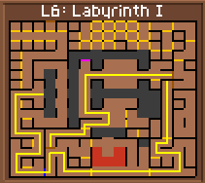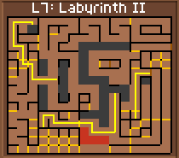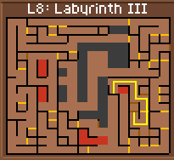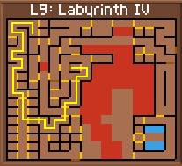

Prerequisites: Wind Knight Key, Be level 20
CastleGate provides a significant short cut to several quests
The CastleGate Quest allows you a very easy entrance into Castlegate, the center of Labyrinth 4, which allows access to even more portals; finishing the quest activates a secret door in Labyrinth 1, allowing you to pass easily. First go to Labyrinth 1 from the Dungeon Entrance. Then, follow the yellow path to Sirrocco's Door (if it refuses to open for you, refer back to the map of the Wind Knight's Key and see where the path branches off). Go through the teleport beyond to Labyrinth 2, and follow the yellow path to jump into the pit it leads to. You will be now at Labyrinth 3. Take the yellow path again to a teleport back to another section of Labyrinth 2. Once there, follow the yellow path to yet another teleport that takes you back to the bottom of Labyrinth 1 refer back to the first map and take the yellow path there until you reach a locked door. Use the Wind Knights' Key there (refer back to the Wind Knight's Key section to figure out where to get it) and follow the path to a pit, which you must jump into to go back to yet another section of Labyrinth Two where you will follow another path, referring back to the second map, to jump into another pit that takes you into the western section of Labyrinth 4. This is the Castlegate Bazaar. Here, follow the yellow path to the indicated teleport which will tell you that there is a new teleport. If you refer back to the map of Labyrinth 1, you will notice that there is a wall marked in purple. This wall, when gone through, takes you into the center of Labyrinth 4.

War Hammer of Doom & Kite Shield

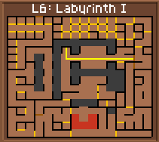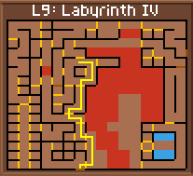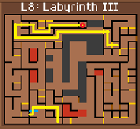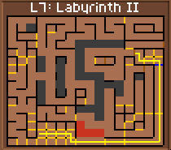

Prerequisites: CastleGate, Voranti's Key, Key to Back Alley
The War Hammer of Doom is the best weapon for Knights, and the second best weapon overall and the Kite Shield is the best Shield in Yserbius.
To get the War Hammer of Doom and Kite Shield, first go to Labyrinth 1. From there, if you have activated the Castlegate door, follow the yellow path through it (if you have not, see Castlegate Quest). From there, follow the path to the teleport that will take you to Labyrinth 3. There, follow the yellow path to the blue locked door. Use Voranti's Key to open it and head through the teleport beyond. From there, follow the yellow path to the Labyrinth Back Alley (to open the blue locked door, you must have the Back Alley Key). Once you are there, follow the yellow path to the battle with the War Hammer of Doom and the Kite Shield, marked with a red circle on the map.

Wolf Helm

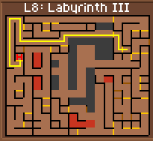

Prerequisites: CastleGate, Voranti's Key, Key to Back Alley
The Wolf Helmet is one of the best helmets in the game, but may be used only by Knights.
To get the Wolf Helmet, first go to the Labyrinth Back Alley (refer to the maps of the War Hammer of Doom if you need to know how to do so). From there, simply follow the yellow path to the battle for the Wolf Helmet, marked with a red H on the map.

Yellow Gem Quest & Kings Bones

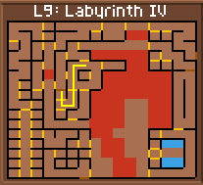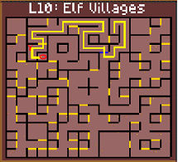

Prerequisites: Castlegate, Elfin Cave Key
The Yellow Gem is needed in the final quest. It is also needed to reach the Earth Elemental to fight for Natures Robe and the Infinite Armor. It is also needed to then reach Arnakkian's Quest and the Blue Gem. The Kings Bones are returned at the end of the Kings Quest for more XP
To get the Yellow Gem, first go to Labyrinth 1 from the Dungeon Entrance. Once there, follow the yellow path and teleport to Castlegate (if you have not activated this teleport yet, see Castlegate Quest). Once there, follow the yellow path to a teleport to the Elf Villages. Once there, follow the yellow path to the blue locked door, which actually looks like a tapestry. Here, you must use the Elfin Cave Key. Once you've opened the door, go through and follow the yellow path to a battle marked with a red Y where you will get the Rainbow Yellow Gem. Now go one step South and one step east to fight for the Kings Bones

Arnakkian's Quest & Blue Gem Quest

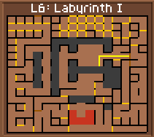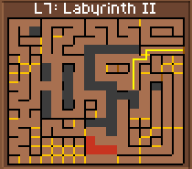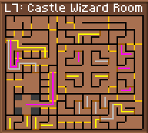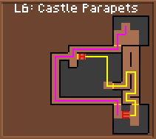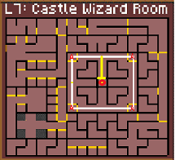

Prerequisites: Must have Yellow Gem & Harvest Horn

Fight and defeat Arnakkian to receive 1 million experience points. The Rainbow Blue gem is needed for the Final Quest

To complete Arnakkian's Quest, first go to Labyrinth 1 from the Dungeon Entrance. Once there, follow the yellow path to jump into a pit which will take you to the Mages' Overlook in Labyrinth 2. There, follow the yellow path through the teleport to the Castle Wizards' Room. Once you are there, follow the yellow path to a wall, marked in the color of a teleport, with a rune word on it. Go through it as you would through a teleport and it will take you to another place on the map. From there, take the yellow path to another wall with runes on it marked in the color of a teleport. Follow through the level in this manner (be sure to follow the yellow path carefully) and you will eventually wind up back at the entrance after fighting a battle and going through a teleport. Now, in the same manner, follow the gray path that will take you through several magical teleport walls and eventually back to the entrance. You might have noticed that if read as an acronym, the first letters of the words on the walls that you go through on the first trip around the level spell out "ARNAKKIAN", and those on the second journey spell out "ENLIKIL". Now, follow the purple path through the level once more, and you will spell out "GHOST". (Note: If you have done this previously, as part of the Nature's Robe/Infinite Armor Quest, you only need to spell Ghost) When the purple path ends at a door, go through it and you will be taken to the Castle Parapets by a ghost. Follow the yellow path through a door and you will enter a large open area, most of it being an open pit. Here, you must have the Harvest Horn and the Yellow Gem. This spot is marked with a red H. Now, the pit will turn into a traversable floor. Once it turns into a solid floor, follow the yellow path across the pit and to the southeast portion of the map, where you will fight the Earth Elemental at a spot marked with a red E. Once you have defeated him, follow the new path, marked in purple to avoid confusion, out of the room and to another door near the spot where you first entered the Parapets. Go through it and, after fighting a battle with Arnakkian's guards, going onto a square that will take you back to the Castle Wizards' Room. Here, you must first follow the white path and fight the four battles marked with red A's to gain access to Arnakkian's tomb. Start with the NE corner and then proceed to the SE corner, the SW corner and finally the NW corner After you have fought all four of these battles, go back to the place where the yellow path starts and follow it into Arnakkian's tomb in the center square.

Seasons Quest

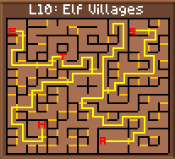
Prerequisites: Nature's Robe, Harvest Horn, CastleGate
If you have the Nature's Robe in your chest or quest bag at the time you use the Radiance, you will be rewarded with every skill except Detect, Lockpick, Bard and Pickpocket, the thieves' skills.
To complete the Seasons' Quest, first go to Labyrinth 1 from the Dungeon Entrance. Once there, follow the yellow path and teleport to Castlegate (if you have not activated this teleport yet, see Castlegate Quest). Once there, follow the yellow path to a teleport to the Elf Villages. Once you are at the Elf Villages, follow the path to the spot marked T on the map. Once you are there, face north. You will see the Aldbora tree. If the message says "The Aldbora Tree proudly displays its summer foliage", you may proceed the quest. Once you have looked at the Albdora Tree, follow the yellow path back to a point marked with a red H on the map. There use the Harvest horn and you will receive the Autumn Seeds. Once you have the seeds, follow the yellow path to a point marked with a red S on the map and use the Autumn Seeds there. you will receive Spring Renewal. Once you have it, follow the yellow path to a spot marked E on the map. Use the Spring Renewal and you will receive the Winter Waters. Once you have them, follow the yellow path to a spot marked A and use the Winter Waters there. you will get a Summer Radiance. Take it back to the point marked T on the map. Face the Albdora Tree and use the Summer Radiance.

Green Gem Quest

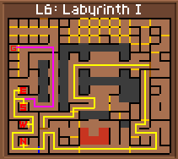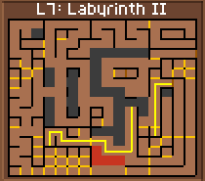

Prerequisites: Wind Knight key
The Green Gem is needed for the final Quest
To get the Rainbow Green Gem, first go to Labyrinth 1 and follow the yellow path through Sirocco's Door (refer to the Wind Knights' Key maps to know how to defeat him) and through the teleport to get to Labyrinth 2. Follow the path to a pit that takes you to Labyrinth 3, and from there follow the line to a teleport taking you back to another part of Labyrinth 2. From there, follow the yellow path to a teleport back to Labyrinth 1. Refer back to the first map and follow the yellow path to the blue locked door. Here you will need to use the Wind Knights' Key to unlock the door. Once you have unlocked the door, proceed through it and follow the yellow path to the battle marked S on the map. Here, you will fight the South Wind. Defeat it and follow the yellow path back to the battle marked N on the map. There, defeat the North Wind. Once you have done that, follow the yellow path to the battle marked E on the map and defeat the East Wind. Once you have done that, go to the battle marked W on the map and defeat the West Wind. Once you have done that, follow the newly colored purple path through a wall and to the battle with the Rainbow Green Gem, marked with a red G on the map.

Red Gem Quest & Barbarian's Axe

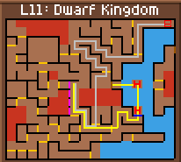

Prerequisites: Sunbeam Key, Silver Bar, Short Sword, Green Lockpick and Cleowyn's Key (Note must have these four items in your inventory when doing the quest. You cannot teleport back and forth from the guild hall to buy them while doing the quest)

The Barbarian Axe is the best weapon in the game; however, only Barbarians can use it. The Red Gem is needed to complete the final quest.

To get the Barbarian Axe, first go to the Dwarf Kingdom (refer to the Cyclops' Mine Key for info on how to do so). Then, follow the yellow path to the door marked blue on the map (be sure to heal at the spots marked H). There you will need the Sunbeam Key. Once you have opened the door, follow the yellow path to face the southernmost wall indicated in purple on the map. There, use a Silver Bar. Then, go 1 step north, face west, and use a Short Sword. Then, go one step north, face west, and use a Green Lockpick. Finally, go 1 step north, face west, and use King Cleowyn's Key. After you have done this, from that point, follow the path that is colored gray (to avoid confusion) on the map across the Keyhole Lava and to the battle for the Barbarian Axe and Red Gem, marked with a red B on the map.

Phoenix Quest

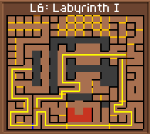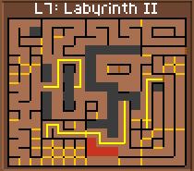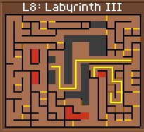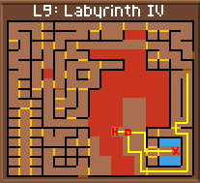
Prerequisites: Wind Knights Key
Receive a boost to Dexterity.
Go to Labyrinth 1 and follow the yellow path through Sirocco's Door (refer to the Wind Knights' Key maps to know how to defeat him) and through the teleport to get to Labyrinth 2. Follow the path to a pit that takes you to Labyrinth 3, and from there follow the line to a teleport taking you back to another part of Labyrinth 2. From there, follow the yellow path to a teleport back to Labyrinth 1. Refer back to the first map and follow the yellow path to the blue locked door. Here you will need to use the Wind Knights' Key to unlock the door. Once you have done so, go to the pit indicated by the yellow path. This will take you back to Labyrinth 2. From there, follow the yellow path and drop into another pit that leads you back to Labyrinth 3. Here, follow the yellow path to a teleport taking you to Labyrinth 4. Here, follow the path once again to a battle marked D. Fight it and go 1 step west, to the spot marked H. After you have done so, follow the yellow path through the doors and into the battle with the Phoenix. Defeat it and go 1 step east to the point marked X.

Card Quest

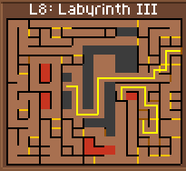
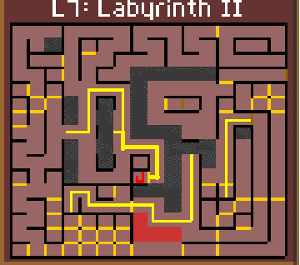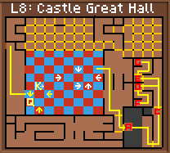

Prerequisites: Chess Piece, Ace Of Spades, Wind Knights Key
Increase your Initiative and Agility by 3 each

First go to Labyrinth 1 and follow the yellow path through Sirocco's Door (refer to the Wind Knights' Key maps to know how to defeat him) and through the teleport to get to Labyrinth 2. Follow the path to a pit that takes you to Labyrinth 3, and from there follow the line to a teleport taking you back to another part of Labyrinth 2. From there, follow the yellow path to a teleport back to Labyrinth 1. Refer back to the first map and follow the yellow path to the blue locked door. Here you will need to use the Wind Knights' Key to unlock the door. Once you have done so, go to the pit indicated by the yellow path. This will take you back to Labyrinth 2. From there, follow the yellow path to the point marked J and fight the battle there to receive the Jack of Spades. Once you have it, follow the yellow path and drop into another pit that leads you back to Labyrinth 3. Once there, follow the yellow path to the teleport that takes you to the Castle Great Hall. Follow the yellow path to the Chessboard, which is where you have to have the Chess Piece. Step on the chess board and follow the sequence of steps, marked in yellow (for example, an arrow pointing south means face south and take one step) to the point marked with a Q. There you will receive the Queen of Spades. From that point, turn north and go 1 step forward to battle the Chess King and receive the King of Spades, marked with a K on the map. Once you have all four cards, exit the chessboard by following the white sequence of steps. Once you have exited the chess board, follow the yellow path to a pedestal out in front of several pits, marked A. There, face west and use the King of Spades. It will create a bridge across the pit. Go across the pit and follow the yellow path to a locked door and a pit, marked with a red C. There, face west and use the Queen of Spades. Pass through the door and follow the yellow path to a locked door, marked D. There, face the door and use the Jack of Spades. After that, follow the yellow path to the point marked E on the map. There, face the locked door and use the Ace of Spades. Now, take the path back to point D and go through the door and follow the yellow path to the point marked F. This is a fountain; drink from it, turn around, and follow the path to the point marked E. There, pass through the door and follow to the point marked G. Drink from the fountain and you will have completed the Cards Quest. Once you have finished the quest and drank from both fountains, throw away the King and Queen of Spades.

Final Quest

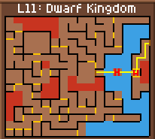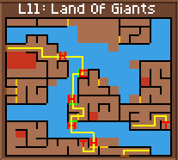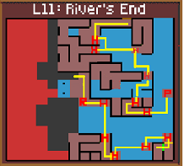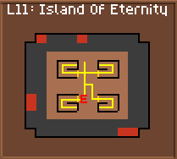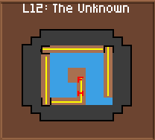

Prerequisites: Cyclops Mine Key, Hidden Mine Key, Flex Sword, Moon Prism, Yellow Gem, Green Gem, Red Gem, Blue Gem, Golden Boat.
Completing the Final Quest nets you 5,300,000 Points and get you a really cool greeting each time you enter the dungeon
Once you have all of the required items, go to the Dwarf Kingdom (refer to the Cyclops Mine Key maps for information on how to get there). From there, follow the yellow path across the River of Eternity. Make sure to heal at the spots marked with a red H. Follow the yellow path through the teleports into the Land of Giants. Be sure, from now on, that whenever you see a red "H" on the map, that you heal completely. In the Land of Giants, follow the yellow path through the waters to the point marked C. BE SURE to heal there completely. After you do that, turn to face the wall marked green. The Cyclops Mine Key will disappear and you will be able to pass through the wall. Do so and follow the yellow path to the point marked with a red H. Heal there completely and face the green-colored wall. Use and Omniscient Prism or the Detect Spell on it and it will turn into a hidden door. Follow the yellow path to the point marked H. There, face the green-colored wall and the Hidden Mine Key will disappear, but the wall will too. Go through and follow the yellow path through the water to a spot marked T. It will teleport you to another location in the level. There, follow the path to the second spot marked T. It will teleport you to yet another location in the level. Follow the yellow path through a teleport that takes you to the River's End. Once you are there, follow the yellow path through a series of land and water sections, healing at the spots marked H, to step on the square marked with a red P. Step on that square; it will teleport you to the southeastern corner of the map. There, face the green wall and use the Moon Prism. A secret door will open; go through it and follow the yellow path through another series of land and water sections. You will finally arrive at a spot marked with a red R. There, face west and use the Rainbow Red Gem. Go one step north & one step west and use the Rainbow Yellow Gem. Go one step north and one step west and use the Rainbow Green Gem. Finally, go one step north and one step west and use the Rainbow Blue Gem. Then Click on the Golden boat. Take one step West into the pit. This will take you into the Island of Eternity. Once there, follow the yellow path into the northwestern room. Follow the path through to a magical teleport wall. Go through it and it takes you to Level 12, the Unknown, the deepest level of Yserbius. Once there, follow the yellow path as indicated on the fifth map. There are some very big battles here; be careful. Follow the path to the back wall and bump it; this will activate a "timeswitch" that is needed to reach En-Li-Kil. Turn to the west, as shown on the map, and go through the wall back to the Island of Eternity. Follow the yellow path to the northeastern square of the four and go through the magical teleport to another section of The Unknown. Go to the back wall, activate the Timeswitch, and teleport out. Repeat this with the southeastern room in the Island of Eternity. Once you have activated all three timeswitches and are back in the Island of Eternity, face the square marked with a red E. Here, En-li-kil will appear and tell you the whole story of how he destroyed Arnakkian; and how he will soon destroy you. He will leave his Wind Elemental to "deal" with you. Now, equip the Flex Sword (be sure to do so; any other weapon will break once you enter the fight) and go one step forward into the square marked E. Defeat the Wind Elemental and follow the yellow path through the last, southwestern, square of the four back into the heart of the Unknown. There, follow the yellow path through the fierce battles to the spot marked H. There, heal completely. Go one step north and En-li-kil will appear before you; he will mock you and says that after he kills you, he will destroy all other mortals in your world. You must fight him and defeat him to proceed. After you do so, go one step north to the Fountain of Life. This is the goal that Arnakkian sought; except he was not strong enough to imprison En-li-kil. Drink from it and you will gain 5,300,000 experience points. Congratulations, hero, you have completed your quest!

