Zane Fernandes - Kafka (On Linux OS)
Building Dockerfile & running compose ->
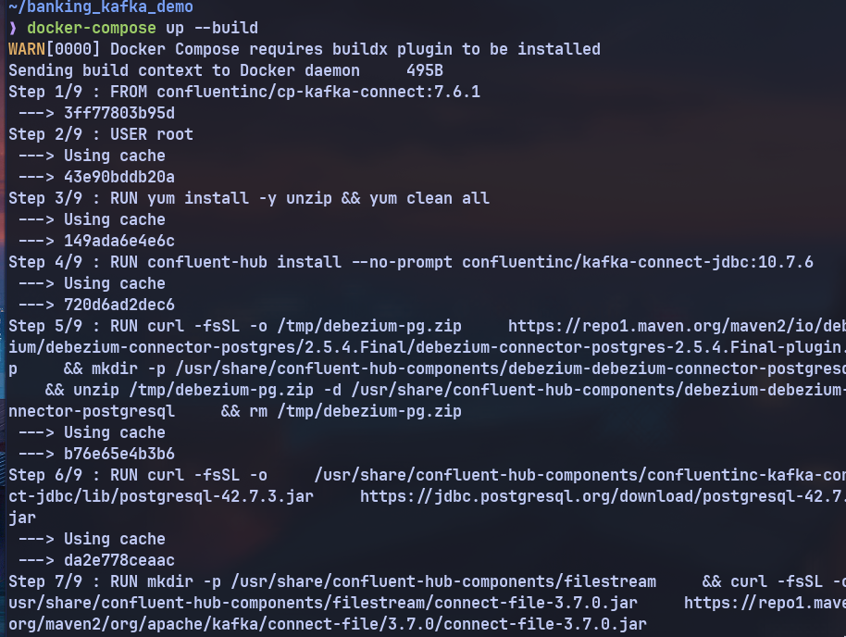
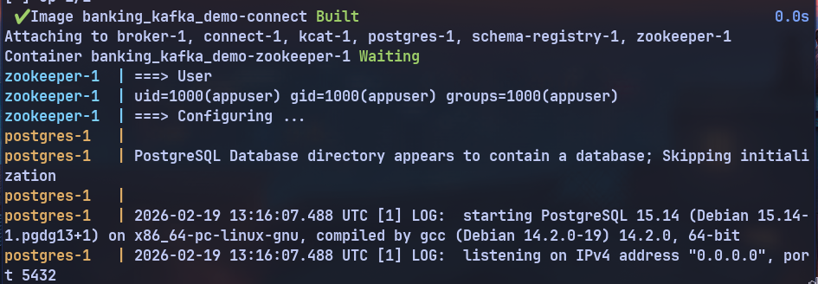

Adding Topics ->
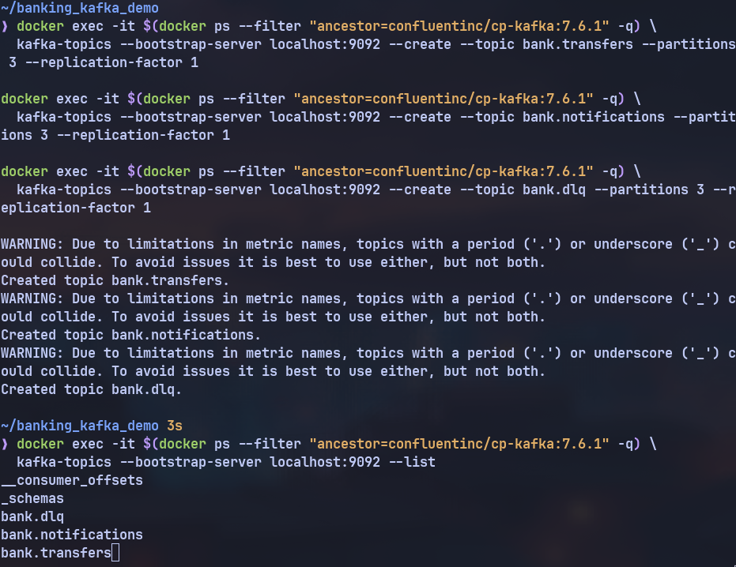
Adding sinks ->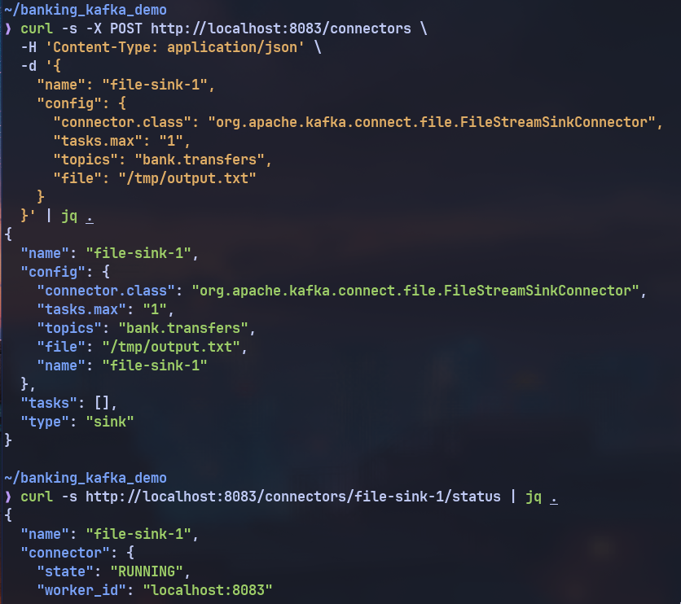

Seeding Table and watching for kafka stream ->
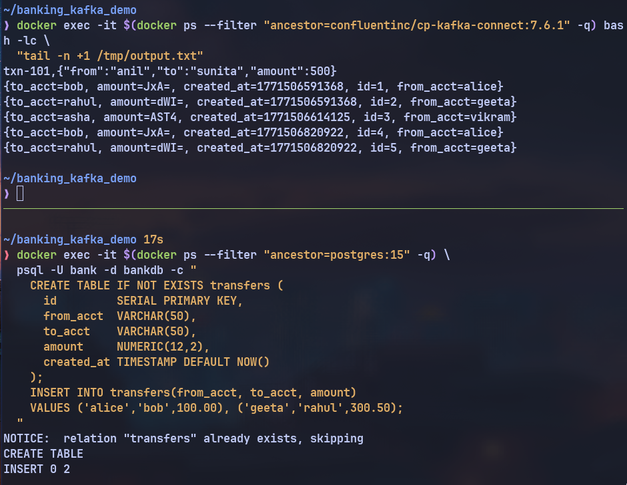

My Dockerfile & Compose changes- >
FROM confluentinc/cp-kafka-connect:7.6.1
USER root
RUN yum install -y unzip && yum clean all
RUN confluent-hub install --no-prompt confluentinc/kafka-connect-jdbc:10.7.6
RUN curl -fsSL -o /tmp/debezium-pg.zip \
https://repo1.maven.org/maven2/io/debezium/debezium-connector-postgres/2.5.4.Final/debezium-connector-postgres-2.5.4.Final-plugin.zip \
&& mkdir -p /usr/share/confluent-hub-components/debezium-debezium-connector-postgresql \
&& unzip /tmp/debezium-pg.zip -d /usr/share/confluent-hub-components/debezium-debezium-connector-postgresql \
&& rm /tmp/debezium-pg.zip

RUN curl -fsSL -o \
/usr/share/confluent-hub-components/confluentinc-kafka-connect-jdbc/lib/postgresql-42.7.3.jar \
https://jdbc.postgresql.org/download/postgresql-42.7.3.jar

# Download FileStream connector jar directly from Maven Central
RUN mkdir -p /usr/share/confluent-hub-components/filestream \
&& curl -fsSL -o /usr/share/confluent-hub-components/filestream/connect-file-3.7.0.jar \
https://repo1.maven.org/maven2/org/apache/kafka/connect-file/3.7.0/connect-file-3.7.0.jar
services:
zookeeper:
image: confluentinc/cp-zookeeper:7.6.1
network_mode: host
environment:
ZOOKEEPER_CLIENT_PORT: 2181
ZOOKEEPER_TICK_TIME: 2000
ZOOKEEPER_4LW_COMMANDS_WHITELIST: "ruok,srvr,stat"
KAFKA_HEAP_OPTS: "-Xmx256m -Xms128m"
healthcheck:
test:
["CMD", "bash", "-c", "echo srvr | nc localhost 2181 | grep -q Mode"]
interval: 10s
timeout: 5s
retries: 10
start_period: 15s

broker:
image: confluentinc/cp-kafka:7.6.1
network_mode: host
mem_limit: 2g
depends_on:
zookeeper:
condition: service_healthy
environment:
KAFKA_BROKER_ID: 1
KAFKA_ZOOKEEPER_CONNECT: localhost:2181
KAFKA_ADVERTISED_LISTENERS: PLAINTEXT://localhost:9092
KAFKA_LISTENER_SECURITY_PROTOCOL_MAP: PLAINTEXT:PLAINTEXT
KAFKA_INTER_BROKER_LISTENER_NAME: PLAINTEXT
KAFKA_LISTENERS: PLAINTEXT://0.0.0.0:9092
KAFKA_OFFSETS_TOPIC_REPLICATION_FACTOR: 1
KAFKA_HEAP_OPTS: "-Xmx512m -Xms256m"
healthcheck:
test:
[
"CMD",
"kafka-broker-api-versions",
"--bootstrap-server",
"localhost:9092",
]
interval: 10s
timeout: 10s
retries: 10
start_period: 30s

schema-registry:
image: confluentinc/cp-schema-registry:7.6.1
network_mode: host
depends_on:
broker:
condition: service_healthy
environment:
SCHEMA_REGISTRY_HOST_NAME: localhost
SCHEMA_REGISTRY_KAFKASTORE_BOOTSTRAP_SERVERS: localhost:9092
SCHEMA_REGISTRY_LISTENERS: http://0.0.0.0:8081
healthcheck:
test: ["CMD", "curl", "-f", "http://localhost:8081/subjects"]
interval: 10s
timeout: 5s
retries: 10
start_period: 20s

connect:
build: ./connect
network_mode: host
mem_limit: 2g
depends_on:
broker:
condition: service_healthy
schema-registry:
condition: service_healthy
environment:
CONNECT_BOOTSTRAP_SERVERS: localhost:9092
CONNECT_REST_ADVERTISED_HOST_NAME: localhost
CONNECT_REST_PORT: 8083
CONNECT_GROUP_ID: connect-group
CONNECT_CONFIG_STORAGE_TOPIC: connect-configs
CONNECT_OFFSET_STORAGE_TOPIC: connect-offsets
CONNECT_STATUS_STORAGE_TOPIC: connect-status
CONNECT_CONFIG_STORAGE_REPLICATION_FACTOR: 1
CONNECT_OFFSET_STORAGE_REPLICATION_FACTOR: 1
CONNECT_STATUS_STORAGE_REPLICATION_FACTOR: 1
CONNECT_KEY_CONVERTER: org.apache.kafka.connect.json.JsonConverter
CONNECT_VALUE_CONVERTER: org.apache.kafka.connect.json.JsonConverter
CONNECT_KEY_CONVERTER_SCHEMAS_ENABLE: "false"
CONNECT_VALUE_CONVERTER_SCHEMAS_ENABLE: "false"
CONNECT_PLUGIN_PATH: /usr/share/java,/usr/share/confluent-hub-components,/usr/share/java/kafka,/usr/share/java/cp-base-new,/usr/share/java/cp-kafka-connect-base
healthcheck:
test: ["CMD", "curl", "-f", "http://localhost:8083/connectors"]
interval: 15s
timeout: 10s
retries: 10
start_period: 60s

postgres:
image: postgres:15
network_mode: host
environment:
POSTGRES_USER: bank
POSTGRES_PASSWORD: bankpw
POSTGRES_DB: bankdb
volumes:
- ./sql/init.sql:/docker-entrypoint-initdb.d/init.sql
command:
- postgres
- -c
- wal_level=logical
- -c
- max_replication_slots=5
- -c
- max_wal_senders=5
healthcheck:
test: ["CMD-SHELL", "pg_isready -U bank -d bankdb"]
interval: 10s
timeout: 5s
retries: 10
start_period: 10s

kcat:
image: edenhill/kcat:1.7.1
platform: linux/amd64
network_mode: host
depends_on:
broker:
condition: service_healthy
entrypoint: ["sh", "-c", "sleep infinity"]

