Artificial Intelligence Applications in Esophageal Dysphagia and Related Esophageal Disorders: A Scoping Review
Article type: Review - Scoping Review
Zane Salman¹,*,†; Ryan Zeitouny²,†; Daliah Refaei³,†; Samer Salman, BSA⁴; Rohan Phadke⁴; Isha Tripuraneni, BS⁵; Anthony Shatby, BS⁶; Akhil Javvadi, MS⁷; Carol Gerges, BS⁸; Yara Abdallah⁹; Ajay Tripuraneni, MD⁴
¹ The University of Texas at Austin, Austin, Texas, USA
² Texas A&M University, College Station, Texas, USA
³ Capital Schools of Austin, Austin, Texas, USA
⁴ Baylor College of Medicine, Houston, Texas, USA
⁵ McGovern Medical School at UTHealth Houston, Houston, Texas, USA
⁶ Texas A&M School of Engineering Medicine, Houston, Texas, USA
⁷ HelloAlfred.Ai, Austin, Texas, USA
⁸ A.T. Still University School of Osteopathic Medicine, Mesa, Arizona, USA
⁹ Northeastern University, Boston, Massachusetts, USA
* Correspondence: Zane Salman; zgs277@eid.utexas.edu
† These authors contributed equally to this work and share first authorship.

Abstract
Objective: To map artificial intelligence and comparable computational applications relevant to esophageal dysphagia, dysfunction, and related esophageal disorders, and to characterize their validation and implementation maturity.
Design: JBI-guided scoping review reported according to PRISMA-ScR.
Data sources: PubMed/MEDLINE, Embase, Scopus, Web of Science Core Collection, IEEE Xplore, and ClinicalTrials.gov were searched on 6 August 2026.
Eligibility criteria: Age-neutral Population-Concept-Context criteria required a relevant esophageal or swallowing population or sample, an eligible AI or computational method, and a clinically relevant application.
Methods: Two reviewers independently screened records and reports, resolved disagreements by consensus, linked companion reports, piloted a JBI-informed charting form, and verified extraction. Evidence was synthesized descriptively.
Results: The searches identified 2664 records; 1003 manual duplicate removals left 1661 records for screening. Of 180 reports sought, 9 were not retrieved and 171 were assessed. Thirty-two reports representing 31 studies were included. Evidence covered reflux disease, dysphagia and swallowing dysfunction, eosinophilic esophagitis, motility disorders, and Barrett’s-related applications across structured clinical data, manometry, imaging, molecular markers, histopathology, and physiologic sensors. External validation was recorded for 4 of 32 reports; all reports were research evaluations.
Conclusions: The evidence is broad but methodologically heterogeneous and remains concentrated in model development and retrospective evaluation. Multicenter external and prospective validation, transparent dataset provenance, calibration, reproducibility, and clinically meaningful implementation studies are priorities.
Keywords: machine learning; esophageal motility; achalasia; eosinophilic esophagitis; gastroesophageal reflux disease; high-resolution manometry; diagnostic decision support; scoping review

Strengths and Limitations of This Review
- Two reviewers independently screened the same record and report universes, with preserved decisions and documented consensus.
- The synthesis distinguishes records, reports, and underlying studies and avoids double-counting an included companion report.
- A frozen JBI-informed charting form was piloted before all 32 included reports were extracted and verified.
- Nine reports were not retrieved; reporting was incomplete for validation, implementation, funding, conflicts, and reproducibility fields; and no formal critical appraisal was performed.

1. Introduction
Esophageal dysphagia and related dysfunction arise from structural, inflammatory, motor, reflux-related, and functional processes. Their evaluation often combines clinical assessment with endoscopy, histopathology, barium or other imaging, high-resolution manometry (HRM), ambulatory reflux monitoring, and, in selected settings, functional lumen imaging probe measurements. These modalities are complementary rather than interchangeable, and their interpretation depends on the clinical question, protocol, and reference standard [1,2].
The growing volume and dimensionality of these data create opportunities for computational support. Machine-learning and other algorithmic methods may assist detection, classification, segmentation, quantitative measurement, physiologic modeling, or diagnostic decision support. Potential utility, however, is distinct from demonstrated clinical benefit: performance can depend strongly on dataset composition, the unit of analysis, internal versus external validation, and the relationship between model outputs and a clinically credible reference standard.
The evidence spans different disorders, modalities, model families, outcomes, and publication formats. A scoping review is therefore appropriate for mapping the range of work, clarifying terminology and units, identifying gaps, and determining where more focused evaluation may be warranted [3,4]. A 2026 scoping review mapped AI tools across adult dysphagia assessment and management [7]; the present review uses a distinct esophageal-disorder and diagnostic-pathway scope that also includes motility, reflux, eosinophilic, and Barrett’s-related applications. This review aimed to characterize AI and comparable computational applications in esophageal dysphagia, esophageal dysfunction, and related esophageal disorders. The primary question was: what clinical conditions, data modalities, computational methods, intended applications, validation approaches, and outcomes have been reported? Secondary questions addressed implementation maturity, study/report overlap, reporting gaps, and priorities for future validation.

2. Materials and Methods

2.1. Review Design and Reporting
We conducted a scoping review using JBI methodological guidance and report it according to the PRISMA extension for Scoping Reviews (PRISMA-ScR) [3-5]. The review was not prospectively registered, and no separate protocol was published.

2.2. Review Questions
The review asked which esophageal conditions and populations have been studied; which clinical data modalities and AI or computational methods were used; which diagnostic, classification, segmentation, quantitative-assessment, modeling, or decision-support objectives were pursued; how models were validated; and which evidence and implementation gaps remain.

2.3. Eligibility Criteria
Eligibility was defined with the Population-Concept-Context framework. Age was described during charting but was not an eligibility criterion in the frozen age-neutral criteria. Eligible evidence had to address a relevant esophageal or swallowing population or sample, an eligible AI or computational method, and a clinically relevant application. Full articles and assessable conference abstracts could be included. Editorials or commentaries without original data, records without an eligible computational concept, and evidence outside the review context were excluded.
Table 1. Population-Concept-Context eligibility criteria.
Element | Included scope | Excluded scope
Population | Esophageal dysphagia or dysfunction and related eligible esophageal disorders or clinical samples | No relevant esophageal or swallowing population, condition, or sample
Concept | AI, machine learning, neural networks, NLP, computer vision, segmentation, comparable computational modeling, or decision support | No eligible AI or computational application
Context | Clinical detection, diagnosis, classification, interpretation, segmentation, phenotyping, quantitative assessment, physiologic assessment, or decision support | Context unrelated to the review objective
Evidence type | Full articles and assessable conference abstracts | Editorial/commentary without original data or otherwise ineligible evidence type
Age was not an eligibility criterion. An unavailable report was classified as Unretrieved rather than Excluded.

2.4. Information Sources
The search covered PubMed/MEDLINE (PubMed), Embase (Embase.com), Scopus (Elsevier), Web of Science Core Collection (Clarivate), IEEE Xplore, and ClinicalTrials.gov. All searches were executed on 6 August 2026 by Zane Salman (ZS). The constituent indexes selected within Web of Science Core Collection were not recorded. No additional website, citation-searching, or author-search source was documented in the finalized search audit.

2.5. Search Strategy
The strategies combined controlled vocabulary, where available, with free-text terms for esophageal dysphagia or dysfunction and AI or comparable computational methods. Complete source-specific strategies are provided in Supplementary Materials. No documented formal peer review of the strategies occurred, and no information-specialist contribution was documented. Amendments are reported in the audit trail, including the transition to age-neutral eligibility criteria.

2.6. Record Management and Deduplication
The searches yielded 2664 records. Reviewers manually removed or consolidated 1003 duplicates using identifiers, including DOI, PMID, and trial numbers, together with normalized titles. No automatic duplicate removal was recorded. The process left 1661 unique records. Stable Record_IDs were retained across screening, retrieval, consensus, linkage, and extraction. The reference-management and screening software used during the review was not recorded in the finalized audit package.

2.7. Selection of Sources of Evidence
Daliah Refaei (DR) and Zane Salman (ZS) independently screened the same 1661-record title-and-abstract universe. They ratified a consensus set of 180 reports for retrieval. Both reviewers independently assessed retrieved reports against the frozen PCC criteria, recorded one primary exclusion reason for excluded reports, and resolved disagreements through consensus. The locked independent files were preserved without overwriting. No unresolved eligibility decision remained after ratification, and no separate adjudicator was required.

2.8. Report Retrieval and Identity Verification
Full reports were sought in the preserved project folders and through available DOI, publisher, PubMed or indexing, metadata, preview, and companion-report sources. Report identity was checked using title, author, DOI or identifier, and publication details. Incorrect or mismatched files were not treated as the target report. Assessable conference abstracts were evaluated using the available abstract evidence. Nine reports remained inaccessible because the complete report was locked or otherwise unavailable after reasonable attempts; they were classified as Unretrieved, not as full-text exclusions.

2.9. Study and Report Linkage
Each publication or abstract received a Report_ID, and each underlying investigation received a Study_ID. Linkage considered authorship, institution, recruitment dates, sample size, dataset or cohort name, registration or ethics identifiers, diagnostic method, model description, and explicit cross-reference. Reports were merged under one Study_ID only when the available evidence supported a common investigation. Primary and companion contributions were retained separately, while study-level summaries avoided participant double-counting.

2.10. Data-Charting Process
The team developed a JBI-informed charting form covering identification, study characteristics, population, modality, computational method, validation, outcomes, implementation, limitations, funding, conflicts, and extraction administration. DR and ZS piloted the form on eight purposively varied reports, revised field definitions and missing-data conventions, and froze version 1.0 on 5 September 2026. DR extracted the included reports and ZS verified the fields against available reports or bibliographic/XML records. Disagreements were resolved using source evidence; original extraction values were preserved in the audit trail. NR denotes not reported, NA not applicable, Unclear information that was present but uninterpretable, and Not assessed a field outside scope.

2.11. Data Items
Charted domains included citation and setting, study design, population and condition, age and sex descriptors, sample size and unit of analysis, data modality and provenance, training/validation/test datasets, model purpose and family, architecture and preprocessing, comparators and reference standards, performance metrics and uncertainty, clinician comparison, intended use and deployment, generalizability, transparency, limitations, funding, conflicts, and source location.

2.12. Synthesis of Results
We summarized evidence descriptively at report and study levels. Categorical fields were counted at report level; multi-response modality and model-family counts could exceed the 32 included reports. Numerical performance values were retained with their reported units, denominators, dataset role, and validation context. We did not pool estimates or rank models across heterogeneous populations, thresholds, datasets, and validation designs. No meta-analysis was performed.

2.13. Critical Appraisal
No formal critical appraisal was performed because the objective was to map the extent, characteristics, and gaps of the evidence rather than estimate a pooled effect or exclude evidence by methodological quality. The review team confirmed that no formal critical appraisal was conducted.

2.14. Protocol Deviations
On 21 August 2026, age was removed as an eligibility criterion from the earlier adult-focused framework before the final consensus decisions were frozen. The amendment aligned eligibility with the review's GI/esophageal question and prevented otherwise relevant mixed-age or age-unspecified evidence from being excluded solely because adult results were not separable. The final screening therefore used the frozen age-neutral PCC criteria, and the amendment was documented in the audit trail. The title-and-abstract consensus was reconstructed from the frozen full-text universe and ratified by both reviewers. The review team confirmed that no other protocol deviations occurred.

3. Results

3.1. Search and Selection Results
The database searches identified 1277 records and ClinicalTrials.gov contributed 1387 registry records, for 2664 records overall. Manual deduplication removed 1003 records, leaving 1661 unique records for title-and-abstract screening. Reviewers excluded 1481 records and sought 180 reports. Nine reports were not retrieved, so 171 reports were assessed for eligibility. Of these, 139 were excluded: population/domain (FT1), 60; no eligible AI concept (FT2), 27; ineligible context/objective (FT3), 21; and ineligible evidence type or no original results (FT4), 31. FT5 and FT6 each had zero exclusions. Thirty-two reports were included. The flow reconciled as 180 = 171 + 9; 171 = 139 + 32; and 139 = 60 + 27 + 21 + 31. Figure 1 presents the selection process.
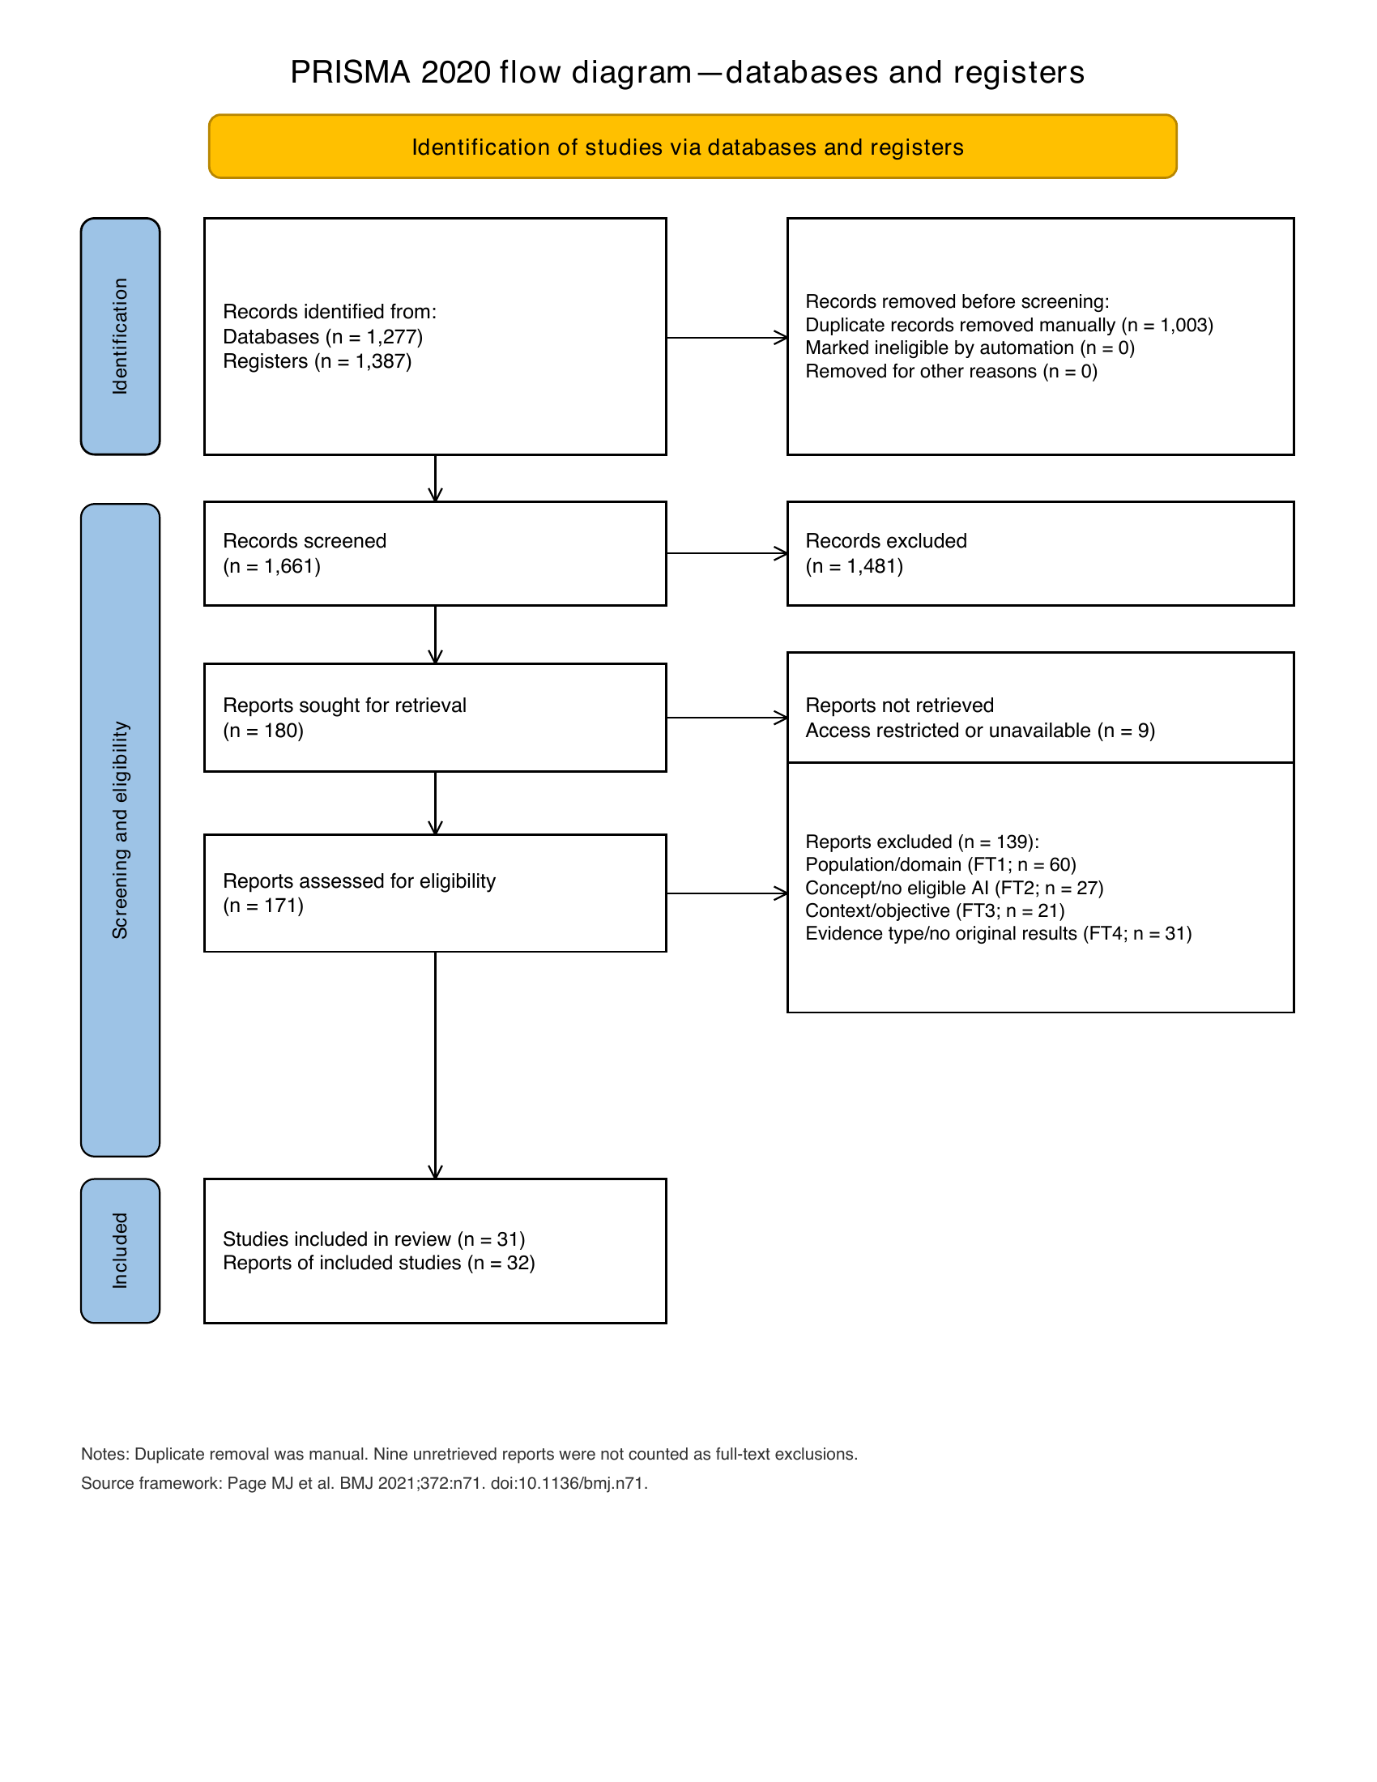
Figure 1. PRISMA-ScR flow diagram. Unretrieved reports were kept separate from full-text eligibility exclusions.

3.2. Study and Report Linkage
The 32 included reports represented 31 underlying studies [8-39]. GI-0097 and GI-0569 were linked to STUDY-004 because the reports described the same 132-participant GERD sample, used related data-mining approaches, and had a matched sample, method, and publication relationship [11,35]. GI-0146 was retained in the linkage audit as an excluded editorial related to the primary study GI-0116, but it was not included or extracted as an eligible report.
Table 2. Verified report relationships relevant to study-level counting.
Study_ID | Report_ID | Relationship | Included? | Counting rule
STUDY-004 | REP-GI-0097 | Primary detailed report | Yes | Count study once
STUDY-004 | REP-GI-0569 | Included companion report | Yes | Complementary evidence; do not add a second study
STUDY-005 | REP-GI-0146 | Editorial related to GI-0116 | No - FT4 | Audit only; not extracted
The full 33-row linkage register contains 32 included reports plus the excluded related editorial GI-0146.

3.3. General Characteristics
Included reports were published from 1997 through 2026. Five were published in 2024, three each in 2021, 2023, and 2025, and the remaining reports were distributed across 13 other publication years (Figure 2). Fourteen reports were charted from the United States, four from Italy, three from China, two each from Israel and Iran, one each from Germany and Denmark, and five with country NR. Sample-size text yielded an interpretable numeric value for 29 reports, ranging from 4 to 772, but these values mixed patients, cases, images, episodes, subjects, and swallows and were therefore not pooled as a single participant distribution.
Table 3. Selected general characteristics of the included reports.
Characteristic | Report-level summary | Interpretive note
Publication years | 1997-2026; 2024 was the most frequent year (n=5) | Counts are reports, not studies
Country | United States 14; Italy 4; China 3; Israel 2; Iran 2; Germany 1; Denmark 1; NR 5 | Report-level country field
Unit of analysis | Patient-level 30; image-level 1; NR 1 | Sample-size labels also included cases, episodes, subjects, and swallows
Design reporting | Design NR in 10 reports | Source descriptions varied in completeness
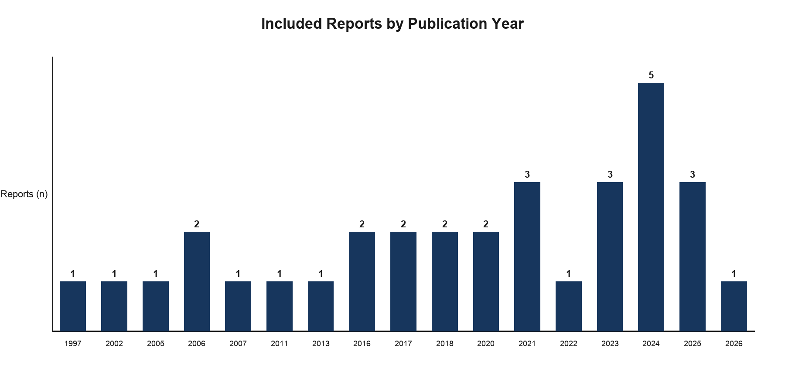
Figure 2. Included reports by publication year (n=32 reports).

3.4. Esophageal Conditions and Clinical Applications
Nine reports addressed gastroesophageal reflux disease (GERD), eight dysphagia or swallowing dysfunction, six eosinophilic esophagitis, five esophageal motility disorders, three Barrett's esophagus or esophageal neoplasia-risk detection, and one another esophageal or upper-GI dysfunction. These were mutually exclusive charted report categories. Applications were primarily diagnosis, detection, or classification (21 reports), followed by segmentation or localization (7), physiological modeling or decision support (2), and quantitative assessment (2).

3.5. Data Modalities
Structured clinical or symptom data were charted in 19 reports, HRM in 9, videofluoroscopy or radiology in 8, molecular biomarkers in 6, high-resolution cervical auscultation in 6, swallowing-sound or sensor data in 5, conventional manometry in 5, histopathology in 4, multichannel intraluminal impedance-pH data in 4, and optical coherence tomography in 2. Because reports could use several modalities, these counts are not mutually exclusive. Figure 3 shows the condition-modality distribution.
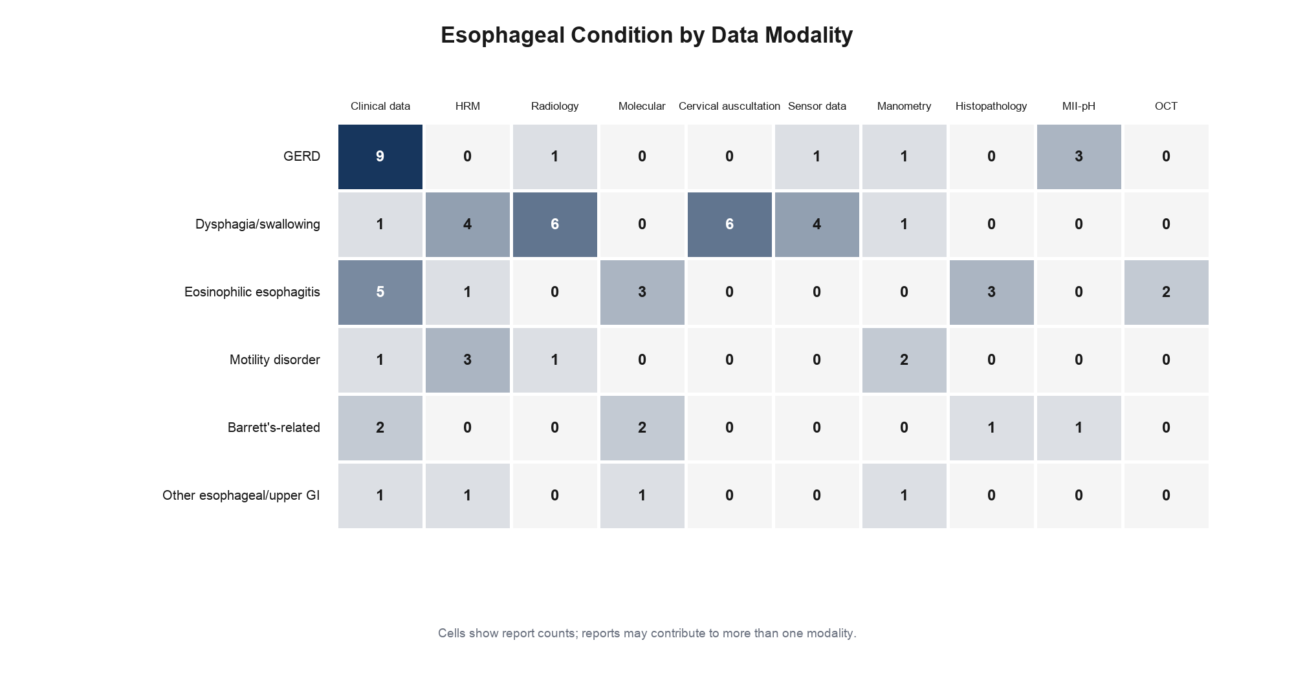
Figure 3. Esophageal condition by data modality. Cells show report counts; a report may contribute to multiple modality cells.

3.6. AI and Computational Approaches
Artificial neural networks were charted in 12 reports, recurrent neural networks in 9, convolutional neural networks in 7, logistic regression in 6, large language models in 5, random forests and support-vector machines in 4 each, decision trees and U-Net architectures in 3 each, and transformers in 2. Some reports used multiple model families, so counts exceed 32. Figure 4 maps the ten most frequently charted families to clinical application categories.
Table 4. Leading model families and clinical applications.
Domain | Category | Reports (n) | Counting note
Model family | Artificial neural network | 12 | Multi-response
Model family | Recurrent neural network | 9 | Multi-response
Model family | Convolutional neural network | 7 | Multi-response
Model family | Logistic regression | 6 | Multi-response
Model family | Large language model | 5 | Multi-response
Purpose | Diagnosis/detection/classification | 21 | Mutually exclusive charted purpose
Purpose | Segmentation/localization | 7 | Mutually exclusive charted purpose
Purpose | Modeling/decision support | 2 | Mutually exclusive charted purpose
Purpose | Quantitative assessment | 2 | Mutually exclusive charted purpose
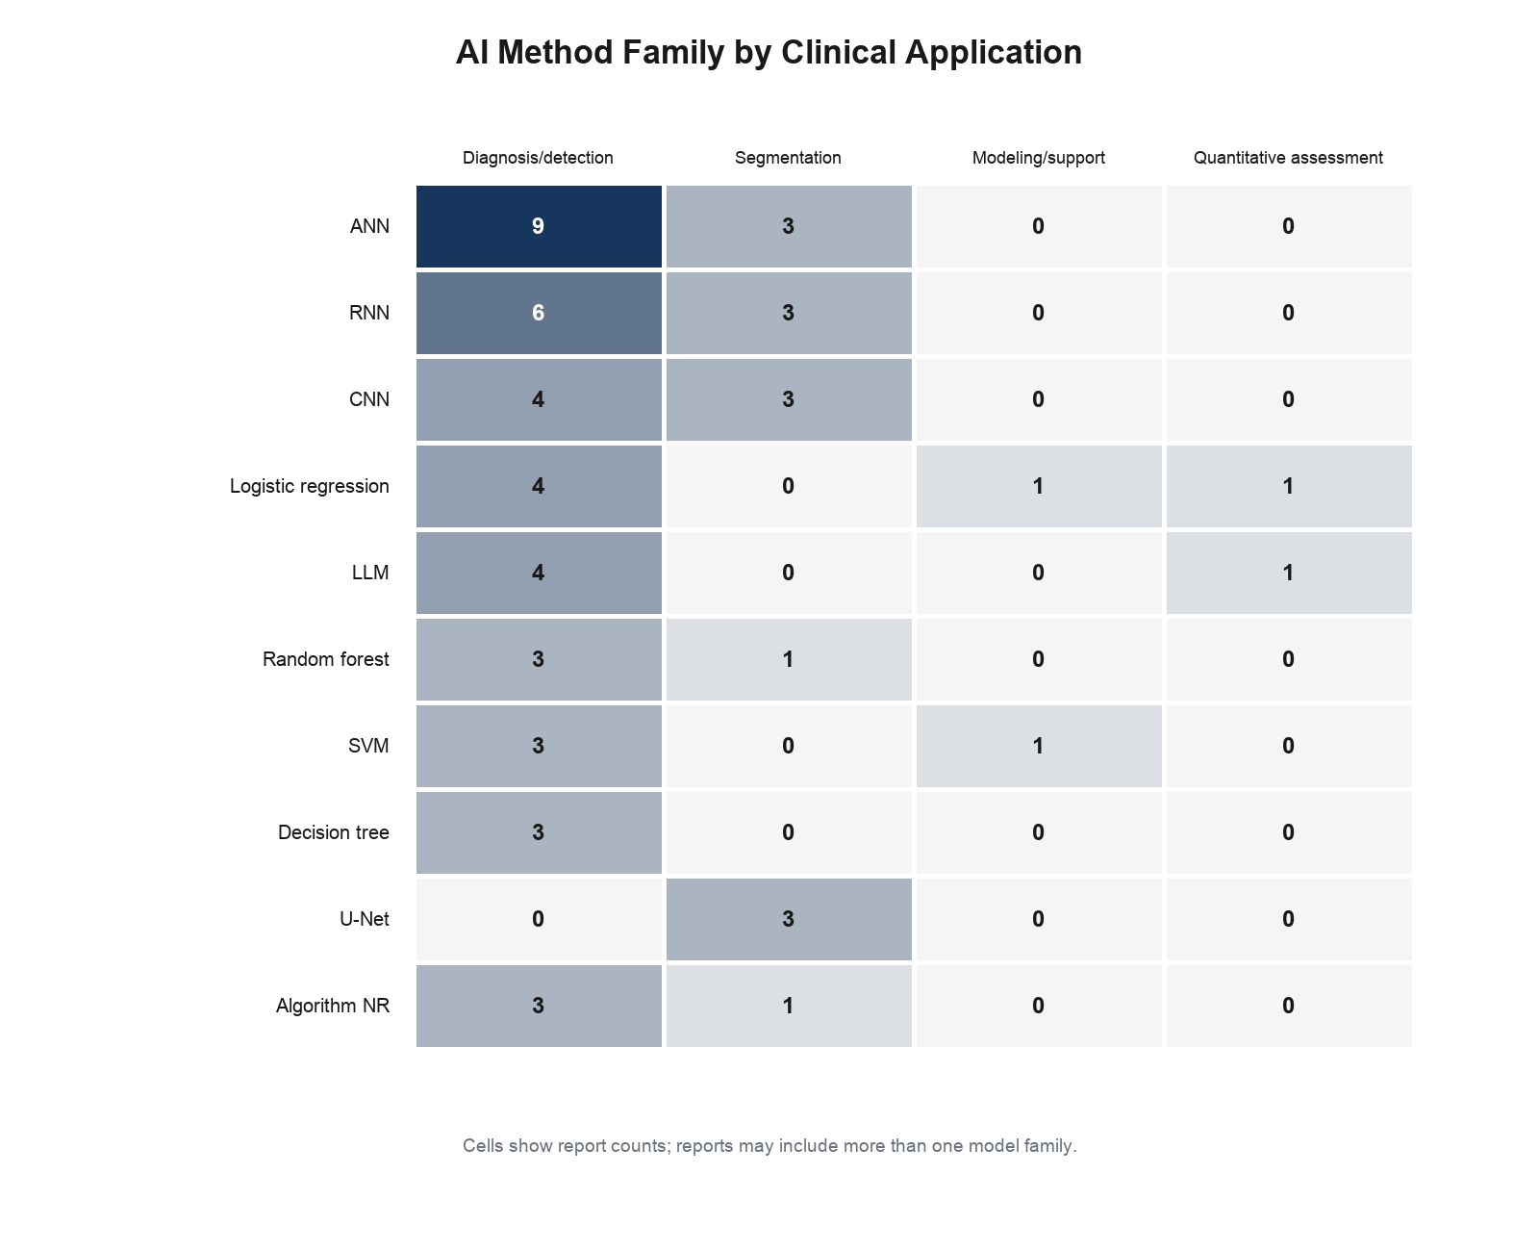
Figure 4. AI method family by clinical application. Cells show report counts; model-family categories are multi-response.

3.7. Model Objectives and Outcomes
Reported objectives included disease or phenotype detection, diagnostic classification, segmentation of tissue or physiologic events, quantitative measurement, and decision support. Performance measures included sensitivity, specificity, accuracy, area under the receiver-operating-characteristic curve, and F1 score. Because dataset roles, thresholds, denominators, and units were frequently incomplete or heterogeneous, values were retained in the report-level performance table rather than pooled or ranked. Patient-level analysis was charted for 30 reports, image-level analysis for one, and the unit was NR for one.

3.8. Validation and Generalizability
Internal validation was reported in 18 reports and NR in 14. External validation was recorded as present in 4 reports, no external-validation evidence identified in 14, and NR in 14 (Figure 5). Cross-validation was not counted as external validation. Multicenter status was charted for 6 reports and NR for 26. Calibration, statistical uncertainty, clinician comparisons, and generalizability were inconsistently reported.
Table 5. Validation maturity of included reports.
Validation domain | Category | Reports, n/N (%)
Internal validation | Reported | 18/32 (56.3%)
Internal validation | NR | 14/32 (43.8%)
External validation | Yes | 4/32 (12.5%)
External validation | No evidence identified | 14/32 (43.8%)
External validation | NR | 14/32 (43.8%)
Center status | Multicenter | 6/32 (18.8%)
Center status | NR | 26/32 (81.3%)
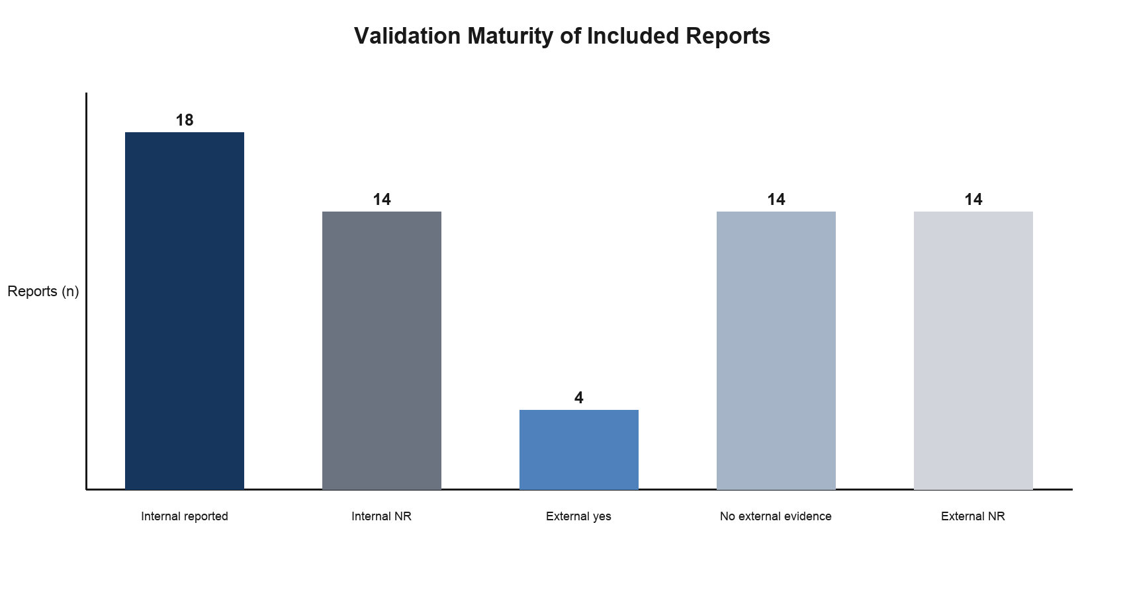
Figure 5. Validation maturity of included reports (n=32). Internal and external categories are separate denominators over the same report set.

3.9. Implementation Characteristics
All 32 reports were charted as research evaluations rather than deployed clinical systems. Software or code availability was NR in all 32 reports, as were formal interpretability methods and clinical-utility results. These findings indicate that the evidence primarily addressed technical or diagnostic-development questions and did not establish routine implementation or patient benefit.

3.10. Funding and Conflicts of Interest
Funding was NR in 24 of 32 included reports. Eight reports contained some funding text, although several extracted statements were incomplete. Conflicts of interest were NR in 30 reports; one report contained a competing-interest statement and one explicitly reported no known competing interests. This scoping review received no external funding; consequently, no external funder had a role in its design, conduct, analysis, interpretation, manuscript preparation, or decision to submit. The authors declare no conflicts of interest.
Table 6. Implementation, transparency, funding, and conflict reporting.
Domain | Finding | Reports, n/N
Deployment | Research evaluation | 32/32
Software/code availability | NR | 32/32
Interpretability method | NR | 32/32
Clinical utility result | NR | 32/32
Funding | NR | 24/32
Conflicts of interest | NR | 30/32

3.11. Evidence Gaps
The mapped evidence showed limited external validation, sparse multicenter documentation, absent code-availability reporting, incomplete dataset provenance and source-location detail, inconsistent units and denominators, limited calibration and uncertainty reporting, and no charted routine deployment or clinical-utility outcomes. Abstract-only evidence and nine unavailable reports further limited detail. These gaps concern evidence maturity and reporting, not proof that the methods lack value.
Table 7. Evidence gaps and research priorities.
Gap | Evidence signal | Research priority
External validation | 4/32 reports recorded external validation | Independent, geographic, temporal, and multicenter validation
Dataset provenance | Frequently NR or incomplete | Describe cohort assembly, partitions, overlap, and data lineage
Calibration and uncertainty | Inconsistently reported | Report calibration, confidence intervals, and decision thresholds
Implementation | 32/32 research evaluation; clinical utility NR in 32/32 | Prospective workflow studies and patient-centered outcomes
Reproducibility | Software/code availability NR in 32/32 | Share code, models, protocols, and reusable data where permissible
Reporting completeness | Funding NR 24/32; conflicts NR 30/32 | Complete declarations and structured model-reporting standards

4. Discussion

4.1. Principal Findings
This review identified a broad but uneven evidence base: 32 reports representing 31 studies applied AI or comparable computational methods across GERD, swallowing dysfunction, eosinophilic esophagitis, motility disorders, and Barrett's-related detection. Diagnostic classification dominated, while segmentation, quantitative assessment, and physiological decision support were less frequent. Structured clinical variables and HRM were prominent, but molecular, histologic, radiologic, impedance, and sensor modalities showed that the field is intrinsically multimodal.
Evidence maturity lagged behind methodological variety. Only four reports were charted with external validation, multicenter status was often unreported, and all reports were classified as research evaluations. Code availability, interpretability, and clinical utility were NR throughout the extraction. These patterns support cautious interpretation: the literature maps technical feasibility and diagnostic-development activity more clearly than clinical implementation or improved patient outcomes.

4.2. Interpretation in the Gastrointestinal Context
For gastroenterologists and motility specialists, computational tools may be most useful when they standardize high-dimensional measurements, reduce reader variability, or integrate discordant clinical and physiologic signals. This role is particularly relevant to HRM, impedance-pH, imaging, histology, and sensor data, where protocols, preprocessing, and reference standards materially influence outputs. The findings do not support replacing clinical interpretation; they indicate where algorithms may be evaluated as adjuncts within established diagnostic pathways [1,2].

4.3. Comparison with Existing Literature
A recent broad AI-dysphagia scoping review identified 27 studies and emphasized assessment and screening applications across videofluoroscopy, endoscopic swallowing evaluation, sensors, acoustic signals, and structured clinical data [7]. Its adult dysphagia scope and care-pathway orientation differ from the present review, which maps 32 reports representing 31 studies across esophageal dysphagia and related esophageal disorders, including reflux disease, eosinophilic esophagitis, motility disorders, and Barrett’s-related detection. Both reviews identify limited prospective, externally validated, and clinically implemented evidence. The present review additionally distinguishes reports from studies, maps validation reporting, and preserves an explicit report-linkage audit. These differences support complementarity rather than a claim that this is the first review.

4.4. Implications for Clinical Practice
Reported technical performance should not be equated with diagnostic validity, clinical utility, implementation feasibility, or patient benefit. Before clinical adoption, candidate systems require evaluation on representative patient-level cohorts, comparison with appropriate clinical standards, analysis of calibration and failure modes, and testing in the workflow and population for which they are intended. Human oversight remains important when outputs depend on data quality, protocol adherence, or uncertain disease labels.

4.5. Implications for Research
Future studies should prioritize multicenter and external validation, prospective evaluation, transparent cohort and dataset provenance, standardized reference standards, separation of training and test results, and denominators that distinguish patients from images, swallows, biopsies, or examinations. Calibration, decision-curve or clinical-utility analysis, subgroup performance, explainability, reproducibility, and code or model sharing should be incorporated when appropriate. Comparisons should be clinically meaningful and should avoid selecting models solely on within-dataset accuracy.

4.6. Strengths and Limitations
Strengths include dual independent screening, preservation of reviewer decisions, documented consensus, separation of records, reports, and studies, an eight-report pilot of a frozen charting form, verification of all included extraction rows, and a traceable PRISMA flow. The study/report linkage prevented double-counting of an included companion report.
Limitations include nine unretrieved reports, inclusion of abstract-level evidence with limited detail, incomplete exact source locators for some extracted fields, and heterogeneous conditions, modalities, units, outcomes, and validation designs. The constituent Web of Science indexes were not recorded, and no documented formal peer review of the search strategies occurred. A record-level manual-duplicate log was not located. Age eligibility changed from an earlier adult-focused framework to the final age-neutral criteria. Funding and conflict information was frequently NR, no formal critical appraisal was performed, and rapidly evolving AI methods may reduce the currency of the map. The title-and-abstract consensus was reconstructed from the frozen full-text universe and ratified by both reviewers.

5. Conclusions
AI and comparable computational methods have been applied across a wide range of esophageal disorders, data modalities, and diagnostic or quantitative tasks. The included evidence shows substantial methodological breadth but limited documented external validation, reproducibility, implementation, and clinical-utility assessment. The field would benefit from representative multicenter datasets, explicit dataset provenance, patient-level evaluation, standardized validation and reference standards, calibration, transparent reporting, and prospective workflow studies. Current findings support continued rigorous evaluation rather than claims of established clinical effectiveness.

Supplementary Materials
The following files accompany the manuscript: Supplementary_Materials.docx; PRISMA_ScR_Checklist.docx; Manuscript_Tables.xlsx; Manuscript_Traceability_Register.xlsx; the citation-level full-text exclusion and unretrieved-report register; and the final PRISMA-ScR flow diagram.

Author Contributions
Author contributions were reviewed and approved by the author group and are reported in the journal submission metadata.

Funding
This research received no external funding. No external funder had a role in the design or conduct of the review; collection, management, analysis, or interpretation of the evidence; preparation, review, or approval of the manuscript; or the decision to submit the manuscript for publication.

Institutional Review Board Statement
Not applicable. This scoping review synthesized published or publicly available evidence and did not involve human participants or identifiable private information.

Informed Consent Statement
Not applicable. This scoping review synthesized published or publicly available evidence and did not involve human participants or identifiable private information.

AI-Assistance Disclosure
All screening, eligibility assessment, consensus decisions, data extraction, evidence verification, synthesis, interpretation, authorship decisions, formatting and writing (including editing and revising) were performed manually by the human authors. No artificial intelligence or AI-assisted tools were used to make research-method or interpretive decisions as well.

Data Availability Statement
The data supporting this review are available within the article and its supplementary materials. No separate public repository deposit is planned. Copyrighted full texts are not redistributed.

Acknowledgments
None.

Conflicts of Interest
The authors declare no conflicts of interest.

References
1. Gyawali, C.P.; Carlson, D.A.; Chen, J.W.; Patel, A.; Wong, R.J.; Yadlapati, R.H. ACG Clinical Guidelines: Clinical Use of Esophageal Physiologic Testing. Am. J. Gastroenterol. 2020, 115, 1412-1428. https://doi.org/10.14309/ajg.0000000000000734.
2. Yadlapati, R.; Kahrilas, P.J.; Fox, M.R.; et al. Esophageal Motility Disorders on High-Resolution Manometry: Chicago Classification Version 4.0. Neurogastroenterol. Motil. 2021, 33, e14058. https://doi.org/10.1111/nmo.14058.
3. Peters, M.D.J.; Marnie, C.; Tricco, A.C.; et al. Updated Methodological Guidance for the Conduct of Scoping Reviews. JBI Evid. Synth. 2020, 18, 2119-2126. https://doi.org/10.11124/JBIES-20-00167.
4. Tricco, A.C.; Lillie, E.; Zarin, W.; et al. PRISMA Extension for Scoping Reviews (PRISMA-ScR): Checklist and Explanation. Ann. Intern. Med. 2018, 169, 467-473. https://doi.org/10.7326/M18-0850.
5. Pollock, D.; Peters, M.; Tricco, A.; et al. Scoping Reviews. In JBI Manual for Evidence Synthesis; JBI: Adelaide, Australia. https://doi.org/10.46658/JBIMES-24-06.
6. Page, M.J.; McKenzie, J.E.; Bossuyt, P.M.; et al. The PRISMA 2020 Statement: An Updated Guideline for Reporting Systematic Reviews. BMJ 2021, 372, n71. https://doi.org/10.1136/bmj.n71.
7. Sreedevi, E.V.; Iyer, S.K.; Thankappan, K.; Roe, J.W.G.; Karuveettil, V.; Janakiram, C.; Guntha, R.; Gunasekaran, S.; Menon, J.R.; Pathinarupothi, R.K. Artificial Intelligence Tools for the Assessment and Management of Dysphagia: A Scoping Review. BMJ Open 2026, 16, e119582. https://doi.org/10.1136/bmjopen-2026-119582.
8. Carniel, E.L.; Frigo, A.; Costantini, M.; Giuliani, T.; Nicoletti, L.; Merigliano, S.; Natali, A.N. A physiological model for the investigation of esophageal motility in healthy and pathologic conditions. Proceedings of the Institution of Mechanical Engineers, Part H: Journal of Engineering in Medicine 2016, 230, 9, 892-899. https://doi.org/10.1177/0954411916658915.
9. Frigo, A.; Costantini, M.; Fontanella, C.G.; Salvador, R.; Merigliano, S.; Carniel, E.L. A Procedure for the Automatic Analysis of High-Resolution Manometry Data to Support the Clinical Diagnosis of Esophageal Motility Disorders. IEEE Transactions on Biomedical Engineering 2018, 65, 7, 1476-1485. https://doi.org/10.1109/tbme.2017.2758441.
10. Iyer, P.G.; Taylor, W.R.; Johnson, M.L.; Lansing, R.L.; Maixner, K.A.; Hemminger, L.L.; Cayer, F.K.; Yab, T.C.; Devens, M.E.; Slettedahl, S.W.; Broderick, B.T.; Mahoney, D.W.; McGlinch, M.C.; Berger, C.K.; Foote, P.H.; Giakomopoulos, M.; Allawi, H.; Smyrk, T.C.; Wang, K.K.; Katzka, D.A.; Wolfsen, H.C.; Burke, J.A.; Ahlquist, D.A.; Kisiel, J.B. Accurate Nonendoscopic Detection of Barrett's Esophagus by Methylated DNA Markers: A Multisite Case Control Study. American Journal of Gastroenterology 2020, 115, 8, 1201-1209. https://doi.org/10.14309/ajg.0000000000000656.
11. Horowitz, N.; Moshkowitz, M.; Halpern, Z.; Leshno, M. Applying Data Mining Techniques in the Development of a Diagnostics Questionnaire for GERD. Digestive Diseases and Sciences 2007, 52, 8, 1871-1878. https://doi.org/10.1007/s10620-006-9202-5.
12. Pace, F.; Buscema, M.; Dominici, P.; Intraligi, M.; Baldi, F.; Cestari, R.; Passaretti, S.; Porro, G.B.; Grossi, E. Artificial neural networks are able to recognize gastro-oesophageal reflux disease patients solely on the basis of clinical data. European Journal of Gastroenterology & Hepatology 2005, 17, 6, 605-610. https://doi.org/10.1097/00042737-200506000-00003.
13. Reddy, A.T.; Patel, A.; Leiman, D.A. Automated software‐derived supine baseline impedance is highly correlated with manual nocturnal baseline impedance for the diagnosis of GERD. Neurogastroenterology & Motility 2024, 36, 9, e14861. https://doi.org/10.1111/nmo.14861.
14. Jungheim, M.; Busche, A.; Miller, S.; Schilling, N.; Schmidt-Thieme, L.; Ptok, M. Calculation of upper esophageal sphincter restitution time from high resolution manometry data using machine learning. Physiology & Behavior 2016, 165, 413-424. https://doi.org/10.1016/j.physbeh.2016.08.005.
15. Basiri, B.; Vali, M.; Agah, S. Classification of normal and dysphagia in patients with GERD using swallowing sound analysis. 2017 Artificial Intelligence and Signal Processing Conference (AISP) 2017, 268-274. https://doi.org/10.1109/aisp.2017.8324095.
16. Oh, T.Y.; Johnson, L.; Westbrook, A.; Vos, M.B.; Rudra, S.; Sinclair, E.M.; Lam, W. Su1281 DETECTION OF MINIMALLY INVASIVE BIOMARKERS FOR PEDIATRIC EOSINOPHILIC ESOPHAGITIS. Gastroenterology 2024, 166, 5, S-723. https://doi.org/10.1016/s0016-5085(24)02136-x.
17. Parimi, V.; Zago, A.; Yang, X.J.; Chen, Z.E. Developing a Digital Analysis Algorithm to Count Intraepithelial Eosinophils on H&E Stained Sections for Diagnosis of Eosinophilic Esophagitis. Mod. Pathol. 2011, 24 (Suppl. 1), 448A, abstract 1927.
18. Ketchem, C.J.; Vurgun, U.U.; Wang, A.; Thomas, S.; Batugo, A.; Pandolfino, J.E.; Falk, G.W.; Lynch, K.L.; Dellon, E.S.; Mowery, D.L.; Lewis, J.D. Development and Validation of a Large Language Model Case Identification Strategy for Eosinophilic Esophagitis. Gastro Hep Advances 2026, 5, 7, 100971. https://doi.org/10.1016/j.gastha.2026.100971.
19. Kalra, A.; Ma, K.; Cheng, Y.; Tsai, H.L.; Wang, H.; Cope, L.; Yang, Y.; Lunz, D.; Laun, S.; Kann, L.; Jit, S.; Ahmed, Y.; Gheshlaghi, S.; Tieu, A.H.; Castillo, V.; Hales, R.; Feliciano, J.; Lam, V.; Marrone, K.; Hui, K.; Ma, M.; Hughes, R.; Akshintala, V.; Bull-Henry, K.; Ha, J.; Boudadi, K.; Foda, Z.H.; Battaforano, R.; Singh, V.K.; Khashab, M.; Shin, E.J.; Brewer, O.; Ngamruengphong, S.; Ganster, R.; Jobe, B.A.; Ayazi, S.; Zellenrath, P.; Spaander, M.; Zaidi, A.H.; Meltzer, S.J. Discovery of Methylated DNA Biomarkers for Potential Nonendoscopic Detection of Barrett's Esophagus and Esophageal Adenocarcinoma. American Journal of Gastroenterology 2025, 120, 10, 2268-2279. https://doi.org/10.14309/ajg.0000000000003323.
20. Mao, J.; Zhu, Z.; Xia, M.; Zhou, M.; Wang, L.; Xia, J.; Wang, Z. Enhanced Runge-Kutta-driven feature selection model for early detection of gastroesophageal reflux disease. Computers in Biology and Medicine 2024, 175, 108394. https://doi.org/10.1016/j.compbiomed.2024.108394.
21. Bertolini, S.; Maoli, A.; Rauch, G.; Giacomini, M. Entropy-Driven Decision Tree Building for Decision Support in Gastroenterology. Stud. Health Technol. Inform. 2013, 186, 93-97. PMID: 23542975.
22. Li, D.; Cheng, Y.; Guo, Y.; Wang, L. Esophageal tissue segmentation on OCT images with hybrid attention network. Multimedia Tools and Applications 2023, 83, 14, 42609-42628. https://doi.org/10.1007/s11042-023-16550-z.
23. Santos, R.; Haack, H.G.; Maddalena, D.; Hansen, R.D.; Kellow, J.E. Evaluation of artificial neural networks in the classification of primary oesophageal dysmotility. Scandinavian Journal of Gastroenterology 2006, 41, 3, 257-263. https://doi.org/10.1080/00365520500234030.
24. Jell, A.; Bernhard, L.; Wilhelm, D.; Feußner, H. Fusion of High-Resolution Manometry and Cinematography in the Diagnosis of Dysphagia. Int. J. Comput. Assist. Radiol. Surg. 2022, 17 (Suppl. 1), S15. https://doi.org/10.1007/s11548-022-02635-x.
25. Donohue, C.; Khalifa, Y.; Perera, S.; Sejdić, E.; Coyle, J.L. How Closely do Machine Ratings of Duration of UES Opening During Videofluoroscopy Approximate Clinician Ratings Using Temporal Kinematic Analyses and the MBSImP?. Dysphagia 2021, 36, 4, 707-718. https://doi.org/10.1007/s00455-020-10191-2.
26. Anwar, A.; Khalifa, Y.; Lucatorto, E.; Coyle, J.L.; Sejdic, E. Non-invasive integrated swallowing kinematic analysis framework leveraging transformer-based multi-task neural networks. Computers in Biology and Medicine 2025, 196, 110887. https://doi.org/10.1016/j.compbiomed.2025.110887.
27. Khalifa, Y.; Mahoney, A.S.; Lucatorto, E.; Coyle, J.L.; Sejdić, E. Non-Invasive Sensor-Based Estimation of Anterior-Posterior Upper Esophageal Sphincter Opening Maximal Distension. IEEE Journal of Translational Engineering in Health and Medicine 2023, 11, 182-190. https://doi.org/10.1109/jtehm.2023.3246919.
28. Rasmussen, C.; Rutz, K.; Jakobsen, E.; Kruse-Andersen, S.; Thøgersen, C. Non-parametric Classification of Esophagus Motility by Means of Neural Networks. Methods of Information in Medicine 1997, 36, 04/05, 352-355. https://doi.org/10.1055/s-0038-1636870.
29. Wechsler, J.B.; Kim, K.Y.; Gray, E.; Amsden, K.; Wang, M.; Chehade, M.; Wershil, B.K.; Ackerman, S.J.; Kagalwalla, A.F. Sa1162 - Noninvasive Biomarkers Accurately Identify Eosinophilic Esophagitis: A Prospective Study in Children. Gastroenterology 2018, 154, 6, S-264. https://doi.org/10.1016/s0016-5085(18)31243-5.
30. Bernhard, L.; Gassert, F.; Fingerle, A.; Feußner, H.; Jell, A. P9. Cinemanography – Challenges and potentials of fusing manometric and fluoroscopic imaging. Clinical Neurophysiology 2021, 132, 8, e4. https://doi.org/10.1016/j.clinph.2021.02.332.
31. Guadagnoli, L.; Geeraerts, A.; Geysen, H.; Pauwels, A.; Vanuytsel, T.; Tack, J.; Van Oudenhove, L. Psychological Processes, Not Physiological Parameters, Are Most Important Contributors to Symptom Severity in Patients With Refractory Heartburn/Regurgitation Symptoms. Gastroenterology 2023, 165, 4, 848-860. https://doi.org/10.1053/j.gastro.2023.06.019.
32. Li, D.; Zhang, M.; Shi, W.; Zhang, H.; Wang, D.; Wang, L. Pyramid Pooling Channel Attention Network for esophageal tissue segmentation on OCT images. 2020 IEEE 19th International Conference on Trust, Security and Privacy in Computing and Communications (TrustCom) 2020, 1476-1480. https://doi.org/10.1109/trustcom50675.2020.00200.
33. Kenari, A.R.; Rabbani, H. Segmentation of gastroesophageal reflux events using a semi-U-Net architecture with 1D/2D CNNs. Scientific Reports 2025, 15, 1, 37152. https://doi.org/10.1038/s41598-025-21031-4.
34. Anwar, A.; Khalifa, Y.; Lucatorto, E.; Coyle, J.L.; Sejdic, E. Swallowing Assessment using High-Resolution Cervical Auscultations and Transformer-based Neural Networks. 2024 46th Annual International Conference of the IEEE Engineering in Medicine and Biology Society (EMBC) 2024, 1-5. https://doi.org/10.1109/embc53108.2024.10782280.
35. Horowitz, N.; Moshkowitz, M.; Leshno, M.; Ribak, J.; Bierkenfeld, S.; Kenneth, G.; Halpern, Z. Symptom Evaluation as an Efficient Diagnostic Tool for Upper Abdominal Diseases. Harefuah 2006, 145, 807-810, 862. PMID: 17183951.
36. Zifan, A.; Jiang, Y.; Mittal, R.K. Temporal and spectral properties of esophageal mucosal blood perfusion: a comparison between normal subjects and nutcracker esophagus patients. Neurogastroenterology & Motility 2017, 29, 2, e12917. https://doi.org/10.1111/nmo.12917.
37. Luo, Y.; Anwar, A.; Ren, S.; Coyle, J.L.; Sejdic, E. Towards Non-Invasive Swallowing Assessment: an AI-Powered Interface for Swallowing Kinematic Analysis using High-Resolution Cervical Auscultation. 2024 46th Annual International Conference of the IEEE Engineering in Medicine and Biology Society (EMBC) 2024, 1-6. https://doi.org/10.1109/embc53108.2024.10781763.
38. Khalifa, Y.; Donohue, C.; Coyle, J.L.; Sejdic, E. Upper Esophageal Sphincter Opening Segmentation With Convolutional Recurrent Neural Networks in High Resolution Cervical Auscultation. IEEE Journal of Biomedical and Health Informatics 2021, 25, 2, 493-503. https://doi.org/10.1109/jbhi.2020.3000057.
39. Barrios Rueda, E.; Conde Gómez, M.; Domínguez Macías, I.; López Carabaño, A.; Méndez Díez, C.; Sáenz Bajo, N. Uso de redes neuronales en medicina: a propósito de la patología dispéptica. Atención Primaria 2002, 30, 2, 99-102. https://doi.org/10.1016/s0212-6567(02)78978-6.

