Neuraxial versus General Anesthesia and Early Postoperative Resource Use after Hip and Knee Arthroplasty: A Retrospective Cohort Study Using INSPIRE
Zane G. Salman^{1,†}; Ryan Zeitouny^{2,†}; Neil Panwalker, BS^{3,†}; Samer G. Salman, BSA³; Rohan Phadke, BS³; Anthony Shatby, BS⁴; Zain G. Baki, BS⁵; Camila Hernandez¹; Ajay Tripuraneni, MD³
¹ The University of Texas at Austin
² Texas A&M University
³ Baylor College of Medicine
⁴ Texas A&M EnMed
⁵ The University of Texas at San Antonio
† These authors contributed equally to this work and share first authorship.
Correspondence: Zane G. Salman; email: Zgs277@eid.utexas.edu.

Abstract
Background/Objectives: Anesthetic technique is a potentially modifiable component of perioperative care after hip and knee arthroplasty. Hospital length of stay (LOS) and intensive care unit (ICU) admission quantify early postoperative resource use, although neither directly measures functional recovery. This study examined whether neuraxial versus general anesthesia was associated with these outcomes.
Methods: This retrospective cohort study used INSPIRE v1.4.2 and included adults undergoing hip or knee arthroplasty with general or neuraxial anesthesia. Gamma regression with a log link modeled LOS, and logistic regression modeled any postoperative ICU admission during the index hospitalization. Models adjusted for age, sex, American Society of Anesthesiologists class, emergency status, and procedure type. Inverse probability of treatment weighting (IPTW), a broader orthopedic cohort, and a log-normal LOS model were sensitivity analyses.
Results: The primary cohort included 2540 operations (269 general and 2271 neuraxial). ICU admission occurred in 41/269 (15.2%) general-anesthesia operations and 113/2271 (5.0%) neuraxial-anesthesia operations. Using HC0 robust standard errors, neuraxial anesthesia was associated with a lower adjusted ratio of mean LOS (0.892, 95% confidence interval [CI] 0.827–0.963; p = 0.003) and lower adjusted odds of ICU admission (odds ratio 0.494, 95% CI 0.315–0.775; p = 0.002). Results were directionally consistent after IPTW, in 16,799 broader orthopedic operations, and in the log-normal LOS analysis.
Conclusions: Neuraxial anesthesia was associated with shorter hospitalization and lower ICU-admission odds after hip or knee arthroplasty. Because anesthesia assignment was nonrandom and the outcomes were administrative measures, the findings should not be interpreted as evidence of causality or improved functional recovery.
Keywords: total joint arthroplasty; neuraxial anesthesia; general anesthesia; hospital length of stay; intensive care; inverse probability weighting; perioperative outcomes

1. Introduction
Total hip and knee arthroplasty are high-volume procedures for end-stage joint disease. Contemporary enhanced-recovery pathways coordinate patient optimization, multimodal analgesia, early oral intake, and mobilization to support timely achievement of discharge criteria [1]. Although hospital LOS is influenced by institutional and social factors, it remains a pragmatic measure of postoperative resource use. ICU admission similarly reflects escalation of postoperative monitoring rather than musculoskeletal function itself.
Related orthopedic-trauma research has treated discharge destination as an admission-time resource-planning outcome. The Fracture Orthopedic Risk of Non-Home Discharge (FORD) score and its national extension, FORD-II, illustrate how early clinical information can identify patients likely to require rehabilitation or other post-acute placement [14,15].
Anesthetic technique is one potentially modifiable element of the perioperative pathway. Neuraxial anesthesia may reduce systemic anesthetic exposure, opioid requirements, postoperative nausea, and impairment of respiratory function, but it may also delay mobilization when motor blockade is prolonged. A systematic review and several large observational studies have associated neuraxial anesthesia with shorter LOS or fewer perioperative complications after hip or knee arthroplasty [2–5]. More recent cohorts have reported greater home-discharge rates, small reductions in resource use, or similar major-complication rates compared with general anesthesia [9–11].
The comparative evidence remains heterogeneous. A randomized fast-track trial reported earlier discharge readiness with a contemporary general-anesthesia regimen than with spinal anesthesia [6], and observational estimates remain susceptible to confounding by indication, institutional practice, and temporal changes in arthroplasty care. Evidence from East Asian perioperative datasets is also comparatively limited.
We therefore evaluated whether neuraxial versus general anesthesia was associated with hospital LOS and any postoperative ICU admission during the index hospitalization among hip and knee arthroplasty operations in INSPIRE. We prespecified LOS as the primary continuous outcome and ICU admission as a clinically important secondary outcome. We hypothesized that neuraxial anesthesia would be associated with lower early postoperative resource use, while explicitly treating both outcomes as administrative measures rather than direct indicators of mobility, rehabilitation progress, or patient-reported recovery.

2. Materials and Methods

2.1. Study Design, Data Source, and Reporting
We conducted a single-center retrospective cohort study using INSPIRE v1.4.2, a de-identified perioperative dataset from Seoul National University Hospital covering January 2011 through December 2020 [7]. INSPIRE provides operation-level demographic, procedural, anesthetic, and perioperative timing information. The analytic unit was the operation; accordingly, results are reported as operations rather than unique patients. Reporting was guided by the Strengthening the Reporting of Observational Studies in Epidemiology (STROBE) statement [8]. The creation and release of INSPIRE were approved by the Seoul National University Hospital Institutional Review Board (H-2210-078-1368) and Data Review Board (BD-R-2022-11-02), with informed consent waived for the retrospective, de-identified source dataset.

2.2. Eligibility and Cohort Construction
Eligible records were adult orthopedic-department operations performed with general or neuraxial anesthesia. Hip replacement was identified using ICD-10-PCS prefixes 0SR9, 0SRB, 0SRA, and 0SRE; knee replacement was identified using 0SRC and 0SRD. Operations performed with other anesthesia categories were excluded. The primary cohort comprised hip or knee arthroplasty operations with valid LOS and complete model covariates. Complete-case analysis excluded 16 of 2556 eligible arthroplasty operations (0.6%). A broader sensitivity cohort included all orthopedic operations performed with general or neuraxial anesthesia. Cohort selection is summarized in Figure 3.

2.3. Exposure, Outcomes, Covariates, and Missing Data
The exposure was neuraxial anesthesia, with general anesthesia as the reference category. The primary outcome, hospital LOS, was calculated from relative admission and discharge timestamps recorded in minutes and expressed in fractional days. LOS values ≤0 or ≥365 days were excluded, and retained values <0.5 day were set to 0.5 day to limit the influence of implausibly short intervals on log-link models. The secondary outcome was ICU admission, defined as a recorded ICU-admission timestamp at any time during the index hospitalization. Prespecified adjustment covariates were five-year-banded age, sex, American Society of Anesthesiologists (ASA) physical status (1–2 versus ≥3), emergency status, and procedure type (hip versus knee). These variables were selected because they were available before or at surgery and were plausibly associated with anesthesia selection and postoperative outcomes. BMI, height, and weight were summarized descriptively but were not included in the models. Missingness for each reported variable is shown in Table 1.

2.4. Statistical Analysis
Continuous variables were summarized using means and standard deviations or medians and interquartile ranges, as appropriate; categorical variables were summarized as counts and percentages. Between-group imbalance was quantified using standardized mean differences (SMDs), with an absolute SMD <0.10 interpreted as acceptable balance. LOS was modeled using a Gamma generalized linear model with a log link; exponentiated coefficients are ratios of adjusted mean LOS. ICU admission was modeled using logistic regression, with exponentiated coefficients reported as odds ratios. Both models adjusted for age, sex, ASA category, emergency status, and procedure type. HC0 heteroskedasticity-consistent sandwich standard errors were used for inference. Two-sided p values <0.05 were considered statistically significant. Analyses were conducted using Python 3.13.15, NumPy 2.1.3, pandas 2.2.3, SciPy 1.16.3, statsmodels 0.14.6, and scikit-learn 1.6.1.

2.5. Sensitivity and Diagnostic Analyses
A propensity score for neuraxial anesthesia was estimated from the prespecified covariates. Stabilized inverse probability of treatment weights were truncated at the 99th percentile, and weighted outcome models retained the adjustment covariates. Covariate balance, propensity-score range, weight distribution, truncation threshold, and effective sample size were evaluated because weighting is reliable only when treatment groups have adequate overlap and measured covariates are balanced [12]. Primary models were also repeated in the broader orthopedic cohort. A log-normal LOS model using the same covariates assessed sensitivity to the Gamma distributional assumption. Model diagnostics included Gamma Pearson dispersion and the ICU-model c-statistic.

2.6. Reproducibility and Disclosure Controls
The complete analytic code, software environment, aggregate model tables, cohort counts, balance diagnostics, and figure-source files were archived before submission. The public archive excludes INSPIRE source tables, identifiers, individual timestamps, row-level propensity scores or weights, and all other patient- or operation-level derivatives. An automated disclosure audit confirmed that only non-disclosive aggregate outputs were exported.

3. Results

3.1. Cohort Selection and Baseline Characteristics
The source extract contained 17,433 orthopedic operations. After excluding 211 operations performed with anesthesia other than general or neuraxial, 17,222 remained. Restriction to hip or knee arthroplasty yielded 2556 operations; exclusion of 16 operations (0.6%) with invalid or missing LOS or model covariates produced a primary analytic cohort of 2540 operations (Figure 3). Of these, 269 (10.6%) received general anesthesia and 2271 (89.4%) received neuraxial anesthesia.
Before adjustment, the general-anesthesia group was older and had higher proportions of ASA class ≥3 and emergency operations, whereas knee arthroplasty and female sex were more prevalent in the neuraxial group (Table 1). These imbalances were consistent with nonrandom treatment selection. Anthropometric variables were not model covariates and were missing for 36 operations for BMI (1.4%), 26 for weight (1.0%), and 13 for height (0.5%).
Characteristic | General (N=269) | Neuraxial (N=2,271) | SMD | Missing, n/N (%)
Age, mean (SD), years | 68.1 (13.7) | 66.1 (12.7) | 0.152 | 0/2,540 (0.0)
Female | 177/269 (65.8) | 1,702/2,271 (74.9) | −0.201 | 0/2,540 (0.0)
BMI, mean (SD), kg/m² | 24.6 (4.3) | 25.4 (3.9) | −0.211 | 36/2,540 (1.4)
Weight, mean (SD), kg | 61.4 (11.1) | 62.7 (11.2) | −0.113 | 26/2,540 (1.0)
Height, mean (SD), cm | 158.4 (9.6) | 157.1 (8.7) | 0.141 | 13/2,540 (0.5)
ASA class ≥3 | 61/269 (22.7) | 191/2,271 (8.4) | 0.402 | 0/2,540 (0.0)
Emergency surgery | 22/269 (8.2) | 62/2,271 (2.7) | 0.242 | 0/2,540 (0.0)
Knee (vs. hip) | 90/269 (33.5) | 1,134/2,271 (49.9) | −0.339 | 0/2,540 (0.0)
LOS, median [IQR], days | 12.0 [10.0–17.0] | 11.0 [10.0–17.0] | 0.170 | 0/2,540 (0.0)
ICU admission | 41/269 (15.2) | 113/2,271 (5.0) | 0.346 | 0/2,540 (0.0)
Table 1. Baseline characteristics by anesthesia type. Values are mean (SD), n/N (%), or median [IQR]. SMD, standardized mean difference; ASA, American Society of Anesthesiologists; ICU, intensive care unit; LOS, length of stay. LOS was calculated from relative admission and discharge times in fractional days. Medians and IQRs are displayed to one decimal place; group IQRs coincided after rounding despite different medians.

3.2. Primary Outcome Models
Median LOS was 12.0 days (interquartile range [IQR], 10.0–17.0) after general anesthesia and 11.0 days (IQR, 10.0–17.0) after neuraxial anesthesia (Figure S1). In the adjusted Gamma model, neuraxial anesthesia was associated with a ratio of mean LOS of 0.892 (95% CI 0.827–0.963; p = 0.003), corresponding to an estimated 10.8% lower adjusted mean LOS. ICU admission during the index hospitalization occurred in 41/269 (15.2%) general-anesthesia operations and 113/2271 (5.0%) neuraxial-anesthesia operations. The adjusted odds ratio for neuraxial versus general anesthesia was 0.494 (95% CI 0.315–0.775; p = 0.002) (Table 2; Figure 1). The Gamma Pearson dispersion was 0.216, and the ICU model c-statistic was 0.780.
Variable | LOS ratio (95% CI) | p | ICU OR (95% CI) | p
Neuraxial (vs. general) | 0.892 (0.827–0.963) | 0.003 | 0.494 (0.315–0.775) | 0.002
ASA class ≥3 | 1.231 (1.103–1.373) | <0.001 | 5.289 (3.524–7.939) | <0.001
Knee (vs. hip) | 1.304 (1.253–1.357) | <0.001 | 0.327 (0.211–0.505) | <0.001
Age (per 5-year-banded value) | 1.000 (0.998–1.002) | 0.764 | 1.028 (1.012–1.045) | <0.001
Female | 1.055 (1.005–1.107) | 0.031 | 0.889 (0.600–1.316) | 0.557
Emergency | 1.113 (0.912–1.358) | 0.294 | 1.200 (0.578–2.489) | 0.625
Table 2. Adjusted associations in the arthroplasty cohort. Models adjusted for age, sex, ASA category, emergency status, and procedure type. LOS ratios are exponentiated Gamma-model coefficients; ICU estimates are odds ratios.

3.3. Sensitivity Analyses and Propensity-Score Diagnostics
The propensity scores ranged from 0.489 to 0.959. After stabilized IPTW and truncation at the 99th percentile (weight cutoff, 1.671), all measured covariates achieved |SMD| <0.05 (Figure 2). The effective weighted sample size was 2473, representing 97.4% of the unweighted primary cohort. IPTW estimates remained directionally consistent with the primary models: LOS ratio 0.900 (95% CI 0.842–0.961; p = 0.002) and ICU odds ratio 0.440 (95% CI 0.272–0.710; p < 0.001). In 16,799 broader orthopedic operations, the adjusted LOS ratio was 0.913 (95% CI 0.880–0.948) and the adjusted ICU odds ratio was 0.669 (95% CI 0.583–0.768); both p < 0.001 (Table 3). The log-normal LOS model also produced a similar association (ratio 0.911, 95% CI 0.864–0.960; p < 0.001).
Analysis | LOS ratio (95% CI) | ICU OR (95% CI)
Arthroplasty, adjusted | 0.892 (0.827–0.963) | 0.494 (0.315–0.775)
Arthroplasty, IPTW-weighted | 0.900 (0.842–0.961) | 0.440 (0.272–0.710)
All orthopedic, adjusted | 0.913 (0.880–0.948) | 0.669 (0.583–0.768)
Table 3. Sensitivity analyses for neuraxial versus general anesthesia. IPTW, inverse probability of treatment weighting; LOS, length of stay; ICU, intensive care unit.
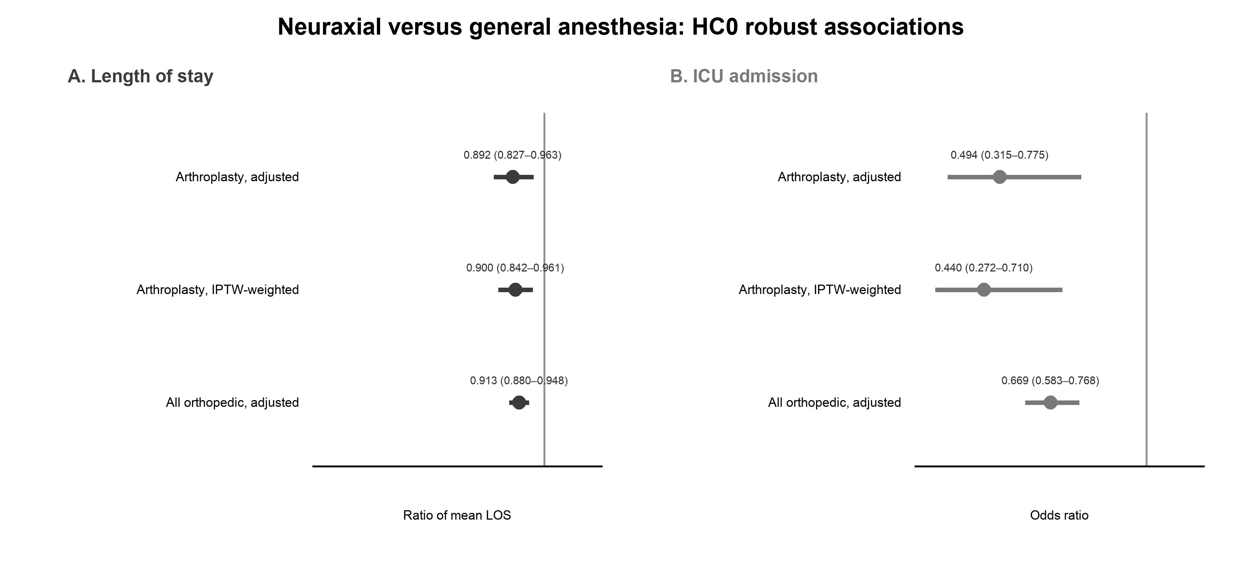
Figure 1. Adjusted associations of neuraxial versus general anesthesia with (A) hospital LOS and (B) ICU admission. Points are effect estimates and bars are 95% confidence intervals. The vertical line at 1.0 denotes no association. Displayed rounded values agree with Tables 2 and 3.
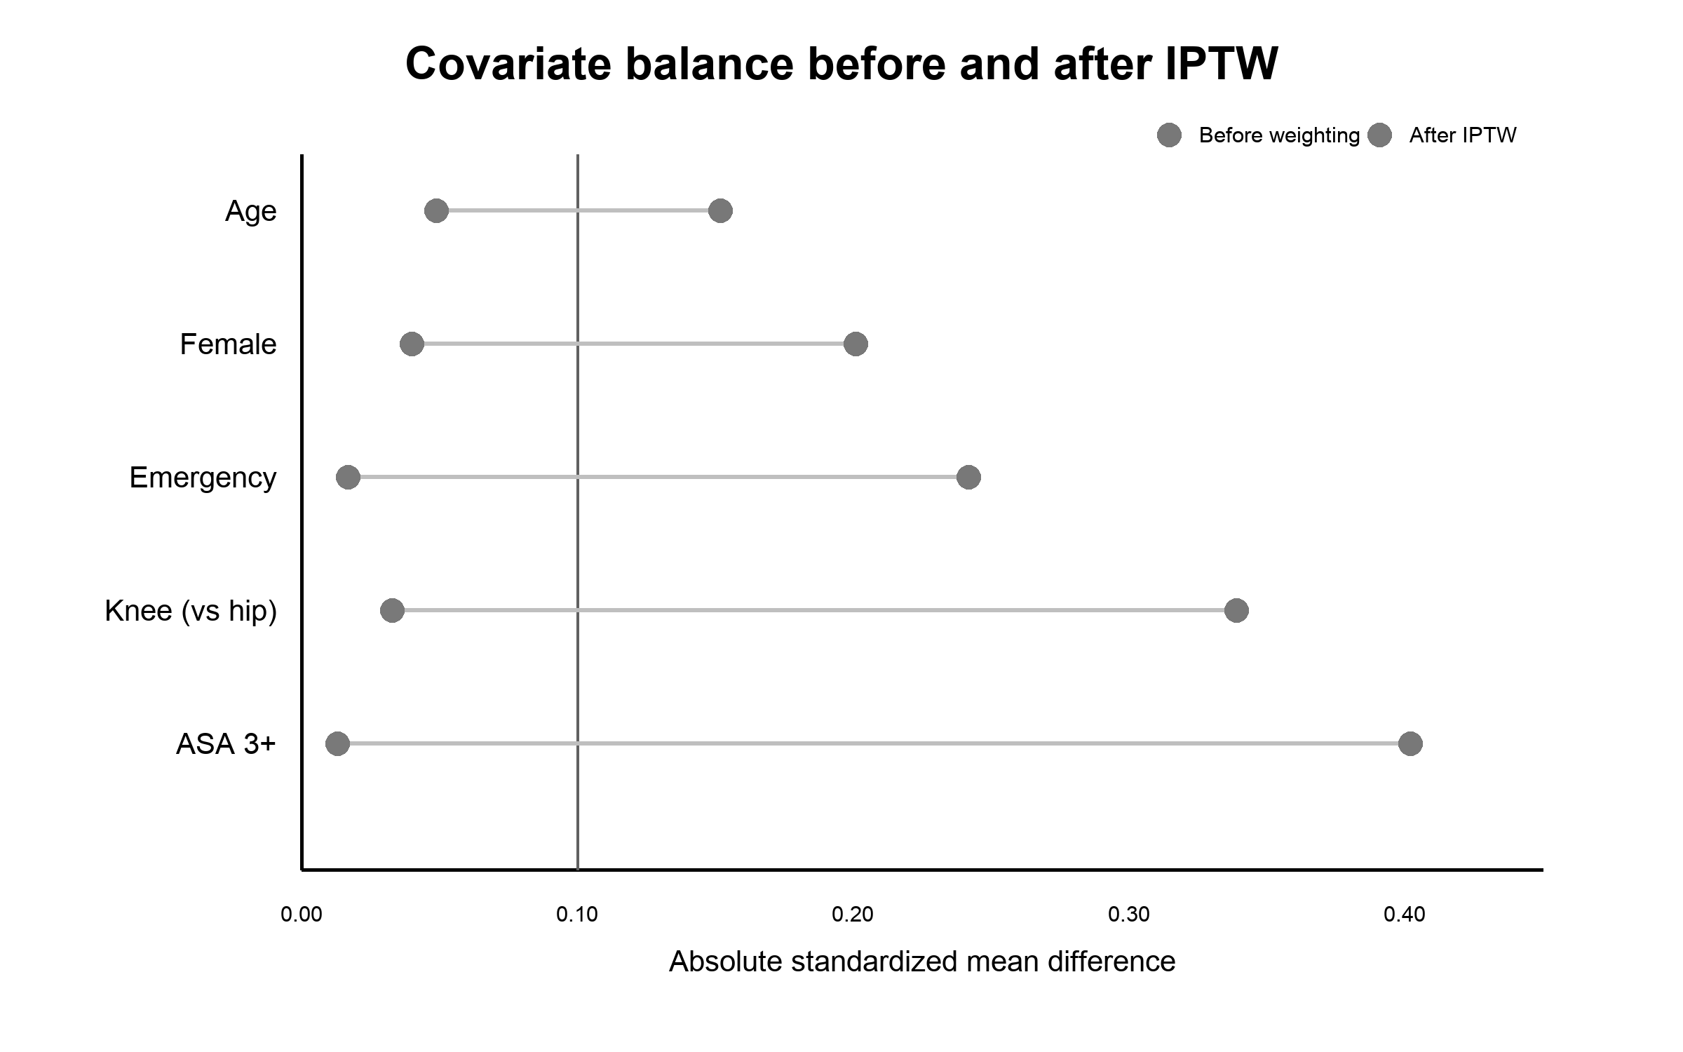
Figure 2. Absolute standardized mean differences before and after IPTW in the arthroplasty cohort. The dashed line denotes |SMD| = 0.10. Exact aggregate balance output confirmed that every post-weighting absolute SMD was below 0.05.
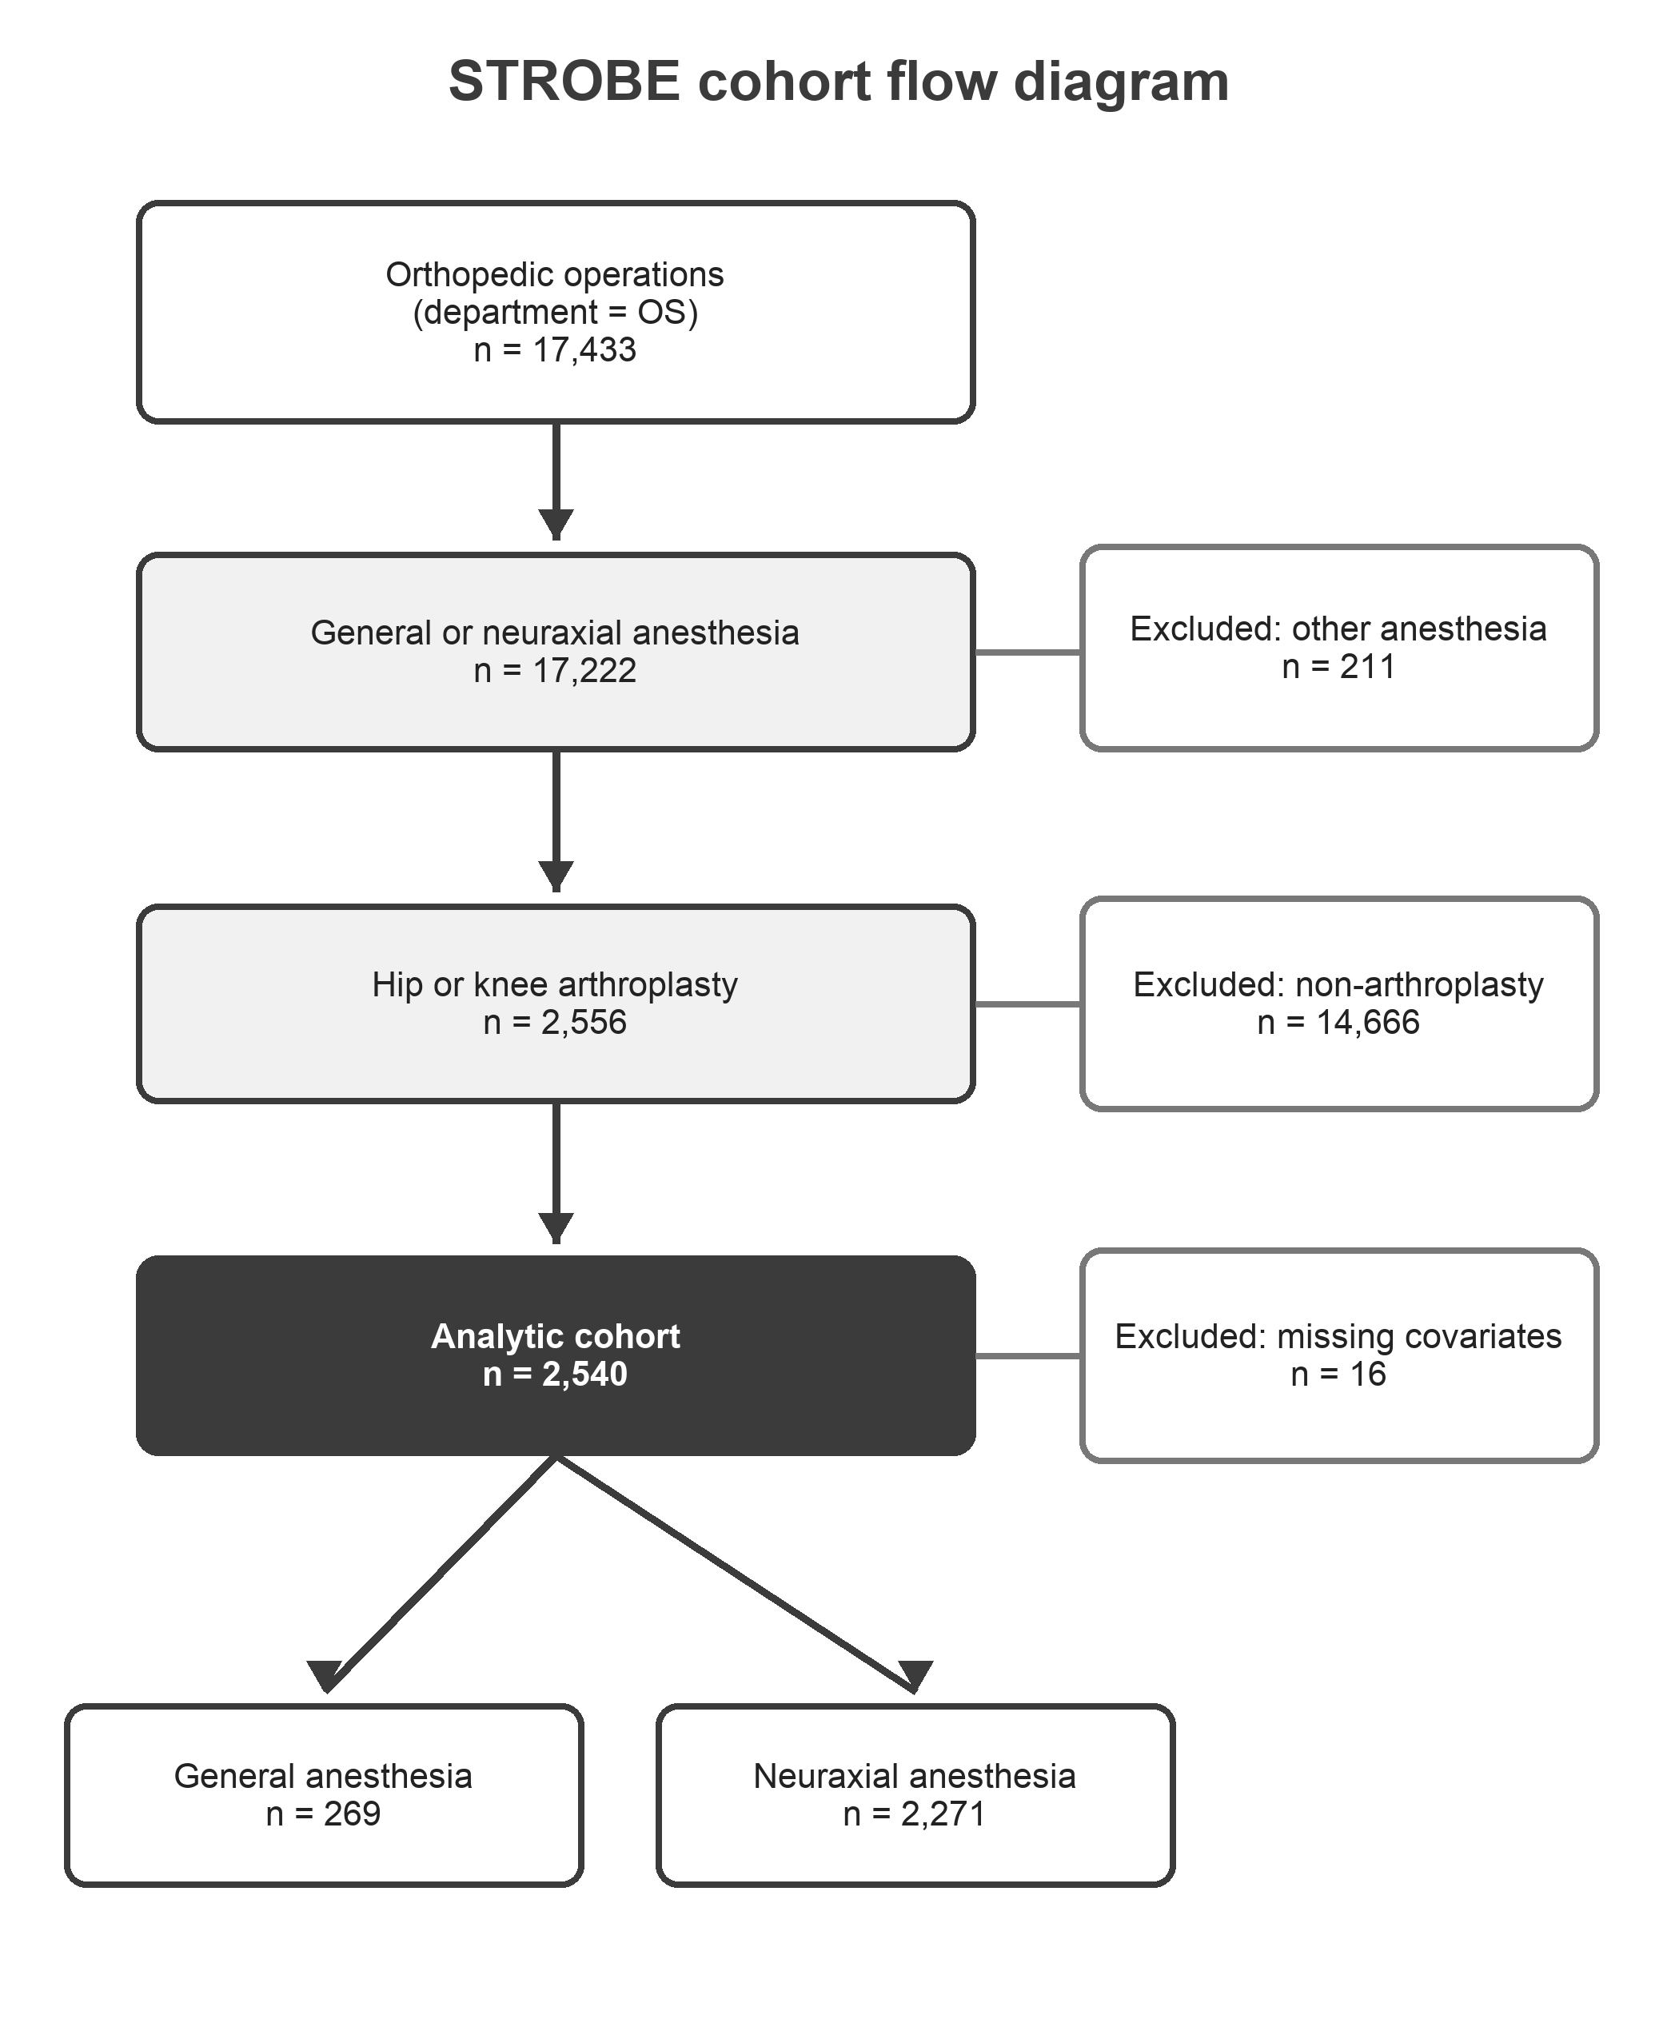
Figure 3. Cohort selection. Counts reconcile as 17,433 − 211 = 17,222; 17,222 − 14,666 = 2,556; and 2,556 − 16 = 2,540; group totals reconcile as 269 + 2,271 = 2,540.

4. Discussion

4.1. Principal Findings
In this single-center arthroplasty cohort, neuraxial anesthesia was associated with shorter hospital LOS and lower odds of any postoperative ICU admission during the index hospitalization after adjustment for measured preoperative and procedural characteristics. The direction and magnitude of the associations were stable across IPTW, broader orthopedic-cohort, and alternative LOS-model analyses. Weighting achieved strong measured-covariate balance without a substantial loss of effective sample size. These convergent results support the robustness of the observed association to the evaluated model specifications, but they do not eliminate residual confounding or establish a causal effect.

4.2. Comparison with Existing Evidence
The findings are broadly consistent with a systematic review and large observational arthroplasty studies associating neuraxial anesthesia with modestly shorter hospitalization or fewer perioperative complications [2–5]. In more contemporary cohorts, neuraxial anesthesia has been associated with greater home-discharge probability [9], lower failure of same-day discharge despite a longer recovery-room stay [10], and small reductions in LOS and hospital charges after knee arthroplasty [11]. The present estimate for LOS is larger than the 1% reduction reported in one national knee-arthroplasty database [11], which may reflect differences in case mix, procedure definitions, discharge systems, and the much longer hospitalization observed in INSPIRE.
Interpreting perioperative resource use requires separating administrative endpoints from direct measures of recovery. This distinction is central to related work on orthopedic resource outcomes: predictive models for non-home discharge after fracture trauma treat discharge destination as an admission-time resource-planning endpoint, shaped by patient selection and care pathways rather than by functional status [14,15]. The same caution applies here, where length of stay and ICU admission quantify resource use but not mobility, rehabilitation progress, or patient-reported recovery.

4.3. Interpretation for Arthroplasty Recovery Pathways
Anesthetic technique may affect pain, opioid exposure, nausea, respiratory stability, hemodynamics, and early motor function, all of which can influence readiness for mobilization and discharge [1,10]. Nevertheless, the randomized fast-track literature does not uniformly favor neuraxial anesthesia; one trial reported earlier discharge readiness with a contemporary general-anesthesia regimen [6]. Technique-specific factors—including intrathecal dose, duration of motor block, multimodal analgesia, and local rehabilitation protocols—may be more informative than a binary anesthesia label. The current data therefore support an association with early postoperative resource use, not a universal recommendation for one anesthetic technique.

4.4. Strengths and Limitations
This study has several strengths: a clearly defined arthroplasty cohort, prespecified covariate adjustment, complete saved model output, robust standard errors, explicit propensity-score diagnostics, and consistent findings across multiple sensitivity analyses. The principal limitation is outcome validity. LOS and ICU admission are administrative measures rather than direct assessments of mobility, pain, range of motion, rehabilitation progress, discharge destination, or patient-reported recovery. LOS is additionally influenced by institutional practice, social support, payer constraints, and bed availability. Second, anesthesia assignment was nonrandom. The smaller general-anesthesia group had greater ASA and emergency burden, supporting concern for confounding by indication. Adjustment and IPTW address measured covariates but cannot account for frailty, baseline function, surgical complexity, contraindications, clinician preference, or unmeasured temporal changes. Third, the analysis used operation-level records from one South Korean academic center over 2011–2020; repeated operations by the same patient could not be assessed with the aggregate outputs, and generalizability to current fast-track or outpatient pathways is limited. Fourth, no time-period variable was included, leaving potential confounding by secular changes in anesthesia and discharge practice. Finally, the predominance of neuraxial anesthesia limits precision for the general-anesthesia comparator despite acceptable measured propensity-score overlap.

4.5. Clinical and Research Implications
The results support considering anesthetic technique within multidisciplinary arthroplasty pathway evaluation, but they should not be used alone to mandate neuraxial anesthesia. Future studies should distinguish spinal, epidural, and combined techniques; capture anesthetic dose and conversion; account for calendar time and repeated operations; and incorporate pain, opioid exposure, time to ambulation, rehabilitation participation, discharge destination, and validated patient-reported outcomes. A prospective multicenter design or target-trial emulation with richer baseline function and frailty measures would better address treatment-selection bias and clarify whether differences in resource use translate into meaningful recovery benefits.
This priority aligns with broader evidence that translating perioperative prediction and decision tools into practice remains limited by external validation, calibration drift, interpretability, and workflow integration [13].

5. Conclusions
In this retrospective INSPIRE cohort, neuraxial anesthesia was associated with shorter hospital LOS and lower odds of any postoperative ICU admission during the index hospitalization after hip or knee arthroplasty. Results were consistent across adjusted, weighted, broader-cohort, and alternative-distribution analyses. Because anesthesia assignment was nonrandom and outcomes measured resource use rather than function, the findings should be interpreted as associations and not as evidence that neuraxial anesthesia causes better functional recovery. Studies incorporating direct recovery outcomes and stronger control of treatment selection are warranted.

Supplementary Materials
Figure S1: Distribution of hospital LOS by anesthesia type; Figure S2: LOS violin plot by anesthesia type; Figure S3: ICU-admission rate by anesthesia type. The Zenodo archive additionally contains aggregate cohort-flow data, Table 1 source data, complete model coefficient tables, propensity-score diagnostics, weight summaries, software metadata, and the disclosure-audit result.

Author Contributions
Conceptualization, Z.S., R.Z., N.P. and A.T.; methodology, Z.S., R.Z., N.P., S.S. and A.T.; software, Z.S.; validation, R.Z., N.P., S.S., R.P. and A.T.; formal analysis, Z.S., R.Z. and N.P.; investigation, Z.S., R.Z., N.P., S.S., R.P., A.S., Z.B. and C.H.; data curation, Z.S., R.Z. and N.P.; writing—original draft preparation, Z.S., R.Z. and N.P.; writing—review and editing, Z.S., R.Z., N.P., S.S., R.P., A.S., Z.B., C.H. and A.T.; visualization, Z.S., R.Z. and N.P.; supervision, A.T.; project administration, Z.S. and A.T. All authors have read and agreed to the published version of the manuscript. Z.S., R.Z. and N.P. contributed equally to this work and share first authorship.

Funding
This research received no external funding.

Institutional Review Board Statement
The creation and public release of the de-identified INSPIRE dataset were approved by the Seoul National University Hospital Institutional Review Board (H-2210-078-1368) and Data Review Board (BD-R-2022-11-02).

Informed Consent Statement
The Seoul National University Hospital Institutional Review Board waived informed consent because of the retrospective design and de-identified data.

Data Availability Statement
Patient-level data were obtained from INSPIRE version 1.4.2, available through PhysioNet under credentialed access (https://physionet.org/content/inspire/1.4.2/; DOI: 10.13026/1eay-yc85). Access requires credentialing, required training, and execution of the applicable data-use agreement. The authors cannot redistribute the source data. Complete analysis code and non-disclosive aggregate reproducibility outputs are archived on Zenodo (Version v1.0.0; https://doi.org/10.5281/zenodo.22051133) and maintained at https://github.com/ZaneSalman/inspire-arthroplasty-anesthesia.

Acknowledgments
The authors acknowledge the investigators who created and shared INSPIRE through PhysioNet and the maintainers of the open-source software used in this analysis.

Conflicts of Interest
The authors declare no conflicts of interest.

References
1. Wainwright, T.W.; Gill, M.; McDonald, D.A.; et al. Consensus statement for perioperative care in total hip replacement and total knee replacement surgery: Enhanced Recovery After Surgery (ERAS®) Society recommendations. Acta Orthop. 2020, 91, 3–19. https://doi.org/10.1080/17453674.2019.1683790.
2. Johnson, R.L.; Kopp, S.L.; Burkle, C.M.; et al. Neuraxial vs general anaesthesia for total hip and total knee arthroplasty: A systematic review of comparative-effectiveness research. Br. J. Anaesth. 2016, 116, 163–176. https://doi.org/10.1093/bja/aev455.
3. Memtsoudis, S.G.; Sun, X.; Chiu, Y.L.; et al. Perioperative comparative effectiveness of anesthetic technique in orthopedic patients. Anesthesiology 2013, 118, 1046–1058. https://doi.org/10.1097/ALN.0b013e318286061d.
4. Pugely, A.J.; Martin, C.T.; Gao, Y.; Mendoza-Lattes, S.; Callaghan, J.J. Differences in short-term complications between spinal and general anesthesia for primary total knee arthroplasty. J. Bone Joint Surg. Am. 2013, 95, 193–199. https://doi.org/10.2106/JBJS.K.01682.
5. Basques, B.A.; Toy, J.O.; Bohl, D.D.; Golinvaux, N.S.; Grauer, J.N. General compared with spinal anesthesia for total hip arthroplasty. J. Bone Joint Surg. Am. 2015, 97, 455–461. https://doi.org/10.2106/JBJS.N.00662.
6. Harsten, A.; Kehlet, H.; Toksvig-Larsen, S. Recovery after total intravenous general anaesthesia or spinal anaesthesia for total knee arthroplasty: A randomized trial. Br. J. Anaesth. 2013, 111, 391–399. https://doi.org/10.1093/bja/aet104.
7. Lim, L.; et al. INSPIRE, a publicly available research dataset for perioperative medicine. Sci. Data 2024, 11, 655. https://doi.org/10.1038/s41597-024-03517-4.
8. von Elm, E.; Altman, D.G.; Egger, M.; Pocock, S.J.; Gøtzsche, P.C.; Vandenbroucke, J.P.; STROBE Initiative. The Strengthening the Reporting of Observational Studies in Epidemiology (STROBE) statement: Guidelines for reporting observational studies. Lancet 2007, 370, 1453–1457. https://doi.org/10.1016/S0140-6736(07)61602-X.
9. Duque, M.; Schnetz, M.P.; Yates, A.J., Jr.; Monahan, A.; Whitehurst, S.; Mahajan, A.; Kaynar, A.M. Impact of neuraxial versus general anesthesia on discharge destination in patients undergoing primary total hip and total knee replacement. Anesth. Analg. 2021, 133, 1379–1386. https://doi.org/10.1213/ANE.0000000000005156.
10. Yap, E.; Wei, J.; Webb, C.; Ng, K.; Behrends, M. Neuraxial and general anesthesia for outpatient total joint arthroplasty result in similarly low rates of major perioperative complications: A multicentered cohort study. Reg. Anesth. Pain Med. 2022, 47, 294–300. https://doi.org/10.1136/rapm-2021-103189.
11. Long, H.; Zeng, C.; Xiong, Y.; Shi, Y.; Wang, H.; Lei, G. Neuraxial versus general anesthesia for perioperative outcomes and resource utilization following knee arthroplasty: Experience from a large national database. Arch. Orthop. Trauma Surg. 2023, 143, 2153–2163. https://doi.org/10.1007/s00402-022-04483-5.
12. Austin, P.C.; Stuart, E.A. Moving towards best practice when using inverse probability of treatment weighting using the propensity score to estimate causal treatment effects in observational studies. Stat. Med. 2015, 34, 3661–3679. https://doi.org/10.1002/sim.6607.
13. Salman, S.; Phadke, R.; Kumar, R.; Momin, A.; Tavakkoli, A. Risk prediction in spine surgery: A scoping review of traditional models, artificial intelligence, and the challenge of clinical translation. Spine Deform. 2026. https://doi.org/10.1007/s43390-026-01365-3.
14. Salman, S.G.; Phadke, R.; Carlin, T.; et al. The fracture orthopedic risk of non-home discharge (FORD) score: A novel bedside predictive tool for non-home discharge in orthopedic trauma patients. Injury 2026, 57, 113301. https://doi.org/10.1016/j.injury.2026.113301.
15. Salman, S.G.; Phadke, R.; Carlin, T.; et al. Fracture orthopedic risk of non-home discharge score II (FORD-II). Injury 2026, 57, 113527. https://doi.org/10.1016/j.injury.2026.113527.

