Neuraxial versus General Anesthesia and Recovery Burden after Orthopedic Surgery
Tables and figures. Estimates derived from INSPIRE (Seoul National University Hospital perioperative registry). Values are the study's own model output; see Methods for cohort and model definitions.

Table 1. Baseline characteristics of the arthroplasty cohort, by anesthesia type
Characteristic | General (n=269) | Neuraxial (n=2271)
Age, mean (years) | 68.1 | 66.1
Female, % | 65.8 | 74.9
ASA class 3+, % | 22.7 | 8.4
Emergency surgery, % | 8.2 | 2.7
Knee (vs hip), % | 33.5 | 49.9
Length of stay, median (days) | 12.0 | 11.0
ICU admission, % | 15.2 | 5.0
Arthroplasty cohort (n = 2,540 with complete covariates). General-anesthesia patients were older and had higher ASA class and emergency proportions, indicating confounding by indication.

Table 2. Adjusted associations with recovery outcomes (arthroplasty, primary models)
Variable | LOS ratio (95% CI) | p | ICU OR (95% CI) | p
Neuraxial (vs general) | 0.892 (0.840–0.947) | <0.001 | 0.494 (0.324–0.753) | 0.001
ASA 3+ | 1.231 (1.156–1.310) | <0.001 | 5.289 (3.613–7.743) | <0.001
Knee (vs hip) | 1.304 (1.250–1.360) | <0.001 | 0.327 (0.215–0.498) | <0.001
Age (per year) | 1.000 (0.998–1.001) | 0.739 | 1.028 (1.013–1.045) | <0.001
Female | 1.055 (1.009–1.103) | 0.019 | 0.889 (0.605–1.306) | 0.548
Emergency | 1.113 (1.003–1.235) | 0.045 | 1.200 (0.608–2.369) | 0.599
LOS from Gamma generalized linear model (log link); ratio <1 indicates shorter mean length of stay. ICU admission from logistic regression; OR <1 indicates lower odds. Adjusted for age, sex, ASA class, emergency status, and procedure (hip/knee).

Table 3. Sensitivity analyses of the neuraxial effect
Analysis | LOS ratio (95% CI) | ICU OR (95% CI)
Arthroplasty, adjusted | 0.892 (0.840–0.947) | 0.494 (0.324–0.753)
Arthroplasty, IPTW-weighted | 0.900 (0.847–0.955) | 0.440 (0.277–0.697)
All orthopedic, adjusted | 0.913 (0.879–0.949) | 0.669 (0.584–0.767)
The neuraxial association was consistent across the adjusted primary model, IPTW-weighted analysis, and the broader all-orthopedic cohort.

Figure 1. Forest plot of the neuraxial effect across analyses
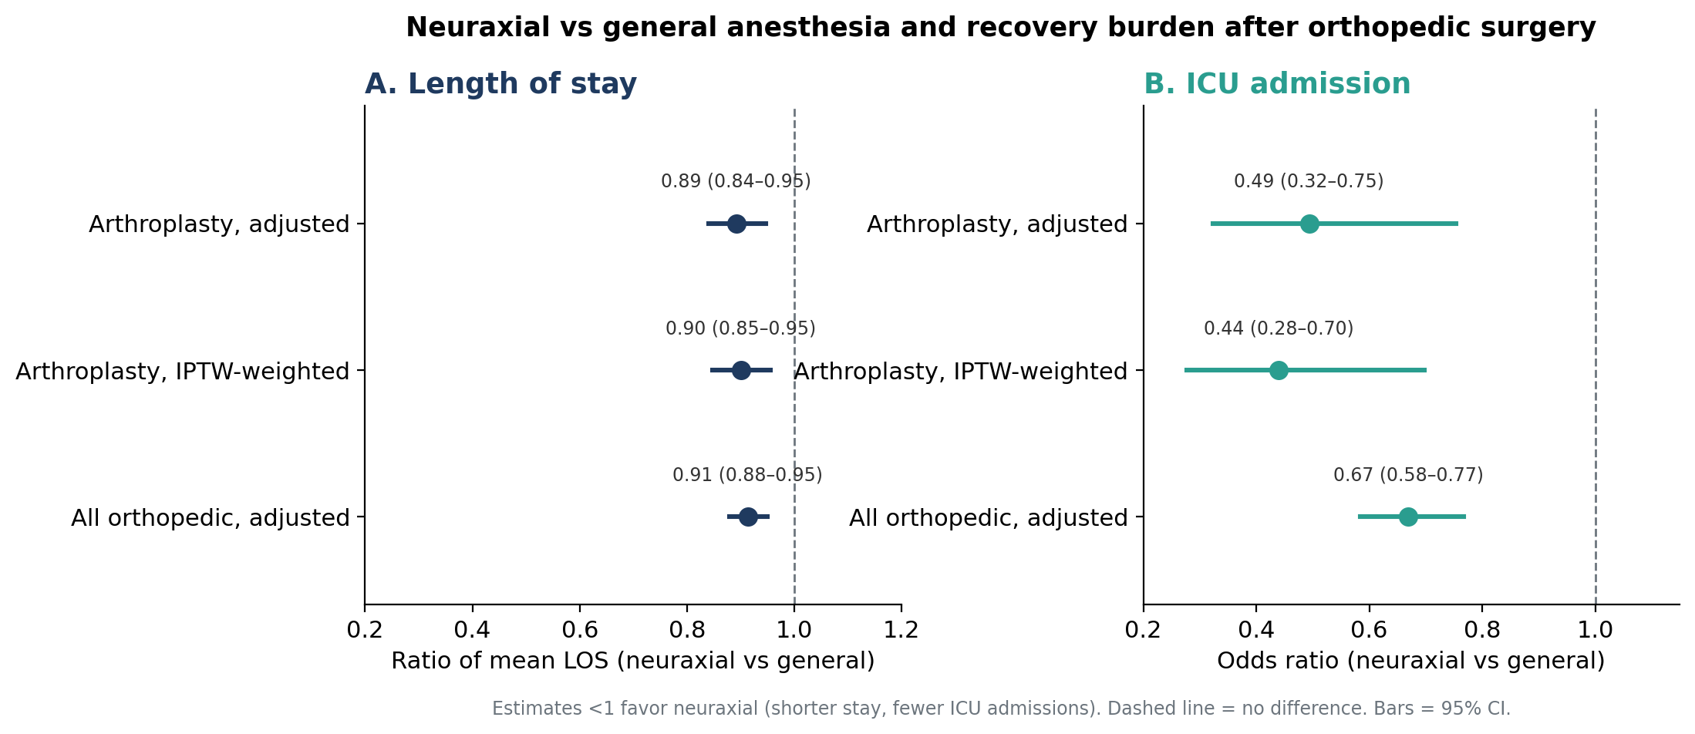
Panel A: ratio of mean length of stay. Panel B: odds of ICU admission. Estimates below 1 favor neuraxial anesthesia. Bars are 95% confidence intervals.

Figure 2. Covariate balance before and after IPTW
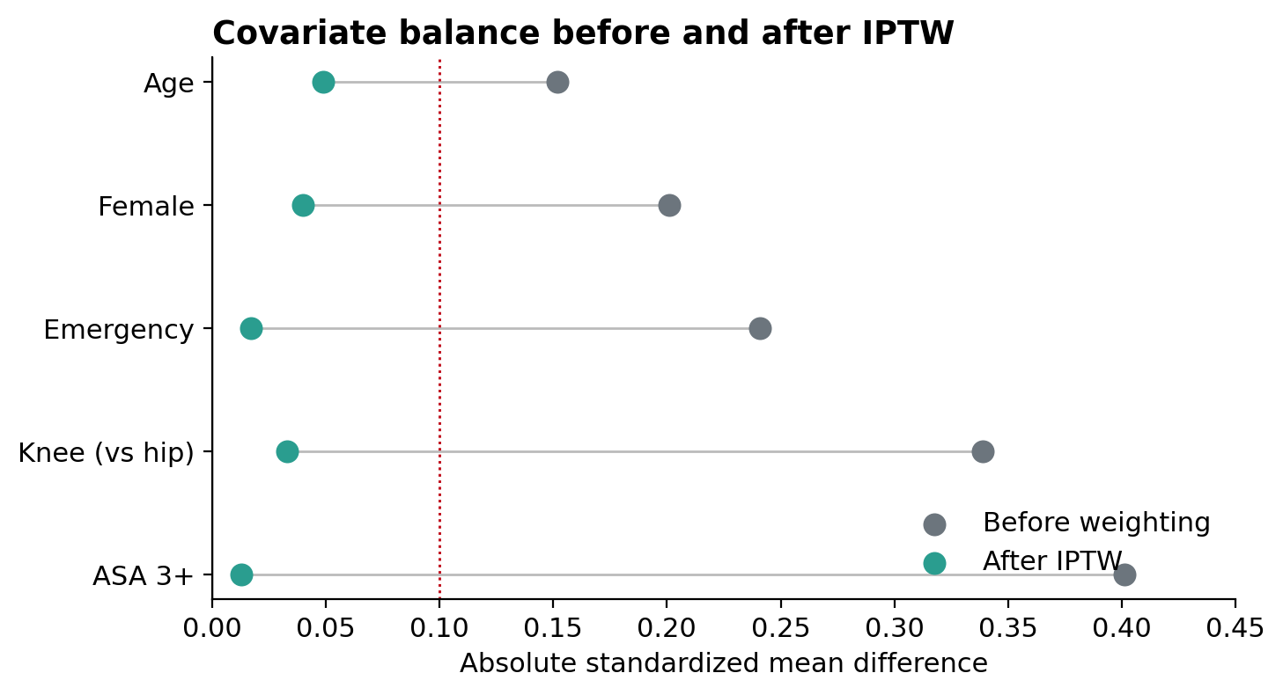
Absolute standardized mean differences. After inverse-probability-of-treatment weighting, all covariates fall below the 0.1 threshold, indicating good balance between anesthesia groups.
Limitation note: length of stay and ICU admission are administrative proxies for recovery burden, not direct measures of musculoskeletal function. Anesthetic choice was non-random; residual confounding from unmeasured factors (frailty, functional status, surgeon preference) cannot be excluded.

