Lab4
1.. Objective
- Learn how to install and run Gitea using Docker Desktop on Windows.
- Understand and verify Git LFS (Large File Storage) functionality.
- Learn how to create, commit, and back up repositories in Gitea.
- Explore installing Gitea without Docker.
3. Experiment Steps
2.Install Docker Desktop
Run the following command in PowerShell (Administrator):
wsl --install
Skip this step if WSL2 is already installed.
Then download and install Docker Desktop for Windows from
https://www.docker.com/products/docker-desktop/
After installation, open Docker Desktop and log in (register a Docker ID if needed).
Make sure the whale icon turns blue, indicating Docker Engine is running properly
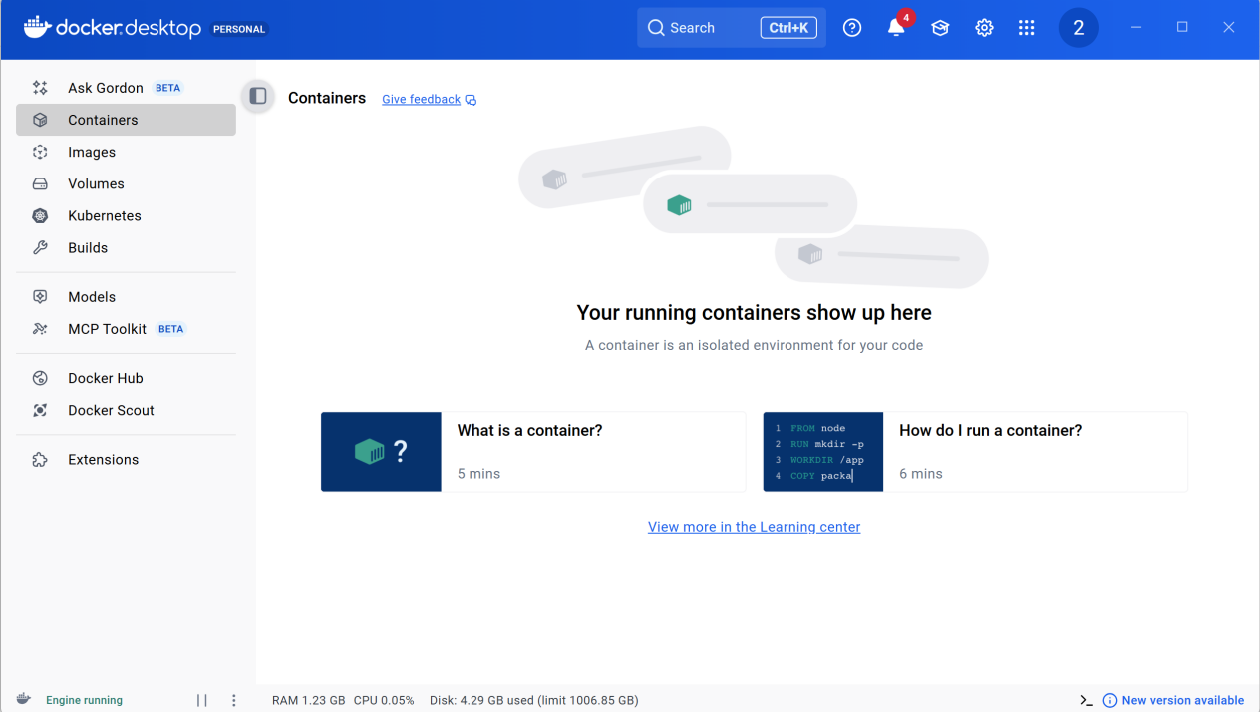
3. Install Gitea Using Docker
Create Gitea directories (example: on drive D:):
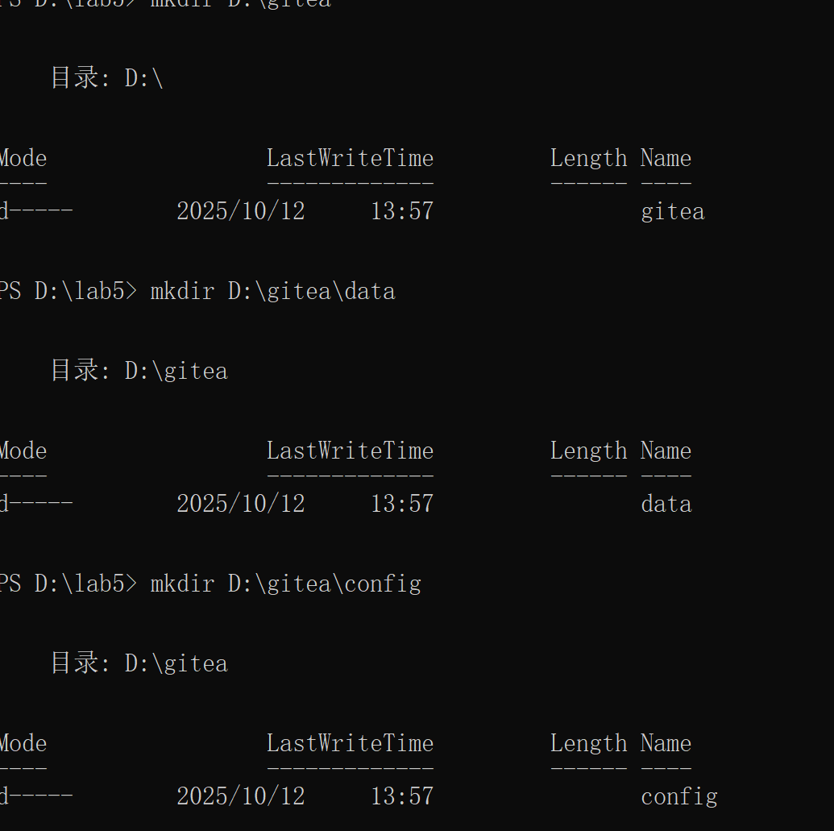
Run the container:
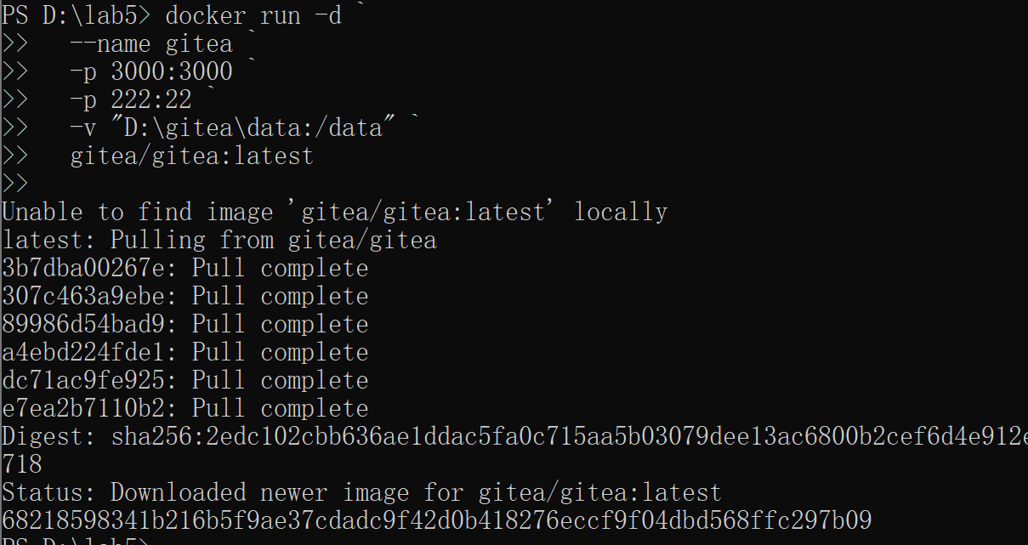
Then open a browser and visit:
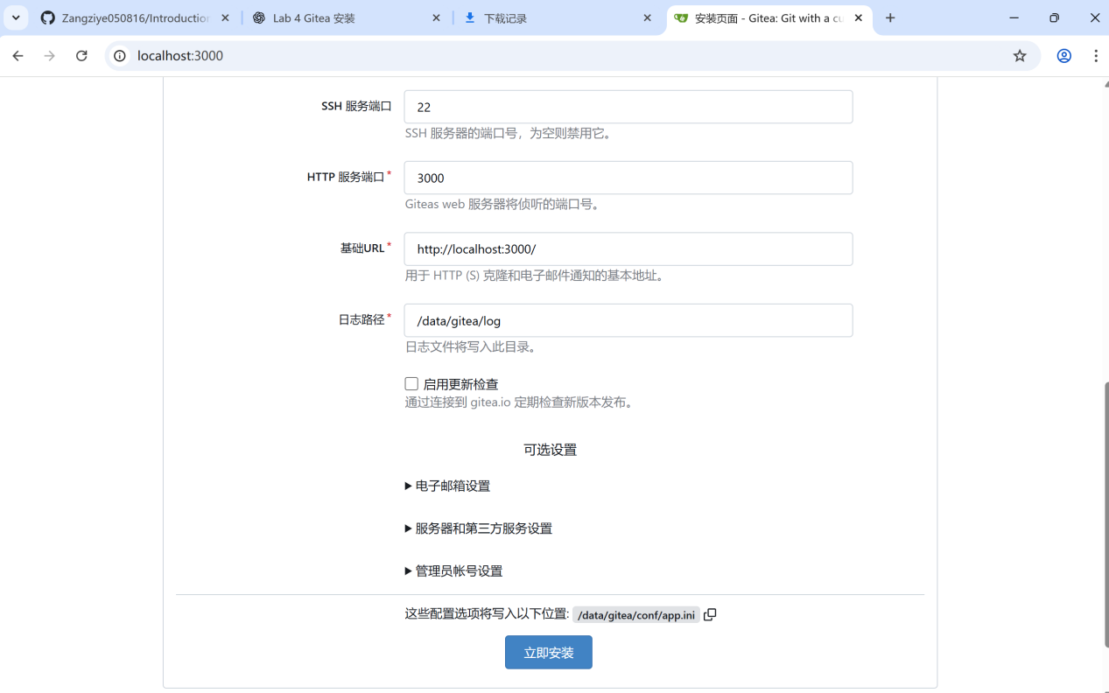
Complete the installation using SQLite3 as the database and create an administrator account.
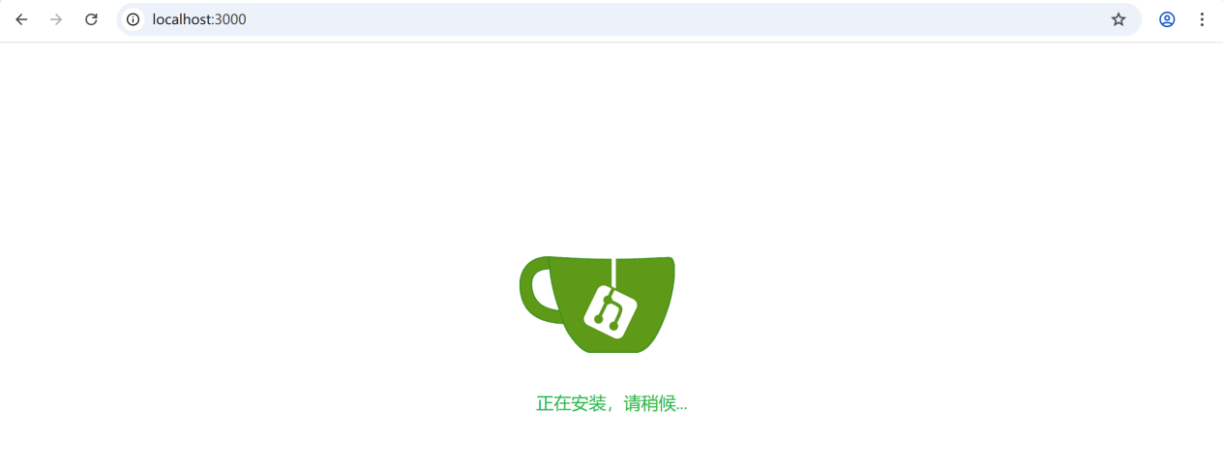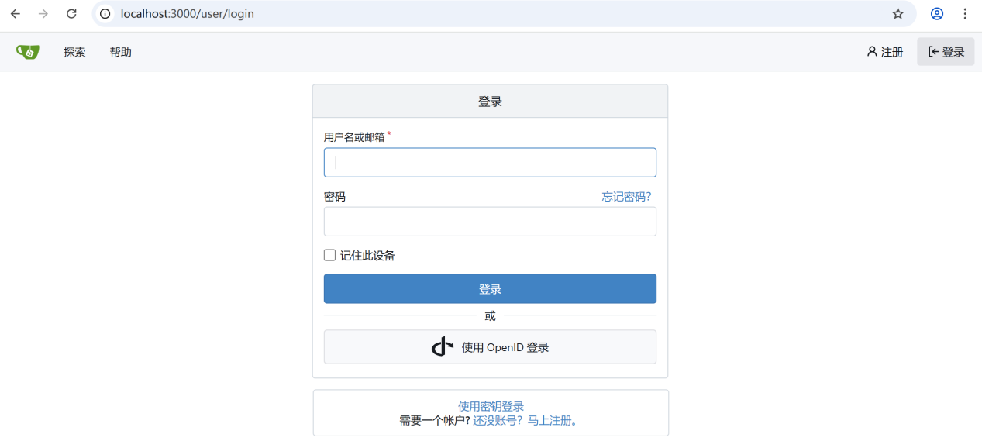
3. Verify LFS Support

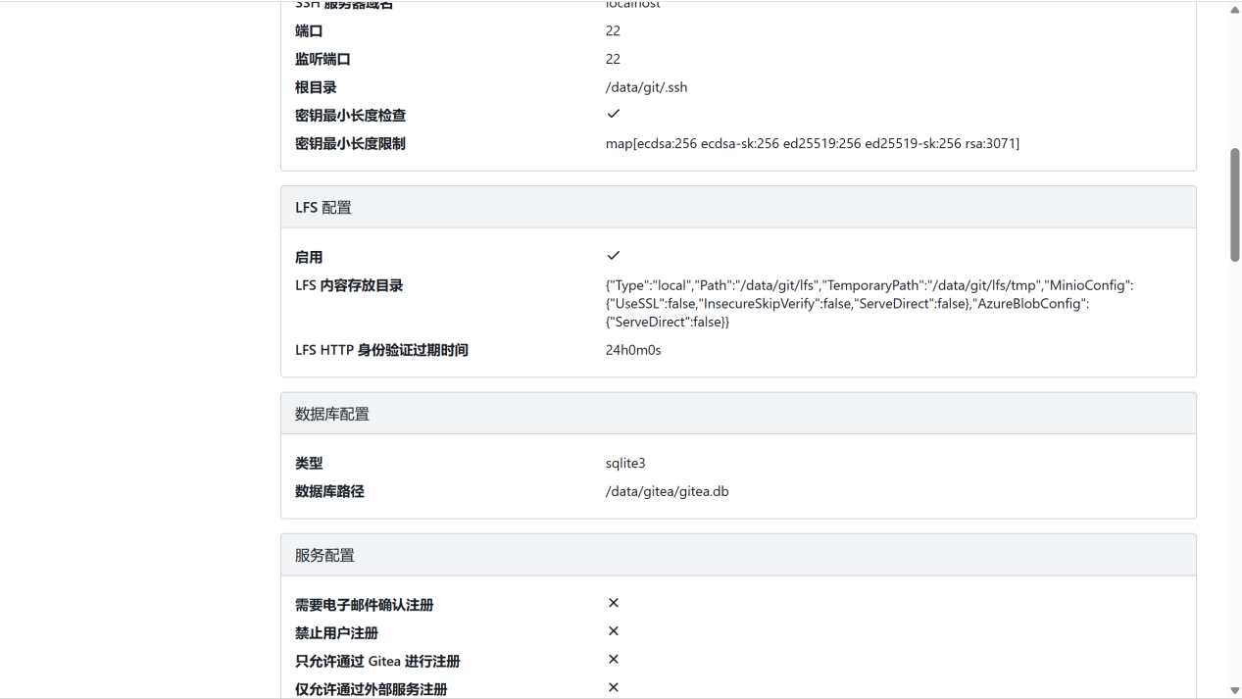
SUPPORT！
4.Create a Repository with a Large File (1GB+)
In Gitea, create a new repository called bigfile-test.
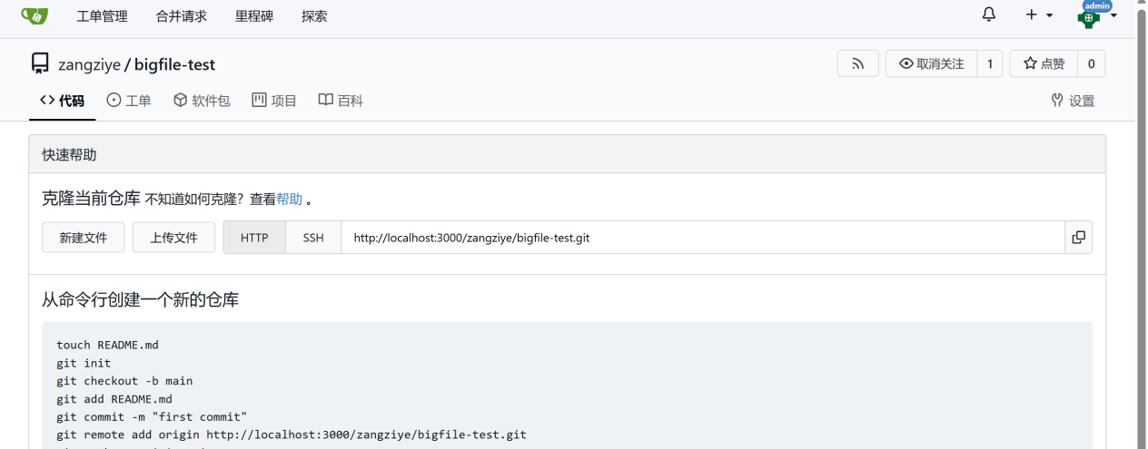
Clone it to local:
Command：
git clone http://localhost:3000/zangziye/bigfile-test.git
cd bigfile-test
Generate a large file:
Track with LFS and commit:
