Lab3（Create personal page）
Requirements
- Create a GitHub account.
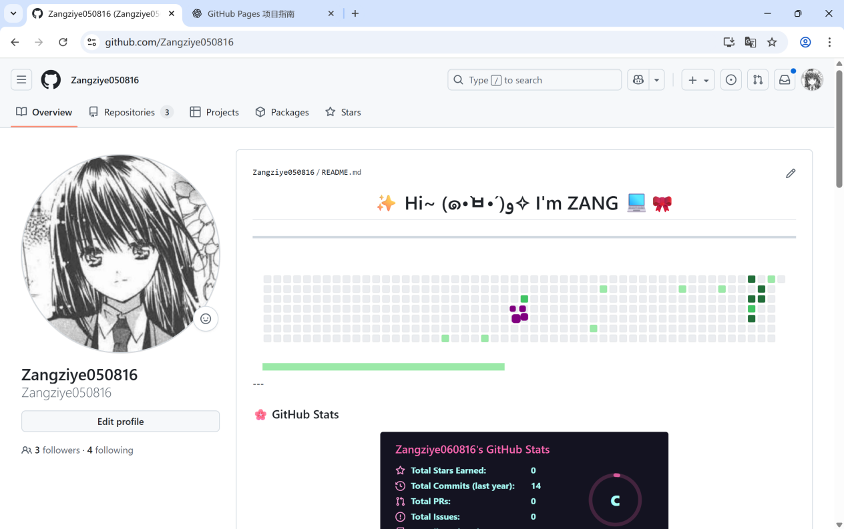
- Set up a new repository named username.github.io, where username is your GitHub username.
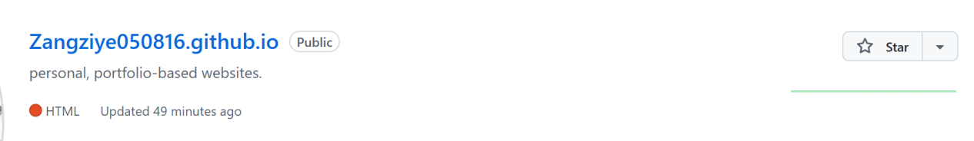
- Add at least a home page to give a brief introduction of yourself.
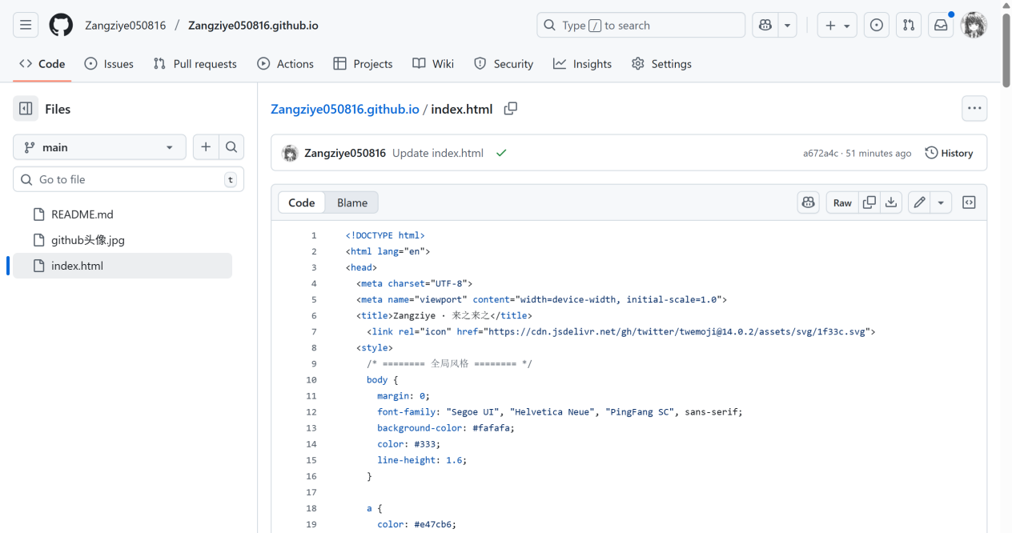
4. Optional: Customize the layout and style using HTML and CSS by using Jekyll themes or other templates.
5. Publish the website and verify that it is accessible at https://username.github.io.
