(a) Describe the Three Primary Cloud Service Models
In cloud computing, there are three primary service models that provide different levels of abstraction and flexibility for managing IT resources. These are:
1. Infrastructure as a Service (IaaS)
- Description: IaaS provides virtualized computing resources over the internet. It offers essential infrastructure components such as virtual machines (VMs), storage, networking, and security tools, which users can rent on-demand without owning the hardware.
- Example: AWS EC2 (Elastic Compute Cloud), Google Compute Engine, Microsoft Azure Virtual Machines.
- Application in Software Development: Developers can provision and scale infrastructure to run applications and services without having to worry about managing physical hardware. For example, a development team can use AWS EC2 to set up development and staging environments that mimic production environments.
2. Platform as a Service (PaaS)
- Description: PaaS provides a platform that allows developers to build, deploy, and manage applications without dealing with the underlying infrastructure. PaaS platforms typically offer tools for development, testing, and hosting, along with built-in scalability.
- Example: Heroku, Google App Engine, Microsoft Azure App Services.
- Application in Software Development: PaaS allows developers to focus on coding and application logic rather than infrastructure management. For instance, a developer can deploy a Node.js app on Heroku, where the platform automatically manages scaling, load balancing, and server provisioning.
3. Software as a Service (SaaS)
- Description: SaaS delivers fully functional applications over the internet, which users can access through a browser. These applications are hosted, managed, and updated by the service provider, with little to no involvement from the end user in terms of infrastructure or software management.
- Example: Google Workspace (Gmail, Google Docs), Microsoft 365, Slack.
- Application in Software Development: Developers can use SaaS tools for collaboration, project management, and version control, such as using GitHub or Bitbucket for source code hosting, or Slack for team communication.
(b) What is Docker?
Docker is an open-source platform that automates the process of building, deploying, and running applications inside lightweight, portable containers. These containers encapsulate an application and its dependencies, ensuring that it runs consistently across different environments. Docker provides an efficient and reliable way to package and distribute software.
Scenario for Using Docker in Software Development:
Imagine you are developing a web application that uses a specific version of Node.js, a MongoDB database, and Redis for caching. On a developer's machine, these services may be running on different versions, which can lead to inconsistencies. By using Docker, you can create containers for each service (Node.js, MongoDB, Redis), ensuring that the application works the same way on every developer's machine, as well as in staging and production environments.
How Docker Contributes to Development and Deployment:
- Consistency: Docker containers ensure that the software behaves the same way in different environments (e.g., development, testing, production). This removes issues such as "it works on my machine" that arise due to environment differences.
- Isolation: Docker isolates applications and their dependencies in containers, allowing developers to run multiple versions of the same application or service on the same machine without conflicts.
- Scalability: With Docker, you can quickly spin up new containers to scale your application as needed, and Kubernetes can manage container orchestration for even larger applications.
- Faster Deployment: Docker simplifies the deployment process by providing a standardized environment. This makes it easier to automate deployments and rollbacks.

(c) Deploy n8n (n8n.io) with Docker
n8n is an open-source workflow automation tool that can be easily deployed using Docker. Here is how you can deploy it with Docker on your local machine.
Docker Command to Deploy n8n:
- Pull the n8n Docker Image:
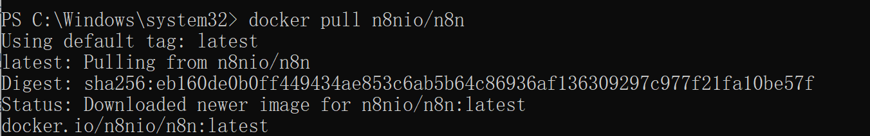
Accessing the n8n Web Interface:
Once the container is up and running, open a browser and go to http://127.0.0.1:5678. You should see the n8n interface where you can start creating and managing workflows.
Explanation of the Docker Command:
- docker run: This command starts a new container from a specified image (in this case, n8nio/n8n).
- -d: Detaches the container, meaning it runs in the background.
- -p 5678:5678: This exposes port 5678 of the container to port 5678 on the host machine, making the n8n web interface accessible at http://127.0.0.1:5678.
- --name n8n: This option assigns a human-readable name (in this case, n8n) to the running container, which helps in managing the container later (e.g., stopping or restarting).
Screenshot:
