1. Get the following files from your lecturer:
your name.crt
your name.key
ca.crt
and then put the files in the folder called nebula
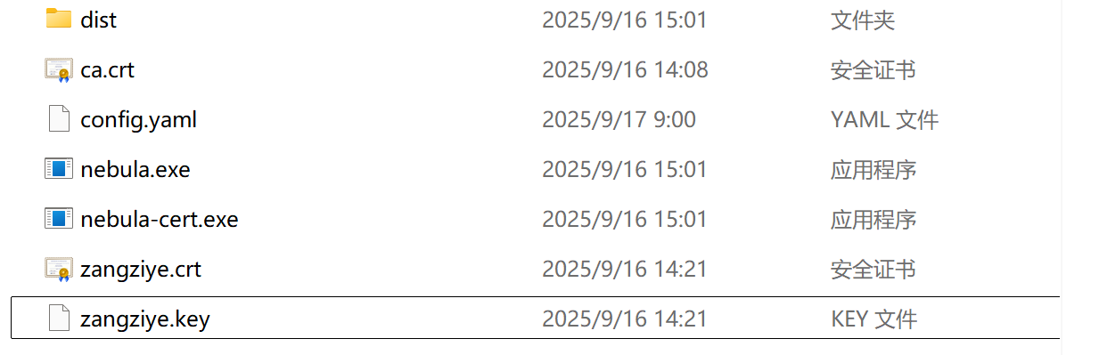
2. You should make your own configuration file for all participating comptuers. use a data comparison utility such as Meld and [Beyond Compare] to compare the configuration files attached to see where the changes should be made.
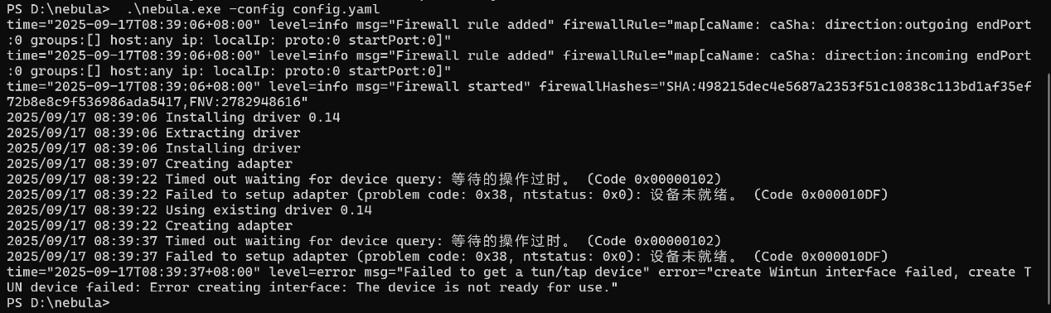
3. Run nebula and check the connectivity between your computer and the light house. The IP address of the light house in the overlay network is 192.168.100.1. Please note that the config.yaml for the lighthouse is already properly prepared.
Ping an ip address
