Lab10 KServe
Deploying a Predictive Model with KServe on Minikube
1.Experiment Objectives
This experiment aims to deploy KServe on a local Minikube Kubernetes cluster and serve a machine learning model for inference. The goals are:
Install and configure KServe
- Deploy a predictive model using InferenceService
- Monitor the service and debug issues
- Access the model endpoint from outside the cluster
- Send inference requests and interpret the results
2.Experiment Environment
OS：Windows + WSL2 Ubuntu
Kubernetes：Minikube (driver=docker, 4 CPU, 8GB RAM)
Container Runtime：Docker
Helm：v3.19.2
cert-manager：v1.17.0
KServe：v0.15.0
Model：sklearn Iris Classification
3.Experimental Steps
3.1 Start Minikube
Expected: Node is in Ready state.
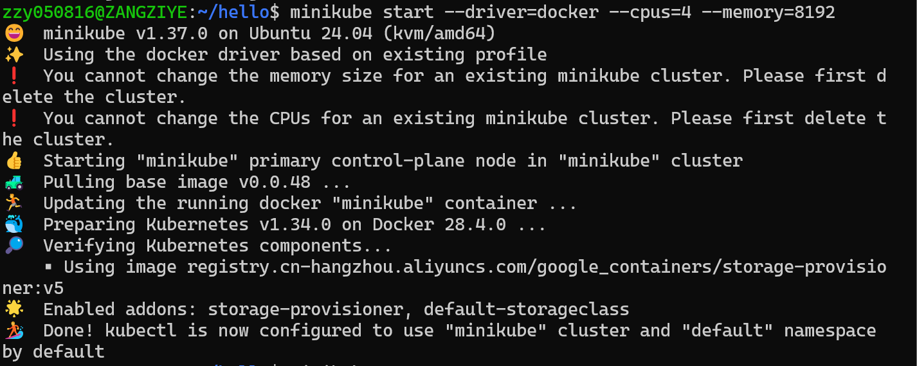
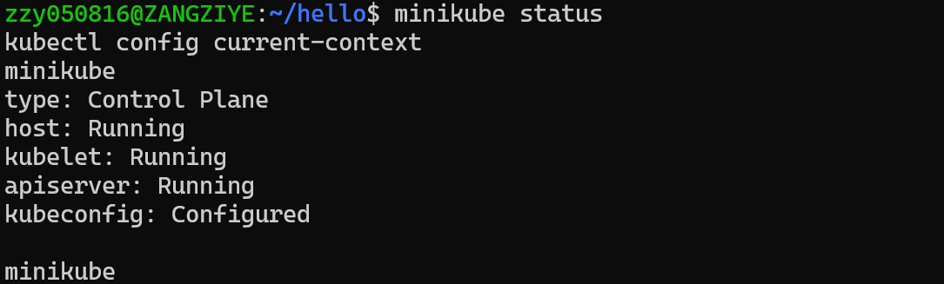
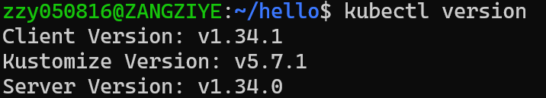
3.2Install Helm
Expected output includes:
3.3Install KServe CRDs
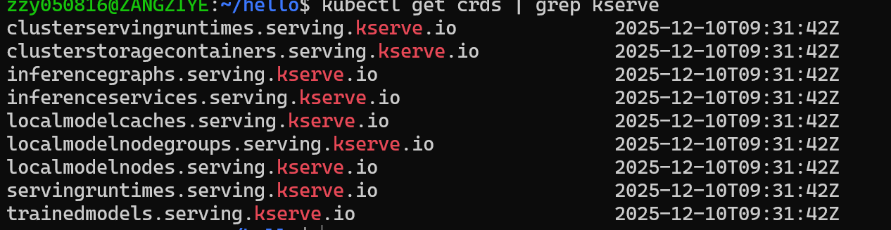
3.4Install cert-manager (local YAML)
(Installed using local YAML due to WSL network limits)
All cert-manager pods must be Running.
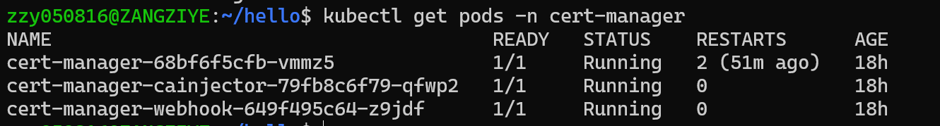
3.5 Install KServe Core Components
kubectl apply --server-side -f kserve.yaml
kubectl apply --server-side -f kserve-cluster-resources.yaml
3.6 Debugging Controller CrashLoopBackOff (Important Part of the Experiment)
Initially, KServe controller failed with:
"error": "invalid deployment mode. Supported modes are Serverless, RawDeployment, ModelMesh"
Fix：kubectl patch configmap/inferenceservice-config -n kserve \
--type=strategic \
-p '{"data":{"deploy":"{\"defaultDeploymentMode\":\"RawDeployment\"}"}}'
kubectl rollout restart deployment kserve-controller-manager -n kserve
Verify:
3.7 Deploy the InferenceService
Create namespace&Deploy the sklearn-iris model
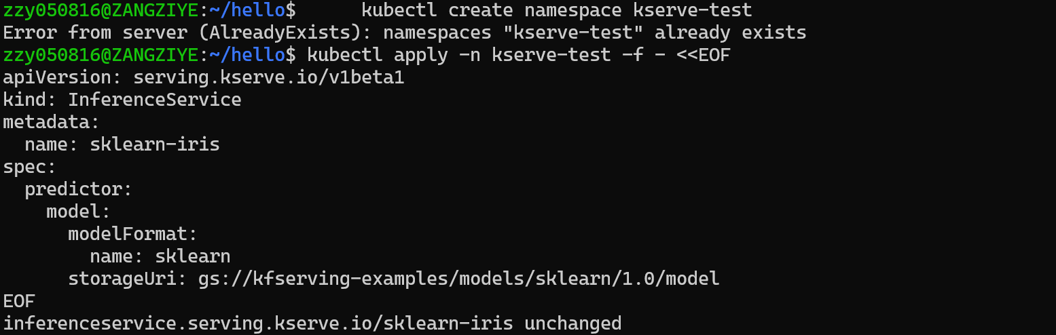
Check status:
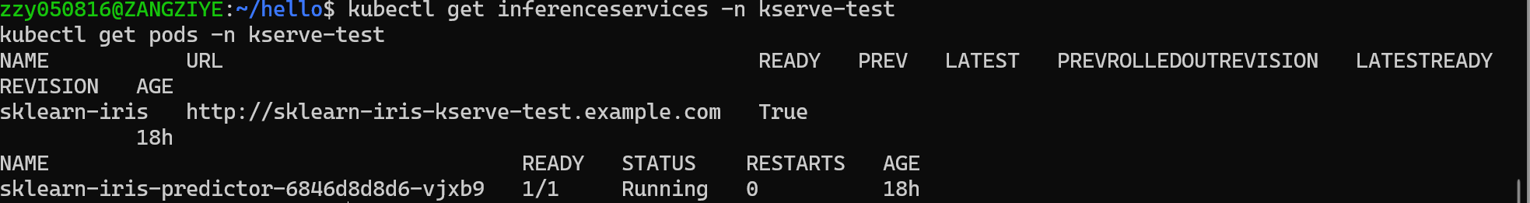
3.8 Access the Model Service (Port Forwarding)
Find the service:
Forward port:
3.9 Send Inference Request
Prepare input:
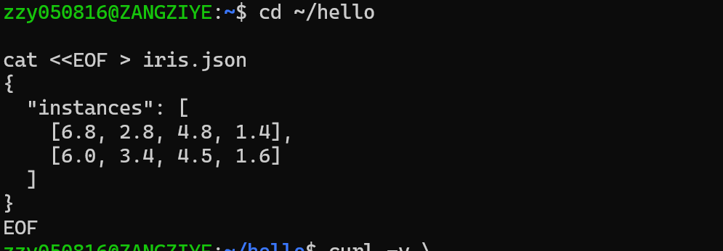
Send request:
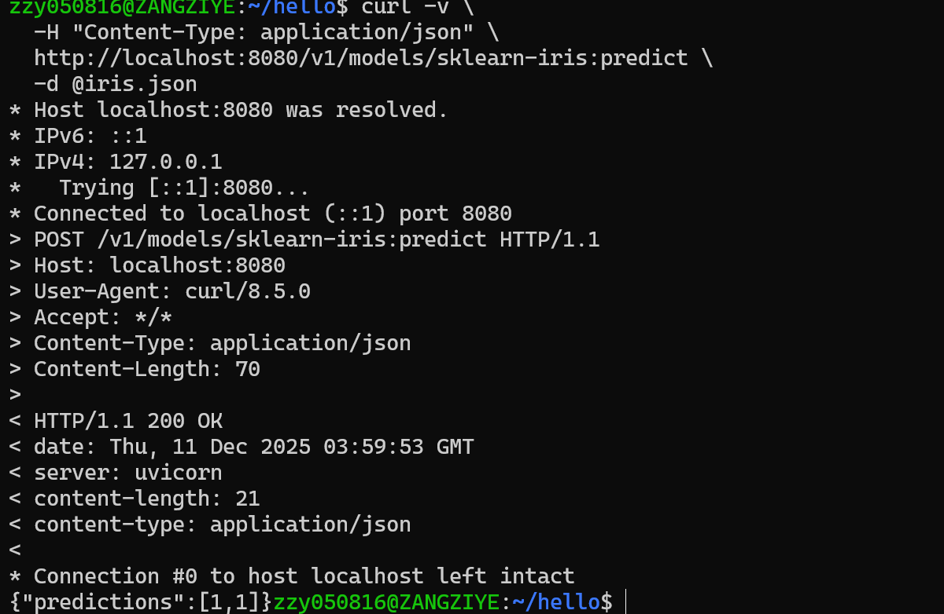

4. Conclusion
This experiment successfully demonstrated:
Installing KServe on Minikube
Debugging controller issues (deploymentMode, TLS certs)
Deploying a model via InferenceService
Accessing the inference API from outside the cluster
Running a real prediction request
The experiment met all the required objectives and provided hands-on experience with Kubernetes-based ML model serving.

