Lab9 Knative Lab Report
Building, Deploying and Managing Serverless Applications with Knative
- Introduction
This lab provides hands-on experience with Knative for building, deploying,
and managing serverless cloud-native applications on Kubernetes.

The experiment covers the installation of Knative Serving and Eventing,
local development using Knative Functions, deployment of a Knative Service,
and event-driven communication using Knative Eventing.
- Experimental Environment
The experiment was conducted in the following environment:
- Operating System: Windows + WSL (Linux)
- Kubernetes: Minikube
- Container Runtime: Docker
- Knative CLI: kn
- Knative Functions CLI: func v0.47.0
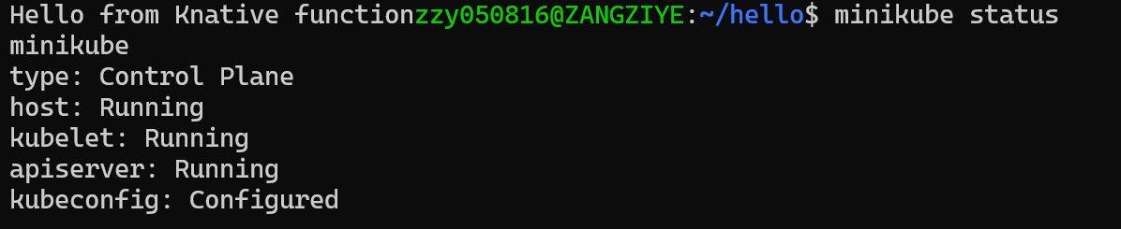
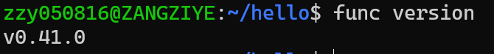
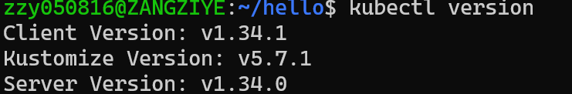

3. Installing Knative Serving and Eventing

3.1 Knative Serving Installation
Knative Serving was installed using the official YAML manifests.
The Serving CRDs and core components were applied successfully.
Istio was used as the networking layer for Knative Serving.
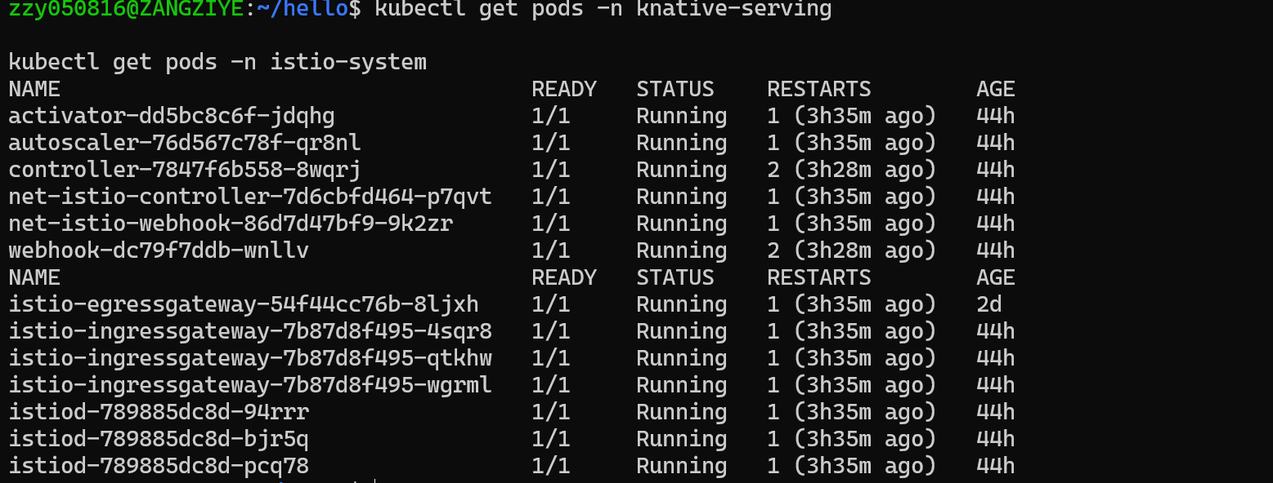
3.2 Knative Eventing Installation
Knative Eventing was installed using the official YAML manifests.
All Eventing components were successfully deployed and running.
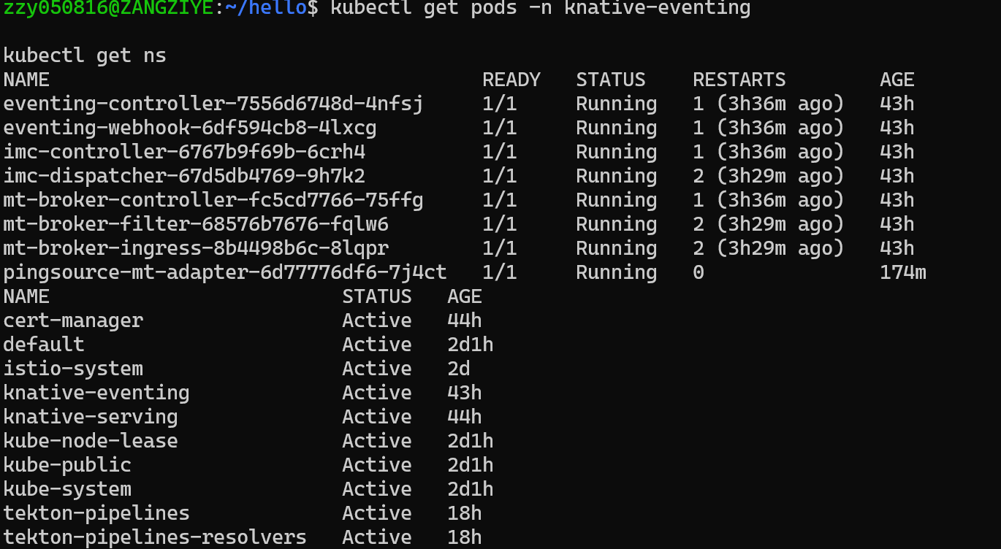4.Knative Functions
A Go-based Knative Function was created using the func CLI.
The function image was built and pushed to a local container registry
(localhost:5001) using the following command:
func run --registry localhost:5001
After the build completed, the function was started locally and
successfully invoked using `func invoke`, returning the expected response.
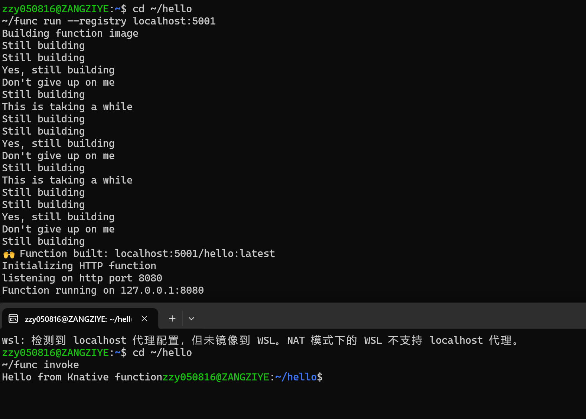
- Knative Serving: First Service
A Knative Service named `hello-serving` was created using the kn CLI.
The service was successfully deployed and reached the Ready state.
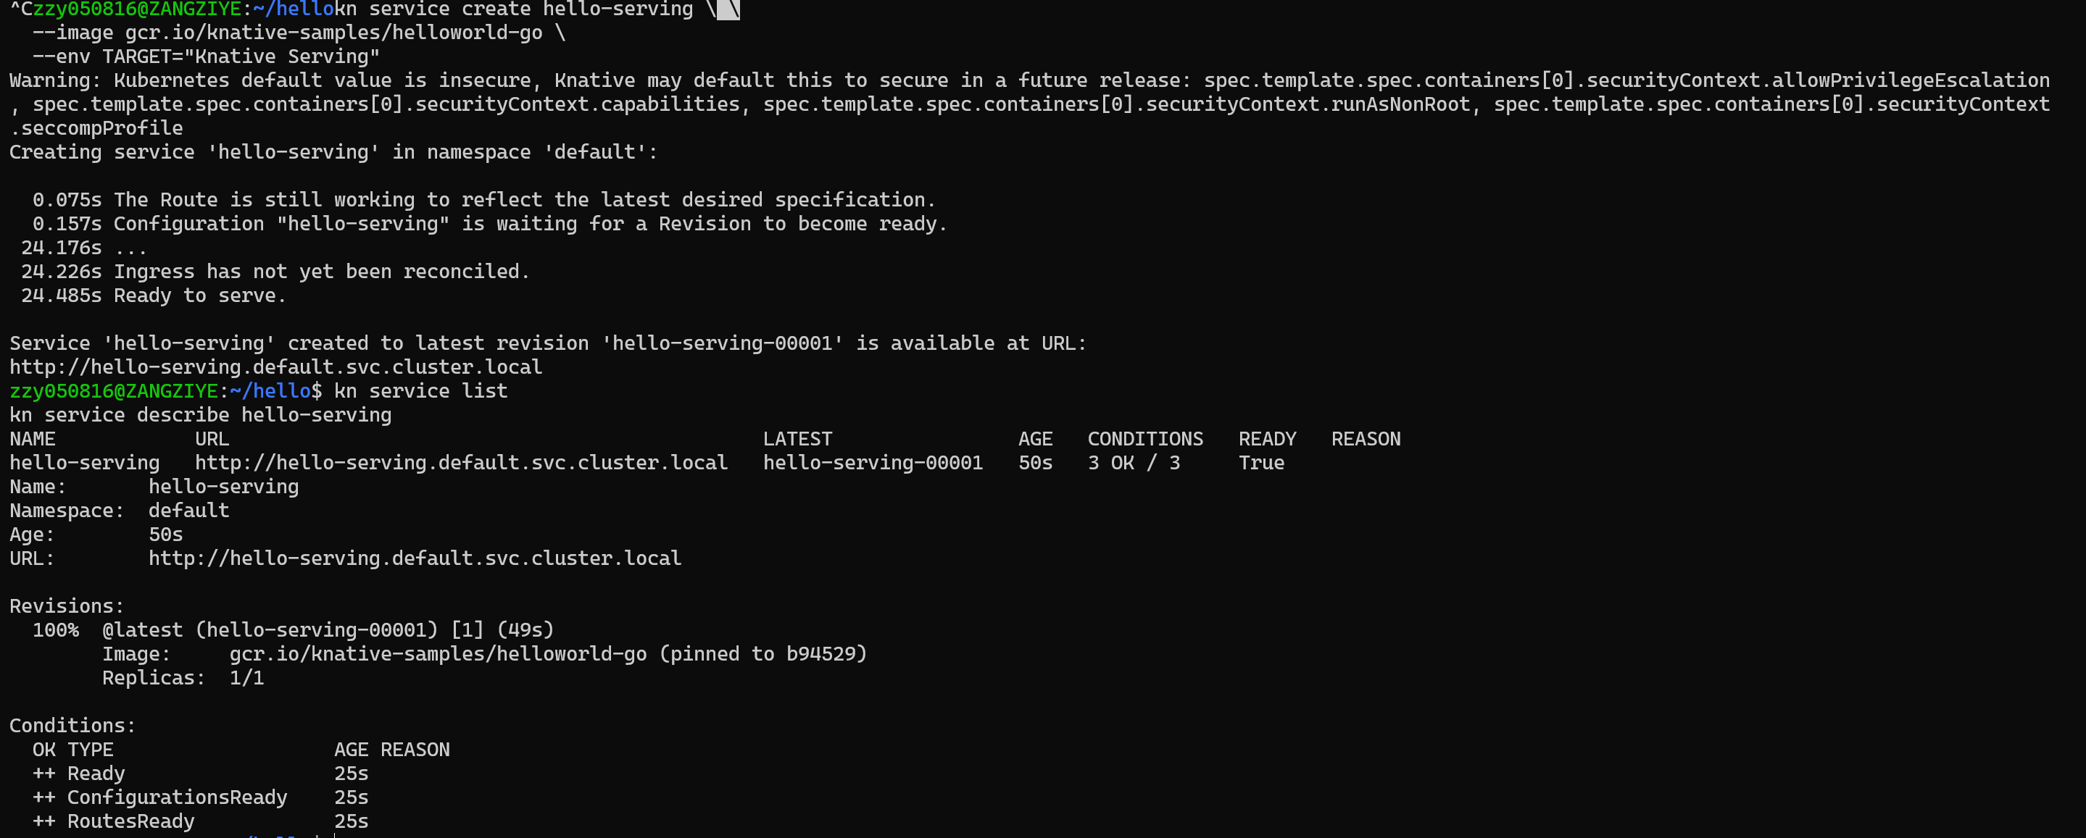

6. Knative Eventing: Event-driven Architecture

6.1 Event Display Service
An event-display Knative Service was deployed to receive and
display incoming CloudEvents.
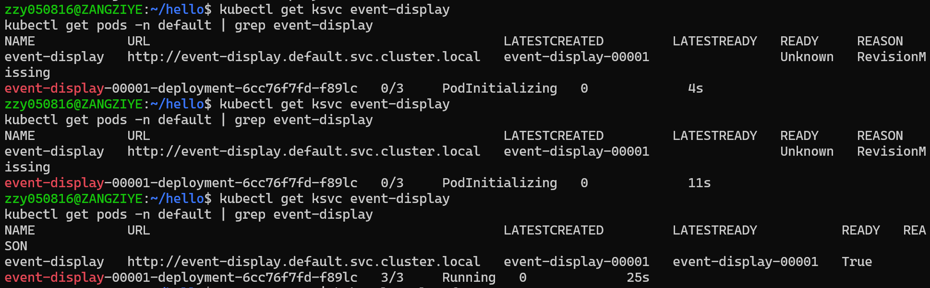
6.2 PingSource Creation
A PingSource was created to generate periodic events and send them
to the event-display service.
6.3 Event Verification
The event flow was verified by checking the logs of the event-display pod.
CloudEvents generated by the PingSource were successfully received.
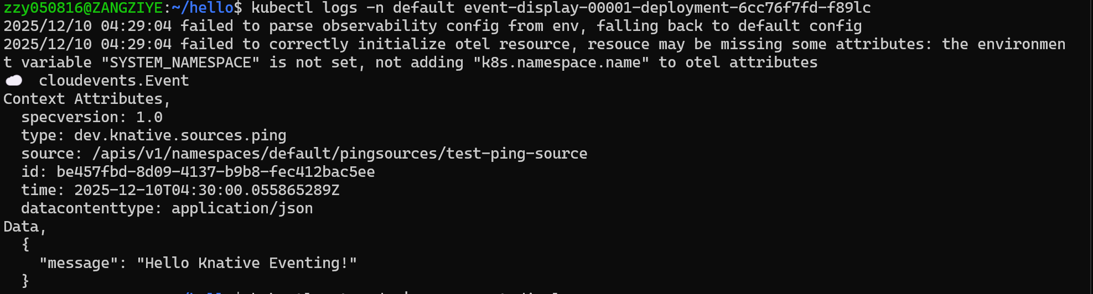
7. Results and Analysis
All components of Knative Serving, Functions, and Eventing were successfully
deployed and verified. The experiment demonstrates how Knative enables
serverless and event-driven workloads on Kubernetes.
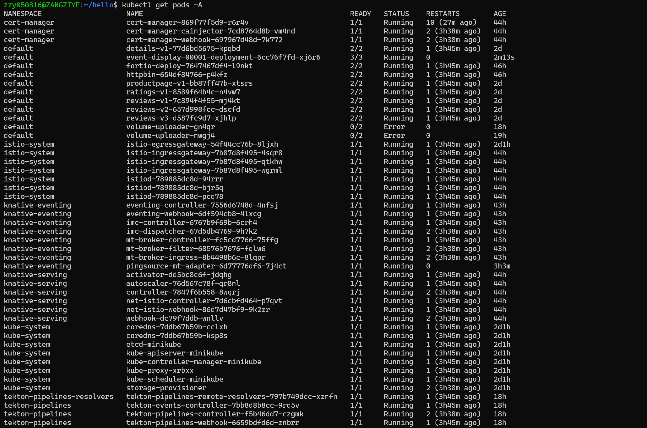
- Conclusion
Through this lab, a complete Knative environment was built and validated.
The experiment deepened understanding of serverless computing,
event-driven architecture, and cloud-native application deployment.

