RELATIONS AND FUNCTIONS

1.Let T be the set of all triangles in a plane with R a relation in T given by
R = {(T 1 , T 2 ) : T 1 is congruent to T 2 }. Show that R is an equivalence relation.

2.Let L be the set of all lines in a plane and R be the relation in L defined as
R = {(L 1 , L 2 ) : L 1 is perpendicular to L 2 }. Show that R is symmetric but neither
reflexive nor transitive.

3.Show that the relation R in the set {1, 2, 3} given by R = {(1, 1), (2, 2),
(3, 3), (1, 2), (2, 3)} is reflexive but neither symmetric nor transitive.

4.Let R is the equivalence relation in the set
A={0,1,2,3,4,5} given. by R = {(a,b): 2 divides
(a - b)}. Write the equivalence class [0]

5.IfA={1,2,3},B={4,5,6,7} and f ={(2, 4), (2, 5), (3, 6)} is a function from A to B. State whether
f is one-one or not.

6.If f: R-> Ris defined by f(x) = 3x + 2, then define f[f(x)]

7.State the reason for the relation R in the set {1, 2, 3} given by R= {(1, 2), (2, 1)} not to be
transitive.

8.What is the range of the function

f(x)= |x-1|
____ , x != 1 ? (! = not)
x-1

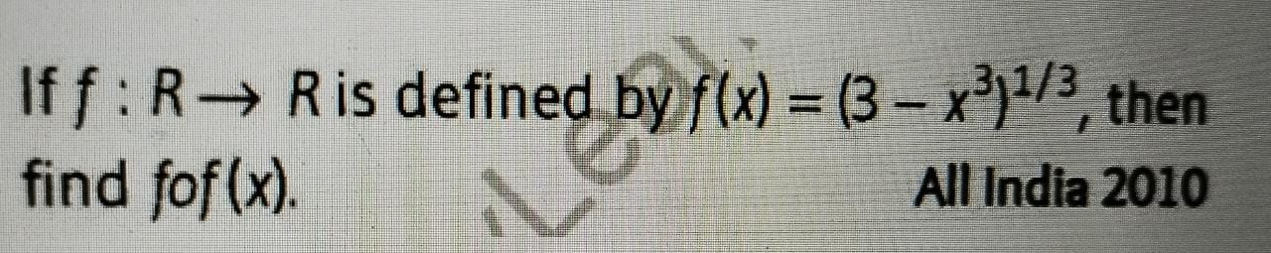
9.

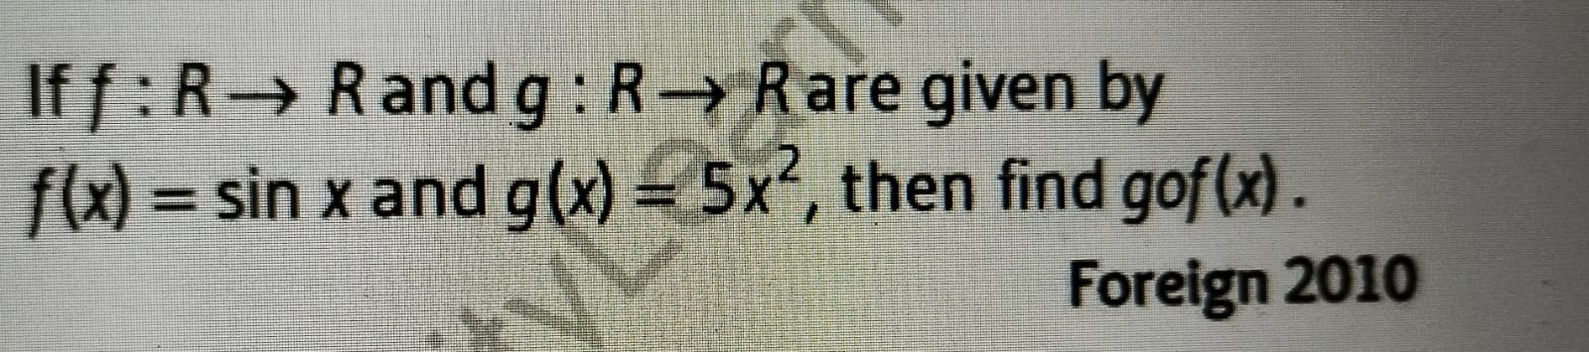
10.

12. State whether the function f : N —> N given by
f(x) = 5x is injective, surjective or both.

13.Let S = {a, b, c} and T = {1, 2, 3}. Find F –1 of the following functions F from S to T, if it exists.
(i) F = {(a, 3), (b, 2), (c, 1)}
(ii) F = {(a, 2), (b, 1), (c, 1)}
14. If f : R → R is defined by f(x) = x 2 – 3x + 2, find f (f (x)).
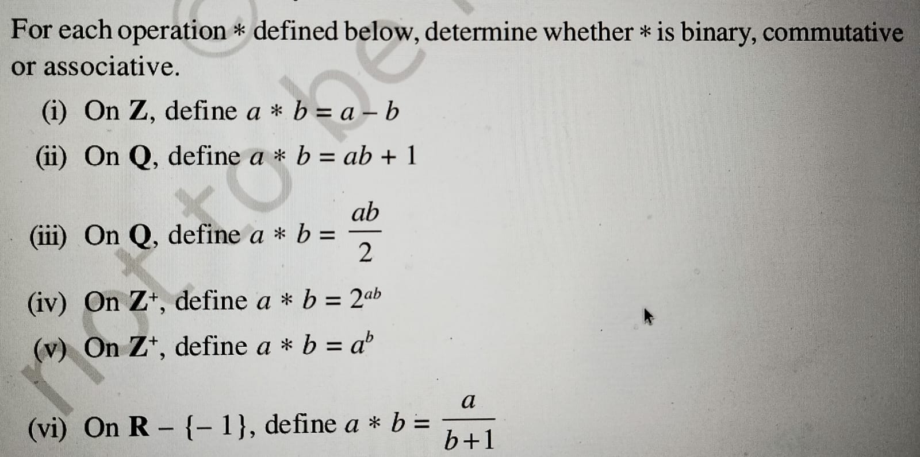
15.

16. Show that ∗ : R × R → R given by a ∗ b → a + 2b is not associative.
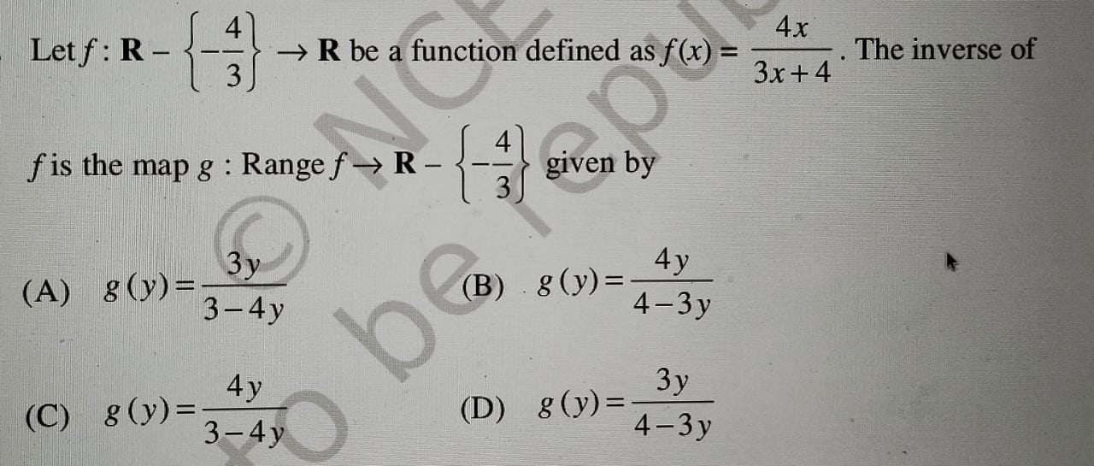
17.

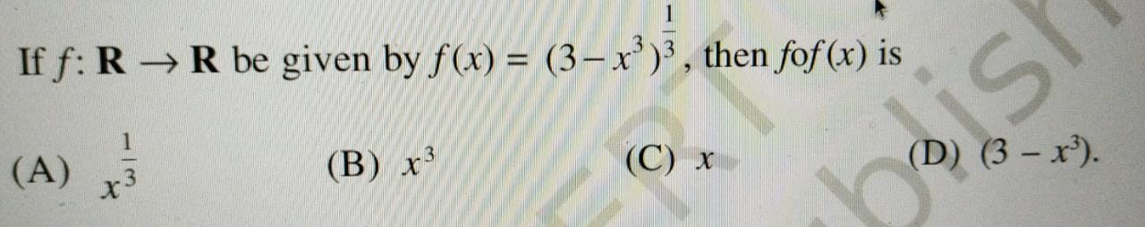
18.

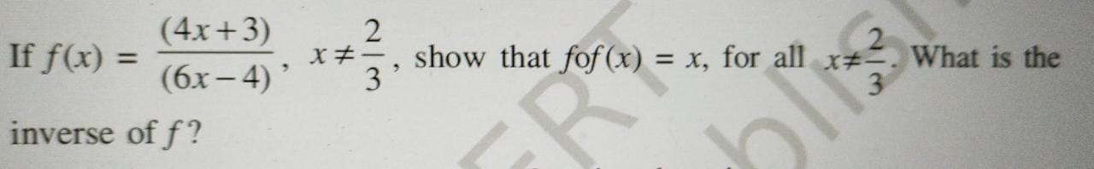
19.

20.Let R be the relation in the set N given by R = {(a, b) : a = b – 2, b > 6}. Choose
the correct answer.
(A) (2, 4) ∈ R
(B) (3, 8) ∈ R
(C) (6, 8) ∈ R
(D) (8, 7) ∈ R

BEST OF LUCK HINATA

