**Лабораторна робота №16**

**Розробка графічного інтерфейсу користувача**

**Мета:** Придбання навичок використання засобів клієнтських технологій (Client Technologies) платформи Java SE.

1. **ВИМОГИ**

Розробити графічний інтерфейс користувача для програми рішення попередньої лабораторної роботи з використанням засобів JavaFX.

* 1. **Розробник**
* П.І.Б: Заночкин Є. Д.
* Группа: КІТ-119а
* Варіант: 7

1. **ОПИС ПРОГРАМИ**
   1. **Засоби ООП:**

@FXML – анотація, необхідна для того, щоб fxml файл мав доступ до приватних полів та приватних методів;

Pattern pattern = Pattern.compile() – компілює регулярний вираз у шаблон;

Matcher matcher = pattern.matcher(data); – створює matcher, який буде відповідати даному вводу для цього шаблону.

* 1. **Ієрархія та структура класів**

Було створено файли розмітки ClientEditDialog (вікно редагування або додавання нового клієнта), ClientOverview (вікно огляду клієнтів), RootLayout (обгортка файлу ClientOverview, що містить меню) та класи MainApp (головний клас програми), Client (клас-модель, шо містить інформацію про клієнта), ClientListWrapper (клас-обгортка, потрібний для збереження колекції у файл XML), DateUtil (клас, що перетворює дату у рядок), LocalDateAdapter (клас, що перетворює дату у формат XML), ClientEditDialogController (клас-контролер вікна редагування або додавання клієнта), ClientOverviewController (клас-контролер огляду клієнтів), RootLayoutController (клас-контролер поведінки меню).

* 1. **Важливі фрагменти програми**

Файл ClientOverview

<?xml version="1.0" encoding="UTF-8"?>

<?import javafx.scene.control.Button?>

<?import javafx.scene.control.ButtonBar?>

<?import javafx.scene.control.Label?>

<?import javafx.scene.control.SplitPane?>

<?import javafx.scene.control.TableColumn?>

<?import javafx.scene.control.TableView?>

<?import javafx.scene.layout.AnchorPane?>

<?import javafx.scene.layout.ColumnConstraints?>

<?import javafx.scene.layout.GridPane?>

<?import javafx.scene.layout.RowConstraints?>

<AnchorPane prefHeight="500.0" prefWidth="800.0" xmlns="http://javafx.com/javafx/15.0.1" xmlns:fx="http://javafx.com/fxml/1" fx:controller="ua.khpi.oop.zanochkyn16.view.ClientOverviewController">

<children>

<SplitPane dividerPositions="0.20050125313283207" prefHeight="502.0" prefWidth="803.0" AnchorPane.bottomAnchor="0.0" AnchorPane.leftAnchor="0.0" AnchorPane.rightAnchor="0.0" AnchorPane.topAnchor="0.0">

<items>

<AnchorPane minHeight="0.0" minWidth="0.0" prefHeight="160.0" prefWidth="100.0">

<children>

<TableView fx:id="clientListTable" layoutX="-12.0" layoutY="39.0" prefHeight="469.0" prefWidth="230.0" AnchorPane.bottomAnchor="0.0" AnchorPane.leftAnchor="0.0" AnchorPane.rightAnchor="0.0" AnchorPane.topAnchor="0.0">

<columns>

<TableColumn fx:id="genderColumn" prefWidth="75.0" text="Gender" />

<TableColumn fx:id="ageColumn" prefWidth="75.0" text="Age" />

</columns>

<columnResizePolicy>

<TableView fx:constant="CONSTRAINED_RESIZE_POLICY" />

</columnResizePolicy>

</TableView>

</children>

</AnchorPane>

<AnchorPane minHeight="0.0" minWidth="0.0" prefHeight="300.0" prefWidth="600.0">

<children>

<Label layoutX="14.0" layoutY="6.0" text="Client Information" AnchorPane.leftAnchor="5.0" AnchorPane.topAnchor="5.0" />

<GridPane layoutX="80.0" layoutY="42.0" AnchorPane.leftAnchor="5.0" AnchorPane.rightAnchor="5.0" AnchorPane.topAnchor="40.0">

<columnConstraints>

<ColumnConstraints hgrow="SOMETIMES" maxWidth="332.20001220703125" minWidth="10.0" prefWidth="169.4000244140625" />

<ColumnConstraints hgrow="SOMETIMES" maxWidth="518.6000213623047" minWidth="10.0" prefWidth="455.79997558593755" />

</columnConstraints>

<rowConstraints>

<RowConstraints minHeight="10.0" prefHeight="30.0" vgrow="SOMETIMES" />

<RowConstraints minHeight="10.0" prefHeight="30.0" vgrow="SOMETIMES" />

<RowConstraints minHeight="10.0" prefHeight="30.0" vgrow="SOMETIMES" />

<RowConstraints minHeight="10.0" prefHeight="30.0" vgrow="SOMETIMES" />

<RowConstraints minHeight="10.0" prefHeight="30.0" vgrow="SOMETIMES" />

<RowConstraints minHeight="10.0" prefHeight="30.0" vgrow="SOMETIMES" />

<RowConstraints minHeight="10.0" prefHeight="30.0" vgrow="SOMETIMES" />

<RowConstraints minHeight="10.0" prefHeight="30.0" vgrow="SOMETIMES" />

<RowConstraints minHeight="10.0" prefHeight="30.0" vgrow="SOMETIMES" />

<RowConstraints minHeight="10.0" prefHeight="30.0" vgrow="SOMETIMES" />

<RowConstraints minHeight="10.0" prefHeight="30.0" vgrow="SOMETIMES" />

<RowConstraints minHeight="10.0" prefHeight="30.0" vgrow="SOMETIMES" />

</rowConstraints>

<children>

<Label text="Client gender" GridPane.rowIndex="2" />

<Label fx:id="idLabel" text="Label" GridPane.columnIndex="1" />

<Label text="ID" />

<Label fx:id="registrationDateLabel" text="Label" GridPane.columnIndex="1" GridPane.rowIndex="1" />

<Label fx:id="clientGenderLabel" text="Label" GridPane.columnIndex="1" GridPane.rowIndex="2" />

<Label text="Registration date" GridPane.rowIndex="1" />

<Label fx:id="clientNameLabel" text="Label" GridPane.columnIndex="1" GridPane.rowIndex="3" />

<Label fx:id="clientAgeLabel" text="Label" GridPane.columnIndex="1" GridPane.rowIndex="4" />

<Label fx:id="clientHeightLabel" text="Label" GridPane.columnIndex="1" GridPane.rowIndex="5" />

<Label text="Client name" GridPane.rowIndex="3" />

<Label text="Client age" GridPane.rowIndex="4" />

<Label text="Client height" GridPane.rowIndex="5" />

<Label text="Client eye colour" GridPane.rowIndex="6" />

<Label text="Client hobbies" GridPane.rowIndex="7" />

<Label text="Partner gender" GridPane.rowIndex="8" />

<Label text="Partner min age" GridPane.rowIndex="9" />

<Label text="Partner max age" GridPane.rowIndex="10" />

<Label text="Partner hobbies" GridPane.rowIndex="11" />

<Label fx:id="clientEyeColourLabel" text="Label" GridPane.columnIndex="1" GridPane.rowIndex="6" />

<Label fx:id="clientHobbiesLabel" text="Label" GridPane.columnIndex="1" GridPane.rowIndex="7" />

<Label fx:id="partnerGenderLabel" text="Label" GridPane.columnIndex="1" GridPane.rowIndex="8" />

<Label fx:id="partnerMinAgeLabel" text="Label" GridPane.columnIndex="1" GridPane.rowIndex="9" />

<Label fx:id="partnerMaxAgeLabel" text="Label" GridPane.columnIndex="1" GridPane.rowIndex="10" />

<Label fx:id="partnerHobbiesLabel" text="Label" GridPane.columnIndex="1" GridPane.rowIndex="11" />

</children>

</GridPane>

<ButtonBar buttonMinWidth="50.0" layoutX="209.0" layoutY="257.0" prefHeight="26.0" prefWidth="375.0" AnchorPane.bottomAnchor="10.0" AnchorPane.rightAnchor="10.0">

<buttons>

<Button mnemonicParsing="false" onAction="#handleNewClient" text="New..." />

<Button mnemonicParsing="false" onAction="#handleEditClient" text="Edit..." />

<Button mnemonicParsing="false" onAction="#handleDeleteClient" text="Delete" />

</buttons>

</ButtonBar>

</children>

</AnchorPane>

</items>

</SplitPane>

</children>

</AnchorPane>

Файл ClientEditDialog

<?xml version="1.0" encoding="UTF-8"?>

<?import javafx.scene.control.Button?>

<?import javafx.scene.control.ButtonBar?>

<?import javafx.scene.control.ComboBox?>

<?import javafx.scene.control.Label?>

<?import javafx.scene.control.TextField?>

<?import javafx.scene.layout.AnchorPane?>

<?import javafx.scene.layout.ColumnConstraints?>

<?import javafx.scene.layout.GridPane?>

<?import javafx.scene.layout.RowConstraints?>

<AnchorPane prefHeight="446.0" prefWidth="600.0" xmlns="http://javafx.com/javafx/15.0.1" xmlns:fx="http://javafx.com/fxml/1" fx:controller="ua.khpi.oop.zanochkyn16.view.ClientEditDialogController">

<children>

<GridPane layoutX="100.0" layoutY="18.0" prefWidth="400.0" AnchorPane.leftAnchor="40.0" AnchorPane.rightAnchor="40.0" AnchorPane.topAnchor="20.0">

<columnConstraints>

<ColumnConstraints hgrow="SOMETIMES" maxWidth="255.20001220703125" minWidth="10.0" prefWidth="148.0" />

<ColumnConstraints hgrow="SOMETIMES" maxWidth="377.60003662109375" minWidth="10.0" prefWidth="372.0" />

</columnConstraints>

<rowConstraints>

<RowConstraints minHeight="10.0" prefHeight="30.0" vgrow="SOMETIMES" />

<RowConstraints minHeight="10.0" prefHeight="30.0" vgrow="SOMETIMES" />

<RowConstraints minHeight="10.0" prefHeight="30.0" vgrow="SOMETIMES" />

<RowConstraints minHeight="10.0" prefHeight="30.0" vgrow="SOMETIMES" />

<RowConstraints minHeight="10.0" prefHeight="30.0" vgrow="SOMETIMES" />

<RowConstraints minHeight="10.0" prefHeight="30.0" vgrow="SOMETIMES" />

<RowConstraints minHeight="10.0" prefHeight="30.0" vgrow="SOMETIMES" />

<RowConstraints minHeight="10.0" prefHeight="30.0" vgrow="SOMETIMES" />

<RowConstraints minHeight="10.0" prefHeight="30.0" vgrow="SOMETIMES" />

<RowConstraints minHeight="10.0" prefHeight="30.0" vgrow="SOMETIMES" />

<RowConstraints minHeight="10.0" prefHeight="30.0" vgrow="SOMETIMES" />

<RowConstraints minHeight="10.0" prefHeight="30.0" vgrow="SOMETIMES" />

</rowConstraints>

<children>

<Label text="ID" />

<Label text="Registration date" GridPane.rowIndex="1" />

<Label text="Client gender" GridPane.rowIndex="2" />

<Label text="Client age" GridPane.rowIndex="4" />

<Label text="Client height" GridPane.rowIndex="5" />

<Label text="Client eye colour" GridPane.rowIndex="6" />

<Label text="Client hobbies" GridPane.rowIndex="7" />

<Label text="Partner gender" GridPane.rowIndex="8" />

<Label text="Partner min age" GridPane.rowIndex="9" />

<Label text="Partner max age" GridPane.rowIndex="10" />

<Label text="Partner hobbies" GridPane.rowIndex="11" />

<Label text="Client name" GridPane.rowIndex="3" />

<TextField fx:id="idField" GridPane.columnIndex="1" />

<TextField fx:id="registrationDateField" GridPane.columnIndex="1" GridPane.rowIndex="1" />

<TextField fx:id="clientNameField" GridPane.columnIndex="1" GridPane.rowIndex="3" />

<TextField fx:id="clientAgeField" GridPane.columnIndex="1" GridPane.rowIndex="4" />

<TextField fx:id="clientHeightField" GridPane.columnIndex="1" GridPane.rowIndex="5" />

<TextField fx:id="clientEyeColourField" GridPane.columnIndex="1" GridPane.rowIndex="6" />

<TextField fx:id="clientHobbiesField" GridPane.columnIndex="1" GridPane.rowIndex="7" />

<TextField fx:id="partnerMinAgeField" GridPane.columnIndex="1" GridPane.rowIndex="9" />

<TextField fx:id="partnerMaxAgeField" GridPane.columnIndex="1" GridPane.rowIndex="10" />

<TextField fx:id="partnerHobbiesField" GridPane.columnIndex="1" GridPane.rowIndex="11" />

<ComboBox fx:id="clientGenderComboBox" prefWidth="150.0" GridPane.columnIndex="1" GridPane.rowIndex="2" />

<ComboBox fx:id="partnerGenderComboBox" prefWidth="150.0" GridPane.columnIndex="1" GridPane.rowIndex="8" />

</children>

</GridPane>

<ButtonBar layoutX="406.0" layoutY="446.0" prefHeight="40.0" prefWidth="165.0" AnchorPane.bottomAnchor="10.0" AnchorPane.rightAnchor="10.0">

<buttons>

<Button mnemonicParsing="false" onAction="#handleOk" text="OK" />

<Button mnemonicParsing="false" onAction="#handleCancel" text="Cancel" />

</buttons>

</ButtonBar>

</children>

</AnchorPane>

Файл RootLayout

<?xml version="1.0" encoding="UTF-8"?>

<?import javafx.scene.control.Menu?>

<?import javafx.scene.control.MenuBar?>

<?import javafx.scene.control.MenuItem?>

<?import javafx.scene.input.KeyCodeCombination?>

<?import javafx.scene.layout.BorderPane?>

<BorderPane prefHeight="500.0" prefWidth="800.0" xmlns="http://javafx.com/javafx/15.0.1" xmlns:fx="http://javafx.com/fxml/1" fx:controller="ua.khpi.oop.zanochkyn16.view.RootLayoutController">

<top>

<MenuBar BorderPane.alignment="CENTER">

<menus>

<Menu mnemonicParsing="false" text="File">

<items>

<MenuItem mnemonicParsing="false" onAction="#handleNew" text="New list" />

<MenuItem mnemonicParsing="false" onAction="#handleSaveXMLFile" text="Save to XML file">

<accelerator>

<KeyCodeCombination alt="UP" code="S" control="DOWN" meta="UP" shift="UP" shortcut="UP" />

</accelerator></MenuItem>

<MenuItem mnemonicParsing="false" onAction="#handleOpenXMLFile" text="Open from XML file">

<accelerator>

<KeyCodeCombination alt="UP" code="O" control="DOWN" meta="UP" shift="UP" shortcut="UP" />

</accelerator></MenuItem>

</items>

</Menu>

<Menu mnemonicParsing="false" text="Help">

<items>

<MenuItem mnemonicParsing="false" onAction="#handleAbout" text="About" />

</items>

</Menu>

</menus>

</MenuBar>

</top>

</BorderPane>

Клас MainApp

package ua.khpi.oop.zanochkyn16;

import java.io.File;

import java.io.IOException;

import java.time.LocalDate;

import javax.xml.bind.JAXBContext;

import javax.xml.bind.Marshaller;

import javax.xml.bind.Unmarshaller;

import javafx.application.Application;

import javafx.collections.FXCollections;

import javafx.collections.ObservableList;

import javafx.fxml.FXMLLoader;

import javafx.scene.Scene;

import javafx.scene.control.Alert;

import javafx.scene.control.Alert.AlertType;

import javafx.scene.image.Image;

import javafx.scene.layout.AnchorPane;

import javafx.scene.layout.BorderPane;

import javafx.stage.Modality;

import javafx.stage.Stage;

import ua.khpi.oop.zanochkyn16.model.Client;

import ua.khpi.oop.zanochkyn16.model.ClientListWrapper;

import ua.khpi.oop.zanochkyn16.view.ClientEditDialogController;

import ua.khpi.oop.zanochkyn16.view.ClientOverviewController;

import ua.khpi.oop.zanochkyn16.view.RootLayoutController;

public class MainApp extends Application

{

private ObservableList<Client> clientList = FXCollections.observableArrayList();

private Stage primaryStage;

private BorderPane rootLayout;

@Override

public void start(Stage primaryStage)

{

this.primaryStage = primaryStage;

this.primaryStage.setTitle("Dating Office");

this.primaryStage.getIcons().add(new Image("file:D:\\Eclipse_Workspace\\zanochkyn-yehor\\src\\ua\\khpi\\oop\\zanochkyn16\\thumbnail.jpg"));

initRootLayout();

showClientOverview();

}

public MainApp()

{

clientList.add(new Client("Male", 1, LocalDate.now(), "Yehor", 19, 185, "Blue", "Video games, Music", "Female", 18, 25, "None"));

clientList.add(new Client("Female", 2, LocalDate.now(), "Kate", 18, 170, "Green", "Art", "Male", 18, 25, "Music"));

}

/**

* Returns the data as an observable list of client's.

* @return

*/

public ObservableList<Client> getClientList()

{

return clientList;

}

/**

* Initializes the root layout.

*/

public void initRootLayout()

{

try

{

// Load root layout from fxml file.

FXMLLoader loader = new FXMLLoader();

loader.setLocation(MainApp.class.getResource("view/RootLayout.fxml"));

rootLayout = (BorderPane) loader.load();

Scene scene = new Scene(rootLayout);

primaryStage.setScene(scene);

RootLayoutController controller = loader.getController();

controller.setMainApp(this);

primaryStage.show();

}

catch (IOException e)

{

e.printStackTrace();

}

}

/**

* Shows the client overview inside the root layout.

*/

public void showClientOverview()

{

try

{

// Load client overview.

FXMLLoader loader = new FXMLLoader();

loader.setLocation(MainApp.class.getResource("view/ClientOverview.fxml"));

AnchorPane clientListOverview = (AnchorPane) loader.load();

// Set client overview into the center of root layout.

rootLayout.setCenter(clientListOverview);

ClientOverviewController controller = loader.getController();

controller.setMainApp(this);

}

catch (IOException e)

{

e.printStackTrace();

}

}

/**

* Opens a dialog to edit details for the specified client. If the user

* clicks OK, the changes are saved into the provided person object and true

* is returned.

*

* @param client the client object to be edited

* @return true if the user clicked OK, false otherwise.

*/

public boolean showClientEditDialog(Client client)

{

try

{

// Load the fxml file and create a new stage for the popup dialog.

FXMLLoader loader = new FXMLLoader();

loader.setLocation(MainApp.class.getResource("view/ClientEditDialog.fxml"));

AnchorPane page = (AnchorPane) loader.load();

// Create the dialog Stage.

Stage dialogStage = new Stage();

dialogStage.setTitle("Edit Client");

dialogStage.initModality(Modality.WINDOW_MODAL);

dialogStage.initOwner(primaryStage);

Scene scene = new Scene(page);

dialogStage.setScene(scene);

// Set the client into the controller.

ClientEditDialogController controller = loader.getController();

controller.setDialogStage(dialogStage);

controller.setClient(client);

// Show the dialog and wait until the user closes it

dialogStage.showAndWait();

return controller.isOkClicked();

}

catch (IOException e)

{

e.printStackTrace();

return false;

}

}

/**

* Returns the main stage.

* @return

*/

public Stage getPrimaryStage()

{

return primaryStage;

}

public static void main(String[] args)

{

launch(args);

}

/**

* Saves the current client data to the specified file.

*

* @param file

*/

public void saveClientsToXMLFile(File file)

{

try

{

JAXBContext context = JAXBContext.newInstance(ClientListWrapper.class);

Marshaller m = context.createMarshaller();

m.setProperty(Marshaller.JAXB_FORMATTED_OUTPUT, true);

// Wrapping our person data.

ClientListWrapper wrapper = new ClientListWrapper();

wrapper.setClients(clientList);

// Marshalling and saving XML to the file.

m.marshal(wrapper, file);

}

catch (Exception e)

{ // catches ANY exception

e.printStackTrace();

Alert alert = new Alert(AlertType.ERROR);

alert.setTitle("Error");

alert.setHeaderText("Could not save data");

alert.setContentText("Could not save data to file:\n" + file.getPath());

alert.showAndWait();

}

}

/**

* Loads client data from the specified file. The current client data will

* be replaced.

*/

public void loadClientsFromXMLFile(File file)

{

try

{

JAXBContext context = JAXBContext.newInstance(ClientListWrapper.class);

Unmarshaller um = context.createUnmarshaller();

// Reading XML from the file and unmarshalling.

ClientListWrapper wrapper = (ClientListWrapper) um.unmarshal(file);

clientList.clear();

clientList.addAll(wrapper.getClients());

}

catch (Exception e)

{ // catches ANY exception

e.printStackTrace();

Alert alert = new Alert(AlertType.ERROR);

alert.setTitle("Error");

alert.setHeaderText("Could not load data");

alert.setContentText("Could not load data from file:\n" + file.getPath());

alert.showAndWait();

}

}

}

Клас Client

package ua.khpi.oop.zanochkyn16.model;

import java.time.LocalDate;

import java.util.Objects;

import javax.xml.bind.annotation.adapters.XmlJavaTypeAdapter;

import javafx.beans.property.IntegerProperty;

import javafx.beans.property.ObjectProperty;

import javafx.beans.property.SimpleIntegerProperty;

import javafx.beans.property.SimpleObjectProperty;

import javafx.beans.property.SimpleStringProperty;

import javafx.beans.property.StringProperty;

import ua.khpi.oop.zanochkyn16.util.LocalDateAdapter;

public class Client

{

/*

* Client info

*/

private StringProperty clientGender;

private IntegerProperty id;

private ObjectProperty<LocalDate> registrationDate;

private StringProperty name;

private IntegerProperty age;

private IntegerProperty height;

private StringProperty eyeColour;

private StringProperty clientHobbies;

/*

* Partner requirements

*/

private StringProperty partnerGender;

private IntegerProperty minAge;

private IntegerProperty maxAge;

private StringProperty partnerHobbies;

/*

* Constructors

*/

public Client(String clientGender, int id, LocalDate date, String name, int age, int height, String eyeColour,

String clientHobbies, String partnerGender, int minAge, int maxAge, String partnerHobbies)

{

this.clientGender = new SimpleStringProperty(clientGender);

this.id = new SimpleIntegerProperty(id);

this.registrationDate = new SimpleObjectProperty<LocalDate>(date);

this.name = new SimpleStringProperty(name);

this.age = new SimpleIntegerProperty(age);

this.height = new SimpleIntegerProperty(height);

this.eyeColour = new SimpleStringProperty(eyeColour);

this.clientHobbies = new SimpleStringProperty(clientHobbies);

this.partnerGender = new SimpleStringProperty(partnerGender);

this.minAge = new SimpleIntegerProperty(minAge);

this.maxAge = new SimpleIntegerProperty(maxAge);

this.partnerHobbies = new SimpleStringProperty(partnerHobbies);

}

public Client()

{

this(null, 0, LocalDate.now(), null, 0, 0, null, null, null, 0, 0, null);

}

/*

* Getters and setters

*/

public String getClientGender()

{

return clientGender.get();

}

public void setClientGender(String gender)

{

this.clientGender.set(gender);

}

public int getId()

{

return id.get();

}

public void setId(int id)

{

this.id.set(id);

}

@XmlJavaTypeAdapter(LocalDateAdapter.class)

public LocalDate getRegistrationDate()

{

return registrationDate.get();

}

public void setRegistrationDate(LocalDate date)

{

this.registrationDate.set(date);

}

public String getName()

{

return name.get();

}

public void setName(String name)

{

this.name.set(name);

}

public int getAge()

{

return age.get();

}

public void setAge(int age)

{

this.age.set(age);

}

public int getHeight()

{

return height.get();

}

public void setHeight(int height)

{

this.height.set(height);

}

public String getEyeColour()

{

return eyeColour.get();

}

public void setEyeColour(String eyeColour)

{

this.eyeColour.set(eyeColour);

}

public String getClientHobbies()

{

return clientHobbies.get();

}

public void setClientHobbies(String clientHobbies)

{

this.clientHobbies.set(clientHobbies);

}

public String getPartnerGender()

{

return partnerGender.get();

}

public void setPartnerGender(String partnerGender)

{

this.partnerGender.set(partnerGender);

}

public int getMinAge()

{

return minAge.get();

}

public void setMinAge(int minAge)

{

this.minAge.set(minAge);

}

public int getMaxAge()

{

return maxAge.get();

}

public void setMaxAge(int maxAge)

{

this.maxAge.set(maxAge);

}

public String getPartnerHobbies()

{

return partnerHobbies.get();

}

public void setPartnerHobbies(String partnerHobbies)

{

this.partnerHobbies.set(partnerHobbies);

}

public StringProperty clientGenderProperty()

{

return clientGender;

}

public IntegerProperty idProperty()

{

return id;

}

public ObjectProperty<LocalDate> registrationDateProperty()

{

return registrationDate;

}

public StringProperty nameProperty()

{

return name;

}

public IntegerProperty ageProperty()

{

return age;

}

public IntegerProperty heightProperty()

{

return height;

}

public StringProperty eyeColourProperty()

{

return eyeColour;

}

public StringProperty clientHobbiesProperty()

{

return clientHobbies;

}

public StringProperty partnerGenderProperty()

{

return partnerGender;

}

public IntegerProperty minAgeProperty()

{

return minAge;

}

public IntegerProperty maxAgeProperty()

{

return maxAge;

}

public StringProperty partnerHobbiesProperty()

{

return partnerHobbies;

}

@Override

public boolean equals(Object o)

{

if (this == o)

return true;

if (o == null || getClass() != o.getClass())

return false;

Client client = (Client) o;

return Objects.equals(getClientGender(), client.getClientGender()) && Objects.equals(getId(), client.getId()) &&

Objects.equals(getRegistrationDate(), client.getRegistrationDate()) && Objects.equals(getName(), client.getName()) &&

Objects.equals(getAge(), client.getAge()) && Objects.equals(getHeight(), client.getHeight()) && Objects.equals(getEyeColour(), client.getEyeColour()) &&

Objects.equals(getClientHobbies(), client.getClientHobbies()) && Objects.equals(getPartnerGender(), client.getPartnerGender()) &&

Objects.equals(getMinAge(), client.getMinAge()) && Objects.equals(getMaxAge(), client.getMaxAge()) && Objects.equals(getPartnerHobbies(), client.getPartnerHobbies());

}

}

Клас ClientListWrapper

package ua.khpi.oop.zanochkyn16.model;

import java.util.List;

import javax.xml.bind.annotation.XmlElement;

import javax.xml.bind.annotation.XmlRootElement;

/**

* Helper class to wrap a list of clients. This is used for saving the

* list of persons to XML.

*/

@XmlRootElement(name = "clients")

public class ClientListWrapper

{

private List<Client> clients;

@XmlElement(name = "client")

public List<Client> getClients()

{

return clients;

}

public void setClients(List<Client> clients)

{

this.clients = clients;

}

}

Клас DateUtil

package ua.khpi.oop.zanochkyn16.util;

import java.time.LocalDate;

import java.time.format.DateTimeFormatter;

import java.time.format.DateTimeParseException;

public class DateUtil

{

private static final String DATE_PATTERN = "dd.MM.yyyy";

private static final DateTimeFormatter DATE_FORMATTER = DateTimeFormatter.ofPattern(DATE_PATTERN);

/**

* Returns the given date as a well formatted String. The above defined

* {@link DateUtil#DATE_PATTERN} is used.

*

* @param date the date to be returned as a string

* @return formatted string

*/

public static String format(LocalDate date)

{

if (date == null)

return null;

return DATE_FORMATTER.format(date);

}

/**

* Converts a String in the format of the defined {@link DateUtil#DATE_PATTERN}

* to a {@link LocalDate} object.

*

* Returns null if the String could not be converted.

*

* @param dateString the date as String

* @return the date object or null if it could not be converted

*/

public static LocalDate parse(String dateString)

{

try

{

return DATE_FORMATTER.parse(dateString, LocalDate::from);

}

catch (DateTimeParseException e)

{

return null;

}

}

/**

* Checks the String whether it is a valid date.

*

* @param dateString

* @return true if the String is a valid date

*/

public static boolean validDate(String dateString)

{

return DateUtil.parse(dateString) != null;

}

}

Клас LocalDateAdapter

package ua.khpi.oop.zanochkyn16.util;

import java.time.LocalDate;

import javax.xml.bind.annotation.adapters.XmlAdapter;

public class LocalDateAdapter extends XmlAdapter<String, LocalDate>

{

@Override

public LocalDate unmarshal(String v) throws Exception

{

return LocalDate.parse(v);

}

@Override

public String marshal(LocalDate v) throws Exception

{

return v.toString();

}

}

Клас ClientEditDialogController

package ua.khpi.oop.zanochkyn16.view;

import java.time.LocalDate;

import java.util.regex.Matcher;

import java.util.regex.Pattern;

import javafx.collections.FXCollections;

import javafx.collections.ObservableList;

import javafx.fxml.FXML;

import javafx.scene.control.Alert;

import javafx.scene.control.Alert.AlertType;

import javafx.scene.control.ComboBox;

import javafx.scene.control.TextField;

import javafx.stage.Stage;

import ua.khpi.oop.zanochkyn16.model.Client;

import ua.khpi.oop.zanochkyn16.util.DateUtil;

/**

* Dialog to edit details of a client.

*/

public class ClientEditDialogController

{

@FXML private TextField idField;

@FXML private TextField registrationDateField;

@FXML private TextField clientNameField;

@FXML private TextField clientAgeField;

@FXML private TextField clientHeightField;

@FXML private TextField clientEyeColourField;

@FXML private TextField clientHobbiesField;

@FXML private TextField partnerMinAgeField;

@FXML private TextField partnerMaxAgeField;

@FXML private TextField partnerHobbiesField;

@FXML private ComboBox<String> clientGenderComboBox;

@FXML private ComboBox<String> partnerGenderComboBox;

private Stage dialogStage;

private Client client;

private boolean okClicked = false;

private static int ID = 3;

/**

* Initializes the controller class. This method is automatically called

* after the fxml file has been loaded.

*/

@FXML

private void initialize()

{

ObservableList<String> langs = FXCollections.observableArrayList("Male", "Female");

clientGenderComboBox.setItems(langs);

partnerGenderComboBox.setItems(langs);

}

/**

* Sets the stage of this dialog.

*

* @param dialogStage

*/

public void setDialogStage(Stage dialogStage) { this.dialogStage = dialogStage; }

/**

* Sets the client to be edited in the dialog.

*

* @param client

*/

public void setClient(Client client)

{

this.client = client;

if(client.getClientGender() != null)

{

idField.setText(Integer.toString(client.getId()));

registrationDateField.setText(DateUtil.format(client.getRegistrationDate()));

registrationDateField.setPromptText("dd.mm.yyyy");

clientGenderComboBox.getSelectionModel().select(client.getClientGender());

clientNameField.setText(client.getName());

clientAgeField.setText(Integer.toString(client.getAge()));

clientHeightField.setText(Integer.toString(client.getHeight()));

clientEyeColourField.setText(client.getEyeColour());

clientHobbiesField.setText(client.getClientHobbies());

partnerGenderComboBox.getSelectionModel().select(client.getPartnerGender());

partnerMinAgeField.setText(Integer.toString(client.getMinAge()));

partnerMaxAgeField.setText(Integer.toString(client.getMaxAge()));

partnerHobbiesField.setText(client.getPartnerHobbies());

}

else

{

idField.setText(Integer.toString(ID++));

registrationDateField.setText(DateUtil.format(LocalDate.now()));

clientGenderComboBox.setValue("");

clientNameField.setText("");

clientAgeField.setText("");

clientHeightField.setText("");

clientEyeColourField.setText("");

clientHobbiesField.setText("");

partnerGenderComboBox.setValue("");

partnerMinAgeField.setText("");

partnerMaxAgeField.setText("");

partnerHobbiesField.setText("");

}

}

/**

* Returns true if the user clicked OK, false otherwise.

*

* @return

*/

public boolean isOkClicked() { return okClicked; }

/**

* Called when the user clicks ok.

*/

@FXML

private void handleOk()

{

if (isInputValid())

{

client.setId(Integer.parseInt(idField.getText()));

client.setRegistrationDate(DateUtil.parse(registrationDateField.getText()));

client.setClientGender(clientGenderComboBox.getValue());

client.setName(clientNameField.getText());

client.setAge(Integer.parseInt(clientAgeField.getText()));

client.setHeight(Integer.parseInt(clientHeightField.getText()));

client.setEyeColour(clientEyeColourField.getText());

client.setClientHobbies(clientHobbiesField.getText());

client.setPartnerGender(partnerGenderComboBox.getValue());

client.setMinAge(Integer.parseInt(partnerMinAgeField.getText()));

client.setMaxAge(Integer.parseInt(partnerMaxAgeField.getText()));

client.setPartnerHobbies(partnerHobbiesField.getText());

okClicked = true;

dialogStage.close();

}

}

/**

* Called when the user clicks cancel.

*/

@FXML

private void handleCancel() { dialogStage.close(); }

/**

* Validates the user input in the text fields.

*

* @return true if the input is valid

*/

private boolean isInputValid()

{

String errorMessage = "";

Pattern patternId = Pattern.compile("\\d+");

Pattern patternRegistrationDay = Pattern.compile("(0[1-9]|[12][0-9]|3[01])\\.(0[1-9]|1[0-2])\\.(19|20)\\d{2}");

Pattern patternName = Pattern.compile("^([a-zA-Z]+)");

Pattern patternAge = Pattern.compile("^(([1-9])|([1-9][0-9]))");

Pattern patternHeight = Pattern.compile("^(([1-9])|([1-9][0-9])|([1-2][0-9][0-9]))");

Pattern patternEyeColour = Pattern.compile("^([a-zA-Z]+)");

Pattern patternHobby = Pattern.compile("^(([a-zA-Z]+|[a-zA-Z]+\\s[a-zA-Z]+)(,\\s([a-zA-Z]+|[a-zA-Z]+\\s[a-zA-Z]+))*)");

Matcher matcher = patternId.matcher(idField.getText());

if (!matcher.matches())

errorMessage += "No valid ID!\n";

matcher = patternRegistrationDay.matcher(registrationDateField.getText());

if (!matcher.matches())

errorMessage += "No valid registration date!\n";

matcher = patternName.matcher(clientNameField.getText());

if (!matcher.matches())

errorMessage += "No valid name!\n";

matcher = patternAge.matcher(clientAgeField.getText());

if (!matcher.matches())

errorMessage += "No valid age!\n";

matcher = patternHeight.matcher(clientHeightField.getText());

if (!matcher.matches())

errorMessage += "No valid height!\n";

matcher = patternEyeColour.matcher(clientEyeColourField.getText());

if (!matcher.matches())

errorMessage += "No valid eye colour!\n";

matcher = patternHobby.matcher(clientHobbiesField.getText());

if (!matcher.matches())

errorMessage += "No valid client hobbies!\n";

matcher = patternAge.matcher(partnerMinAgeField.getText());

if (!matcher.matches())

errorMessage += "No valid min age!\n";

matcher = patternAge.matcher(partnerMaxAgeField.getText());

if (!matcher.matches())

errorMessage += "No valid max age!\n";

matcher = patternHobby.matcher(partnerHobbiesField.getText());

if (!matcher.matches())

errorMessage += "No valid partner hobbies!\n";

if (errorMessage.length() == 0)

return true;

else

{

// Show the error message.

Alert alert = new Alert(AlertType.ERROR);

alert.initOwner(dialogStage);

alert.setTitle("Invalid Fields");

alert.setHeaderText("Please correct invalid fields");

alert.setContentText(errorMessage);

alert.showAndWait();

return false;

}

}

}

Клас ClientOverviewController

package ua.khpi.oop.zanochkyn16.view;

import javafx.fxml.FXML;

import javafx.scene.control.Alert;

import javafx.scene.control.Alert.AlertType;

import javafx.scene.control.Label;

import javafx.scene.control.TableColumn;

import javafx.scene.control.TableView;

import ua.khpi.oop.zanochkyn16.MainApp;

import ua.khpi.oop.zanochkyn16.model.Client;

import ua.khpi.oop.zanochkyn16.util.DateUtil;

public class ClientOverviewController

{

@FXML private TableView<Client> clientListTable;

@FXML private TableColumn<Client, String> genderColumn;

@FXML private TableColumn<Client, Integer> ageColumn;

@FXML private Label clientGenderLabel;

@FXML private Label idLabel;

@FXML private Label registrationDateLabel;

@FXML private Label clientNameLabel;

@FXML private Label clientAgeLabel;

@FXML private Label clientHeightLabel;

@FXML private Label clientEyeColourLabel;

@FXML private Label clientHobbiesLabel;

@FXML private Label partnerGenderLabel;

@FXML private Label partnerMinAgeLabel;

@FXML private Label partnerMaxAgeLabel;

@FXML private Label partnerHobbiesLabel;

private MainApp mainApp;

public ClientOverviewController() {}

@FXML

private void initialize()

{

genderColumn.setCellValueFactory(cellData -> cellData.getValue().clientGenderProperty());

ageColumn.setCellValueFactory(cellData -> cellData.getValue().ageProperty().asObject());

// Clear client details.

showClientDetails(null);

// Listen for selection changes and show the client details when changed.

clientListTable.getSelectionModel().selectedItemProperty().addListener(

(observable, oldValue, newValue) -> showClientDetails(newValue));

}

/**

* Is called by the main application to give a reference back to itself.

*

* @param mainApp

*/

public void setMainApp(MainApp mainApp)

{

this.mainApp = mainApp;

clientListTable.setItems(mainApp.getClientList());

}

/**

* Fills all text fields to show details about the client.

* If the specified client is null, all text fields are cleared.

*

* @param client the client or null

*/

private void showClientDetails(Client client)

{

if (client != null)

{

// Fill the labels with info from the person object.

clientGenderLabel.setText(client.getClientGender());

idLabel.setText(Integer.toString(client.getId()));

registrationDateLabel.setText(DateUtil.format(client.getRegistrationDate()));

clientNameLabel.setText(client.getName());

clientAgeLabel.setText(Integer.toString(client.getAge()));

clientHeightLabel.setText(Integer.toString(client.getHeight()));

clientEyeColourLabel.setText(client.getEyeColour());

clientHobbiesLabel.setText(client.getClientHobbies());

partnerGenderLabel.setText(client.getPartnerGender());

partnerMinAgeLabel.setText(Integer.toString(client.getMinAge()));

partnerMaxAgeLabel.setText(Integer.toString(client.getMaxAge()));

partnerHobbiesLabel.setText(client.getPartnerHobbies());

}

else

{

// Person is null, remove all the text.

clientGenderLabel.setText("");

idLabel.setText("");

registrationDateLabel.setText("");

clientNameLabel.setText("");

clientAgeLabel.setText("");

clientHeightLabel.setText("");

clientEyeColourLabel.setText("");

clientHobbiesLabel.setText("");

partnerGenderLabel.setText("");

partnerMinAgeLabel.setText("");

partnerMaxAgeLabel.setText("");

partnerHobbiesLabel.setText("");

}

}

/**

* Called when the user clicks on the delete button.

*/

@FXML

private void handleDeleteClient()

{

int selectedIndex = clientListTable.getSelectionModel().getSelectedIndex();

if (selectedIndex >= 0)

clientListTable.getItems().remove(selectedIndex);

else

{

// Nothing selected.

Alert alert = new Alert(AlertType.WARNING);

alert.initOwner(mainApp.getPrimaryStage());

alert.setTitle("No Selection");

alert.setHeaderText("No Client Selected");

alert.setContentText("Please select a client in the table.");

alert.showAndWait();

}

}

/**

* Called when the user clicks the new button. Opens a dialog to edit

* details for a new client.

*/

@FXML

private void handleNewClient()

{

Client tempPerson = new Client();

boolean result = false;

boolean okClicked = mainApp.showClientEditDialog(tempPerson);

if (okClicked)

{

for (Client element : mainApp.getClientList())

{

result = tempPerson.equals(element);

if (result)

break;

}

if (!result)

mainApp.getClientList().add(tempPerson);

else

{

Alert alert = new Alert(AlertType.INFORMATION);

alert.initOwner(mainApp.getPrimaryStage());

alert.setTitle("Result of search");

alert.setHeaderText("This element is in the list");

alert.showAndWait();

}

}

}

/**

* Called when the user clicks the edit button. Opens a dialog to edit

* details for the selected client.

*/

@FXML

private void handleEditClient()

{

Client selectedPerson = clientListTable.getSelectionModel().getSelectedItem();

if (selectedPerson != null)

{

boolean okClicked = mainApp.showClientEditDialog(selectedPerson);

if (okClicked)

showClientDetails(selectedPerson);

}

else

{

// Nothing selected.

Alert alert = new Alert(AlertType.WARNING);

alert.initOwner(mainApp.getPrimaryStage());

alert.setTitle("No Selection");

alert.setHeaderText("No Client Selected");

alert.setContentText("Please select a client in the table.");

alert.showAndWait();

}

}

}

Клас RootLayoutController

package ua.khpi.oop.zanochkyn16.view;

import java.io.File;

import javafx.fxml.FXML;

import javafx.scene.control.Alert;

import javafx.scene.control.Alert.AlertType;

import javafx.stage.FileChooser;

import ua.khpi.oop.zanochkyn16.MainApp;

/**

* The controller for the root layout. The root layout provides the basic

* application layout containing a menu bar and space where other JavaFX

* elements can be placed.

*/

public class RootLayoutController

{

private MainApp mainApp;

/**

* Is called by the main application to give a reference back to itself.

*

* @param mainApp

*/

public void setMainApp(MainApp mainApp)

{

this.mainApp = mainApp;

}

/**

* Creates an empty address book.

*/

@FXML

private void handleNew()

{

mainApp.getClientList().clear();

}

@FXML

private void handleSaveXMLFile()

{

FileChooser fileChooser = new FileChooser();

FileChooser.ExtensionFilter extFilter = new FileChooser.ExtensionFilter("XML files (*.xml)", "*.xml");

fileChooser.getExtensionFilters().add(extFilter);

File file = fileChooser.showSaveDialog(mainApp.getPrimaryStage());

if (file != null)

{

if (!file.getPath().endsWith(".xml"))

file = new File(file.getPath() + ".xml");

mainApp.saveClientsToXMLFile(file);

}

}

@FXML

private void handleOpenXMLFile()

{

FileChooser fileChooser = new FileChooser();

FileChooser.ExtensionFilter extFilter = new FileChooser.ExtensionFilter("XML files (*.xml)", "*.xml");

fileChooser.getExtensionFilters().add(extFilter);

File file = fileChooser.showOpenDialog(mainApp.getPrimaryStage());

if (file != null)

mainApp.loadClientsFromXMLFile(file);

}

@FXML

private void handleAbout()

{

Alert alert = new Alert(AlertType.INFORMATION);

alert.setTitle("About window");

alert.setHeaderText("About");

alert.setContentText("Author: Zanochkyn Yehor\nGroup: KIT-119a");

alert.showAndWait();

}

}

1. **РЕЗУЛЬТАТИ РОБОТИ ПРОГРАМИ**

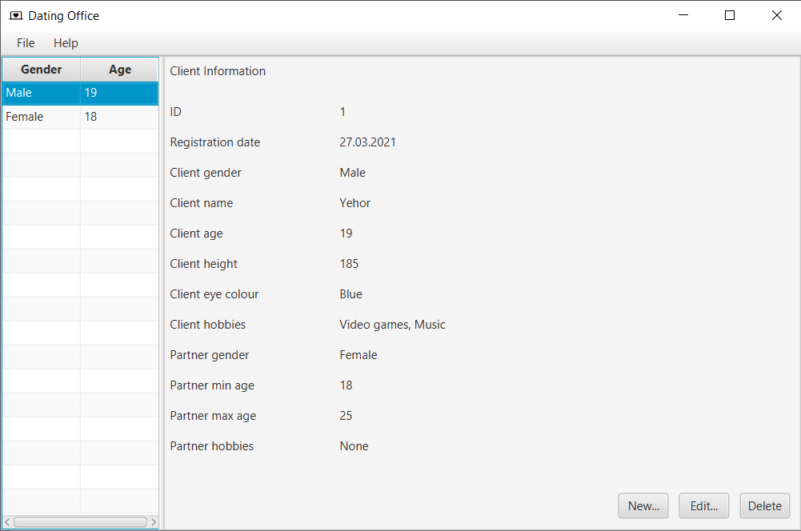

Рисунок 16.1 – Вікно огляду клієнтів

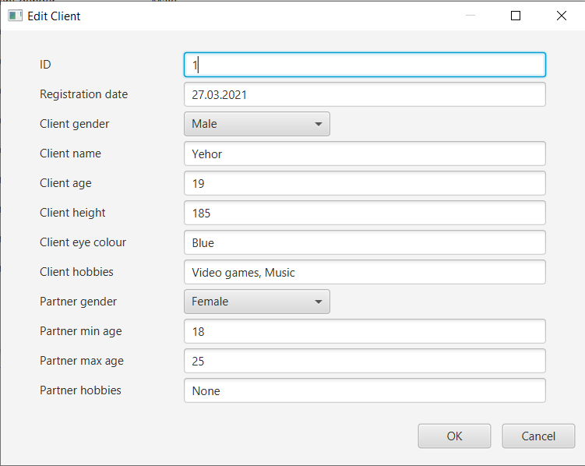

Рисунок 16.2 – Вікно редагування або додавання клієнта

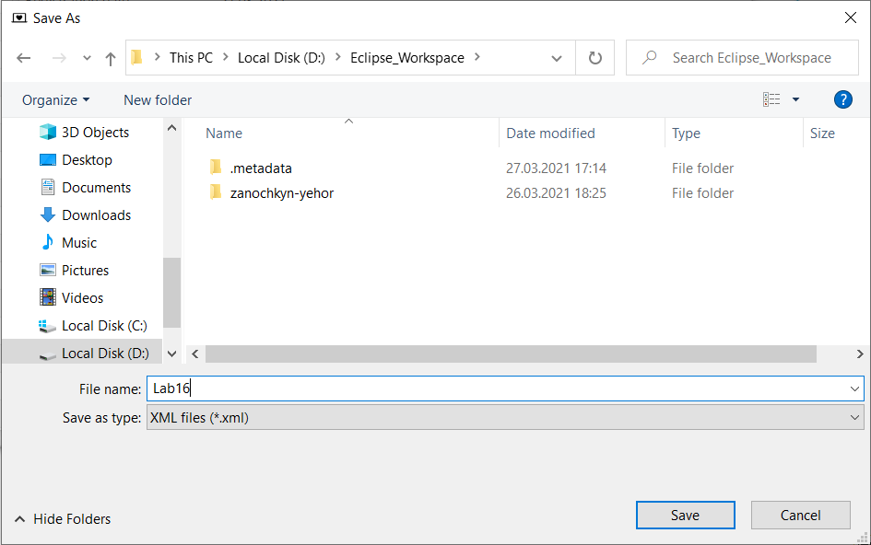

Рисунок 16.3 – Вікно збереження даних у файл XML

**Висновок**

Під час виконання лабораторної роботи було набуто навички використання засобів клієнтських технологій (Client Technologies) платформи Java SE та було розроблено графічний інтерфейс користувача з використанням засобів JavaFX.