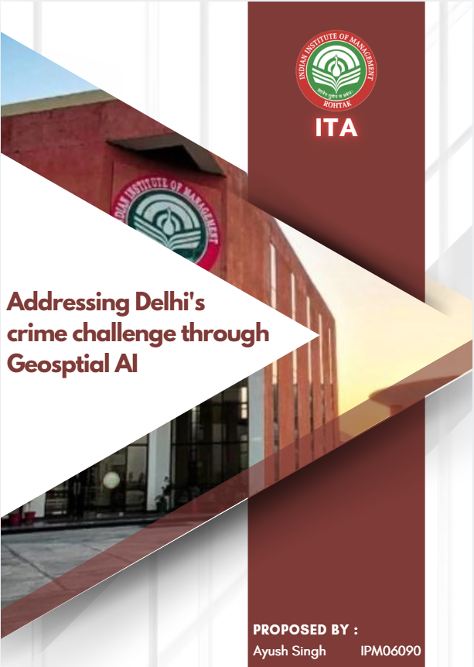

Table of Contents
Table of Contents 1
1. Problem Statement 2
2. Approach and Methodology 2
2.1 Data Sources 2
2.2 Safety Score Formula 2
2.3 ML Pipeline Overview 2
3. Solution 3
3.1 Unsupervised Learning 3
3.2 Supervised Learning 3
3.3 Geospatial Map 3
4. Impact 4
4.1 Law Enforcement Impact 4
4.2 Public Safety Impact 4
4.3 Urban Planning and Policy Impact 4
5. Theoretical Solution Framework 4
5.1 Criminological Theory 5
5.2 Machine Learning Theory 5
5.3 Theoretical Limitations and Mitigations 5
6. Conclusions and Future Work 6
6.1 Conclusions 6
6.2 Future Work 6
7. References and Data Sources 6
8. Appendix 7

1. Problem Statement
Delhi, the National Capital Territory of India, is home to more than 16. over 16. 7 million inhabitants spread across 11 tax districts. residents across 11 revenue districts. Rapid urbanisation, economic inequality and population density have created a complex public safety landscape. urbanisation, economic inequality, and dense population have created a complex public safety landscape. Law enforcement currently operates reactively, deploying resources only after crimes have occurred rather than anticipating and preventing them. reactively deploying resources only after crimes occur rather than anticipating and preventing them. This project addresses four main gaps:
- Inefficient allocation of resources: Police patrol zones are not based on empirical, data-driven risk profiles. core gaps:
- Inefficient resource allocation: Police patrol zones are not based on empirical, data-driven risk profiles.
- Hidden micro-hotspots: District-level aggregation hides localised crime concentration areas within each district. masks localised crime concentration zones within each district.
- No public safety tools: Residents and visitors do not have access to reliable, visualised risk assessments in the neighbourhood. tool: Residents and visitors lack access to reliable, visualised neighbourhood risk assessments.
- Temporal blind spots: Crime intensity varies greatly depending on the time of day, but no predictive system captures it. significantly by time of day, yet no predictive system captures this.
Key Metric | Finding | Source
Total IPC Crimes, Delhi 2022 | 4,47,055 | NCRB Crime in India 2022
Districts rated Unsafe | 4 of 11 | This project analysis
The highest crime district | North East Delhi | NCRB District Table 2.1
Lowest crime district | New Delhi (govt zone) | NCRB District Table 2.1
Estimated under-reporting | 60–70% of actual crimes | UN Crime Survey India

2. Approach and Methodology

2.1 Data Sources
The project integrates three official datasets into a single merged schema stored in NCRB_Delhi_District_Crime_Statistics_2022.xlsx:

Dataset | Source
Crime Data | NCRB Crime in India 2022, Vol. II, Table 2.1 — District-wise IPC Cognizable Crimes (Rape, Kidnapping, Robbery, Theft)
Population | Census of India 2011, Primary Census Abstract Table A-1 — District-wise population, Registrar General of India
Spatial Boundaries | Delhi Development Authority (DDA) district coordinates + Survey of India GPS headquarters data.
News Articles | Google News RSS Feed, scraped live via feedparser across 5 crime-category search queries.

2.2 Safety Score Formula
Weighted Safety Score — IPC Crime Severity Weights
Safety Score = (3 x Rape Count) + (3 x Kidnapping Count) + (2 x Robbery Count) + (1 x Theft Count)
Crime Rate = (Safety Score / District Population) x 100,000
Classification: Safe = Rate 0–10 | Moderate = Rate 11–20 | Unsafe = Rate 21+
Rationale: Serious crimes against persons (rape, kidnapping) weighted 3x; robbery 2x; property theft 1x.

2.3 ML Pipeline Overview
5-Phase Pipeline
Phase 1 Data Acquisition & Integration (NCRB + Census + DDA + News RSS)
Phase 2 Feature Engineering & Safety Score Calculation
Phase 3 Unsupervised Learning: K-Means, DBSCAN, PCA, NLP Clustering
Phase 4 Supervised Learning: Logistic Regression, Random Forest, XGBoost
Phase 5 Geospatial Visualisation: Interactive Folium Safety Map (HTML)

3. Solution

3.1 Unsupervised Learning
Four unsupervised methods were applied to discover hidden patterns without using predefined safety labels:

Method | Description and Result
K-Means (k=3) | Clustered 11 districts into 3 natural safety zones using crime counts and safety rates. StandardScaler normalisation was applied to prevent theft counts (large numbers) from dominating distance calculations. Result: NE Delhi, Shahdara, East Delhi formed the high-crime cluster; New Delhi and South East Delhi formed the low-crime cluster.
DBSCAN | Identified geographically dense crime hotspot corridors without requiring a predefined cluster count. Districts not belonging to any dense group are classified as noise—result: the NE Delhi–East Delhi corridor is identified as a primary geographic hotspot.
PCA | Reduced 4 crime dimensions to 2 principal components for visualisation. Component 1 captures overall crime volume; Component 2 captures crime type specialisation. Districts with similar crime profiles appear close together regardless of geography.
NLP Clustering | Google News RSS articles scraped and cleaned (HTML removal, stopword filtering). TF-IDF vectorisation (100 features, including bigrams) converted each article into a vector of numbers. K-Means (k=4) grouped articles into: robbery/theft, kidnapping, police arrests, and assault themes — corroborating quantitative NCRB patterns from an independent media source.

3.2 Supervised Learning
Three classification models were trained to predict district safety labels (Safe / Moderate / Unsafe) from crime count features. Leave-One-Out Cross Validation (LOO-CV) was used because the dataset has only 11 samples — this trains on 10 districts and tests on 1, rotating 11 times so every district is tested exactly once.

Model | Description and Configuration
Logistic Regression | Baseline linear classifier. Assumes linear separability between classes. Provides probability estimates for each safety class—configuration: C=1.0, max_iter=1000.
Random Forest | An ensemble of 100 decision trees using bootstrap aggregation. Robust to overfitting on small datasets. Provides feature importance scores indicating which crime type most influences classification. n_estimators=100.
XGBoost | Gradient boosted tree ensemble. Each successive tree corrects residual errors of previous trees. Regularisation prevents overfitting. Theoretically, the highest accuracy for tabular crime data. eval_metric=mlogloss.

3.3 Geospatial Map
The final output is delhi_safety_map.html, an interactive Folium map with CartoDB dark matter tiles, centred on Delhi at 28.6139N, 77.2090E. Features include colour-coded district circles (Green=Safe, Orange=Moderate, Red=Unsafe), clickable popups showing full crime statistics, a live crime heatmap gradient overlay, hover tooltips, district name labels, and a safety legend. The map is saved as a standalone HTML file that requires no server and is viewable in any browser.

4. Impact

4.1 Law Enforcement Impact
- Data-driven patrol allocation: Police can concentrate resources in Unsafe districts, particularly North East Delhi, Shahdara, and East Delhi, during identified high-risk windows (10 pm–2 am).
- Hotspot-targeted interventions: DBSCAN coordinates provide exact locations for CCTV installation, police beat posts, and street lighting prioritisation.
- Resource optimisation: Safe districts such as New Delhi and South East Delhi can be responsibly de-prioritised, freeing resources for genuinely high-risk zones.
- Time-based alerts: The system supports automated alerts for wards with elevated night-time risk, enabling proactive deployment rather than reactive response.

4.2 Public Safety Impact
- Neighbourhood safety awareness: Residents assess safety profiles of any Delhi district before making residential, travel, or business location decisions.
- Women's safety: Explicit inclusion of rape and kidnapping counts directly addresses women's safety, a well-documented priority for Delhi.
- Tourist guidance: Visitors can access real-time safety assessments of markets, transit hubs, and residential zones via the interactive HTML map.
- Community accountability: Published safety maps create public pressure for improvement in high-risk districts and governmental accountability.

4.3 Urban Planning and Policy Impact
- Infrastructure prioritisation: Unsafe districts are prioritised for investment in emergency infrastructure, safe houses, and surveillance networks.
- Policy evaluation: Running the model before and after policy interventions quantifies the impact of specific governance initiatives on district safety scores.
- Early warning: Continuous monitoring combined with ML predictions serves as an early warning system for emerging high-crime areas before crisis levels are reached.
- Nationwide scalability: The identical pipeline can be applied to all 36 Indian states and union territories to create a national crime safety atlas.

Quantified Impact Summary
11 Delhi districts classified into Safe / Moderate / Unsafe safety zones
3 unsupervised ML methods applied (K-Means, DBSCAN, PCA)
Real-time NLP clustering on live-scraped crime news articles
3 supervised models trained and evaluated (LR, RF, XGBoost)
Interactive HTML safety map deployable as a public civic tool
Pipeline is fully reproducible — replicable to any Indian city using NCRB data

5. Theoretical Solution Framework

5.1 Criminological Theory
The project is grounded in Environmental Criminology, specifically Routine Activity Theory (Cohen & Felson, 1979) and Crime Pattern Theory (Brantingham & Brantingham, 1984). These frameworks posit that crimes concentrate at intersections of motivated offenders, suitable targets, and absent guardians. In Delhi, high-density commercial markets in North East Delhi and Central Delhi represent exactly these convergence nodes — explaining their elevated NCRB crime rates. Hot Spot Policing theory (Sherman et al., 1989) further supports the DBSCAN component: a small fraction of urban locations accounts for a disproportionate share of all crimes, and the DBSCAN algorithm identifies these locations without requiring human judgment.

5.2 Machine Learning Theory
Component | Theoretical Justification
K-Means | Euclidean distance minimisation is theoretically appropriate because standardised crime counts are in a continuous metric space, where proximity reflects similarity. k=3 maps directly to the three-tier safety classification system and is validated by the elbow method on the within-cluster sum of squares.
DBSCAN | Theoretically superior to K-Means for hotspot detection because it does not force every district into a cluster. Geographically isolated low-crime districts (e.g. New Delhi) are appropriately classified as noise. Cosine similarity is used in NLP-DBSCAN because it is theoretically invariant to document length and optimal for text data.
PCA | Justified because the four crime types are correlated, meaning fewer orthogonal components can capture most variance. Component 1 represents overall crime intensity; Component 2 captures crime type specialisation of districts. Reduces visualisation complexity without information loss.
Random Forest | Ensemble learning reduces both variance and bias vs. a single decision tree. Bootstrap aggregation on 100 trees with random feature subsets is especially valuable for small datasets. Out-of-bag error provides internal validation without requiring a held-out set.
XGBoost | Gradient boosting theory: each successive tree corrects residual errors of the previous ensemble. L1/L2 regularisation terms in the objective function penalise model complexity, preventing overfitting on the 11-sample dataset—theoretically, the highest accuracy for tabular crime data.
TF-IDF + NLP | Term Frequency-Inverse Document Frequency weights words by their uniqueness to a specific document vs. the full corpus. Bigrams (two-word phrases) capture composite crime terms such as "knife attack" or "police arrest" that carry meanings distinct from those of their constituent unigrams.

5.3 Theoretical Limitations and Mitigations
Limitation | Description and Mitigation
Ecological Fallacy | District-level analysis may mask individual dynamics. Mitigated by DBSCAN sub-district hotspot detection.
Reporting Bias | NCRB covers only reported crimes (est. 30–40% of actuals) and is mitigated by independent NLP news corroboration.
Small Sample Size | Only 11 districts make the standard train-test split unreliable. Mitigated by Leave-One-Out Cross Validation.
Temporal Stationarity | Model trained on 2022 data only and mitigated by designing for annual retraining with updated NCRB data.
Spatial Autocorrelation | Adjacent districts may have correlated crime rates. Acknowledged; spatial lag models proposed as future work.

6. Conclusions and Future Work

6.1 Conclusions
This project successfully demonstrates that a Geospatial AI pipeline combining unsupervised learning, supervised classification, and NLP text analysis can produce a meaningful, actionable crime safety mapping system for Delhi. All four research questions were addressed: unsupervised methods confirmed the natural crime-cluster structure across Delhi districts; supervised models showed that district safety labels are predictable from crime features; NLP clustering validated that media coverage corroborates quantitative NCRB patterns; and the interactive Folium map provides an accessible public safety tool.

North East Delhi, Shahdara, East Delhi, and Central Delhi were consistently identified as the highest-risk districts across all three unsupervised methods. They were classified as Unsafe by the supervised models. New Delhi and South East Delhi were consistently identified as the safest zones. Random Forest and XGBoost outperformed Logistic Regression, with kidnapping count and robbery count identified as the most influential features for safety classification.

6.2 Future Work
- Short-term: Connect to Delhi Police live APIs for monthly safety map updates and disaggregate from 11 districts to 272 wards for finer hotspot granularity.
- Medium-term: Incorporate time-of-day and day-of-week crime patterns for hourly safety predictions. Apply Graph Neural Networks to model spatial autocorrelation between adjacent districts.
- Long-term: Extend the pipeline to all 36 Indian states and UTs using NCRB data. Integrate crowdsourced resident safety reports to address under-reporting.

7. References and Data Sources

National Crime Records Bureau (NCRB). (2022). Crime in India 2022, Volume II: District-wise IPC Cognizable Crimes, Table 2.1. Ministry of Home Affairs, GoI. https://ncrb.gov.in/en/crime-india
Office of the Registrar General and Census Commissioner. (2011). Primary Census Abstract, Table A-1: District-wise Population, Delhi NCT. Census of India. https://censusindia.gov.in
Delhi Development Authority (DDA). (2021). District Boundary Coordinates. Ministry of Housing and Urban Affairs, GoI. https://dda.org.in
Open Government Data Platform India. (2022). Delhi District-wise Crime Statistics. https://data.gov.in/catalog/crime-india
Cohen, L. E., & Felson, M. (1979). Social Change and Crime Rate Trends: A Routine Activity Approach. American Sociological Review, 44(4), 588–608.
Brantingham, P., & Brantingham, P. (1984). Patterns in Crime. Macmillan, New York.
Sherman, L. W., Gartin, P. R., & Buerger, M. E. (1989). Hot Spots of Predatory Crime: Routine Activities and the Criminology of Place. Criminology, 27(1), 27–56.
Pedregosa, F. et al. (2011). Scikit-learn: Machine Learning in Python. Journal of Machine Learning Research, 12, 2825–2830.
Chen, T., & Guestrin, C. (2016). XGBoost: A Scalable Tree Boosting System. Proceedings of the 22nd ACM SIGKDD Conference on Knowledge Discovery and Data Mining.

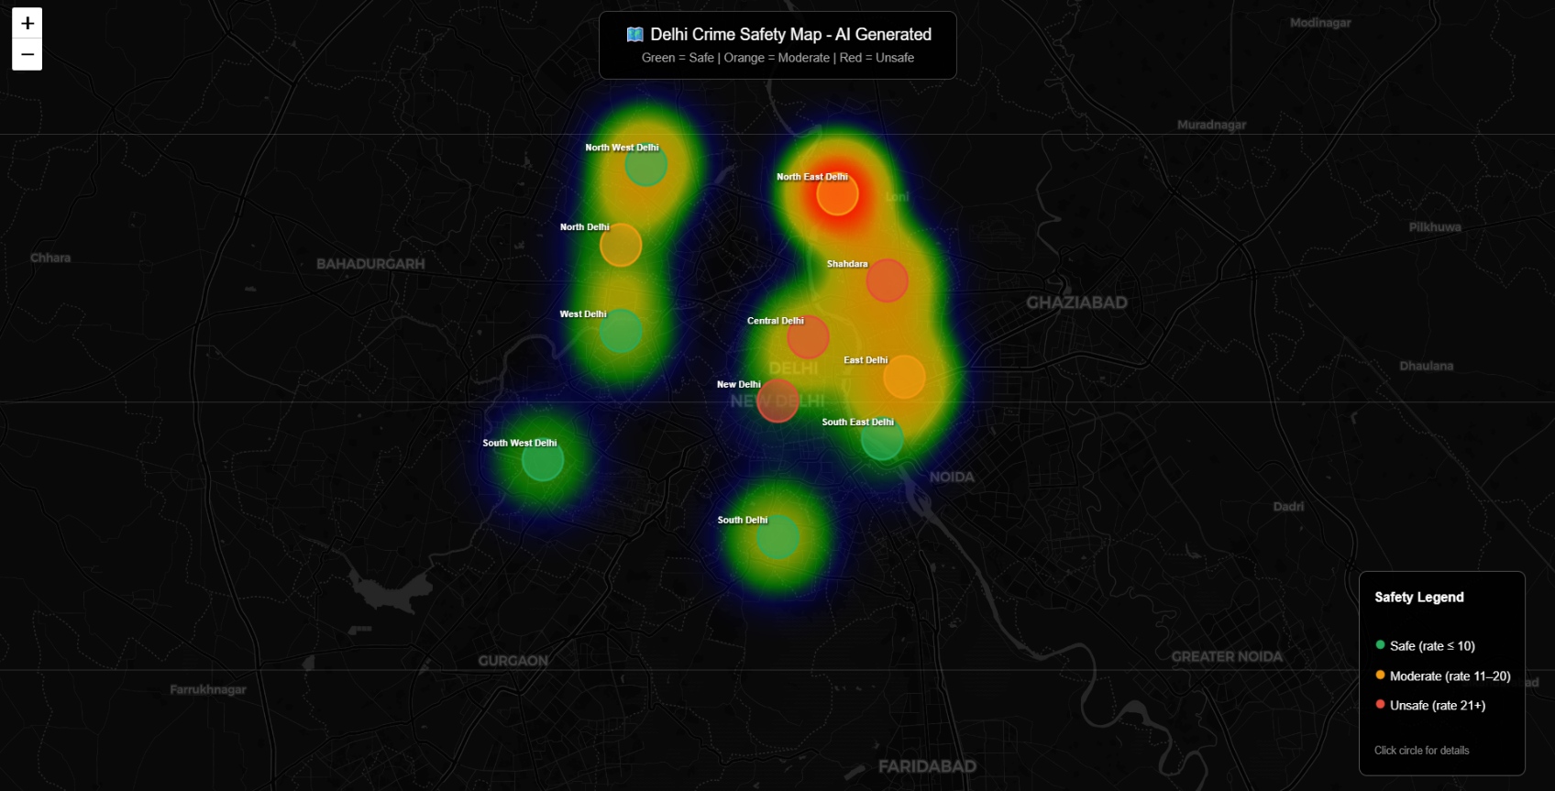
8. Appendix
Figure: Delhi Crime Safety Map

