ngOC KIEU THANH huYNH – 2688093

Bilal Butt – 2688700

Michel Clerger – 2694646

moNICA DADASHIAN - 2478862

OOD1 – ASSIGNMNET 13-14

GROUP MEMBERS:

## A. use case for finding information about an animal, based on a chip-number.

### Goal level: Sea level

### Main success scenario:

1. User scans the dog to detect the chip-number in the RFID Tag
2. System shows the information of the animal being identified by the given chip-number.

### Extensions:

2.a System cannot find the animal corresponding to the chip-number

.1: System notifies user about the results.

2: Reference to the use case for adding a dog (user case B).

## B. Write a use case for adding a dog to the system

Precondition: the dog has the chip installed in it and does not exist in the system.

Trigger: A dog scanned and the chip-number is read and system does not recognize chip-number in database so it knows that it is a new chip-number.

## Goal: sea level

### MSS

1. System displays animal entry form.

2. User selects option (perhaps in the form of radio button) to enter dog into the system database.

3. System enables relevant data inputs for registering a dog into the system, which include input information such as description fields for describing physical features of the animal. The system also initializes field for days since dog's last walk as 0. Dog's instance is created in database with the uniquely associated RFID.

## C. Write a use case for finding information about all the animals that are owned by a certain person.

### Goal level: Sea level

### Main success scenario:

1. System shows the search window.
2. User enters the name of the person.
3. System shows the information of the animals own by that person.

### Extensions:

3.a System cannot find the name of the person provided

.1: System notifies user about the results and ask them to verify that they have provided the right information.

.2: System go back the step 1.

## D. Rules/Decisions:

1. When adding an animal to the system the physical features must be filled in.

2. The animal should not be already in the system.

3. Every registered animal has to have a chip.

4. User’s ID verification is required when picking up an animal.

5. If the animal is kept longer than 20 days the animal can be assigned for another owner.

6. Only the staff of the shelter can interact with the system.

## CLASS DIAGRAM – Version 1

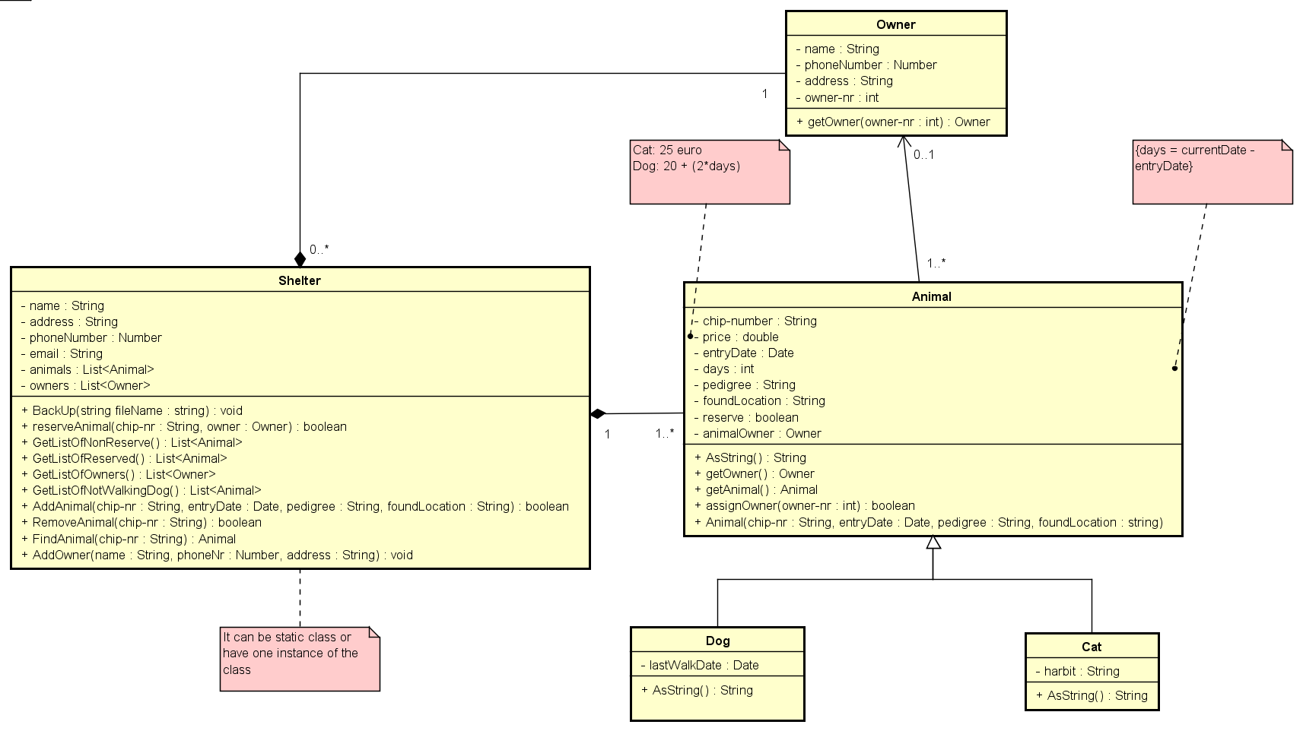

## CLASS DIAGRAM – Version 2

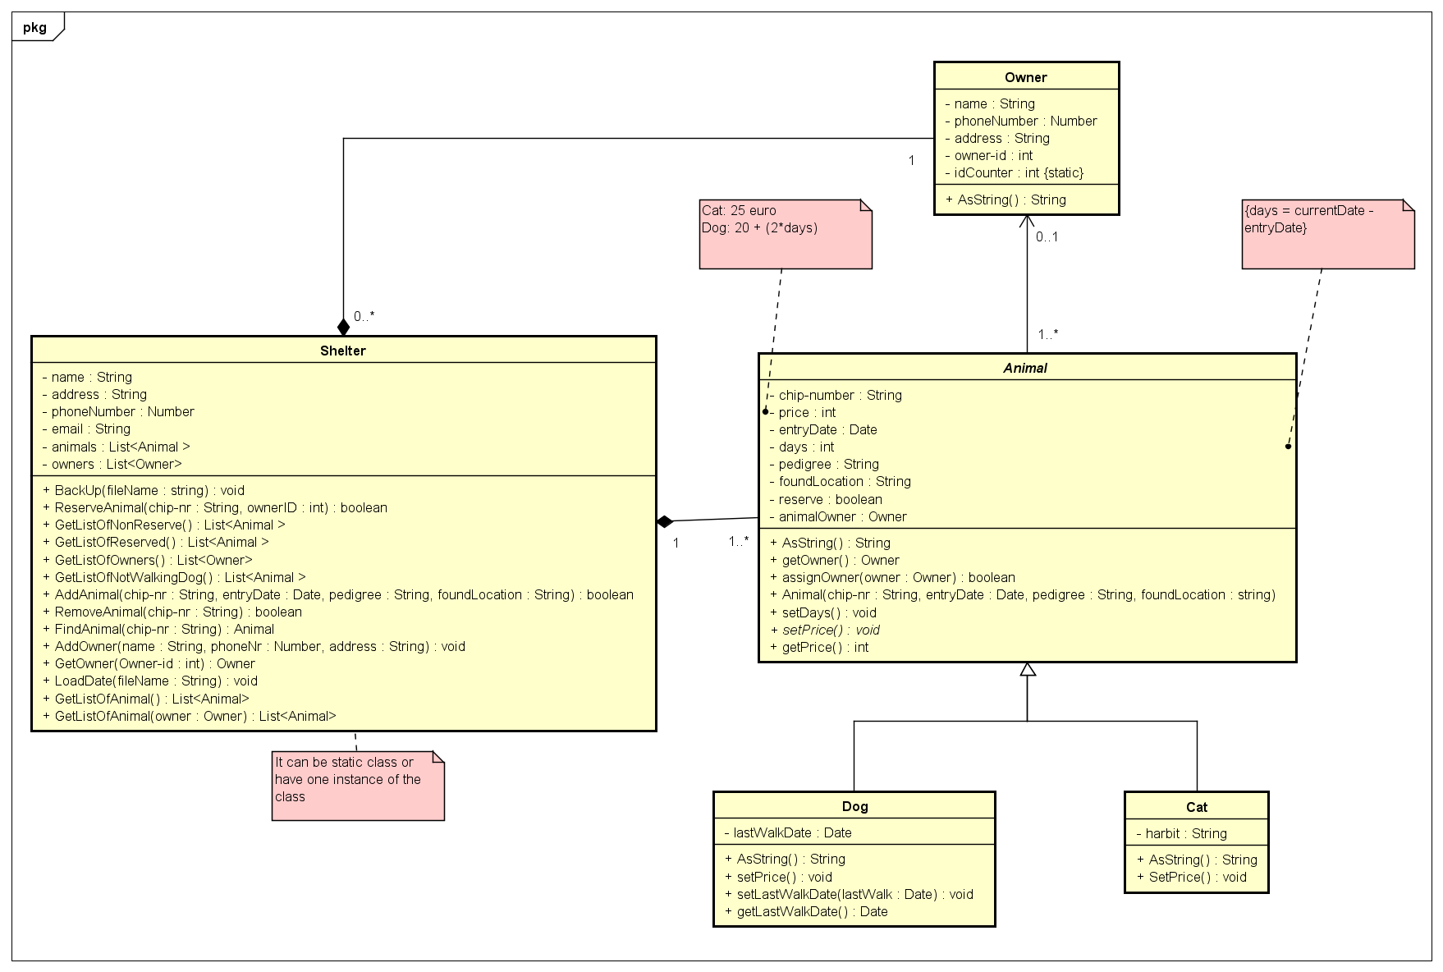

## SEQUENCE DIAGRAM

#### Sequence diagram for reserving animal:

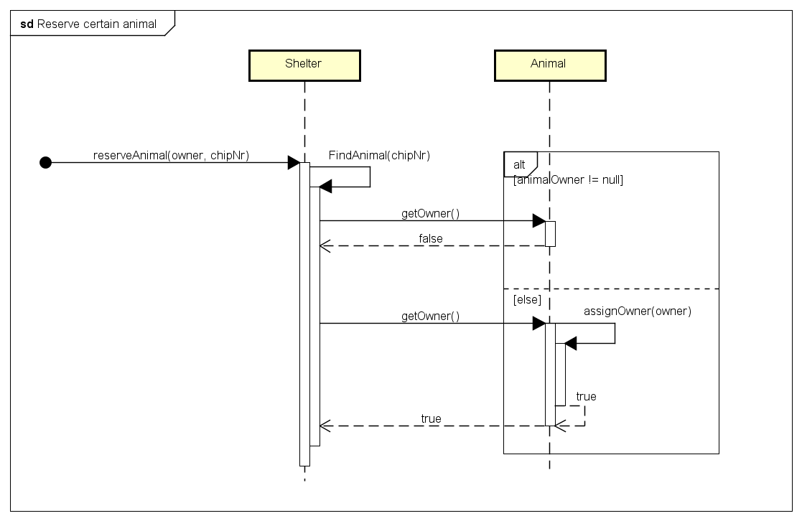

#### Sequence diagram for adding a dog

