

**DATABASES**

April – Sep 2011

## SCHOOL OF INFOCOMM TECHNOLOGY

Diploma in Information Technology

Diploma in Financial Informatics

**Databases Assignment**

**(20 % of DB Module)**

**3rd July 2011 – 15th July 2011 (2 Weeks)**

**Deadline: 15th July 2011, 5PM**

|  |  |  |  |
| --- | --- | --- | --- |
| DB Class group | : | T 10 | |
| Team Number | : | 4 | |
| Tutor | : | Mr. Chiu Kok Lan | |
| Members | : | Student No. | Student Name |
|  |  | 1)S10096590G | Yu ZongDong |
|  |  | 2)S10095037H | Toh Eng Kong |
|  |  | 3)S10097443G | Liew Sau Teng |
|  |  | 4)S10085092D | Mcvie Chua Qihe |
|  |  |  |  |

**Penalty for late submission:**

10% of the marks will be deducted for everyday (inclusive of Saturdays and Sundays) after the deadline.

**NO** submission will be accepted after 20th July 2011, 5PM.

Contents

SCHOOL OF INFOCOMM TECHNOLOGY 1

Nail Palace Service (Pedicure) Description 3

Services and Staff 3

Product sell 3

Booking and Customers 3

Receipt 3

Pay Slip 4

List of Relation 8

Data Dictionary 9

Relation: Staff 9

Relation: Member 9

Relation: Booking 10

Relation: Product 10

Relation: NPService 11

Relation: Branch 11

Relation: PaySlip 12

Relation: Stock 12

Relation: ServiceDetail 12

Relation: ServiceReceipt 13

Relation: ProductDetail 13

Relation: ProductReceipt 14

SQL Table Creation And Inserts 15

Business Queries 30

Constrains 46

# Nail Palace Service (Pedicure) Description

Nail Palace is a newly setup local book rental company. It provides a wide range of services to their customer. Currently it has 3 branches located in different parts of Singapore. The company is planning to set up a database to manage the data more efficiently.

Each branch is operated by a few staffs and the staff will be assigned with the branch’s number.

## Services and Staff

Nail Palace provides a wide range of services that serves the customers from head to toes and it has a group of high standard pedicurists taking turns to work for 8 hours per day to serve the customers. There will be a service menu provided which will provide details of the services, name, prices and the descriptions of the service, approximated duration, picture and each service has a service number allocated to them.

All the staffs will provide name card to customers for convenient contact. Staff’s name card, providing the staff’s working information, contact information, Staff Name and staff’s email, the branch he belong to and details .

## Product sell

Nail Palace provides a range of pedicure related products that are available for the customers for purchase. A product will have a product ID, Name, Quantity, Price, description, expiry date, manufacture, and origin. When the customer wants to buy a product, the database will show the number of products being purchased and the total price of the products

## Booking and Customers

Customer can either make a booking or walk-in to the shop to be serviced.

For members who make booking, they need to provide their memberNRIC and also inform the staff the time, date and the services he/she wants during booking. The member will then receive a booking number for his/her booking. So when the member goes for their services, they will need to inform the staff his/her booking number.

For customers who walk in to the shop, they will require to become a member immediately. They have to provide their Identity card number, name, contact number, home address, email address and date of birth. Thus, they will receive a member card containing the above information and the customer’s gender and date Join. After they had registered to become a member, the staff will help them book the time slot that is available during the walk-in time and thus they can enjoy the services.

## Receipt

Receipt/invoice will be received after payment has been made for the services done and for the products sold by a particular member. Receipt includes staff’s information, service information, payment information and branch information.

## Pay Slip

A pay slip contains the total salary of a staff for the whole month. It is calculated by adding the basic salary and the commission together. The commission is five percent of the total amount spent by the customers that have been served by the staff over the month.

**Processes**

Walk in customer wants to be serviced.

1. Walk in Customer ask the counter whether there is any free slot of timing that they can be serviced.
2. The staff will take down their information such as their name, NRIC, date of birth and contact number.
3. The staff will check if there is any free timing slot available.
4. If there is free timing slot, the counter staff will book for the customer stay and wait for their turn.
5. If there is no free timing slot, the counter will ask the customer to book a day for service

When the customer pay for the service

1. The staff will tell the amount that need to be paid and ask what mode of payment, does the customer want to pay the payment. ( By credit card or cash)
2. The customer will say he will like to pay in cash or credit card
3. After receiving the payment, the staff will produce a receipt for the customer

Customer making booking through phone

1. The customer call the service counter
2. Staff ask for name and member ID of the customer
3. Staff take down the date and timing the customer want and check whether the timing is booked
4. If the timing is free, the staff will take down the services the customer want to have. And write the service code in the book under that customer and tell the customer the booking number.

Service Provided

1. We will provide a few services such as manicure and pedicure. Fish Spa, nail polishing, nail trimming etc…
2. If the customer wants to know about a service provided by the shop the staff will give the customer the service menu and explain to the customer.
3. If the customer selected a service, the staff will enter the service code in to the receipt and calculate the amount.

Product sell

1. Customer inquiries the product used by the shop.
2. The staff describe the product to the customer and tell the price to the customer
3. If the customer want to buy the product, the staff will get the money from the customer and give the product to the customer
4. The staff will add the product code and product name of the product in to the receipt.

When the staffs get their pay slips

1. The pay slip contains date of issue and the commission.
2. The commission is generated from the receipts. So we will select the receipts that belong to the customer that is served by the staff.
3. Then we are going to calculate the 5 percent of the total amount and that will be the staff’s commission.
4. Lastly we will add the commission and the basic salary together to have the total salary for that month for the staff.

The staffs details which will be given to customers

1) Staffs provide name card to customers

2) Name card consists of staff’s working information, contact, and name.

3) If the customer wishes to make booking, he can contact the counter providing them the details of the staffs which they wish to be serviced.

Generate receipt for customers

1. After customer finish their services, the staff will key in their service ID to the system in order to add records to the receipts.
2. If customers purchase products, staff will key in product ID, quantity to the system in order to add products purchase records to the receipts.



List of Relation

1. Staff (StaffID, StaffName, StaffGender, StaffContactNo, StaffDateJoin, BasicSalary, <BranchNo> )
2. Member ( MemberNRIC, MemberName, MemberGender, MemberBirthDate, MemberContactNo, MemberAddress, MemberEmailAddr, MemberDateJoin)
3. Branch (BranchNo, BranchName, BranchAddress, BranchContactNo)
4. Product (ProductID, ProductPrice, ProductName, ProductDesc, ProductOrigin, Manufacturer, ProductExpiryDate)
5. Service (ServiceID, ServiceName, ServiceDescription, ServicePrice, ServiceDuration, <staffID>)
6. PaySlip (PayslipNo, PayslipDate, Commission, <ReceiptNo>, TotalSalary )
7. Booking (BookingNo, SeatNo, DateBooked, TimeBooked, EndTimeBooked, <ServiceID>, <MemberID> )
8. ServiceReceipt (ReceiptNo, AmountOfGST, TotalAmount, PaymentMode, ReceiptDateTime, Change, PaymentAmount, <ServiceID> )
9. ProductReceipt (ReceiptNo, AmountOfGST, TotalAmount, PaymentMode, ReceiptDateTime, Change, PaymentAmount, <ProductID> )
10. Stock(Quantity, <BranchNo>, <ProductID>)
11. ProductDetail (<ProductID>, DateBought ,ProductName, ProductQuantity, ProductPrice, <ReceiptNo>)
12. ServiceDetail(<ServiceID>,DateService, ServiceName, ServicePrice,< ReceiptNo>)

# Data Dictionary

## Relation: Staff

|  |  |  |  |  |
| --- | --- | --- | --- | --- |
| **Attribute** | **Description** | **Data Type** | **Constraint** | **Null Value** |
| StaffID | Unique identifier of each member of staff. | varchar(10) | Primary Key | No. |
| StaffName | Name of staff | varchar(50) |  | No. |
| StaffGender | Gender of staff | char(1) | Values: M for Male, F for Female. | No. |
| StaffContactNo | Contact Number of Staff | varchar(10) |  | No. |
| staffDateJoin | Date that staff joined the company | datetime | DateJoin not later than today. | No. |
| BasicSalary | Basic Salary of each Staff. | money |  | No. |
| BranchNo | Identifies branch that staff is working. | int | Foreign Key 🡪 Branch (BranchNo) | No. |

## Relation: Member

|  |  |  |  |  |
| --- | --- | --- | --- | --- |
| **Attribute** | **Description** | **Data Type** | **Constraint** | **Null Value** |
| MemberNRIC | NRIC of Member. | char(9) | Primary Key | No. |
| MemberName | Name of Member. | varchar(50) |  | No. |
| MemberGender | Gender of Member | char(1) | Values: M for Male, F for Female. | No. |
| MemberBirthDate | Date of Birth of Member | datetime |  | Yes. |
| MemberContactNo | Contact number of Member | char(10) |  | No. |
| MemberAddress | Local address of member. | varchar(150) |  | No. |
| MemberEmailAddr | Email address of Member | varchar(50) |  | Yes. |
| MemberDateJoin | Date that member joined (Default to today’s date) | datetime | DateJoin not later than today. | No. |

## Relation: Booking

|  |  |  |  |  |
| --- | --- | --- | --- | --- |
| **Attribute** | **Description** | **Data Type** | **Constraint** | **Null Value** |
| Booking No | Unique identifier of each member of booking. | Auto-generated numeric | Primary Key | No |
| SeatNo | The seat number of the booking. | int |  | No |
| DateBooked | Date selected by the customer when they make the booking | datetime |  | No |
| TimeBooked | Time chosen by the customer when they made the booking | datetime |  | No |
| EndTimeBooked | The time that the booking ended | datetime |  | No |
| ServiceID | Unique identifier of each Service | int | Foreign Key 🡪 Service(ServiceID) | No. |
| MemberID | Unique identifier of each member | int | Foreigh Key 🡪  Member(MemberID) | No |

## Relation: Product

|  |  |  |  |  |
| --- | --- | --- | --- | --- |
| **Attribute** | **Description** | **Data Type** | **Constraint** | **Null Value** |
| ProductID | Unique identifier of each product | Auto-generated numeric , int | Primary Key | No |
| ProductPrice | Price of the product | smallmoney |  | No |
| ProductName | Name of the product | Varchar(50) |  | No |
| ProductDesc | Description of the product | Varchar(200) |  | Yes |
| ProductOrigin | The origin of the product | Varchar(50) |  | No |
| Manufacturer | The name of the manufacture that produce | Varchar(50) |  | No |
| ProductExpriyDate | The expiry date of the product | Datetime |  | Yes |

## Relation: NPService

|  |  |  |  |  |
| --- | --- | --- | --- | --- |
| **Attribute** | **Description** | **Data Type** | **Constraint** | **Null Value** |
| ServiceID | Unique identifier of each service | Auto-generated numeric | Primary key | No |
| ServiceName | Name of services | varchar(50) |  | No |
| ServiceDesc | Description of the sevices | varchar(100) |  | Yes |
| ServicePrice | Pricing of the services | money |  | No |
| ServiceDuration | Duration of the services | varchar(5) |  | No |

## Relation: Branch

|  |  |  |  |  |
| --- | --- | --- | --- | --- |
| **Attribute** | **Description** | **Data Type** | **Constraint** | **Null Value** |
| BranchNo | Unique identifier of each Branch No | int | Primary Key | No |
| BranchName | Name of the branch | varchar(50) |  | No |
| BranchAddress | Address of the branch | varchar(150) |  | No |
| branchContactNo | Contact Number of the branch | char(10) |  | No |

## Relation: PaySlip

|  |  |  |  |  |
| --- | --- | --- | --- | --- |
| **Attribute** | **Description** | **Data Type** | **Constraint** | **Null Value** |
| PaySlipNo | Unique identifier of each PaySlip | Int | Auto-generated  Primary Key | No |
| PaySlipDate | Date the pay slip is been produced | Datetime |  | No |
| Commission | The amount of commission earn monthly by the staff. | smallmoney | 5% of the receipt. | No |
| TotalSalary | The total salary of the staff | money |  | No |
| StaffID | Unique identifier of each member of staff. | varchar(10) | Primary Key  Foreign Key 🡪 Staff(StaffID) | No. |

## Relation: Stock

|  |  |  |  |  |
| --- | --- | --- | --- | --- |
| **Attribute** | **Description** | **Data Type** | **Constraint** | **Null Value** |
| Quantity | Quantity of the stocks | Int |  | No |
| ProductID | Unique identifier of each product | Int | Foreign Key 🡪 Product(ProductID)  PrimaryKey | No |
| BranchNo | Unique identifier of each branch | Int | Foreign Key 🡪 Branch(BranchID)  PrimaryKey | No |

## Relation: ServiceDetail

|  |  |  |  |  |
| --- | --- | --- | --- | --- |
| **Attribute** | **Description** | **Data Type** | **Constraint** | **Null Value** |
| ServiceID | Unique identifier of each service | int | Foreign Key 🡪  Product(ProductID) | No |
| ServiceName | The name of service been bought | datetime |  | No |
| ServicePrice | The price of the services bought | varchar(50) |  | No |
| DateServiced | The date of the member bought the service | Money |  | No |
| ReceiptNo | Unique identifier of each receipt | Int | Foreign Key 🡪 Receipt(ReceiptNo) | No. |

## Relation: ServiceReceipt

|  |  |  |  |  |
| --- | --- | --- | --- | --- |
| **Attribute** | **Description** | **Data Type** | **Constraint** | **Null Value** |
| ReceiptNo | Unique identifier of each receipt | Auto-generated numeric | Primary key | No |
| SubTotal | The total of product and service bought | Money |  | No |
| AmountOfGST | The amount of GST, 7% | smallmoney | Cannot be lesser than 7% or greater than 7% |  |
| TotalAmount | The amount of the product and service after gst | money |  | No |
| Change | The changes of the receipt | money |  | No |
| PaymentMode | Type of payment, such as nets, visa or cash | varchar(20) |  | No |
| PaymentAmount | The payment amount | money |  | No |
| StaffID | Unique identifier of each staff | Int | Foreign Key 🡪 staff(StaffID) | No. |
| PaySlipNo | Unique identifier of each payslip | int | Foreign Key 🡪 PaySlipNo(PaySlip) | No |

## Relation: ProductDetail

|  |  |  |  |  |
| --- | --- | --- | --- | --- |
| **Attribute** | **Description** | **Data Type** | **Constraint** | **Null Value** |
| ProductID | Unique identifier of each Product | int | Foreign Key 🡪  Product(ProductID) | No |
| DateBought | The date the member bought the products | datetime |  | No |
| ProductName | The name of the products bought | varchar(50) |  | No |
| ProductPrice | Price of the products | Money |  | No |
| ProductQuantity | The quantity of the product bought by member | int |  | Yes |
| ReceiptNo | Unique identifier of each receipt | Int | Foreign Key 🡪 Receipt(ReceiptNo) | No. |

## Relation: ProductReceipt

|  |  |  |  |  |
| --- | --- | --- | --- | --- |
| **Attribute** | **Description** | **Data Type** | **Constraint** | **Null Value** |
| ReceiptNo | Unique identifier of each receipt | Auto-generated numeric | Primary key | No |
| SubTotal | The total of product and service bought | Money |  | No |
| AmountOfGST | The amount of GST, 7% | smallmoney | Cannot be lesser than 7% or greater than 7% |  |
| TotalAmount | The amount of the product and service after gst | money |  | No |
| Change | The changes of the receipt | money |  | No |
| PaymentMode | Type of payment, such as nets, visa or cash | varchar(20) |  | No |
| PaymentAmount | The payment amount | money |  | No |
| StaffID | Unique identifier of each staff | Int | Foreign Key 🡪 staff(StaffID) | No. |
| PaySlipNo | Unique identifier of each payslip | int | Foreign Key 🡪 PaySlipNo(PaySlip) | No |

# SQL Table Creation And Inserts

Create Database NailPalaces

GO

use NailPalaces

GO

drop table Member

/*** Create tables ***/

/* Table: Member */

CREATE TABLE Member

(

MemberNRIC char(9) NOT NULL,

MemberName varchar(50) NOT NULL,

MemberGender char(1) NOT NULL CHECK (MemberGender IN ('M','F')),

MemberBirthDate datetime NOT NULL,

MemberContactNo char(10) NOT NULL,

MemberAddress varchar(150) NOT NULL,

MemberEmailAddr varchar(50) NULL,

MemberDateJoin datetime NOT NULL,

CONSTRAINT PK_Member PRIMARY KEY (MemberNRIC)

)

GO

/* Table: Branch */

CREATE TABLE Branch

(

BranchNo int,

BranchName varchar(50) NOT NULL,

BranchAddress varchar(150) NOT NULL,

BranchContactNo varchar(10) NOT NULL,

CONSTRAINT PK_Branch PRIMARY KEY (BranchNo)

)

Go

/* Table: Product */

CREATE TABLE Product

(

ProductID int IDENTITY(11111111, 10),

ProductPrice smallmoney NOT NULL,

ProductName varchar(50) NOT NULL,

ProductDesc varchar(200) NULL,

ProductOrigin varchar(50) NOT NULL,

Manufacturer varchar(50) NOT NULL,

ProductExpiryDate datetime NULL,

CONSTRAINT PK_Product PRIMARY KEY (ProductID)

)

/* Table: ProductDetail */

CREATE TABLE ProductDetail

(

ProductID int NOT NULL,

DateBought datetime NOT NULL,

ProductName varchar(50) NOT NULL,

ProductPrice money NOT NULL,

ProductQuantity int NOT NULL,

ReceiptNo int NOT NULL,

CONSTRAINT PK_ProductDetail PRIMARY KEY (ProductID, DateBought),

CONSTRAINT FK_ProductDetail_ProductID FOREIGN KEY (ProductID) REFERENCES Product(ProductID),

CONSTRAINT FK_ProductDetail_ReceiptNo FOREIGN KEY (ReceiptNo) REFERENCES ProductReceipt(ReceiptNo)

)

/* Table: ProductReceipt */

CREATE TABLE ProductReceipt

(

ReceiptNo int IDENTITY(10101010, 1),

Subtotal money NOT NULL,

AmountOfGST money NOT NULL,

TotalAmount money NOT NULL,

Change money NULL,

PaymentMode varchar(20) NOT NULL,

PaymentAmount money NULL,

StaffID varchar(10) NOT NULL,

PaySlipNo int NOT NULL,

CONSTRAINT PK_ProductReceipt PRIMARY KEY (ReceiptNo),

CONSTRAINT FK_Receipt_StaffID FOREIGN KEY (StaffID) REFERENCES Staff(StaffID),

CONSTRAINT FK_ProductReceipt_PaySlipNo FOREIGN KEY (PaySlipNo) REFERENCES PaySlip(PaySlipNo)

)

GO

/* Table: Stock */

CREATE TABLE Stock

(

BranchNo int,

ProductID int NOT NULL,

Quantity int NOT NULL,

CONSTRAINT PK_Stock PRIMARY KEY (BranchNo, ProductID),

CONSTRAINT FK_Stock_BranchNo FOREIGN KEY (BranchNo) REFERENCES Branch(BranchNo),

CONSTRAINT FK_Stock_ProductID FOREIGN KEY (ProductID) REFERENCES Product(ProductID)

)

GO

/* Table: Staff */

CREATE TABLE Staff

(

StaffID varchar(10),

StaffName varchar(50) NOT NULL,

StaffGender char(1) NOT NULL CHECK (StaffGender IN ('M','F')),

StaffContactNo varchar(10) NOT NULL,

StaffDateJoin datetime NOT NULL,

BasicSalary smallmoney NOT NULL,

BranchNo int NOT NULL,

CONSTRAINT PK_Staff PRIMARY KEY (StaffID),

CONSTRAINT FK_Staff_BranchNo FOREIGN KEY (BranchNo) REFERENCES Branch(BranchNo)

)

GO

/* Table: Pay Slip */

CREATE TABLE PaySlip

(

PaySlipNo int IDENTITY(1,1),

StaffID varchar(10) NOT NULL,

PaySlipDate datetime NOT NULL,

Commission money NOT NULL,

TotalSalary money NOT NULL,

CONSTRAINT PK_PaySlip PRIMARY KEY (PaySlipNo),

CONSTRAINT FK_PaySlip_StaffID FOREIGN KEY (StaffID) REFERENCES Staff(StaffID)

)

GO

/* Table: Service */

CREATE TABLE NPService

(

ServiceID int IDENTITY(10010001, 10),

ServiceName varchar(50) NOT NULL,

ServiceDesc varchar(100) NULL,

ServicePrice money NOT NULL,

ServiceDuration varchar(5) NOT NULL,

CONSTRAINT PK_NPService PRIMARY KEY (ServiceID)

)

Go

/* Table: ServiceDetail */

CREATE TABLE ServiceDetail

(

ServiceID int NOT NULL,

ServiceName varchar(50) NOT NULL,

ServicePrice money NOT NULL,

DateServiced datetime NOT NULL,

ReceiptNo int NOT NULL,

CONSTRAINT PK_ServiceDetail PRIMARY KEY (ServiceID, DateServiced),

CONSTRAINT FK_ServiceDetail FOREIGN KEY (ServiceID) REFERENCES NPService(ServiceID),

CONSTRAINT FK_ServiceDetail_ReceiptNo FOREIGN KEY (ReceiptNo) REFERENCES ServiceReceipt(ReceiptNo)

)

GO

/* Table: ServiceReceipt */

CREATE TABLE ServiceReceipt

(

ReceiptNo int IDENTITY(01010101, 1),

Subtotal money NOT NULL,

AmountOfGST money NOT NULL,

TotalAmount money NOT NULL,

Change money NULL,

PaymentMode varchar(20) NOT NULL,

PaymentAmount money NULL,

StaffID varchar(10) NOT NULL,

PaySlipNo int NOT NULL,

CONSTRAINT PK_ServiceReceipt PRIMARY KEY (ReceiptNo),

CONSTRAINT FK_ServiceReceipt_StaffID FOREIGN KEY (StaffID) REFERENCES Staff(StaffID),

CONSTRAINT FK_ServiceReceipt_PaySlipDate FOREIGN KEY (PaySlipNo) REFERENCES PaySlip(PaySlipNo)

)

Go

/* Table: Booking */

CREATE TABLE Booking

(

BookingNo int IDENTITY(0001, 1),

SeatNo int NOT NULL,

DateBooked datetime NOT NULL,

TimeBooked datetime NOT NULL,

EndTimeBooked datetime NOT NULL,

ServiceID int NOT NULL,

MemberNRIC char(9) NOT NULL,

CONSTRAINT PK_Booking PRIMARY KEY (BookingNo),

CONSTRAINT FK_Booking_ServiceID FOREIGN KEY (ServiceID) REFERENCES NPService(ServiceID),

CONSTRAINT FK_Booking_MemberNRIC FOREIGN KEY (MemberNRIC) REFERENCES Member(MemberNRIC)

)

SELECT * FROM Booking

SELECT * FROM Branch

SELECT * FROM Member

SELECT * FROM NPService

SELECT * FROM PaySlip

SELECT * FROM Product

SELECT * FROM ProductDetail

SELECT * FROM ProductReceipt

SELECT * FROM ServiceDetail

SELECT * FROM ServiceReceipt

SELECT * FROM Staff

SELECT * FROM Stock

/***** Create Records in Service Detail *****/

DELETE ServiceDetail

INSERT INTO ServiceDetail(ServiceID, ServiceName, ServicePrice, DateServiced, ReceiptNo)

VALUES ('10010001', 'Express Manicure', '9.9', '07-09-2011', '1010101')

INSERT INTO ServiceDetail(ServiceID, ServiceName, ServicePrice, DateServiced, ReceiptNo)

VALUES ('10010011', 'Express Pedicure', '11.9', '07-18-2011', '1010101')

INSERT INTO ServiceDetail(ServiceID, ServiceName, ServicePrice, DateServiced, ReceiptNo)

VALUES ('10010021', 'Classic Manicure', '17.9', '07-19-2011', '1010101')

INSERT INTO ServiceDetail(ServiceID, ServiceName, ServicePrice, DateServiced, ReceiptNo)

VALUES ('10010031', 'Classic Pedicure', '19.9', '07-20-2011', '1010101')

INSERT INTO ServiceDetail(ServiceID, ServiceName, ServicePrice, DateServiced, ReceiptNo)

VALUES ('10010001', 'Express Manicure', '9.9', '07-11-2011', '1010102')

INSERT INTO ServiceDetail(ServiceID, ServiceName, ServicePrice, DateServiced, ReceiptNo)

VALUES ('10010011', 'Express Manicure', '11.9', '07-13-2011', '1010102')

INSERT INTO ServiceDetail(ServiceID, ServiceName, ServicePrice, DateServiced, ReceiptNo)

VALUES ('10010021', 'Express Manicure', '17.9', '07-15-2011', '1010102')

INSERT INTO ServiceDetail(ServiceID, ServiceName, ServicePrice, DateServiced, ReceiptNo)

VALUES ('10010031', 'Express Pedicure', '19.9', '07-17-2011', '1010102')

INSERT INTO ServiceDetail(ServiceID, ServiceName, ServicePrice, DateServiced, ReceiptNo)

VALUES ('10010001', 'Express Manicure', '9.9', '07-10-2011', '1010103')

INSERT INTO ServiceDetail(ServiceID, ServiceName, ServicePrice, DateServiced, ReceiptNo)

VALUES ('10010011', 'Express Manicure', '11.9', '07-12-2011', '1010103')

INSERT INTO ServiceDetail(ServiceID, ServiceName, ServicePrice, DateServiced, ReceiptNo)

VALUES ('10010021', 'Express Manicure', '17.9', '07-14-2011', '1010103')

INSERT INTO ServiceDetail(ServiceID, ServiceName, ServicePrice, DateServiced, ReceiptNo)

VALUES ('10010031', 'Express Pedicure', '19.9', '07-16-2011', '1010103')

/***** Create Records in Service Receipt *****/

INSERT INTO ServiceReceipt(Subtotal, AmountOfGST, TotalAmount, Change, PaymentMode, PaymentAmount, StaffID, PaySlipNo)

VALUES ('9.9', '0.64', '10.54', '0.46', 'Cash', '11', 'ZD0106', 1)

INSERT INTO ServiceReceipt(Subtotal, AmountOfGST, TotalAmount, Change, PaymentMode, PaymentAmount, StaffID, PaySlipNo)

VALUES ('9.9', '0.64', '10.54', '1.46', 'Cash', '12', 'ZD0106', 1)

INSERT INTO ServiceReceipt(Subtotal, AmountOfGST, TotalAmount, Change, PaymentMode, PaymentAmount, StaffID, PaySlipNo)

VALUES ('9.9', '0.64', '10.54', '4.46', 'Cash', '15', 'ZD0106', 1)

INSERT INTO ServiceReceipt(Subtotal, AmountOfGST, TotalAmount, Change, PaymentMode, PaymentAmount, StaffID, PaySlipNo)

VALUES ('9.9', '0.64', '10.54', '4.46', 'Cash', '15', 'ZD0106', 1)

INSERT INTO ServiceReceipt(Subtotal, AmountOfGST, TotalAmount, Change, PaymentMode, PaymentAmount, StaffID, PaySlipNo)

VALUES ('9.9', '0.64', '10.54', '9.46', 'Cash', '20', 'ZD0106', 1)

INSERT INTO ServiceReceipt(Subtotal, AmountOfGST, TotalAmount, Change, PaymentMode, PaymentAmount, StaffID, PaySlipNo)

VALUES ('9.9', '0.64', '10.54', '4.46', 'Cash', '15', 'ZD0106', 1)

INSERT INTO ServiceReceipt(Subtotal, AmountOfGST, TotalAmount, Change, PaymentMode, PaymentAmount, StaffID, PaySlipNo)

VALUES ('9.9', '0.64', '10.54', '0.46', 'Cash', '11', 'ST0106', 2)

INSERT INTO ServiceReceipt(Subtotal, AmountOfGST, TotalAmount, Change, PaymentMode, PaymentAmount, StaffID, PaySlipNo)

VALUES ('9.9', '0.64', '10.54', '1.46', 'Cash', '12', 'ST0106', 2)

INSERT INTO ServiceReceipt(Subtotal, AmountOfGST, TotalAmount, Change, PaymentMode, PaymentAmount, StaffID, PaySlipNo)

VALUES ('9.9', '0.64', '10.54', '4.46', 'Cash', '15', 'ST0106', 2)

INSERT INTO ServiceReceipt(Subtotal, AmountOfGST, TotalAmount, Change, PaymentMode, PaymentAmount, StaffID, PaySlipNo)

VALUES ('9.9', '0.64', '10.54', '4.46', 'Cash', '15', 'ST0106', 2)

INSERT INTO ServiceReceipt(Subtotal, AmountOfGST, TotalAmount, Change, PaymentMode, PaymentAmount, StaffID, PaySlipNo)

VALUES ('9.9', '0.64', '10.54', '9.46', 'Cash', '20', 'ST0106', 2)

INSERT INTO ServiceReceipt(Subtotal, AmountOfGST, TotalAmount, Change, PaymentMode, PaymentAmount, StaffID, PaySlipNo)

VALUES ('9.9', '0.64', '10.54', '4.46', 'Cash', '15', 'ST0106', 2)

INSERT INTO ServiceReceipt(Subtotal, AmountOfGST, TotalAmount, Change, PaymentMode, PaymentAmount, StaffID, PaySlipNo)

VALUES ('9.9', '0.64', '10.54', '0.46', 'Cash', '11', 'M0106', 3)

INSERT INTO ServiceReceipt(Subtotal, AmountOfGST, TotalAmount, Change, PaymentMode, PaymentAmount, StaffID, PaySlipNo)

VALUES ('9.9', '0.64', '10.54', '1.46', 'Cash', '12', 'M0106', 3)

INSERT INTO ServiceReceipt(Subtotal, AmountOfGST, TotalAmount, Change, PaymentMode, PaymentAmount, StaffID, PaySlipNo)

VALUES ('9.9', '0.64', '10.54', '4.46', 'Cash', '15', 'M0106', 3)

INSERT INTO ServiceReceipt(Subtotal, AmountOfGST, TotalAmount, Change, PaymentMode, PaymentAmount, StaffID, PaySlipNo)

VALUES ('9.9', '0.64', '10.54', '4.46', 'Cash', '15', 'M0106', 3)

INSERT INTO ServiceReceipt(Subtotal, AmountOfGST, TotalAmount, Change, PaymentMode, PaymentAmount, StaffID, PaySlipNo)

VALUES ('9.9', '0.64', '10.54', '9.46', 'Cash', '20', 'M0106', 3)

INSERT INTO ServiceReceipt(Subtotal, AmountOfGST, TotalAmount, Change, PaymentMode, PaymentAmount, StaffID, PaySlipNo)

VALUES ('9.9', '0.64', '10.54', '4.46', 'Cash', '15', 'M0106', 3)

INSERT INTO ServiceReceipt(Subtotal, AmountOfGST, TotalAmount, Change, PaymentMode, PaymentAmount, StaffID, PaySlipNo)

VALUES ('9.9', '0.64', '10.54', '0.46', 'Cash', '11', 'EK0506', 4)

INSERT INTO ServiceReceipt(Subtotal, AmountOfGST, TotalAmount, Change, PaymentMode, PaymentAmount, StaffID, PaySlipNo)

VALUES ('9.9', '0.64', '10.54', '1.46', 'Cash', '12', 'EK0506', 4)

INSERT INTO ServiceReceipt(Subtotal, AmountOfGST, TotalAmount, Change, PaymentMode, PaymentAmount, StaffID, PaySlipNo)

VALUES ('9.9', '0.64', '10.54', '4.46', 'Cash', '15', 'EK0506', 4)

INSERT INTO ServiceReceipt(Subtotal, AmountOfGST, TotalAmount, Change, PaymentMode, PaymentAmount, StaffID, PaySlipNo)

VALUES ('9.9', '0.64', '10.54', '4.46', 'Cash', '15', 'EK0506', 4)

INSERT INTO ServiceReceipt(Subtotal, AmountOfGST, TotalAmount, Change, PaymentMode, PaymentAmount, StaffID, PaySlipNo)

VALUES ('9.9', '0.64', '10.54', '9.46', 'Cash', '20', 'EK0506', 4)

INSERT INTO ServiceReceipt(Subtotal, AmountOfGST, TotalAmount, Change, PaymentMode, PaymentAmount, StaffID, PaySlipNo)

VALUES ('9.9', '0.64', '10.54', '4.46', 'Cash', '15', 'EK0506', 4)

/***** Create Records in Product Detail *****/

INSERT INTO ProductDetail(ProductID, DateBought, ProductName, ProductQuantity, ProductPrice, ReceiptNo)

VALUES('11111171', '07-11-2011', 'Nail Polish(Transparent)', 2, '6', '10101020')

INSERT INTO ProductDetail(ProductID, DateBought, ProductName, ProductQuantity, ProductPrice, ReceiptNo)

VALUES('11111181', '07-11-2011', 'Nail Polish Removal', 1, '4', '10101020')

INSERT INTO ProductDetail(ProductID, DateBought, ProductName, ProductQuantity, ProductPrice, ReceiptNo)

VALUES('11111191', '07-11-2011', 'Cotton Wool(30)', 1, '2', '10101020')

INSERT INTO ProductDetail(ProductID, DateBought, ProductName, ProductQuantity, ProductPrice, ReceiptNo)

VALUES('11111151', '07-13-2011', 'Nail Polish(Pink)', 2, '6', '10101021')

INSERT INTO ProductDetail(ProductID, DateBought, ProductName, ProductQuantity, ProductPrice, ReceiptNo)

VALUES('11111181', '07-13-2011', 'Nail Polish Removal', 1, '4', '10101021')

INSERT INTO ProductDetail(ProductID, DateBought, ProductName, ProductQuantity, ProductPrice, ReceiptNo)

VALUES('11111191', '07-13-2011', 'Cotton Wool(30)', 1, '2', '10101021')

INSERT INTO ProductDetail(ProductID, DateBought, ProductName, ProductQuantity, ProductPrice, ReceiptNo)

VALUES('11111151', '07-15-2011', 'Nail Polish(Pink)', 2, '6', '10101022')

INSERT INTO ProductDetail(ProductID, DateBought, ProductName, ProductQuantity, ProductPrice, ReceiptNo)

VALUES('11111181', '07-15-2011', 'Nail Polish Removal', 1, '4', '10101022')

INSERT INTO ProductDetail(ProductID, DateBought, ProductName, ProductQuantity, ProductPrice, ReceiptNo)

VALUES('11111191', '07-15-2011', 'Cotton Wool(30)', '2', 1, '10101022')

INSERT INTO ProductDetail(ProductID, DateBought, ProductName, ProductQuantity, ProductPrice, ReceiptNo)

VALUES('11111161', '07-17-2011', 'Nail Polish(Yellow)', 2, '6', '10101023')

INSERT INTO ProductDetail(ProductID, DateBought, ProductName, ProductQuantity, ProductPrice, ReceiptNo)

VALUES('11111181', '07-17-2011', 'Nail Polish Removal', 1,'4', '10101023')

INSERT INTO ProductDetail(ProductID, DateBought, ProductName, ProductQuantity, ProductPrice, ReceiptNo)

VALUES('11111191', '07-17-2011', 'Cotton Wool(30)', 1, '2', '10101023')

/***** Create Records in Product Receipt *****/

INSERT INTO ProductReceipt(Subtotal, AmountOfGST, TotalAmount, Change, PaymentMode, PaymentAmount, StaffID, PaySlipNo)

VALUES('12', '0.8', '12.8', '0.0', 'Cash', '12.8', 'ZD0106', 1)

INSERT INTO ProductReceipt(Subtotal, AmountOfGST, TotalAmount, Change, PaymentMode, PaymentAmount, StaffID, PaySlipNo)

VALUES('12', '0.8', '12.8', '0.0', 'Cash', '12.8', 'ZD0106', 1)

INSERT INTO ProductReceipt(Subtotal, AmountOfGST, TotalAmount, Change, PaymentMode, PaymentAmount, StaffID, PaySlipNo)

VALUES('12', '0.8', '12.8', '0.0', 'Cash', '12.8', 'ZD0106', 1)

INSERT INTO ProductReceipt(Subtotal, AmountOfGST, TotalAmount, Change, PaymentMode, PaymentAmount, StaffID, PaySlipNo)

VALUES('12', '0.8', '12.8', '0.0', 'Cash', '12.8', 'ZD0106', 1)

INSERT INTO ProductReceipt(Subtotal, AmountOfGST, TotalAmount, Change, PaymentMode, PaymentAmount, StaffID, PaySlipNo)

VALUES('12', '0.8', '12.8', '0.0', 'Cash', '12.8', 'ZD0106', 1)

INSERT INTO ProductReceipt(Subtotal, AmountOfGST, TotalAmount, Change, PaymentMode, PaymentAmount, StaffID, PaySlipNo)

VALUES('12', '0.8', '12.8', '0.0', 'Cash', '12.8', 'ZD0106', 1)

INSERT INTO ProductReceipt(Subtotal, AmountOfGST, TotalAmount, Change, PaymentMode, PaymentAmount, StaffID, PaySlipNo)

VALUES('12', '0.8', '12.8', '0.0', 'Cash', '12.8', 'ZD0106', 1)

INSERT INTO ProductReceipt(Subtotal, AmountOfGST, TotalAmount, Change, PaymentMode, PaymentAmount, StaffID, PaySlipNo)

VALUES('12', '0.8', '12.8', '0.0', 'Cash', '12.8', 'ZD0106', 1)

INSERT INTO ProductReceipt(Subtotal, AmountOfGST, TotalAmount, Change, PaymentMode, PaymentAmount, StaffID, PaySlipNo)

VALUES('12', '0.8', '12.8', '0.0', 'Cash', '12.8', 'ZD0106', 1)

INSERT INTO ProductReceipt(Subtotal, AmountOfGST, TotalAmount, Change, PaymentMode, PaymentAmount, StaffID, PaySlipNo)

VALUES('12', '0.8', '12.8', '0.0', 'Cash', '12.8', 'ZD0106', 1)

INSERT INTO ProductReceipt(Subtotal, AmountOfGST, TotalAmount, Change, PaymentMode, PaymentAmount, StaffID, PaySlipNo)

VALUES('12', '0.8', '12.8', '2.2', 'Cash', '15', 'ST0106', 2)

INSERT INTO ProductReceipt(Subtotal, AmountOfGST, TotalAmount, Change, PaymentMode, PaymentAmount, StaffID, PaySlipNo)

VALUES('12', '0.8', '12.8', '2.2', 'Cash', '15', 'ST0106', 2)

INSERT INTO ProductReceipt(Subtotal, AmountOfGST, TotalAmount, Change, PaymentMode, PaymentAmount, StaffID, PaySlipNo)

VALUES('12', '0.8', '12.8', '2.2', 'Cash', '15', 'ST0106', 2)

INSERT INTO ProductReceipt(Subtotal, AmountOfGST, TotalAmount, Change, PaymentMode, PaymentAmount, StaffID, PaySlipNo)

VALUES('12', '0.8', '12.8', '2.2', 'Cash', '15', 'ST0106', 2)

INSERT INTO ProductReceipt(Subtotal, AmountOfGST, TotalAmount, Change, PaymentMode, PaymentAmount, StaffID, PaySlipNo)

VALUES('12', '0.8', '12.8', '2.2', 'Cash', '15', 'ST0106', 2)

INSERT INTO ProductReceipt(Subtotal, AmountOfGST, TotalAmount, Change, PaymentMode, PaymentAmount, StaffID, PaySlipNo)

VALUES('12', '0.8', '12.8', '2.2', 'Cash', '15', 'ST0106', 2)

INSERT INTO ProductReceipt(Subtotal, AmountOfGST, TotalAmount, Change, PaymentMode, PaymentAmount, StaffID, PaySlipNo)

VALUES('12', '0.8', '12.8', '2.2', 'Cash', '15', 'ST0106', 2)

INSERT INTO ProductReceipt(Subtotal, AmountOfGST, TotalAmount, Change, PaymentMode, PaymentAmount, StaffID, PaySlipNo)

VALUES('12', '0.8', '12.8', '2.2', 'Cash', '15', 'ST0106', 2)

INSERT INTO ProductReceipt(Subtotal, AmountOfGST, TotalAmount, Change, PaymentMode, PaymentAmount, StaffID, PaySlipNo)

VALUES('12', '0.8', '12.8', '2.2', 'Cash', '15', 'ST0106', 2)

INSERT INTO ProductReceipt(Subtotal, AmountOfGST, TotalAmount, Change, PaymentMode, PaymentAmount, StaffID, PaySlipNo)

VALUES('12', '0.8', '12.8', '2.2', 'Cash', '15', 'ST0106', 2)

INSERT INTO ProductReceipt(Subtotal, AmountOfGST, TotalAmount, Change, PaymentMode, PaymentAmount, StaffID, PaySlipNo)

VALUES('12', '0.8', '12.8', '6.2', 'Cash', '20', 'M0106', 3)

INSERT INTO ProductReceipt(Subtotal, AmountOfGST, TotalAmount, Change, PaymentMode, PaymentAmount, StaffID, PaySlipNo)

VALUES('12', '0.8', '12.8', '6.2', 'Cash', '20', 'M0106', 3)

INSERT INTO ProductReceipt(Subtotal, AmountOfGST, TotalAmount, Change, PaymentMode, PaymentAmount, StaffID, PaySlipNo)

VALUES('12', '0.8', '12.8', '6.2', 'Cash', '20', 'M0106', 3)

INSERT INTO ProductReceipt(Subtotal, AmountOfGST, TotalAmount, Change, PaymentMode, PaymentAmount, StaffID, PaySlipNo)

VALUES('12', '0.8', '12.8', '6.2', 'Cash', '20', 'M0106', 3)

INSERT INTO ProductReceipt(Subtotal, AmountOfGST, TotalAmount, Change, PaymentMode, PaymentAmount, StaffID, PaySlipNo)

VALUES('12', '0.8', '12.8', '6.2', 'Cash', '20', 'M0106', 3)

INSERT INTO ProductReceipt(Subtotal, AmountOfGST, TotalAmount, Change, PaymentMode, PaymentAmount, StaffID, PaySlipNo)

VALUES('12', '0.8', '12.8', '6.2', 'Cash', '20', 'M0106', 3)

INSERT INTO ProductReceipt(Subtotal, AmountOfGST, TotalAmount, Change, PaymentMode, PaymentAmount, StaffID, PaySlipNo)

VALUES('12', '0.8', '12.8', '6.2', 'Cash', '20', 'M0106', 3)

INSERT INTO ProductReceipt(Subtotal, AmountOfGST, TotalAmount, Change, PaymentMode, PaymentAmount, StaffID, PaySlipNo)

VALUES('12', '0.8', '12.8', '6.2', 'Cash', '20', 'M0106', 3)

INSERT INTO ProductReceipt(Subtotal, AmountOfGST, TotalAmount, Change, PaymentMode, PaymentAmount, StaffID, PaySlipNo)

VALUES('12', '0.8', '12.8', '6.2', 'Cash', '20', 'M0106', 3)

INSERT INTO ProductReceipt(Subtotal, AmountOfGST, TotalAmount, Change, PaymentMode, PaymentAmount, StaffID, PaySlipNo)

VALUES('12', '0.8', '12.8', '6.2', 'Cash', '20', 'M0106', 3)

INSERT INTO ProductReceipt(Subtotal, AmountOfGST, TotalAmount, Change, PaymentMode, PaymentAmount, StaffID, PaySlipNo)

VALUES('12', '0.8', '23.4', '0.2', 'Cash', '13', 'EK0506', 4)

INSERT INTO ProductReceipt(Subtotal, AmountOfGST, TotalAmount, Change, PaymentMode, PaymentAmount, StaffID, PaySlipNo)

VALUES('12', '0.8', '23.4', '0.2', 'Cash', '13', 'EK0506', 4)

INSERT INTO ProductReceipt(Subtotal, AmountOfGST, TotalAmount, Change, PaymentMode, PaymentAmount, StaffID, PaySlipNo)

VALUES('12', '0.8', '23.4', '0.2', 'Cash', '13', 'EK0506', 4)

INSERT INTO ProductReceipt(Subtotal, AmountOfGST, TotalAmount, Change, PaymentMode, PaymentAmount, StaffID, PaySlipNo)

VALUES('12', '0.8', '23.4', '0.2', 'Cash', '13', 'EK0506', 4)

INSERT INTO ProductReceipt(Subtotal, AmountOfGST, TotalAmount, Change, PaymentMode, PaymentAmount, StaffID, PaySlipNo)

VALUES('12', '0.8', '23.4', '0.2', 'Cash', '13', 'EK0506', 4)

INSERT INTO ProductReceipt(Subtotal, AmountOfGST, TotalAmount, Change, PaymentMode, PaymentAmount, StaffID, PaySlipNo)

VALUES('12', '0.8', '23.4', '0.2', 'Cash', '13', 'EK0506', 4)

INSERT INTO ProductReceipt(Subtotal, AmountOfGST, TotalAmount, Change, PaymentMode, PaymentAmount, StaffID, PaySlipNo)

VALUES('12', '0.8', '23.4', '0.2', 'Cash', '13', 'EK0506', 4)

INSERT INTO ProductReceipt(Subtotal, AmountOfGST, TotalAmount, Change, PaymentMode, PaymentAmount, StaffID, PaySlipNo)

VALUES('12', '0.8', '23.4', '0.2', 'Cash', '13', 'EK0506', 4)

INSERT INTO ProductReceipt(Subtotal, AmountOfGST, TotalAmount, Change, PaymentMode, PaymentAmount, StaffID, PaySlipNo)

VALUES('12', '0.8', '23.4', '0.2', 'Cash', '13', 'EK0506', 4)

INSERT INTO ProductReceipt(Subtotal, AmountOfGST, TotalAmount, Change, PaymentMode, PaymentAmount, StaffID, PaySlipNo)

VALUES('12', '0.8', '23.4', '0.2', 'Cash', '13', 'EK0506', 4)

/***** Create records in PaySlip Table *****/

INSERT INTO PaySlip(StaffID, PaySlipDate, Commission, TotalSalary)

VALUES('ZD0106', '08/01/2011', '10.95', '3010.95')

INSERT INTO PaySlip(StaffID, PaySlipDate, Commission, TotalSalary)

VALUES('ST0106', '08/01/2011', '10.95', '3010.95')

INSERT INTO PaySlip(StaffID, PaySlipDate, Commission, TotalSalary)

VALUES('M0106', '08/01/2011', '10.95', '3010.95')

INSERT INTO PaySlip(StaffID, PaySlipDate, Commission, TotalSalary)

VALUES('EK0506', '08/01/2011', '10.95', '3010.95')

/***** Create records in Stock Table *****/

INSERT INTO Stock(BranchNo, ProductID, Quantity)

VALUES (1, '11111111', 30)

INSERT INTO Stock(BranchNo, ProductID, Quantity)

VALUES (1, '11111121', 30)

INSERT INTO Stock(BranchNo, ProductID, Quantity)

VALUES (1, '11111131', 30)

INSERT INTO Stock(BranchNo, ProductID, Quantity)

VALUES (1, '11111141', 30)

INSERT INTO Stock(BranchNo, ProductID, Quantity)

VALUES (1, '11111151', 30)

INSERT INTO Stock(BranchNo, ProductID, Quantity)

VALUES (1, '11111161', 30)

INSERT INTO Stock(BranchNo, ProductID, Quantity)

VALUES (1, '11111171', 30)

INSERT INTO Stock(BranchNo, ProductID, Quantity)

VALUES (1, '11111181', 50)

INSERT INTO Stock(BranchNo, ProductID, Quantity)

VALUES (1, '11111191', 100)

INSERT INTO Stock(BranchNo, ProductID, Quantity)

VALUES (1, '11111201', 30)

INSERT INTO Stock(BranchNo, ProductID, Quantity)

VALUES (1, '11111211', 50)

INSERT INTO Stock(BranchNo, ProductID, Quantity)

VALUES (1, '11111221', 50)

INSERT INTO Stock(BranchNo, ProductID, Quantity)

VALUES (2, '11111111', 30)

INSERT INTO Stock(BranchNo, ProductID, Quantity)

VALUES (2, '11111121', 30)

INSERT INTO Stock(BranchNo, ProductID, Quantity)

VALUES (2, '11111131', 30)

INSERT INTO Stock(BranchNo, ProductID, Quantity)

VALUES (2, '11111141', 30)

INSERT INTO Stock(BranchNo, ProductID, Quantity)

VALUES (2, '11111151', 30)

INSERT INTO Stock(BranchNo, ProductID, Quantity)

VALUES (2, '11111161', 30)

INSERT INTO Stock(BranchNo, ProductID, Quantity)

VALUES (2, '11111171', 30)

INSERT INTO Stock(BranchNo, ProductID, Quantity)

VALUES (2, '11111181', 50)

INSERT INTO Stock(BranchNo, ProductID, Quantity)

VALUES (2, '11111191', 100)

INSERT INTO Stock(BranchNo, ProductID, Quantity)

VALUES (2, '11111201', 30)

INSERT INTO Stock(BranchNo, ProductID, Quantity)

VALUES (2, '11111211', 50)

INSERT INTO Stock(BranchNo, ProductID, Quantity)

VALUES (2, '11111221', 50)

INSERT INTO Stock(BranchNo, ProductID, Quantity)

VALUES (3, '11111111', 30)

INSERT INTO Stock(BranchNo, ProductID, Quantity)

VALUES (3, '11111121', 30)

INSERT INTO Stock(BranchNo, ProductID, Quantity)

VALUES (3, '11111131', 30)

INSERT INTO Stock(BranchNo, ProductID, Quantity)

VALUES (3, '11111141', 30)

INSERT INTO Stock(BranchNo, ProductID, Quantity)

VALUES (3, '11111151', 30)

INSERT INTO Stock(BranchNo, ProductID, Quantity)

VALUES (3, '11111161', 30)

INSERT INTO Stock(BranchNo, ProductID, Quantity)

VALUES (3, '11111171', 30)

INSERT INTO Stock(BranchNo, ProductID, Quantity)

VALUES (3, '11111181', 50)

INSERT INTO Stock(BranchNo, ProductID, Quantity)

VALUES (3, '11111191', 100)

INSERT INTO Stock(BranchNo, ProductID, Quantity)

VALUES (3, '11111201', 30)

INSERT INTO Stock(BranchNo, ProductID, Quantity)

VALUES (3, '11111211', 50)

INSERT INTO Stock(BranchNo, ProductID, Quantity)

VALUES (3, '11111221', 50)

/***** Create records in Product Table *****/

INSERT INTO Product(ProductPrice, ProductName, ProductDesc, ProductOrigin, Manufacturer, ProductExpiryDate)

VALUES ('3', 'Nail Polish(Black)', 'A black colour nail polisher', 'China', 'ChinaApple', '11-11-2012')

INSERT INTO Product(ProductPrice, ProductName, ProductDesc, ProductOrigin, Manufacturer, ProductExpiryDate)

VALUES ('3', 'Nail Polish(Red)', 'A red colour nail polisher', 'China', 'ChinaApple', '11-11-2012')

INSERT INTO Product(ProductPrice, ProductName, ProductDesc, ProductOrigin, Manufacturer, ProductExpiryDate)

VALUES ('3', 'Nail Polish(Green)', 'A green colour nail polisher', 'China', 'ChinaApple', '11-11-2012')

INSERT INTO Product(ProductPrice, ProductName, ProductDesc, ProductOrigin, Manufacturer, ProductExpiryDate)

VALUES ('3', 'Nail Polish(Sky Blue)', 'A sky blue colour nail polisher', 'China', 'ChinaApple', '11-11-2012')

INSERT INTO Product(ProductPrice, ProductName, ProductDesc, ProductOrigin, Manufacturer, ProductExpiryDate)

VALUES ('3', 'Nail Polish(Yellow)', 'A yellow colour nail polisher', 'China', 'ChinaApple', '11-11-2012')

INSERT INTO Product(ProductPrice, ProductName, ProductDesc, ProductOrigin, Manufacturer, ProductExpiryDate)

VALUES ('3', 'Nail Polish(Pink)', 'A pink colour nail polisher', 'China', 'ChinaApple', '11-11-2012')

INSERT INTO Product(ProductPrice, ProductName, ProductDesc, ProductOrigin, Manufacturer, ProductExpiryDate)

VALUES ('3', 'Nail Polish(Transparent)', 'A transparent colour nail polisher', 'China', 'ChinaApple', '11-11-2012')

INSERT INTO Product(ProductPrice, ProductName, ProductDesc, ProductOrigin, Manufacturer, ProductExpiryDate)

VALUES ('4', 'Nail Polish Removal', 'A nail polisher removal', 'Thailand', 'ThailandApple', '11-11-2013')

INSERT INTO Product(ProductPrice, ProductName, ProductDesc, ProductOrigin, Manufacturer)

VALUES ('2', 'Cotton Wool(30)', 'A pack of cotton wool', 'Thailand', 'ThailandApple')

INSERT INTO Product(ProductPrice, ProductName, ProductDesc, ProductOrigin, Manufacturer)

VALUES ('1.5', 'Nail Cutter', 'A nail cutter', 'China', 'ChinaApple')

INSERT INTO Product(ProductPrice, ProductName, ProductDesc, ProductOrigin, Manufacturer)

VALUES ('1', 'Nail Sticker', 'A design nail sticker', 'China', 'ChinaApple')

INSERT INTO Product(ProductPrice, ProductName, ProductDesc, ProductOrigin, Manufacturer)

VALUES ('3', 'Nail Filler', 'A nail filler', 'Singapore', 'SingaporeApple')

/***** Create records in Booking Table *****/

INSERT INTO Booking(SeatNo, DateBooked, TimeBooked, EndTimeBooked, ServiceID, MemberNRIC)

VALUES (1, '07/11/2011', '12pm', '12:30pm', '10010001', 'S6100888A')

INSERT INTO Booking(SeatNo, DateBooked, TimeBooked, EndTimeBooked, ServiceID, MemberNRIC)

VALUES (2, '07/11/2011', '12pm', '12:30pm', '10010001', 'S8100777P')

INSERT INTO Booking(SeatNo, DateBooked, TimeBooked, EndTimeBooked, ServiceID, MemberNRIC)

VALUES (3, '07/11/2011', '12pm', '12:30pm', '10010001', 'S7700666B')

INSERT INTO Booking(SeatNo, DateBooked, TimeBooked, EndTimeBooked, ServiceID, MemberNRIC)

VALUES (1, '07/13/2011', '1pm', '1:30pm', '10010011', 'S6100888A')

INSERT INTO Booking(SeatNo, DateBooked, TimeBooked, EndTimeBooked, ServiceID, MemberNRIC)

VALUES (2, '07/13/2011', '1pm', '1:30pm', '10010011', 'S8100777P')

INSERT INTO Booking(SeatNo, DateBooked, TimeBooked, EndTimeBooked, ServiceID, MemberNRIC)

VALUES (3, '07/13/2011', '1pm', '1:30pm', '10010011', 'S7700666B')

INSERT INTO Booking(SeatNo, DateBooked, TimeBooked, EndTimeBooked, ServiceID, MemberNRIC)

VALUES (1, '07/15/2011', '1pm', '2pm', '10010031', 'S6100888A')

INSERT INTO Booking(SeatNo, DateBooked, TimeBooked, EndTimeBooked, ServiceID, MemberNRIC)

VALUES (1, '07/15/2011', '2pm', '3pm', '10010031', 'S8100777P')

INSERT INTO Booking(SeatNo, DateBooked, TimeBooked, EndTimeBooked, ServiceID, MemberNRIC)

VALUES (2, '07/15/2011', '1pm', '2pm', '10010031', 'S7700666B')

/***** Create records in Service Table *****/

INSERT INTO NPService(ServiceName, ServiceDesc, ServicePrice, ServiceDuration)

VALUES ('Express Manicure', 'A Simply Done Manicure In Short Duration', '9.90', '30min')

INSERT INTO NPService(ServiceName, ServiceDesc, ServicePrice, ServiceDuration)

VALUES ('Express Pedicure', 'A Simply Done Pedicure In Short Duration', '11.90', '30min')

INSERT INTO NPService(ServiceName, ServiceDesc, ServicePrice, ServiceDuration)

VALUES ('Classic Manicure', 'A Manicure Done In A Longer Duration', '17.90', '1hrs')

INSERT INTO NPService(ServiceName, ServiceDesc, ServicePrice, ServiceDuration)

VALUES ('Classic Pedicure', 'A Pedicure Done In A Longer Duration', '19.90', '1hrs')

/***** Create records in Staff Table *****/

insert into Staff (StaffID, StaffName, StaffGender, StaffContactNo, StaffDateJoin , BasicSalary, BranchNo)

values ('ZD0106', 'Zong Dong', 'M', '93896799', '07/01/2011', '3000', '1')

insert into Staff (StaffID, StaffName, StaffGender, StaffContactNo, StaffDateJoin, BasicSalary, BranchNo)

values ('ST0106', 'Sau Teng', 'F', '91111111', '07/01/2011', '3000', '2')

insert into Staff (StaffID, StaffName, StaffGender, StaffContactNo, StaffDateJoin, BasicSalary, BranchNo)

values ('M0106', 'Mcvie', 'M', '93333333', '07/01/2011', '3000', '3')

insert into Staff (StaffID, StaffName, StaffGender, StaffContactNo, StaffDateJoin, BasicSalary, BranchNo)

values ('EK0506', 'Eng Kong', 'M', '95555555', '07/01/2011', '3000', '2')

/***** Create records in Branch Table *****/

INSERT INTO Branch(BranchNo, BranchName, BranchAddress, BranchContactNo)

VALUES (1, 'Ang Mo Kio NP', 'Ang Mo Kio Avenue 5', '65551111')

INSERT INTO Branch(BranchNo, BranchName, BranchAddress, BranchContactNo)

VALUES (2, 'Bishan NP', 'Bishan Avenue 10', '65552222')

INSERT INTO Branch(BranchNo, BranchName, BranchAddress, BranchContactNo)

VALUES (3, 'Orchard NP', 'Orchard Avenue 3', '65553333')

/***** Create records in Member Table *****/

insert into Member(MemberNRIC , MemberName, MemberGender, MemberBirthDate, MemberContactNo, MemberAddress, MemberEmailAddr, MemberDateJoin)

values ('S6100888A', 'Peter Ghim', 'M', '04-Jan-1981', '98761234', 'Blk 123 #01-123 Apple Road Singapore 670123', 'pg61@hotmail.com','07/15/2011')

insert into Member(MemberNRIC , MemberName, MemberGender, MemberBirthDate, MemberContactNo, MemberAddress, MemberEmailAddr, MemberDateJoin)

values ('S8100777P', 'Pinky Pander', 'F', '24-Dec-1981', '91234567', 'Blk 456 #01-456 Pineapple Road Singapore 670456', 'pp81@yahoo.com', '07/15/2011')

insert into Member(MemberNRIC , MemberName, MemberGender, MemberBirthDate, MemberContactNo, MemberAddress, MemberEmailAddr, MemberDateJoin)

values ('S7700666B', 'Benjamin Bean', 'M', '07-Jul-1977', '88887777', 'Blk 789 #01-789 Orange Road Singapore 670789', 'bb77@gmail.com', '07/15/2011')

# Business Queries

1. SELECT * FROM Booking

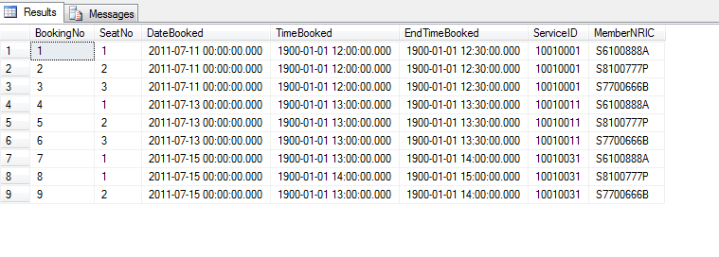

1. SELECT * FROM Branch

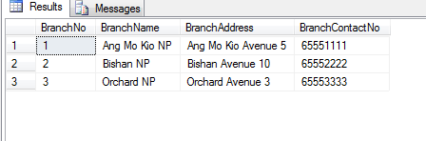

1. SELECT * FROM Member

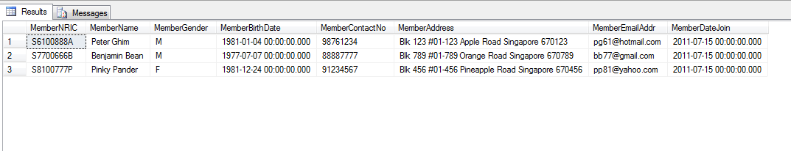

1. SELECT * FROM NPService

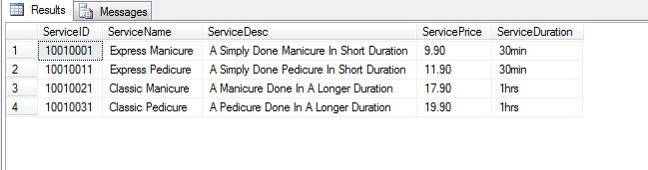

1. SELECT * FROM PaySlip

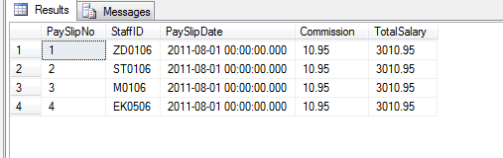

1. SELECT * FROM Product

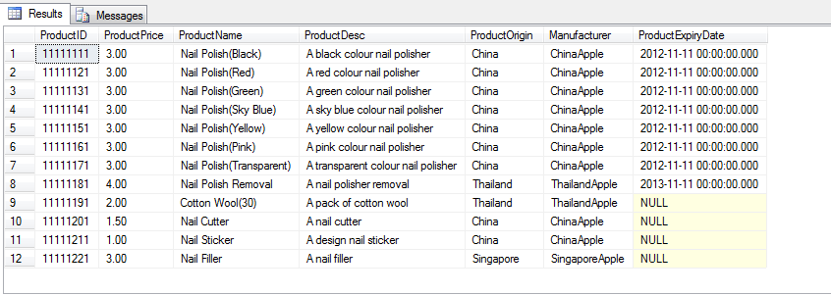

1. SELECT * FROM ProductDetail

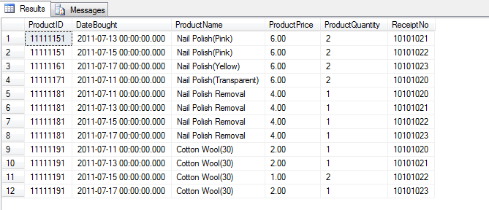

1. SELECT * FROM ProductReceipt

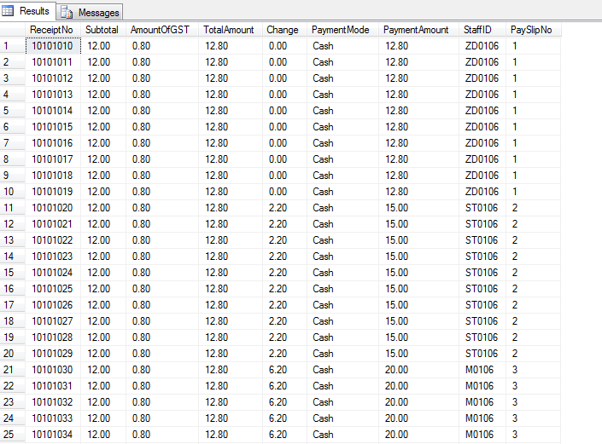

1. SELECT * FROM ServiceDetail

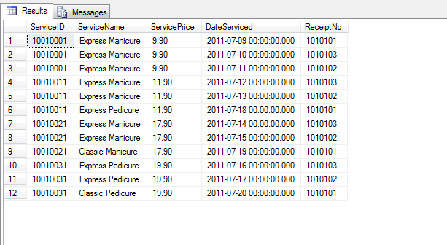

1. SELECT * FROM ServiceReceipt

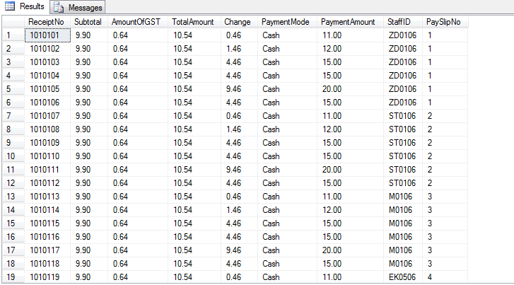

1. SELECT * FROM Staff

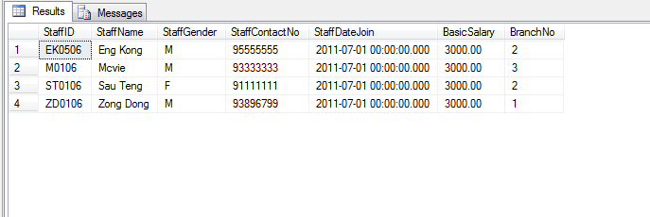

1. SELECT * FROM Stock

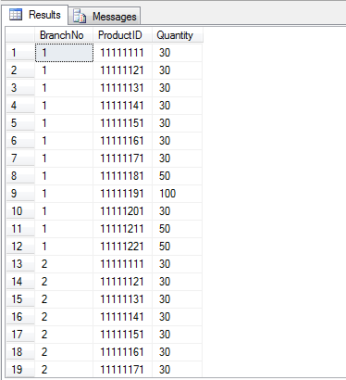

1. List the Service description for services a member ordered and the member name

select s.serviceDesc,m.memberName from npservice s cross Join member m where m.memberNRIC = 'S8100777P'

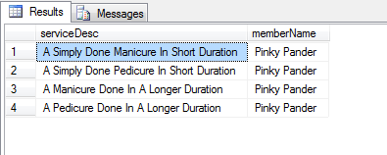

1. List the branch(s) that have 2 0r more staff.

select BranchNo, count(StaffID) As "Number of staff"

From Staff

Group by BranchNO

having Count(StaffID)>1

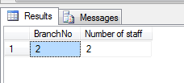

1. List the services booked for a particular booking ( booking 1)

Select s.serviceName from NPService s inner join Booking b on s.serviceID = b.ServiceID where b.bookingNo= 1

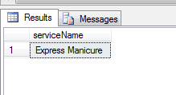

1. List the date and time booked by member S6100888A

Select timeBooked, DateBooked from Booking Where MemberNRIC = 'S6100888A'

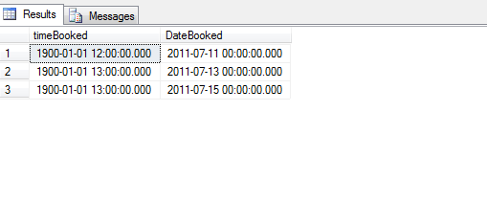

1. Display the amount of money customer spend on product in one visit

Select totalAmount from productreceipt where receiptNo = 10101010

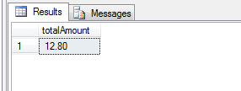

1. Display the amount of money customer spends on service and the service ID in one visit.

Select se.serviceID, s.subtotal from ServiceReceipt s cross Join ServiceDetail se where s.ReceiptNo = 1010102

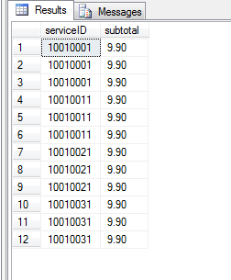

1. Calculate the number of staff in branch 3

select count(staffID) As 'Number of Staff'

from staff

where branchNO = 3

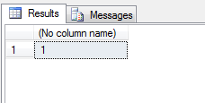

1. List the number of Staff for nail palace

Select count(StaffID) AS 'StaffNumber'

From Staff

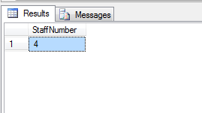

1. List the contact number of Member for nail palace.

select membercontactNo from member

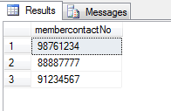

1. List the name of Staff and Member for nail palace in ascending order

select m.membername, s.staffname

from member m

cross join staff s

order by s.staffname asc

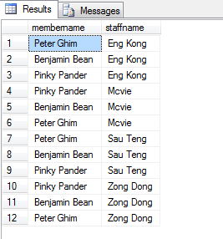

1. List the Member IC of the member for nail palace

select memberNRIC, memberName

from member

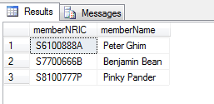

1. List the Staff ID for all the staff for nail palace

select staffID, staffname

from staff

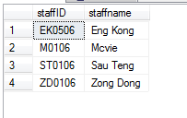

1. List the ‘Year of membership’ of each member

SELECT MemberName, DATEDIFF(Year, '2011-07-05', GETDATE())

AS 'Years of Membership'

FROM Member

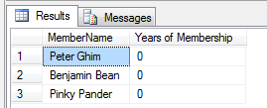

1. List the StaffID, Name of staff, and total salary of staff in the company

SELECT ps.StaffID, s.StaffName, ps.TotalSalary

FROM PaySlip ps

INNER JOIN Staff s

ON ps.StaffID = s.StaffID

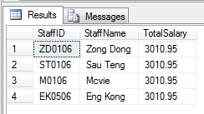

1. List the total number sale of the nail polish removal

SELECT COUNT(ProductID) AS 'Total Number of Sales for Nail polish removal' FROM ProductDetail WHERE ProductID = '11111181'

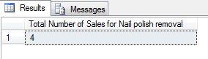

1. Show the Service being done and the price, and the service duration before the date 16th of july 2011

SELECT sd.ServiceName, sd.ServicePrice, s.ServiceDuration FROM NPService s

INNER JOIN ServiceDetail sd ON s.ServiceID = sd.ServiceID WHERE sd.DateServiced < '07/16/2011'

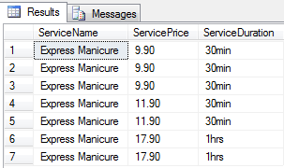

1. Show the total number of stock on hand for ProductID '11111181' in Branch 1 and 3

SELECT SUM(Quantity) AS 'Total Numer of Stock on Hand' FROM Stock WHERE ProductID = ' 11111181' AND BranchNo IN(1,3)

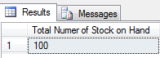

1. Show the details of the Nail Polish (All the colors) from China.

SELECT * FROM Product WHERE ProductOrigin = 'China' AND ProductName LIKE '%Nail Polish%'

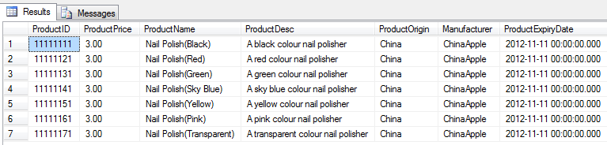

1. Which staff is working in which branch? List the staffname and branchname in ascending order by branchname

SELECT StaffName, BranchName

FROM Staff s

INNER JOIN Branch b

ON s.BranchNo = b.BranchNo

Order by BranchName ASC

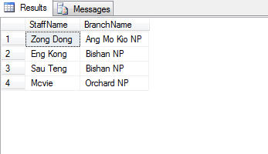

1. List the products avaiable for a particular branch

SELECT b.BranchName, p.ProductName, p.ProductPrice, p.ProductDesc, p.ProductOrigin, p.Manufacturer, s.Quantity

FROM Branch b

INNER JOIN Stock s

ON b.BranchNo = s.BranchNo

INNER JOIN Product p

ON s.ProductID = p.ProductID

WHERE BranchName = 'Bishan NP'

ORDER BY BranchName DESC

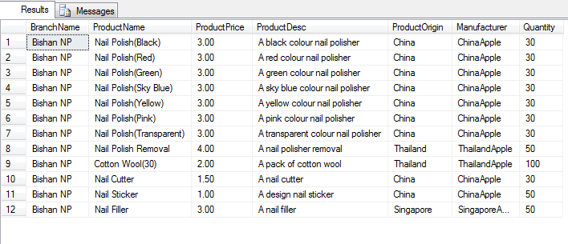

1. What are all the services avaiable in nail palace?

SELECT *

FROM NpService

ORDER BY ServiceID ASC

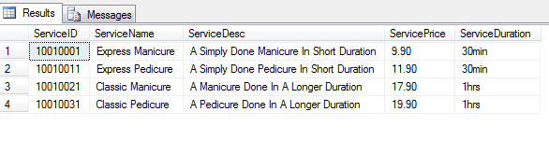

1. List the commission earned by a particular staff

SELECT s.StaffID, s.StaffName, p.Commission

FROM Staff s

INNER JOIN Payslip p

ON s.StaffID = p.StaffID

ORDER BY StaffName DESC

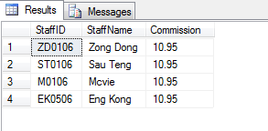

1. What is the amount of stocks avaiable for every branch

SELECT b.BranchNo, b.BranchName, COUNT(s.Quantity)AS 'Amount of stocks available'

FROM Branch b

INNER JOIN Stock s

ON b.BranchNo = s.BranchNo

GROUP BY b.BranchNo, b.BranchName

ORDER BY 'Amount of stocks available'

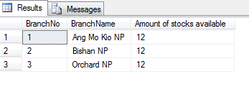

1. List the bookings made by a particular member

SELECT m.MemberNRIC, m.MemberName, b.BookingNo, b.DateBooked, b.TimeBooked, b.EndTimeBooked

FROM Member m

INNER JOIN Booking b

ON m.MemberNRIC = b.MemberNRIC

WHERE m.MemberName = 'Peter Ghim'

ORDER BY b.DateBooked DESC

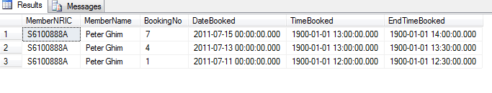

1. List the service receipt keyed in by a particular staff

SELECT s.StaffID, s.StaffName, r.ReceiptNo, r.TotalAmount, r.PaymentMode

FROM Staff s

INNER JOIN servicereceipt r

ON s.StaffID = r.StaffID

WHERE StaffName = 'Sau Teng'

ORDER BY r.ReceiptNo

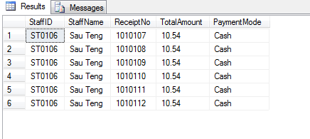

1. List the staff who join nail palace at a particular date.

SELECT *

FROM Staff

WHERE StaffDateJoin = '2011-07-01'

ORDER BY StaffID DESC

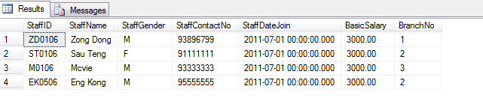

1. List the total number of bookings before the date 14 July 2011

SELECT count(BookingNo) as 'Total Number of Bookings' from booking where DateBooked < '07/14/2011'

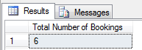

1. List the total number of services served between 10 July 2011 to 18 July 2011

select count(serviceID) as 'Total Number of Services' from servicedetail where dateserviced >= '07/10/2011' and dateserviced <= '07/18/2011'

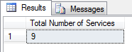

1. List the birthdate of the members

select memberNRIC, memberName,MemberBirthDate from member order by MemberBirthDate asc

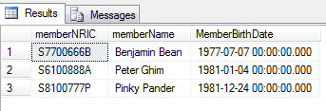

1. List the age of the members

select memberNRIC, memberName, datediff(year, memberbirthdate, getdate()) as 'Age of Member' from member order by 'Age of Member'

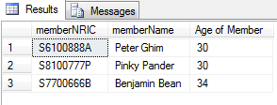

1. List the member who ‘s birthday lies in July

select memberNRIC, memberName,MemberBirthDate from member where memberbirthdate like '%jul%' order by MemberBirthDate asc



1. List the particulars to be input to the name card

select StaffName,StaffContactNo,s.BranchNo,b.BranchName,b.BranchAddress,b.BranchContactNo from staff s inner join branch b on s.branchno = b.branchNo where staffName = 'Mcvie'



1. Display the dates that the customer and being registered as member

select MemberName, MemberDateJoin from member

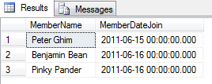

1. List the service name and description the member booked with the member name for a member on a particular day.

select b.MemberNRIC,m.MemberName, bookingNo, seatNo, DateBooked , ServiceName, ServiceDesc from booking b inner join NPService nps on b.serviceid = nps.serviceid inner join member m on b.membernric = m.membernric where m.membername = 'Peter Ghim' and datebooked = '2011-jul-11'



# Constrains

1. **The staff must have name card.**
2. **The shop must generate receipt for the customer**
3. **All customer must have a member ID**
4. **All Staff must have Staff ID**
5. **Each booking made will be given a booking number**
6. **Each receipt will be given an receipt number**
7. **Each services provided will be given a service ID**
8. **All walk-in Customer must become a member.**
9. **All branch only have one branch number**
10. **All staffs have a commission of 5 %.**
11. **GST of 7 percent**
12. **Only one service is allowed to be booked by every booking**
13. **Each branch can have many products. Each branch can only have a storeroom to store the products.**