**ZapPlanCompare**

**Abstract**

ZapPlanCompare is a tool to compare two or more plans created by the Zap-X planning system TPS.

**Installation**

1. You receive a ZIP file. Unzip the file or copy its content into a folder on your hard disk.
2. Open the folder in Windows Explorer, search for the file “ZapClient.cfg“ and open it for editing
3. Search for the entry “Server“ and replace the IP address with the IP address for your broker. Normally this is the DatabasePC (10.0.0.105 in the Zap network). If you want to reach the broker from outside of the Zap network, use the IP address of the firewall. If you want to use it from inside and outside, you have to make a CFG file for each PC you want to use. Best is to have one or two CFG files from inside the Zap network (should be already in the ZIP file) and use the normal “ZapClient.cfg“ for the outside connection.
4. If you don’t want to be asked for user and password each time you start the program: edit the fields „Username“ and „Password“ and provide the correct entries. If you setup more than one CFG file, you have to edit all of them to provide credentials.
5. Save the CFG file
6. Search for “ZapPlanCompare.cfg“ and open it for editing
7. Search for entry “Culture“ and set your right culture. The first part is for the language (currently you can enter “en“ or “de“, the second is for the regional settings. E.g. “de-CH“ or “en-US“ would be valid entries.
8. Save the CFG file

**Using**

1. Start “ZapPlanCompare.exe“
2. If you didn’t provide a username and/or password in the CFG file, you are asked to provide this
3. Main screen should open. Looks like this  
     
   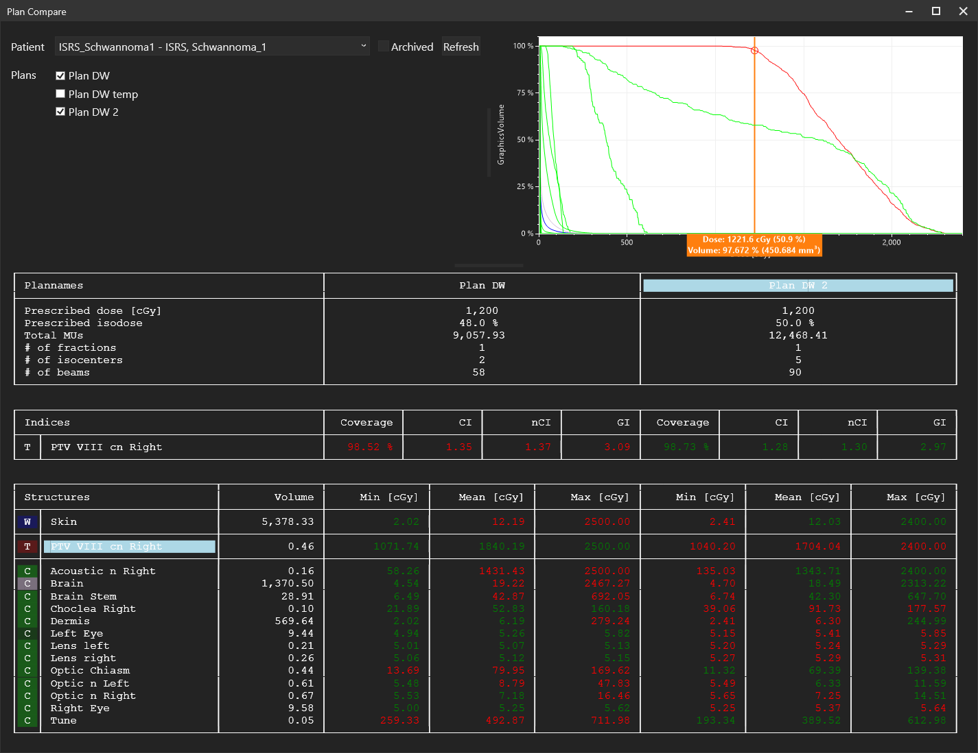
4. Select an active patient. If the patient is already archived, check “Archived“ and you will see all patients.
5. Select one or more plans for this patient by checking each plan you want to compare
6. The best values are displayed in green, the worst are displayed in red. E.g. the smaller CI is in green, the bigger CI is in red, the higher dose for a PTV is in green, the lower dose in red, a lower dose for an OAR is in green, a higher dose in red. Values between are in white.
7. If you double click on the plan name in the header of the table (light blue in the screenshot), you will see all DVHs of this plan in the diagram
8. If you see the DVHs and make a double click on a name of a structure, you get a cursor in the diagram to check the values for this structure

**Problems**

If you have any problems while using ZapPlanCompare, send an e-mail to [d.weltz@snrc.ch](mailto:d.weltz@snrc.ch). Please add the version, a screenshot and the “.log” file of your system (can be found in the app folder).

**Libraries**

The following libraries are used to create ZapPlanCompare

* ScottPlot: <https://scottplot.net/> (MIT license)
* SkiaSharp: <https://github.com/mono/SkiaSharp> (MIT license)
* Harfbuzz: <https://github.com/harfbuzz/harfbuzz> (MIT license)
* Newtonsoft Json.NET: <https://www.newtonsoft.com/json> (MIT license)
* Zap zsClient: https://zapsurgical.com/de/