**Element Picker**

When user is working on an application and user wants to perform some operations (like get/set value, click it, etc) of the specific element (like Textbox, Button, Checkbox, etc) so, the user must specify the element using the element properties (like element Id, element Name, element Value, Class, etc ).

Sometimes the property values ​​will be dynamically changed and automation will fail so as to solve this issue, Zappy Element Picker activity helps to serve dynamic values ​​to run the automation.

Element Picker Form:

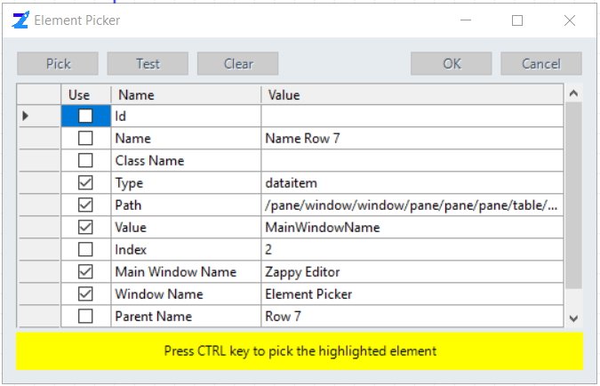

The user can get the **Element** properties using the following:

* **Pick** – Click on this button to select the element.
  + Hover the mouse where user want to pick element.
  + Press **CTRL** key to pick the highlighted element.
  + User can select the elements properties depending on his requirements.

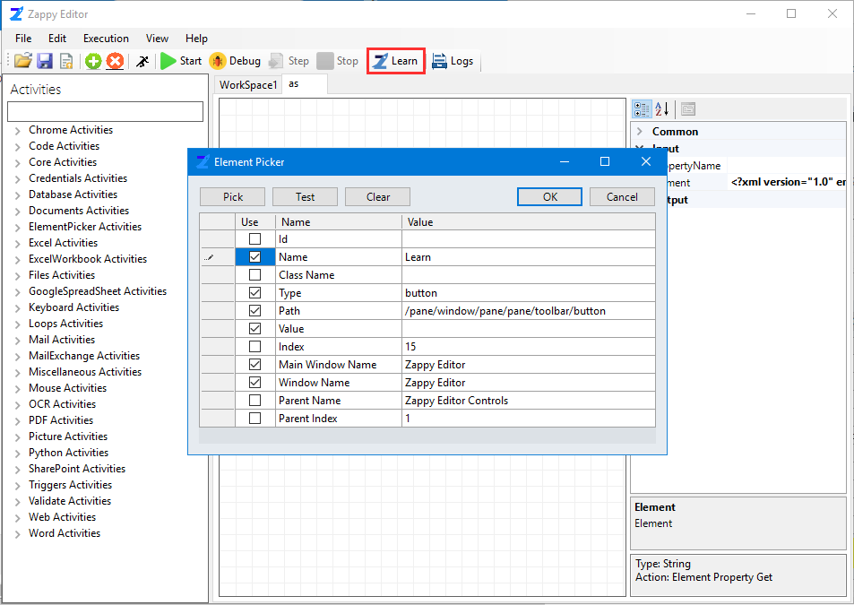

Properties of picked element

Picked Element

* **Test** – Will be displayed the occurrences of the selected type of element.

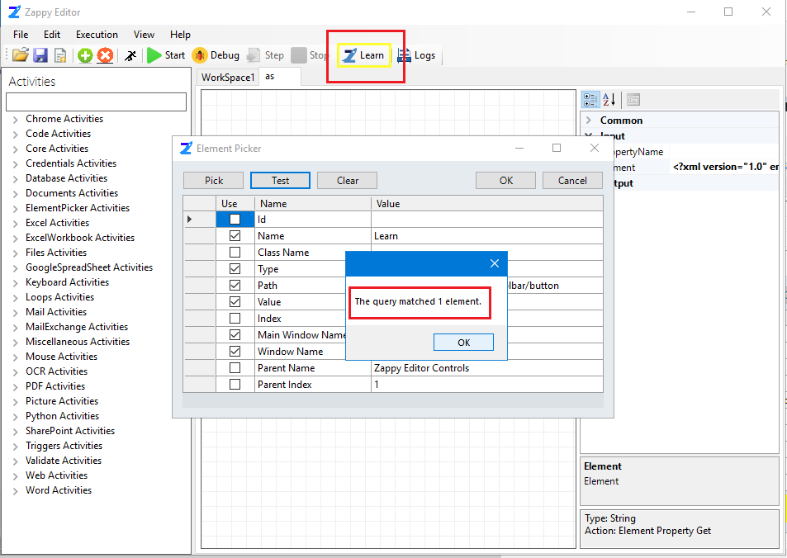

Matched pick element

* **Clear** – Clear the existing element. Now click on pick button to select the new element.

