**Execute Selected Action**

This document will be useful when you want to execute a particular action from complex automation.

**Steps:**

1. Open any one of the automation files.

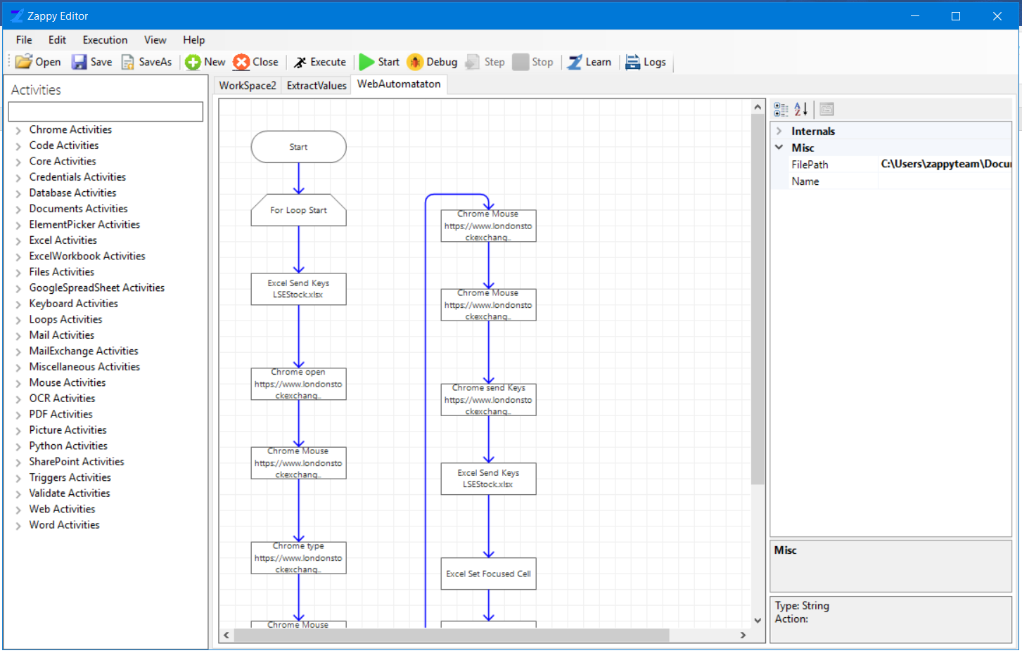

1. Select an action which user wants to execute in an automation.

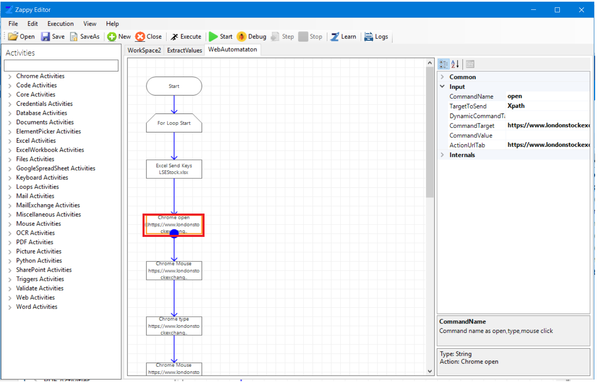

Select an action

1. Select **Execution** from top menu bar, a drop-down list will be open. Then select **Execute Selected Action**.

As shown in below snippet, **Chrome Open** action is selected,

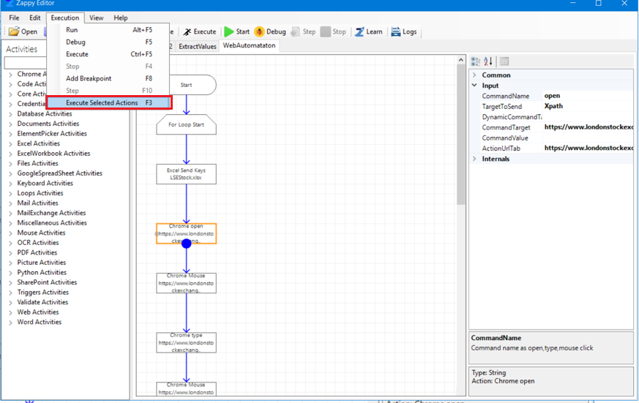

1. The output of the selected action is shown in the below screenshot,

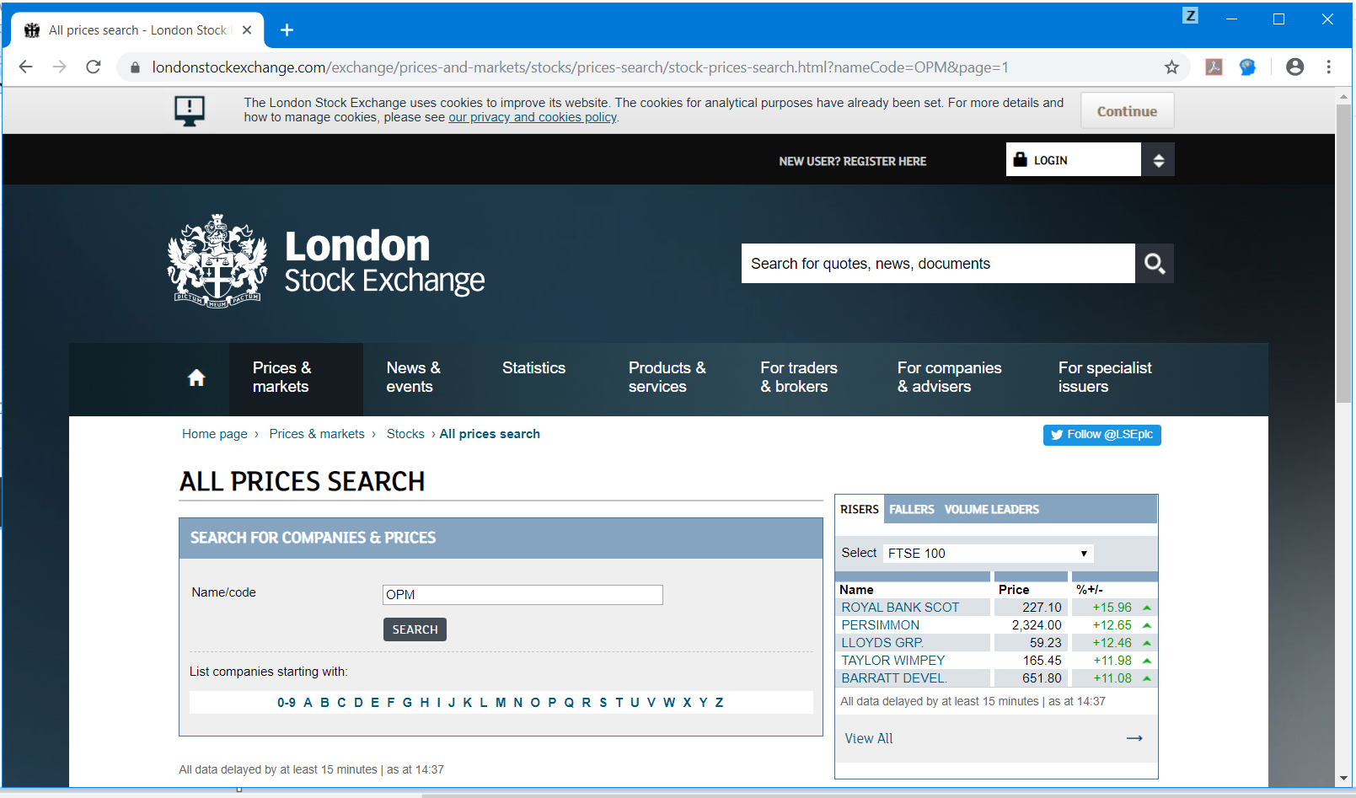

1. Now user will get the message of Successful Execution of the selected action.

