**Run Zappy Using CMD and Trigger Zappy files using Windows Task Schedular.**

**Step 1:** Open Command Prompt.

Click on search on windows and type CMD. Open the cmd.

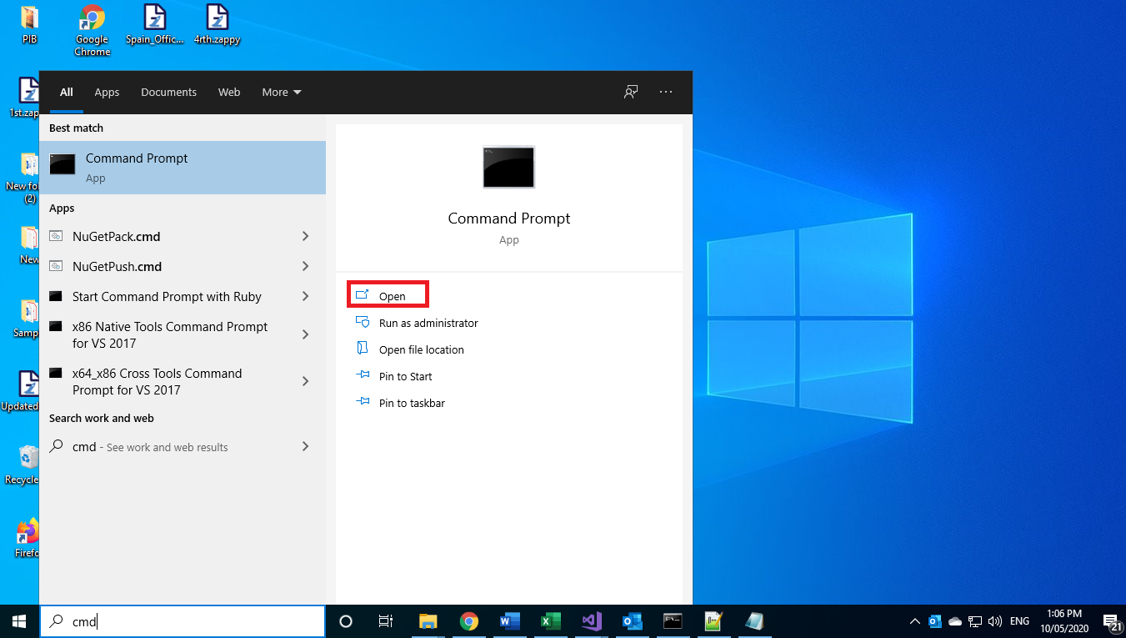

**Step 2:** Enter following commad on CMD and hit enter button.

**"C:\Program Files\ZappyAI Limited\Zap Automation\ZappyRunner.exe" FileName=C:\Users\vaishnavi\Desktop\test.zappy bool _AutoRunFileBool = Environment.CommandLine.Contains("-AutoRunFile");**

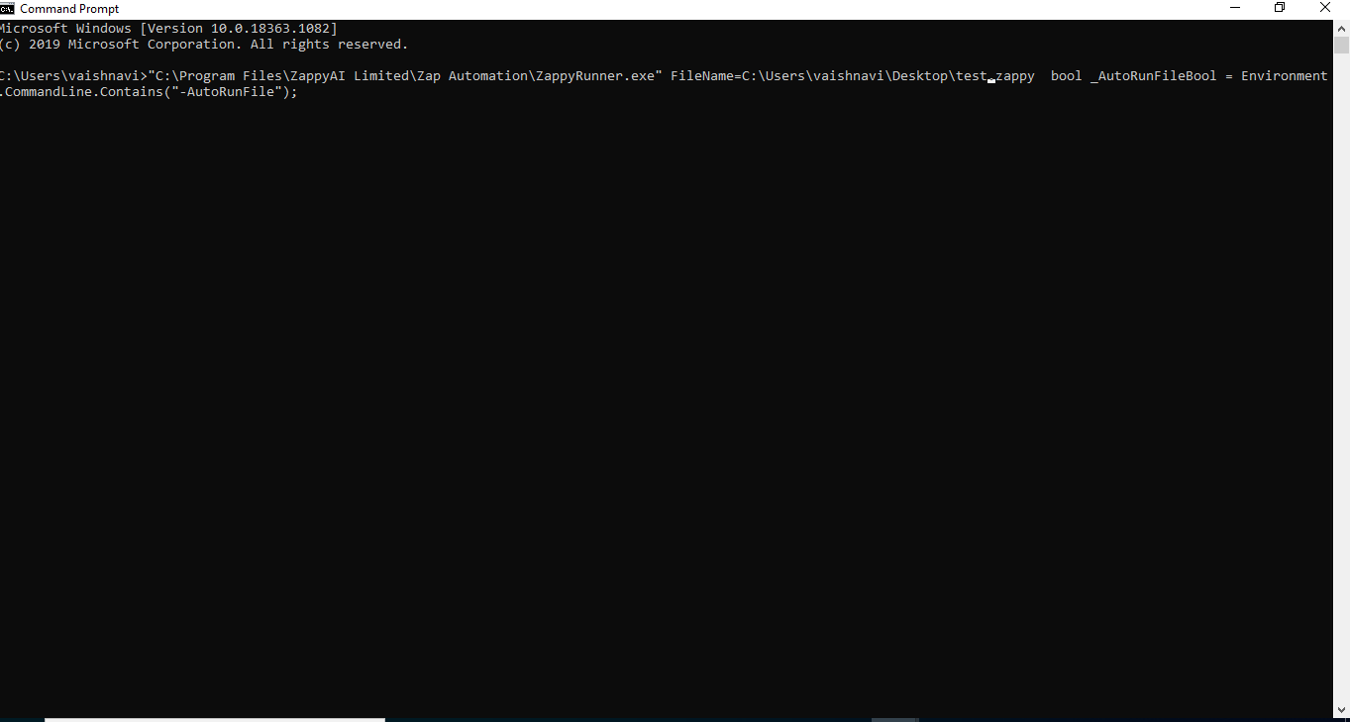

**"C:\Program Files\ZappyAI Limited\Zap Automation\ZappyRunner.exe": This is a ZappyRunner exe file path.**

**FileName=C:\Users\vaishnavi\Desktop\test.zappy: Zappy file path which wants to execute.**

**bool _AutoRunFileBool = Environment.CommandLine.Contains("-AutoRunFile");**

**: Auto Run zappy file.**

**Add windows task schedular to .zappy file on daily basis.**

**Step 1:** Open Task Schedular.

Click on search on windows and type Task Schedular. Open the Task Schedular.

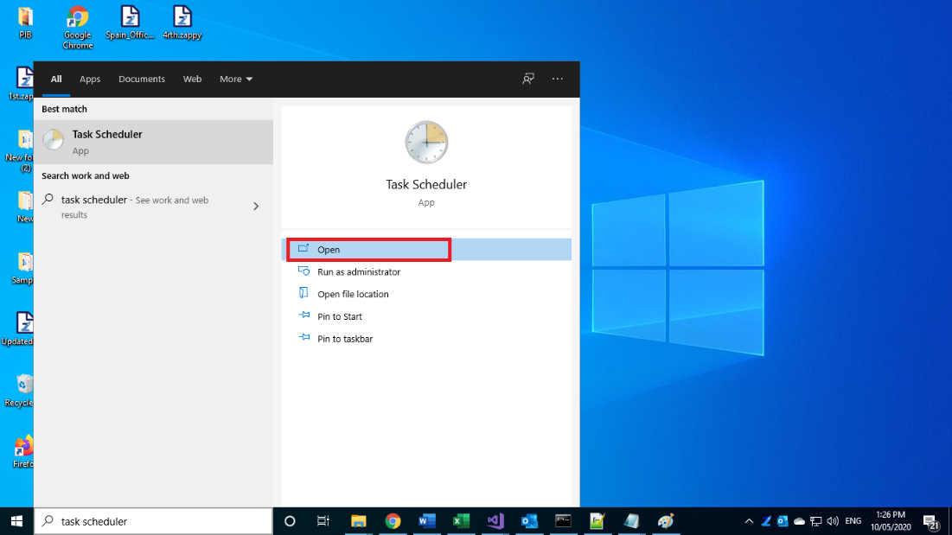

**Step 2:** Right click on Task schedular library and Create Basic Task.

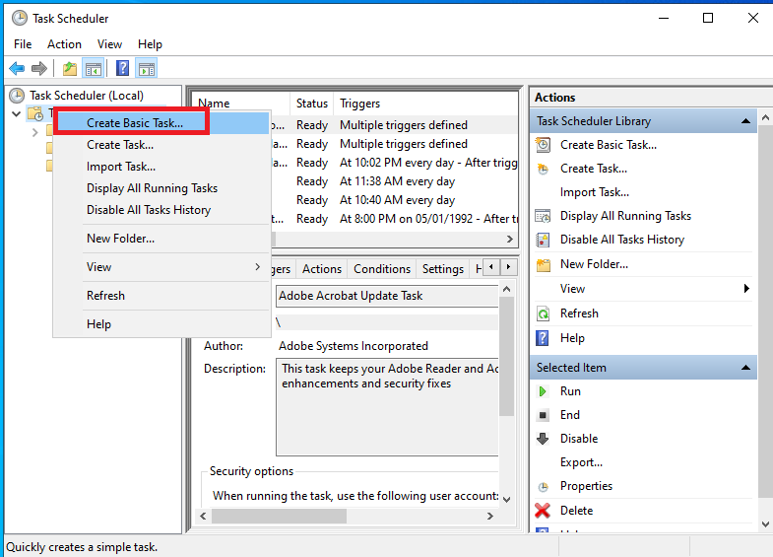

**Create Basic Task** window will popup. Enter the **Name** of task and enter some **Description** and click on **Next**.

**Step 3: Task Trigger** window will popup. Select trigger type like we have select **Daily** as below. Click on **Next**.

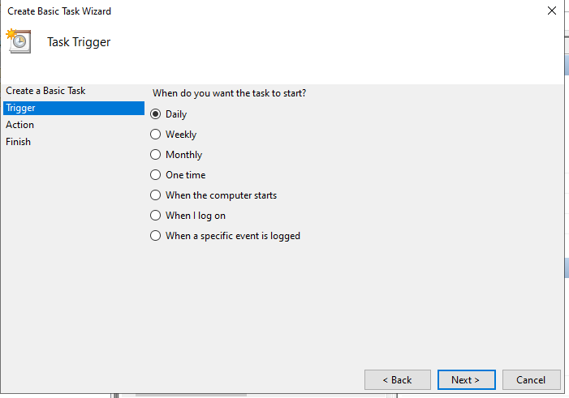

**Step 4:** Enter the **Start Date** and **Time**. Click on **Next**.

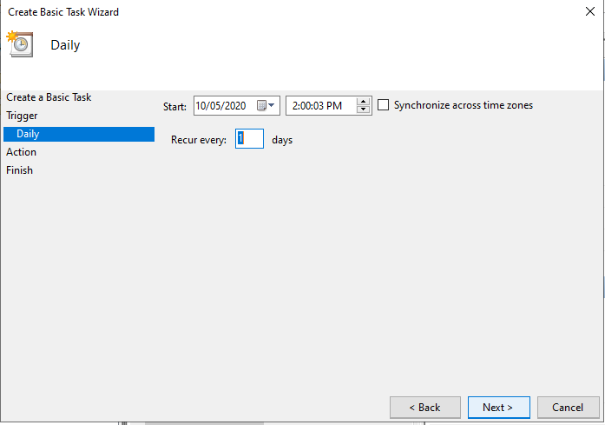

**Action** window will popup, then select **Start Program** and click on **Next**.

**Step 5:** Enter details in **Start Program** window.

In **Program/Script:** Enter Zappy runner Exe file path like,

**"C:\Program Files\ZappyAI Limited\Zap Automation\ZappyRunner.exe"**

**Add argument:** Enter zappy file path which we have to run on daily like,

**FileName="C:\Users\vaishnavi\Desktop\2nd.zappy" bool _AutoRunFileBool = Environment.CommandLine.Contains("-AutoRunFile")**

Click on **Next.**

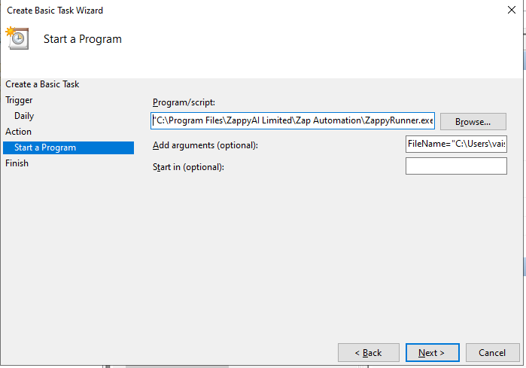

**Summary** window will popup. Click on **Finish**.

**Selected zappy file will execute on entered time.**

**Likewise, we can add trigger on zappy files on daily, monthly basis.**