**Zap Excel Addin**

To add **ZapExcel** plugin, follow the steps,

## Note:

If you have office 2010 setup to run the Zap Automation plugin you must be installed Visual Studio 2010 Tools for Office, Follow below link  
<https://www.microsoft.com/en-in/download/details.aspx?id=48217>

1.Open excel file and Click on **File** option.

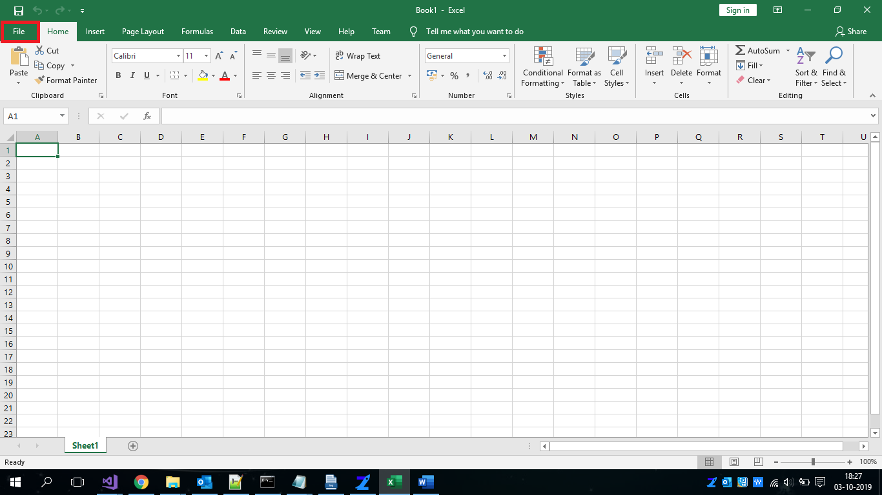

2. Click on **Options.**

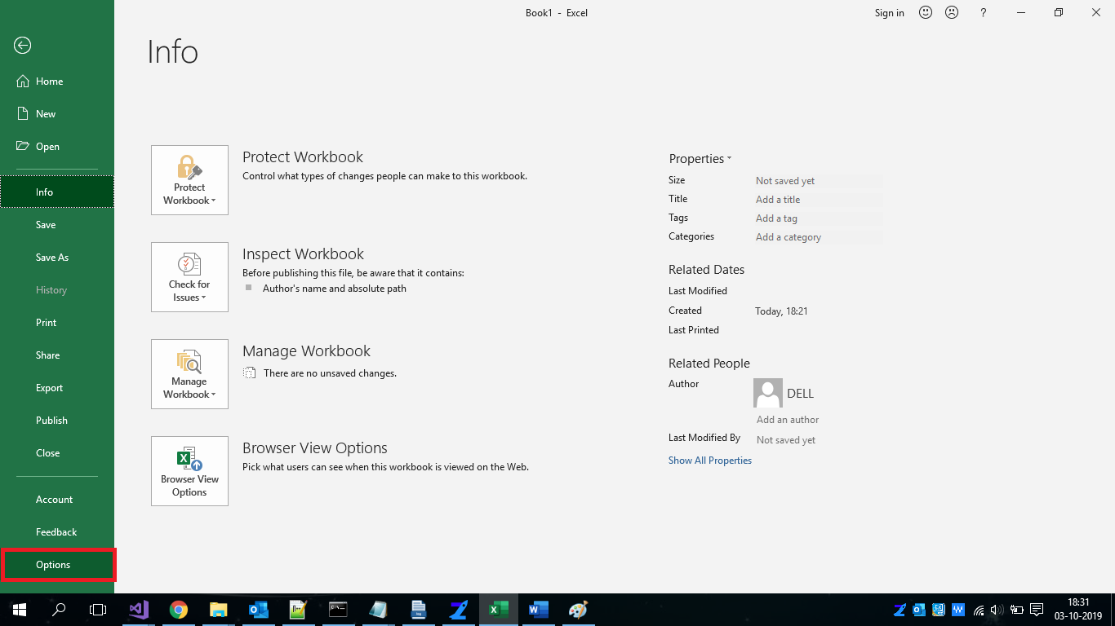

3.Click on **Add-ins** option.

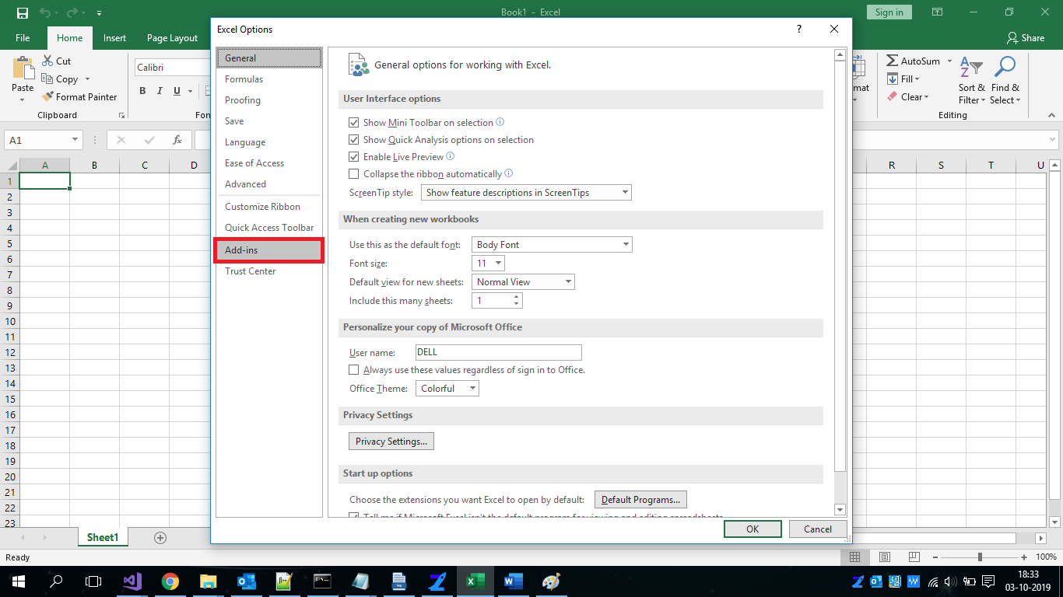

4.Select **COM Add-ins** option and then click on **Go** button.

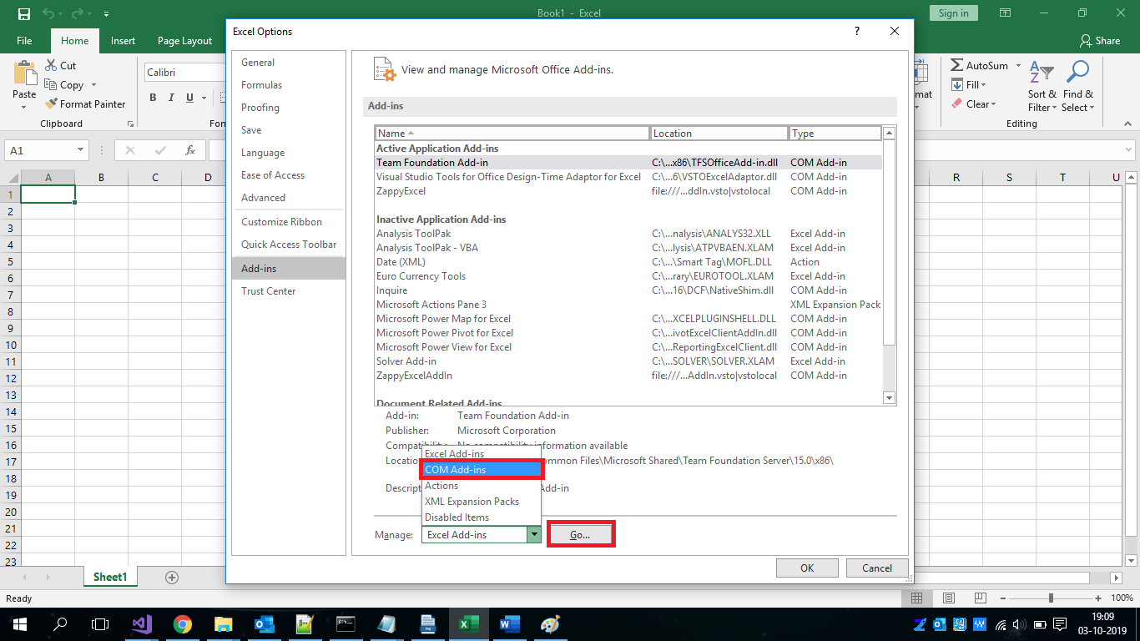

5. Select **ZappyExcel** then click on the **OK** button and restart Excel.

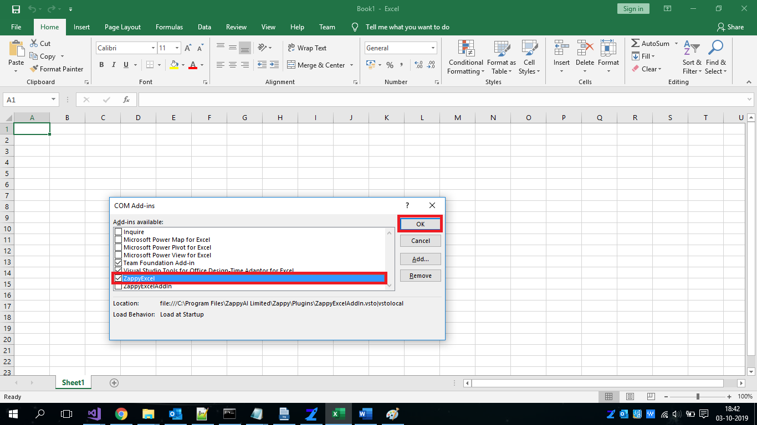

**Zap Chrome Extension**

To enable chrome extension plugin, follow the steps

1. Click on the **3 dots** in the right corner, then click on the **More Tools** option and then on the **Extensions** option.

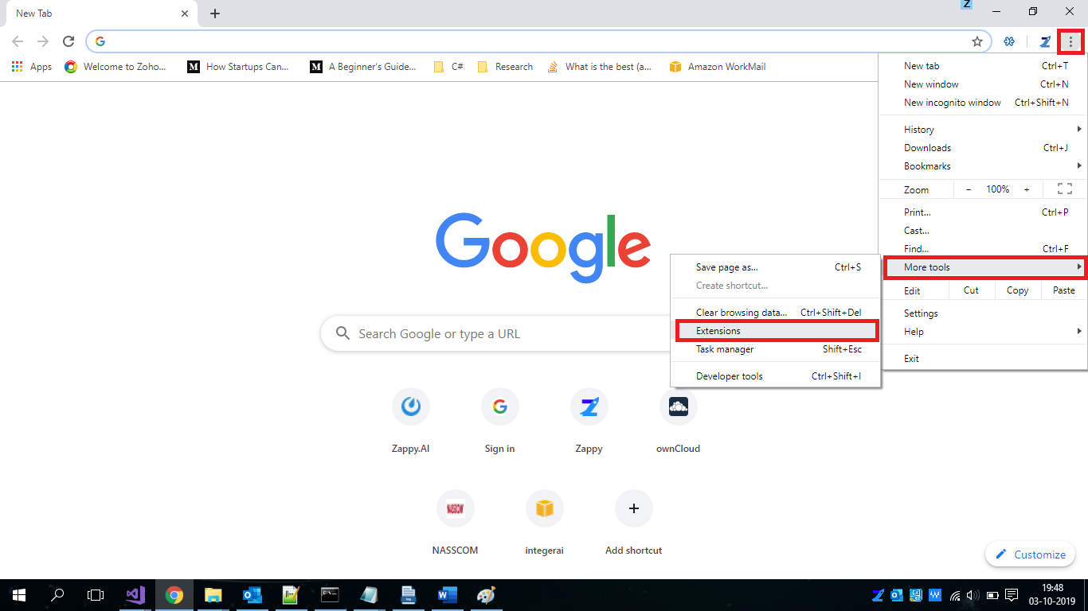

2. Enable the zappy and you can see the zappy icon on the right.

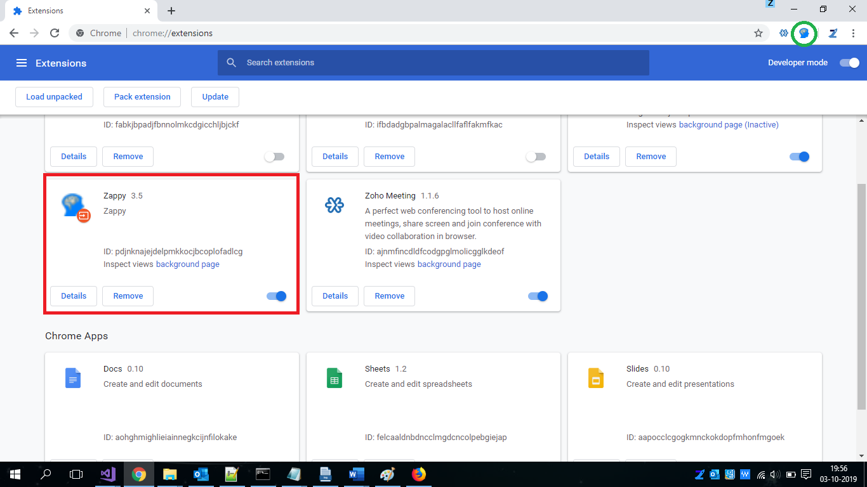

**If the extension is not available/automatically downloaded they you can manually download it from the link below:**

<https://chrome.google.com/webstore/detail/zappy/pdjnknajejdelpmkkocjbcoplofadlcg>

**Zap Outlook Addin**

To add **ZapOutlook** plugin, follow the steps

1.Open Outlook and click on **File** option.

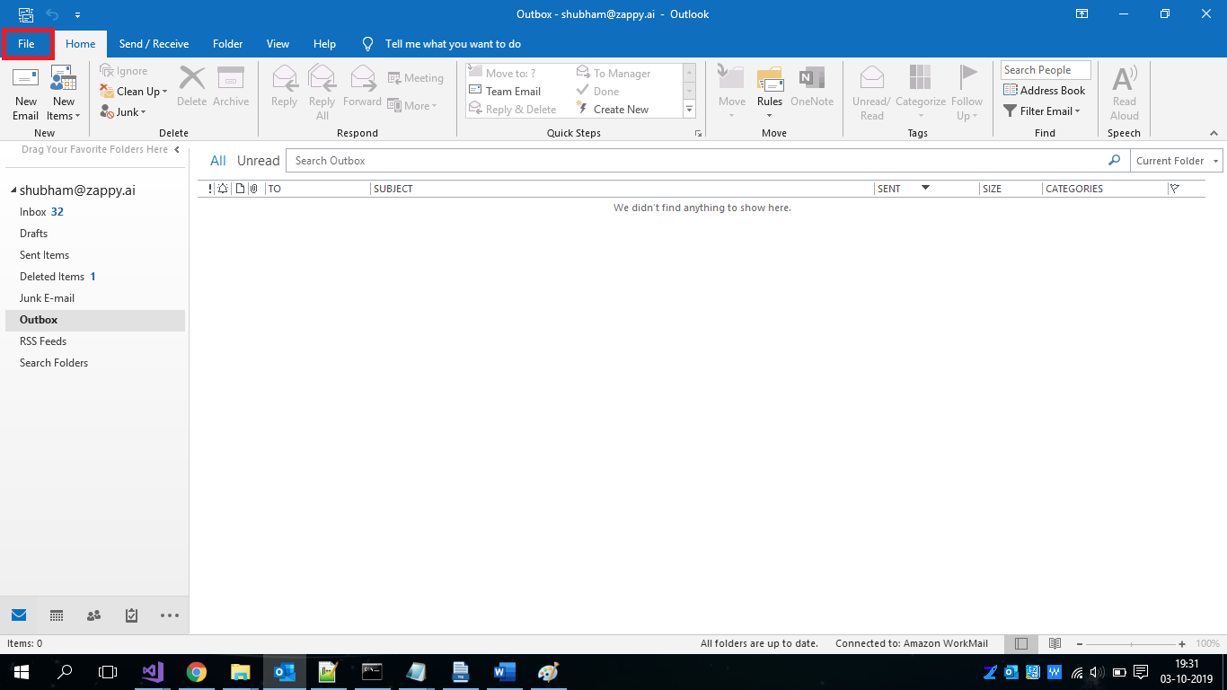

2. Click on **Options** option.

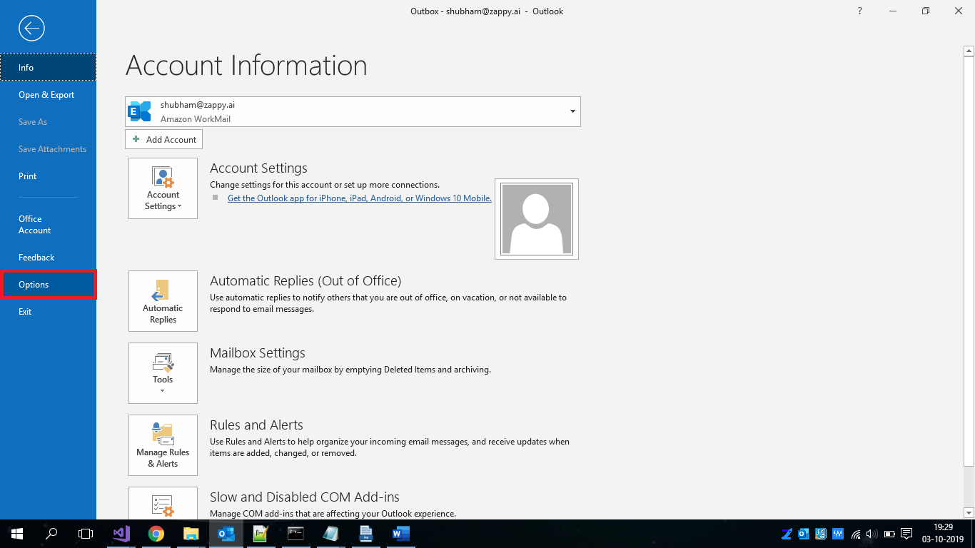

3. Click on the **Add-ins** option and then click on the **Go** button.

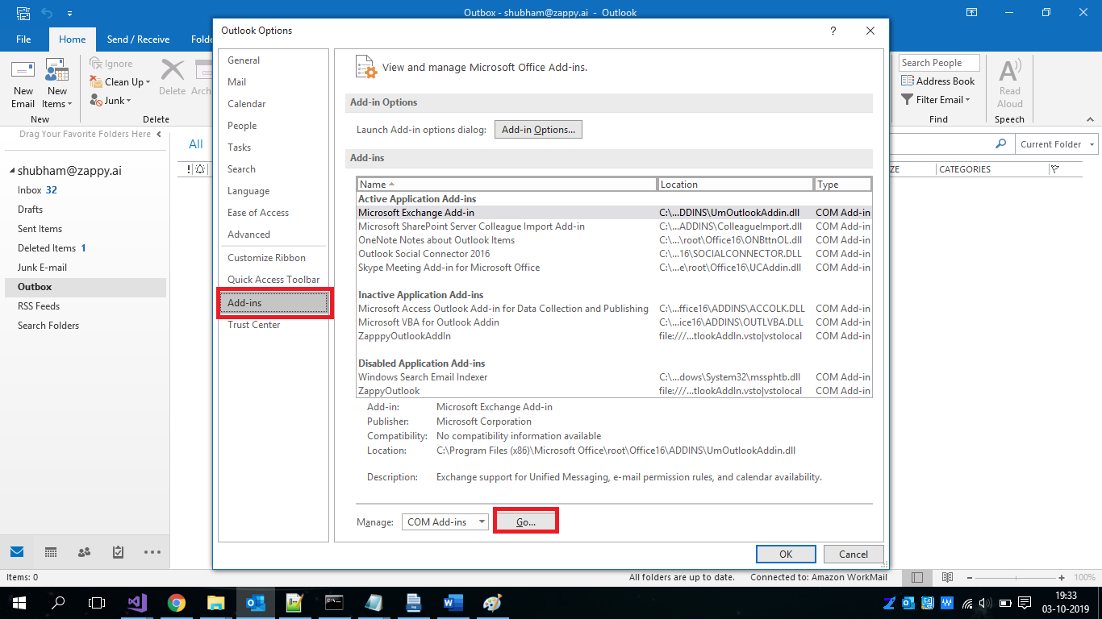

4. Select **ZappyOutlook** then click the **OK** button and reopen Outlook

