**INTRODUCTION TO ZAP TASK EDITOR**

**Summary:**

This document will explain you how to use **ZapTask Editor**.

**Zap Task Editor** can be started from the Zap Context Menu by right clicking on Zap icon at the bottom right corner or by double clicking on it.

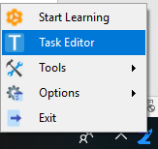

Zap Task editor allows you to manage workflow and add validation actions. Task Editor is our powerful and user-friendly automation canvas, is an essential component in Zap. It features a rich collection of pre-built activities, integrates with several programming languages, and promotes ease-of-use, scalability, and efficiency.

**Menu Bar**: On the top of Task Editor you will see menu bar, A menu bar is a user interface element that contains selectable commands and options for the Zap Task Editor. No need to invent the wheel. Share and reuse ready-made automation components from Editor’s extensible libraries and save on development time and cost. Build reusable components with Zap to collaborate, standardize, and work on automation best practices within your organization and with fellow developers for the most effective results.



1. **Open:**  Open your existing Zap automation.
2. **Save**: Save the automation.
3. **SaveAs**: Save an already **saved** automation or anything (which you want to **save**) **with a** new name.
4. **New**: Insert **New Workspace in Task Editor.**
5. **Close**: C**lose** the current workspace window.
6. **Start**: Execute the automation created by you.
7. **Debug**: To find and resolve bugs or defects.
8. **Record**: Zap learns your actions and build them into an automation workflow.
9. **Logs**: Zap generates audit logs which can be accessed by Zap Logger. They capture events which can show “who” did “what” activity and “how” the system behaved. Zap Logger can be started from the Zap Context Menu or Zap Task Editor.

**Activities Panel:** Activity Panel is on the left-hand side of Zap Task Editor. It shows all the actions which you can drag and drop in task editor.

**Property Panel:** Property panel is on the righthand side of the Zap Task Editor. After dropping action in task editor, you can set its properties in Property panel by clicking on that action.

Create automation with our drag and drop, code-free, editor. Leverage our library of hundreds of activities and pre-built automation components. For fast and easy troubleshooting our visual debugger highlights an exact error and displays easy to comprehend messages. No more manual, error-prone programming of each process and user action, Zap learns your actions and build them into an automation.

**Value Picker**: While setting properties in property panel, if you click on  Zap Value Picker will open.

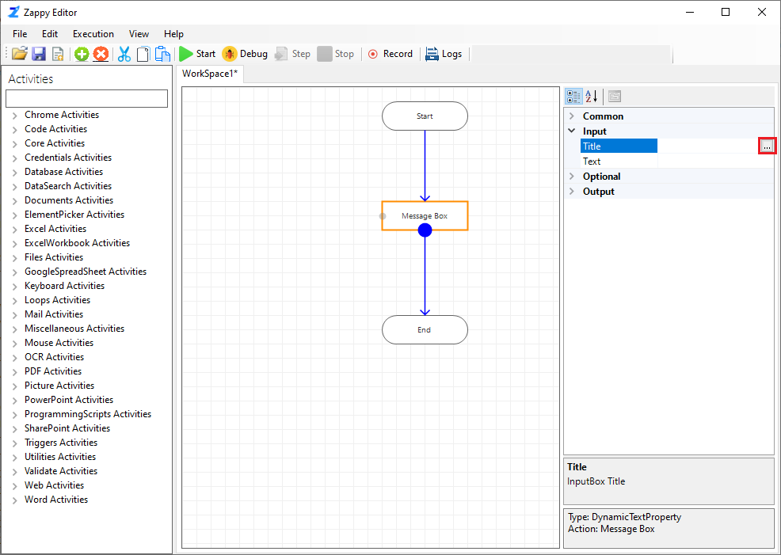

1. **Variable**: Select **Variable** from Value Picker and Select the action whose output will be used as input for another action.

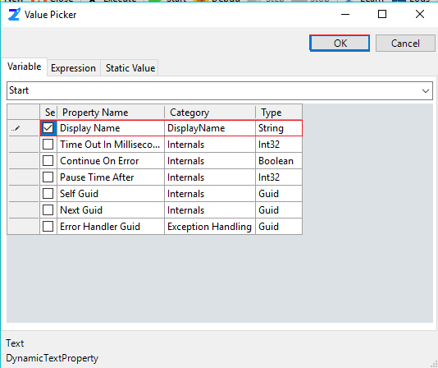

1. **Expression**: User can write their own code in Lambda Expression. Also use for parsing variable.

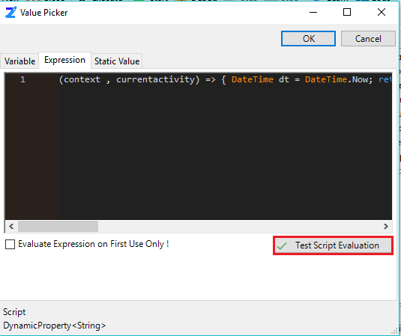

1. **Static Value –** A variable that has been allocated "statically", meaning they have a scope till the program’s lifetime.

