**Zap Value Picker**

This document will explain you how to use **Zap Value Picker**.

**Zap Task Editor** can be started from the Zap Context Menu by right clicking on Zap icon at the bottom right corner or by double clicking on it.

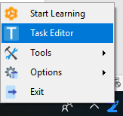

Zap Task editor allows you to manage workflow and add validation actions. Task Editor is our powerful and user-friendly automation canvas, is an essential component in Zap. It features a rich collection of pre-built activities, integrates with several programming languages, and promotes ease-of-use, scalability, and efficiency.

**Value Picker**: While setting properties in property panel, if you click on  **Zap Value Picker** will open. We use Value Picker to get and set the properties of actions.

In Value Picker we will see three options,

1. **Variable 2) Expression 3) Static Value**

Uses of these-options are explained in detail below.

1. **Variable**: Select **Variable** from Value Picker and select the action whose **Input/Output** will be used as Input for current action.

**For E.g.**:

When we click on **Set Variable Value** action, on right hand side in property panel we will see  . In front of **Variable Value** field, click on  dots **Value Picker** will be opened.

Click on **Variable** option and select **Select Folder** action from the drop-down menu, as we want to set the **output** of **Select Folder** action as the **input** of **Set Variable Value** action.

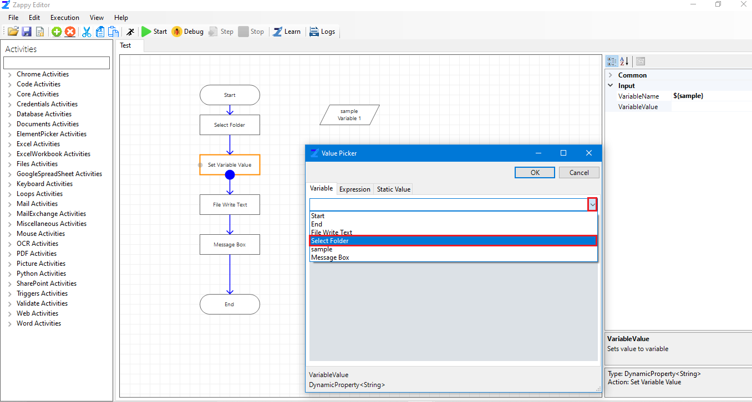

In Variable, we will see all the fields of **Select Folder** action, like Selected Folder, Display Name, Continue On Error, Pause Time After. We can select any field from these according to our requirement. Here we are selecting **Selected Folder** field which we want to set as Input of **Set Variable Value**. Click **OK**.

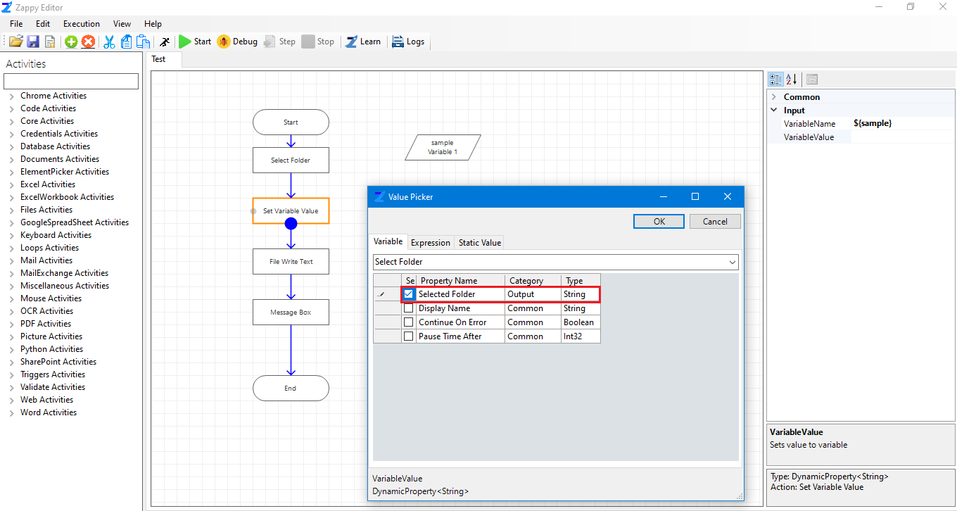

1. **Expression**: Expression is used to write the codes which we will need during automation. This code has to be written in Lambda Expression (C#). Also used for parsing variable.

**Here we have written the code for creating the text file in selected folder**.

In this way you can write any code required for your automation. Click **OK**.

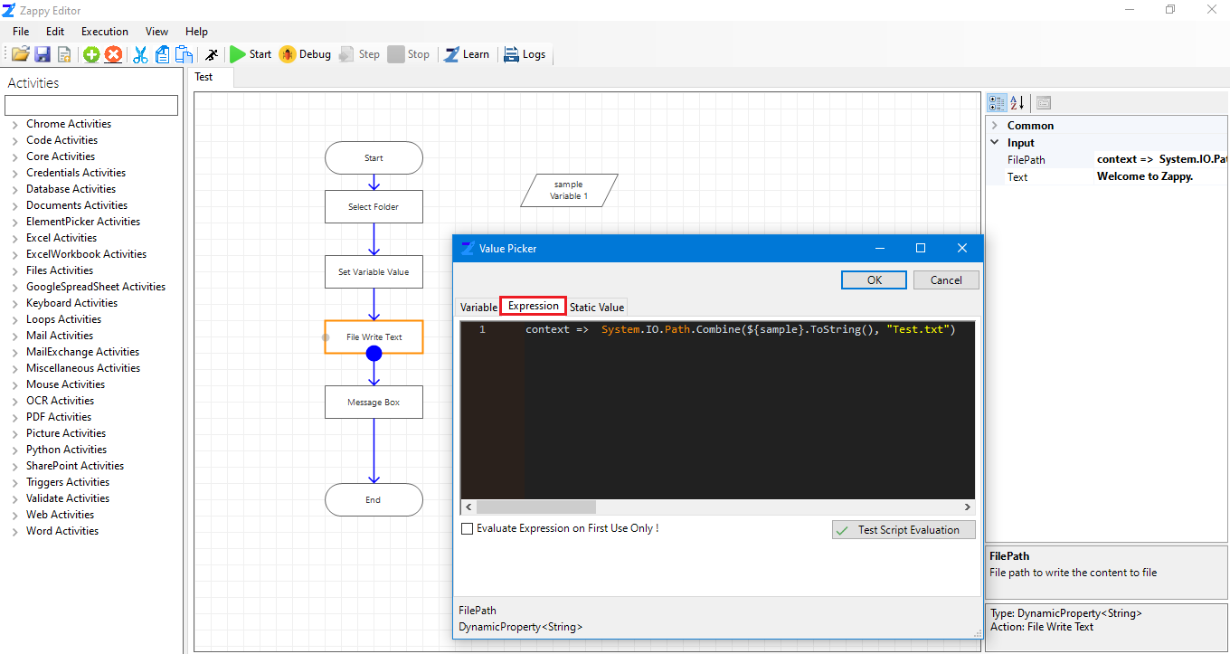

1. **Static Value –** A variable that has been allocated "statically", meaning they have a scope till the program’s lifetime.

We will select static value only when we want our action value to last till the end of automation.

**After selecting static value fixed value box will open where we have to enter static value for that automation.**

**E.g.**  We are entering the text we want in the created file.

Click **OK**.

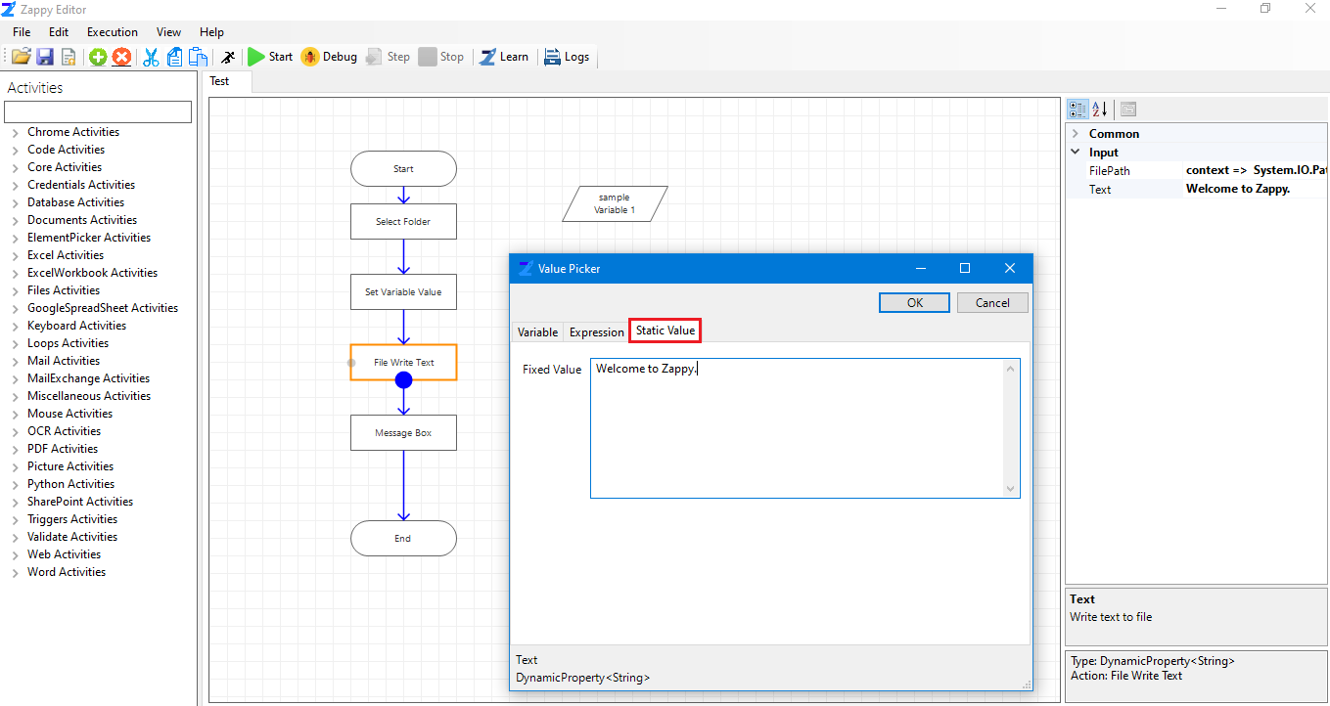

Enter Text

When we click on **Message Box** action, on right hand side in property panel we will see . In front of **Text**, click on  dots Value Picker will open.

Click on Variable option and select **File Write Text** action from the drop-down menu, as we want to set the **Input** of **File Write Text** as the **Input** of **Message Box**.

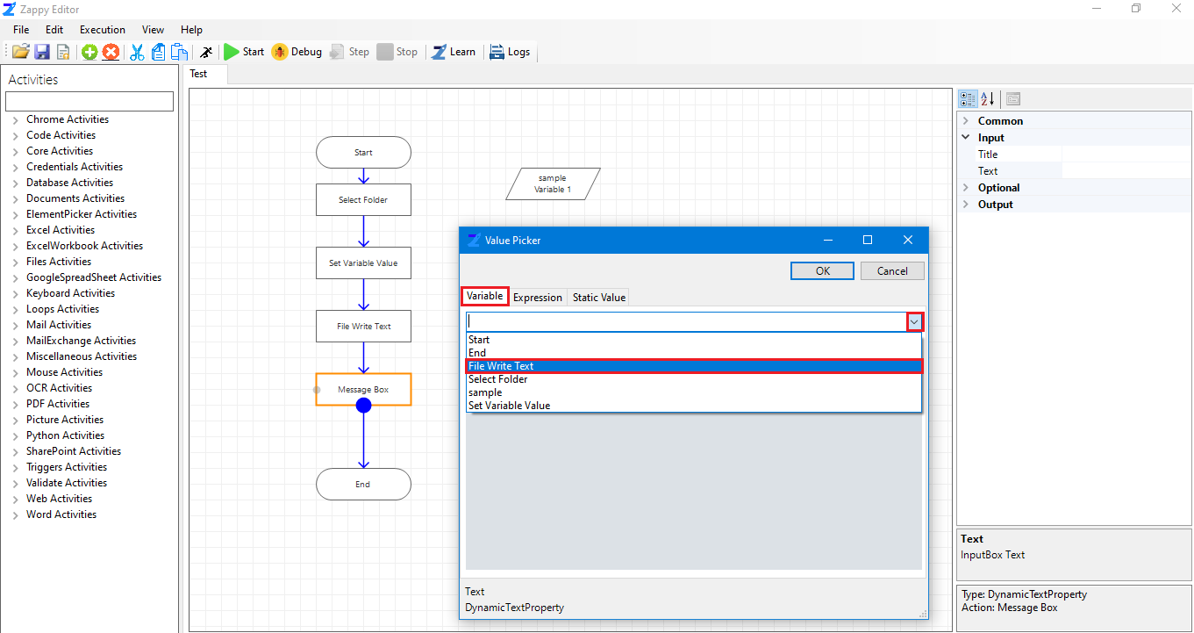

As we have to display the content of **File Write Text** in Message Box, we have to select **Text** field as shown. Click **OK**.

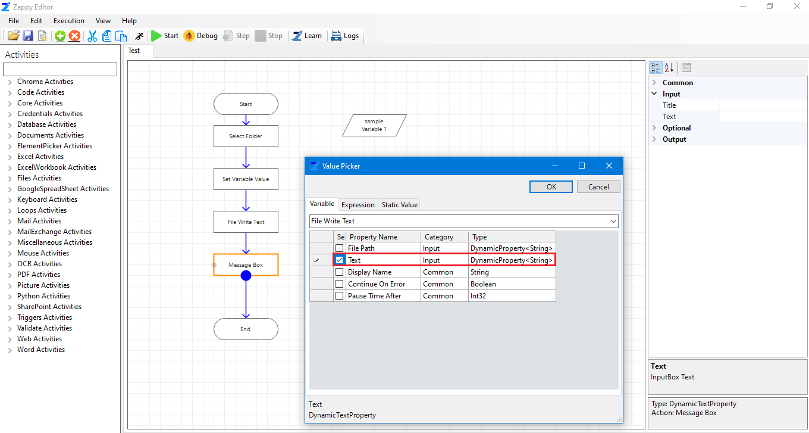

So, by using Value Picker, we can give the reference of one action to another action, we can write our own code as well as we can set the static value for actions.