**Extract Table Data from LSE Website**

This automation shows how to extract table data from multiple pages of web and paste them into an excel.

**Step 1:** Open an **Sample.xlsx** excel File.

Path: C:\...\Documents\zappyai\Crapy\Sample\CollectDataFromWebsites\ExtractTableFromWebSite\sample.xlsx

**Step 2:** Open **Web_To_Excel.zappy** automation in Task Editor of ZapAutomation .

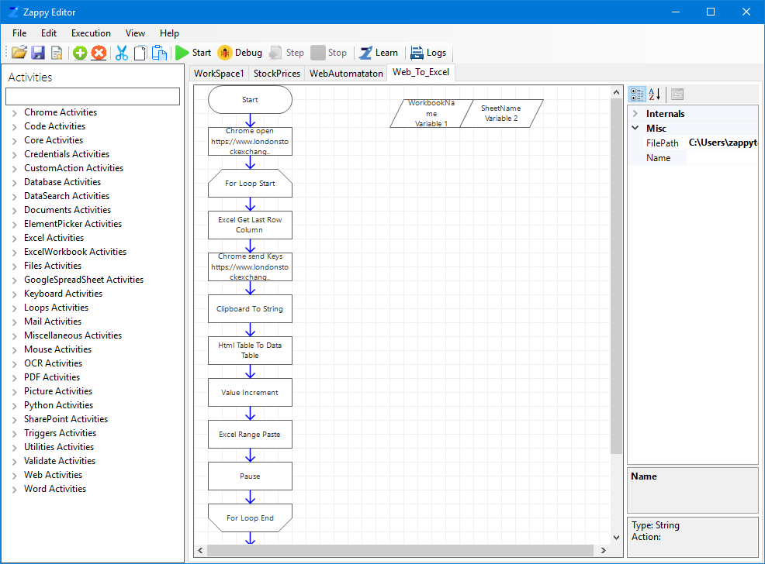

**Step 3:** Click on **Chrome open** Action, and enter the required URL in **CommandTarget** property.

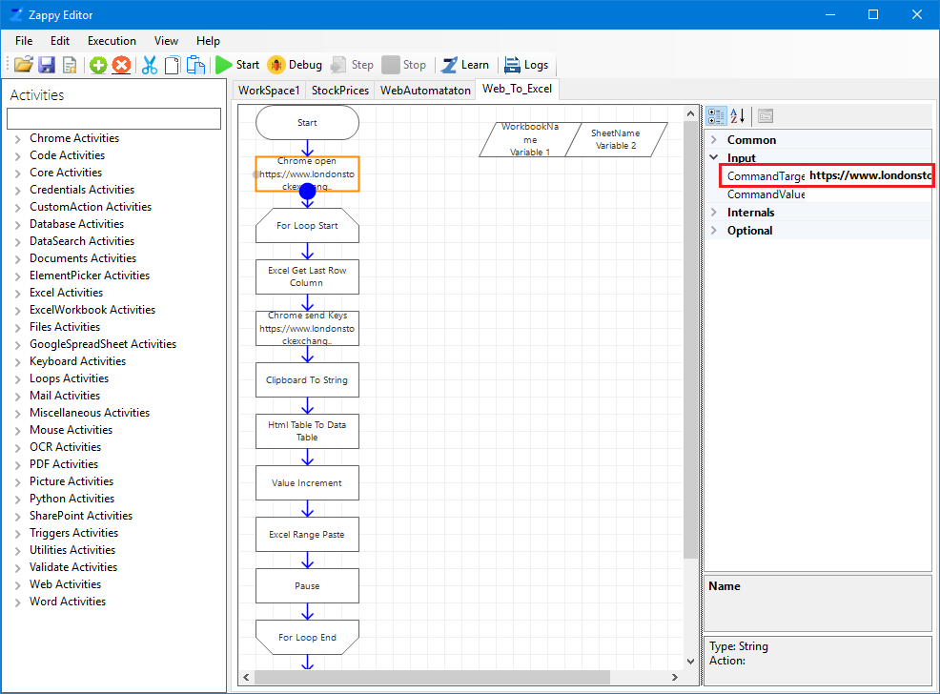

**Step 4:** Click on **For Loop Start** action and set required **Initial** and **Final Value’s.**

**Initial Value:** Starting page number for the web table.

**Final Value:** Last page number for the web table**.**

**Step 5:** You can change **WorkBookName** and **SheetName** in **Variable 1** and **Variable 2** respectively if using a different excel file.

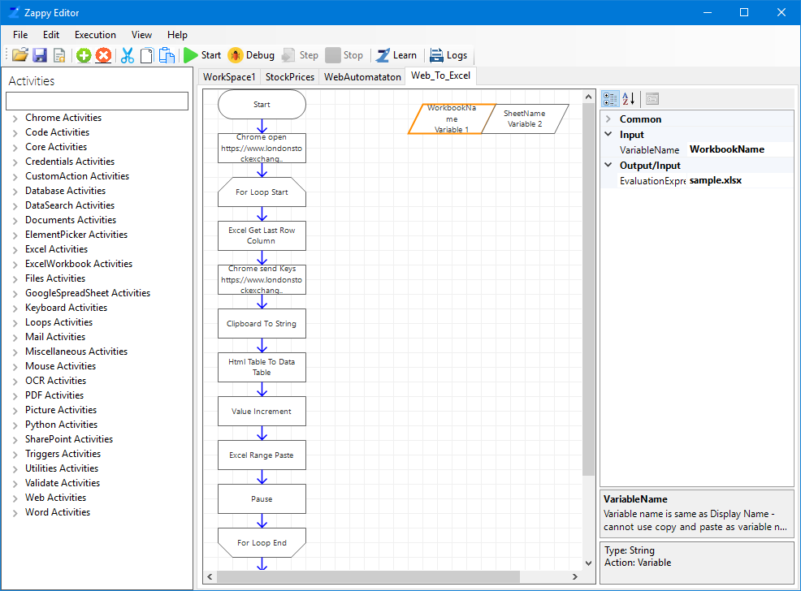

**Step 6:** Click on **Chrome Send Keys** action and set properties for it.

* **CommandTarget:** Copy the **XPath** of the required table.

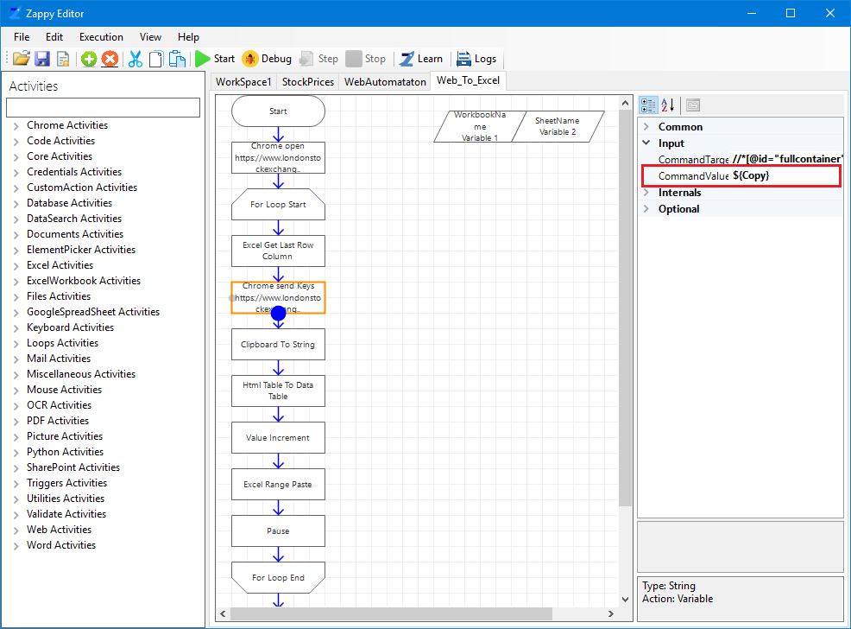

**Follow the steps to copy the Xpath of table**:

1. **Right click** on particular table from where you want to copy the data. Now click on **Inspect (or press Ctrl+Shift+I)**, HTML code will open, move the cursor and search for table tag which you want to select.

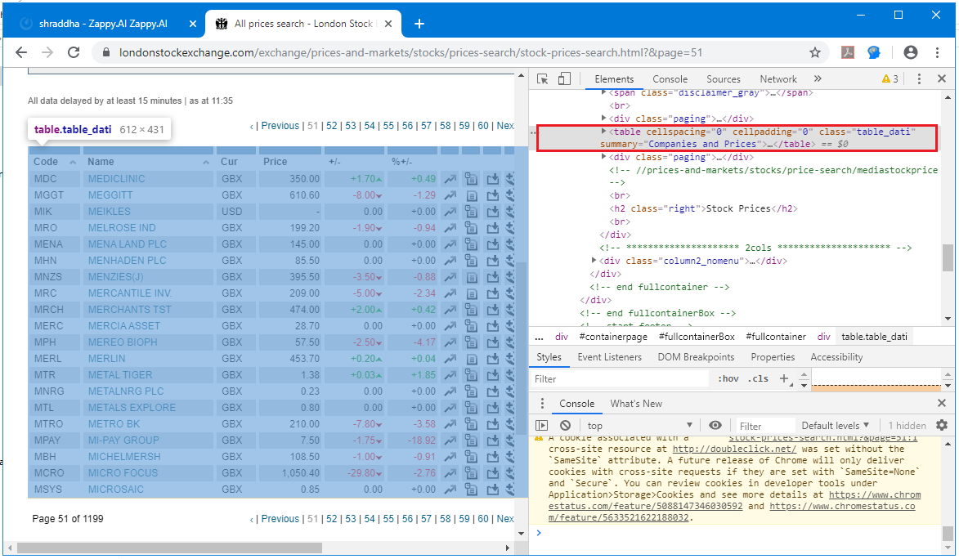

1. Then right click on the table tag, select **Copy** and from the drop-down menu select **Copy XPath.**

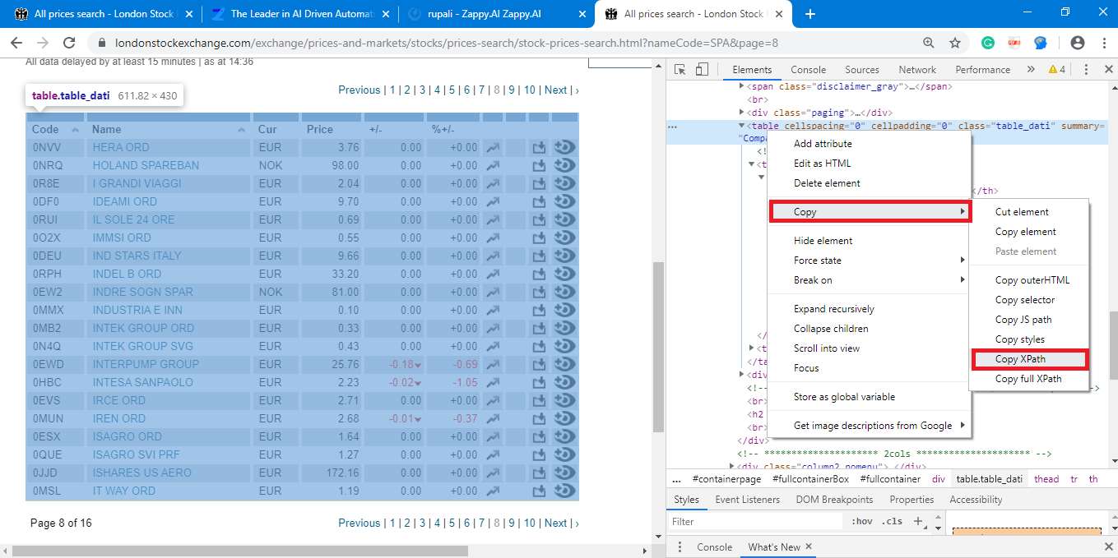

**Step 7:** Modify **Chrome mouse action** as required (can be done by clicking on Learn icon and clicking the required element once in chrome). This action is used to move from one page to next page.

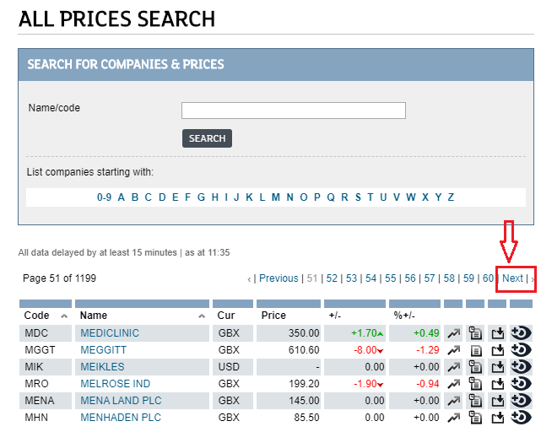

**Output:**

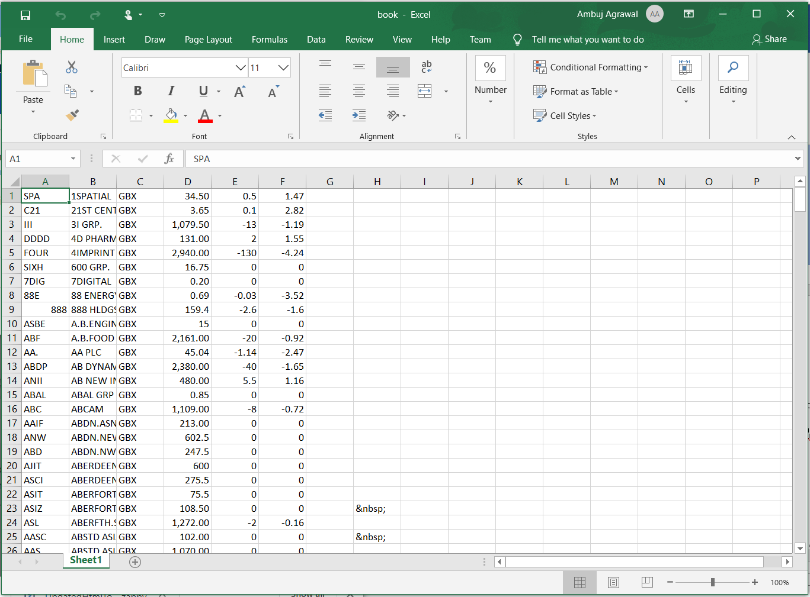

**Note: To Create** **Chrome Mouse Action & Open Chrome Action Activites.**

* Open Chrome.
* Make sure [**Zap Chrome Addin**](https://docs.zappy.ai/docs/chrome-addin) **is Enable.**
* Then click on **Zap** icon & select **Start Learning.**
* Click on **Next** Button on browser.
* Then click on Zap icon & **Stop Learning**.
* **Z** Icon will appear at the top of the chrome. Click on it.

Then select **LearnedActivities**, click on **Task Editor** button .

Zap Automation will learn both Chrome Open and Mouse Click actions.

Then use these actions in your automation by copy pasting them.

**OR**

Drag and drop **Chrome Mouse** action from activity panel and set properties for it.

**CommandTarget:** Enter **XPath** of **Next** button.

To get the **XPath** of Next button **(refer step no 5).**

**ActionUrlTab**: Enter the website URL.

**In this way we can use Zap Automation to extract table data from any website.**