**Collect FX Data from Bloomberg**

This automation shows how to extract FX Datafrom Bloomberg websites and set this extracted data in csv file.

We extract FX data from below websites:

|  |
| --- |
| https://www.bloomberg.com/quote/EURPLN:CUR |
| https://www.bloomberg.com/quote/USDPLN:CUR |
| https://www.bloomberg.com/quote/CHFPLN:CUR |
| https://www.bloomberg.com/quote/GBPPLN:CUR |
| https://www.bloomberg.com/quote/EURUSD:CUR |
| https://www.bloomberg.com/quote/EURGBP:CUR |
| https://www.bloomberg.com/quote/EURCHF:CUR |
| https://www.bloomberg.com/quote/GBPUSD:CUR |
| https://www.bloomberg.com/quote/USDCHF:CUR |
| https://www.bloomberg.com/quote/GBPCHF:CUR |

**Step 1:** Open Chrome.

**Step 2:** **Double click** on **CollectFXDataFromBloomberg.zappy** automation.

**Output**: FX Data is extracted from Bloomberg site’s and and store it in CSV file as shown

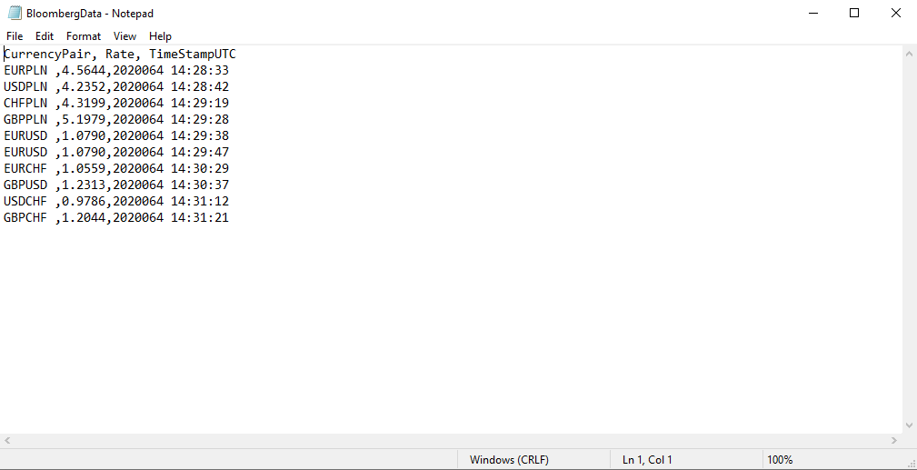

In this automation we extract the FX data from Bloomberg websites and also set the current date time.