**How to Create Automation to Extract Stock Prices from LSE Website**

This automation shows how to extract stock prices from London Stock Exchange Website.

**Step 1:** Open **LSEStock.xlsx** file.

**Step 2:** Open LSE website.

**URL:**<https://www.londonstockexchange.com/exchange/prices-and-markets/stocks/prices-search/stock-prices-search.html>

**Step 3:** Right click on **Zap** icon and select **Start learning**. Copy the **1st Company Code** and paste it in search tab, then click on **SEARCH**.

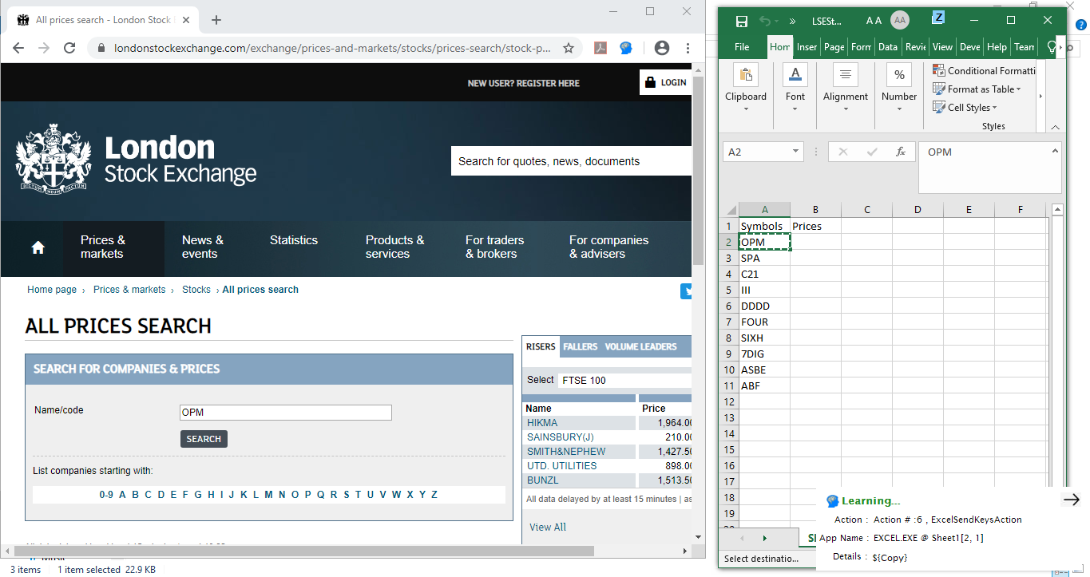

**Step 4:**  **Copy** the **price** of searched Company Code and **paste** it in Price Column. **Then put the cursor on next row as shown.**

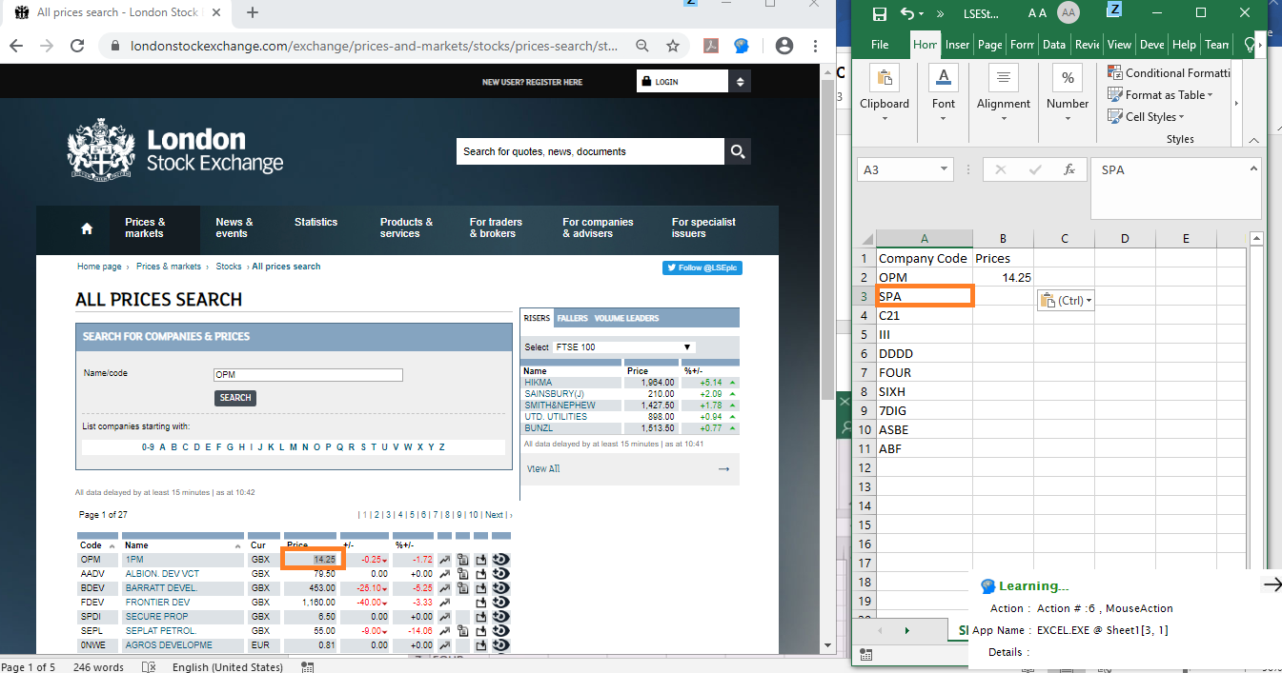

**Step 5:** Right click on **Zap** icon and select **Stop learning**.

**Step 6:** Click on **Z** icon that appears on the top of excel window. Select all **LearnedActivities** from drop down list and select how many times you want to run the task and Click on **Run**.

If you want to run the automation till the end of excel sheet then select Last Row Excel and it will repeat the automation till the last row in excel sheet.

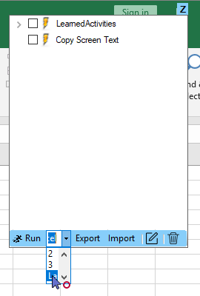

**Output:**

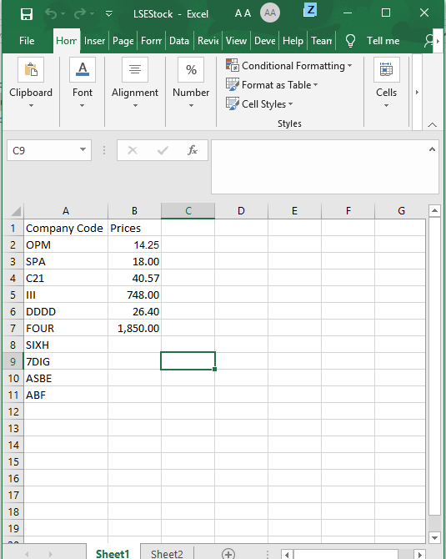

**How to Modify Automation:**

We can also Modify automation by opening this automation in Task Editor.

After running LearnedActivity we will see **CustomActivities**.

Select all CustomActivities and click on **Task Editor Icon** as shown.

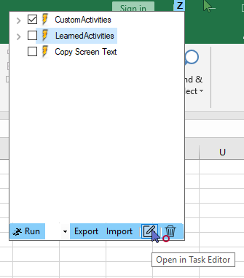

We can see automation in Task editor,

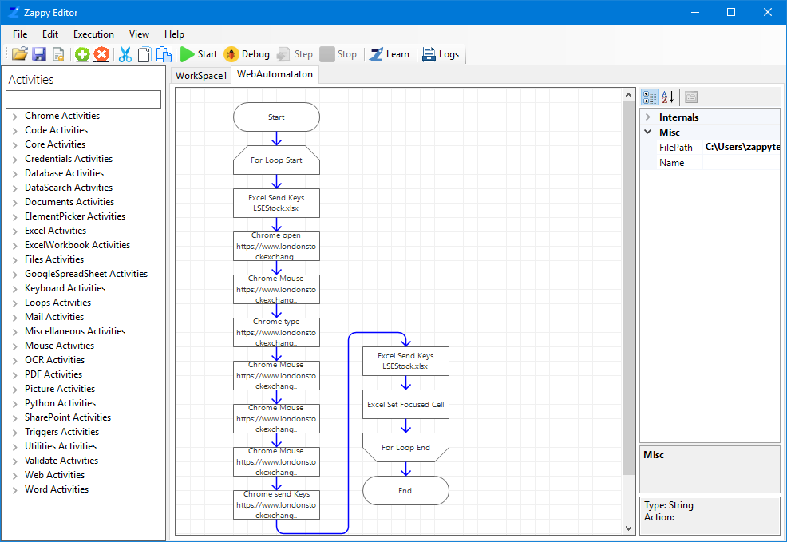

**In this way we can use Zap Automation Start and Stop learning functionality to extract data from any website.**