**Get Contact Email Id from LinkedIn**

This automation shows how to get contact email Id from LinkedIn.

**Step 1:** Open your CSV or Excel file.

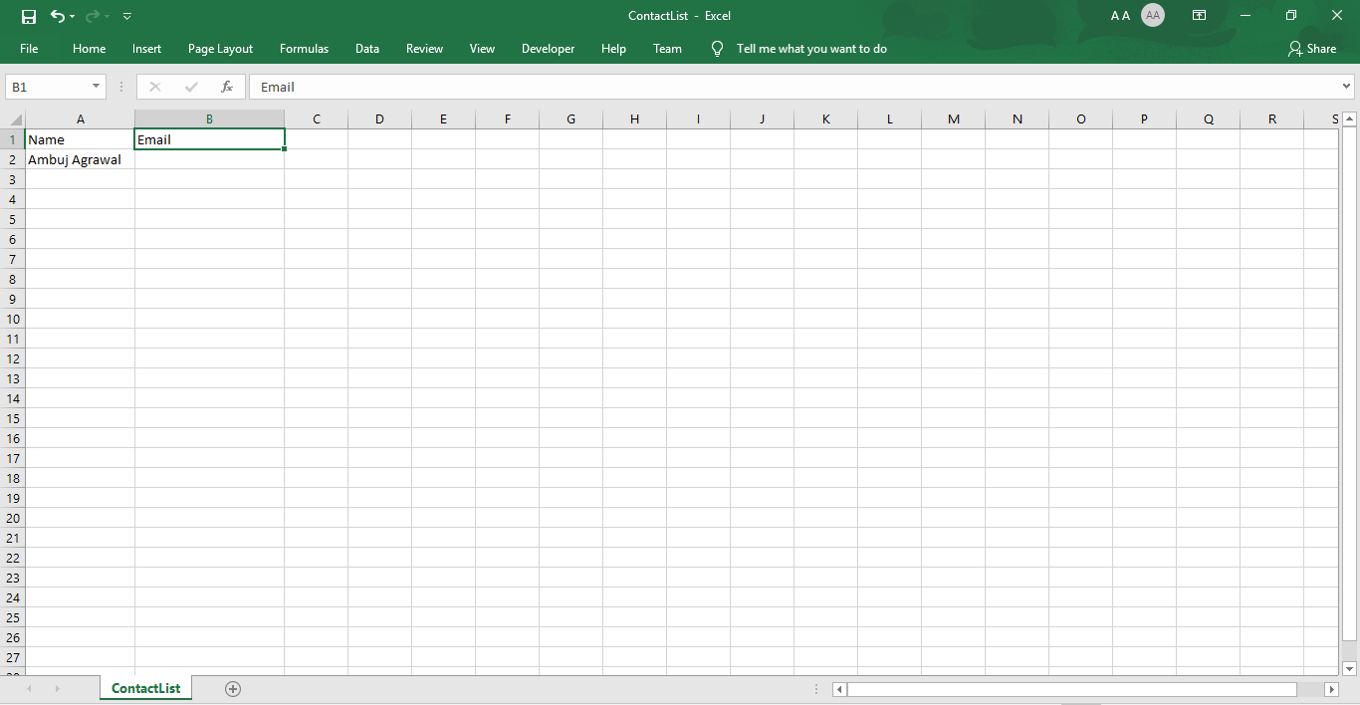

**Step 2:** Right click on **Zap** icon and select Task Editor (or Double click on Zap icon).

**Step 3:** Open the **“LinkdinGetContactEmailIDs.zappy”** file.

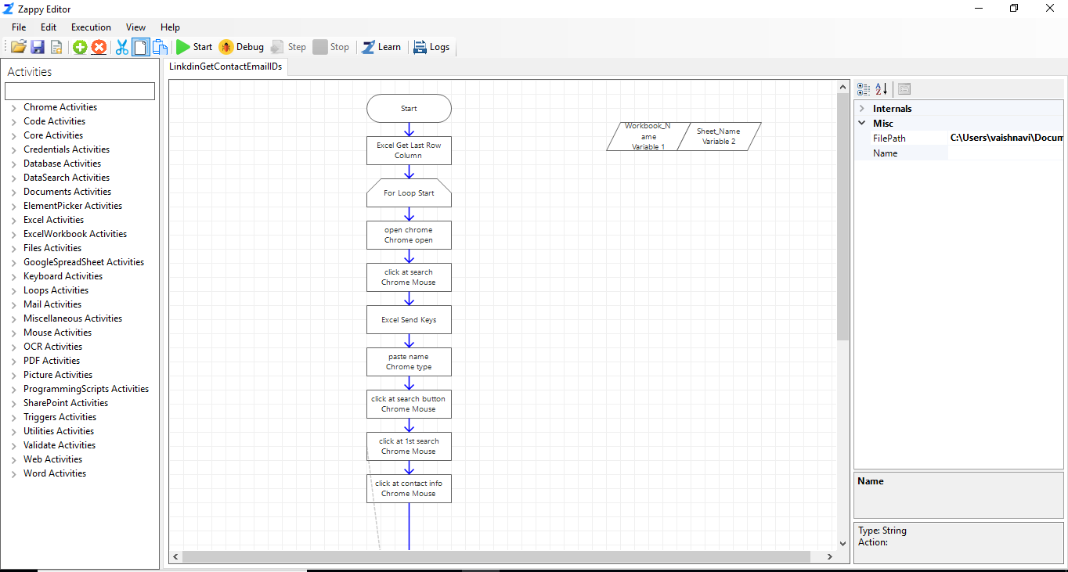

You can change **WorkBook_Name** and **Sheet_Name** in **Variable 1** and **Variable 2** respectively if using a different excel file.

**Step 4:** Sign In to your **LinkedIn** account.

**Step 5:** To start the execution, click on start**.**

**Output:** We will see that the email id is extracted from LinkedIn.

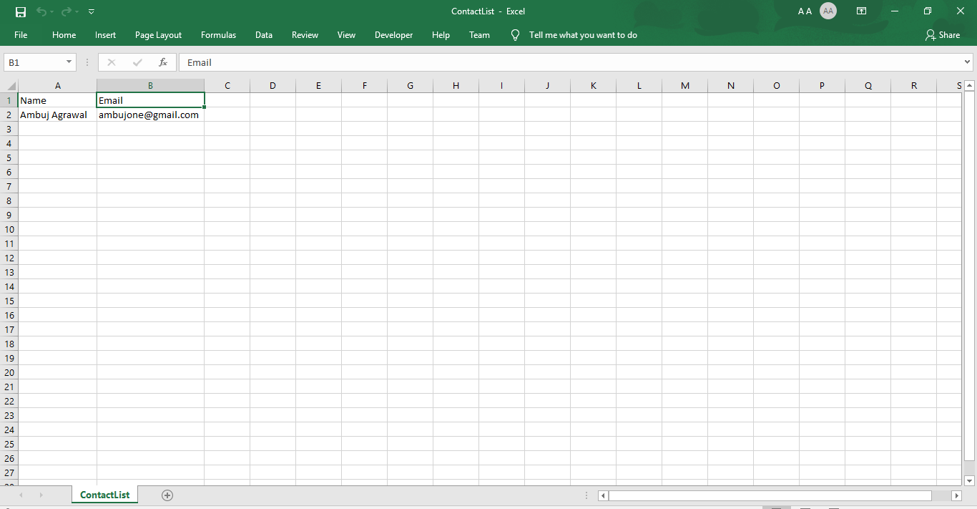

Likewise, we can enter thousands of names in an Excel file and using Zap Automation we can get contact email IDs for that name. We can also get the **Profile pdf**.