**PDF To Text Convertion**

Following are the steps for creating Zap Automation to convert PDF to text.

**Step 1:** Right click on Zap icon at bottom right corner of your window and select **Task Editor** or double click on **Zap** icon.

**Step 2:** Drag and drop **Select File** action from Activity Panel and set the properties.

**Step 3:** Drag and drop **Enable Reading Protected PDF** action from Activity Panel and set the properties.

* **Path –** Set the reference of **Select File** action’s output **FilePath.**

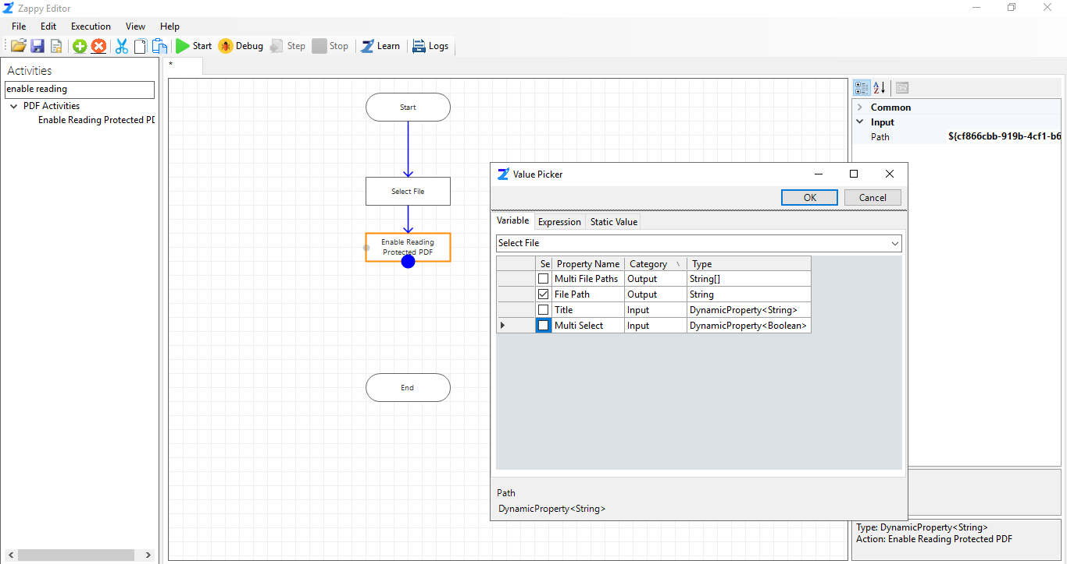

**Step 4: T**o create the text file path, Drag and drop **String Replace** action from Activity Panel and set the properties.

**InputString:** Set the reference **Select File** action’s output **FilePath.**

**OldValue:** Enter .pdf.

**NewValue:** Enter .txt

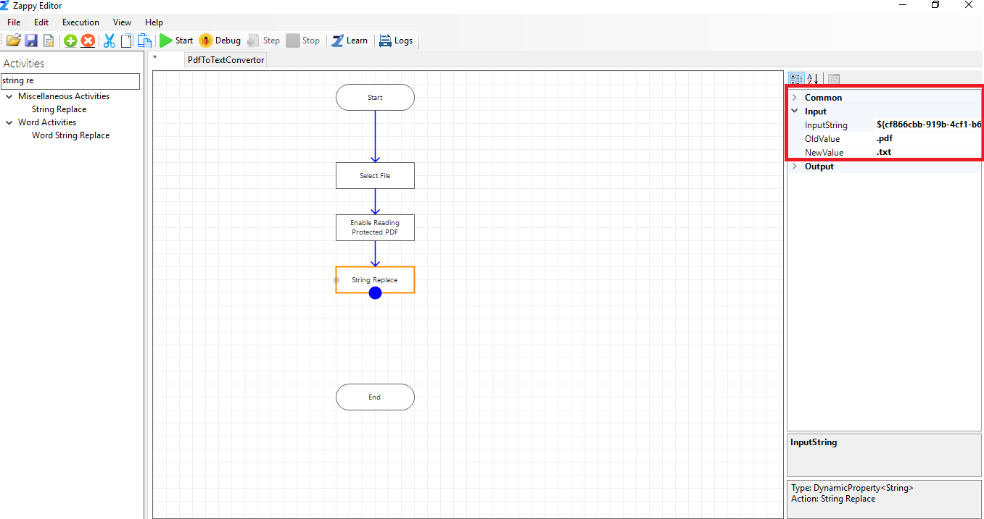

**Step 5:** Drag and drop **PDF To Text** action from Activity Panel and set the properties.

* **InputFilePath –** Set reference of **Select File** action output **File Path**.

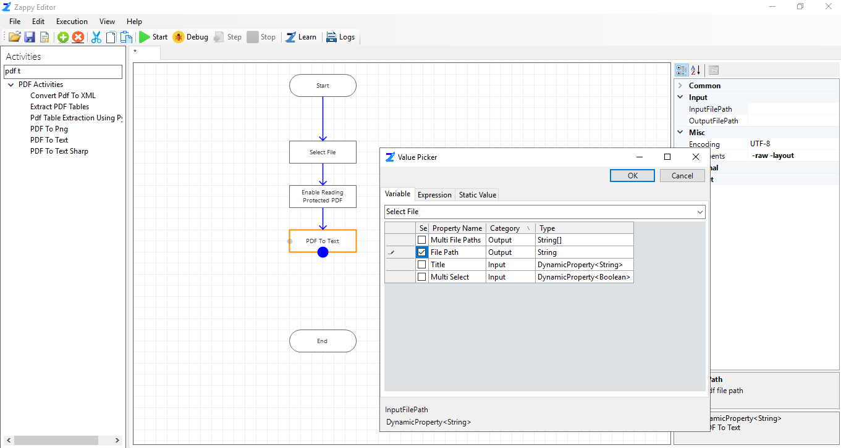

**Step 6:** Drag and drop **File Open** Action from Activity Panel to open the converted text file and set the properties.

* **FilePath –** Set reference of **PDF to Text** action Input **OutputFilePath.**

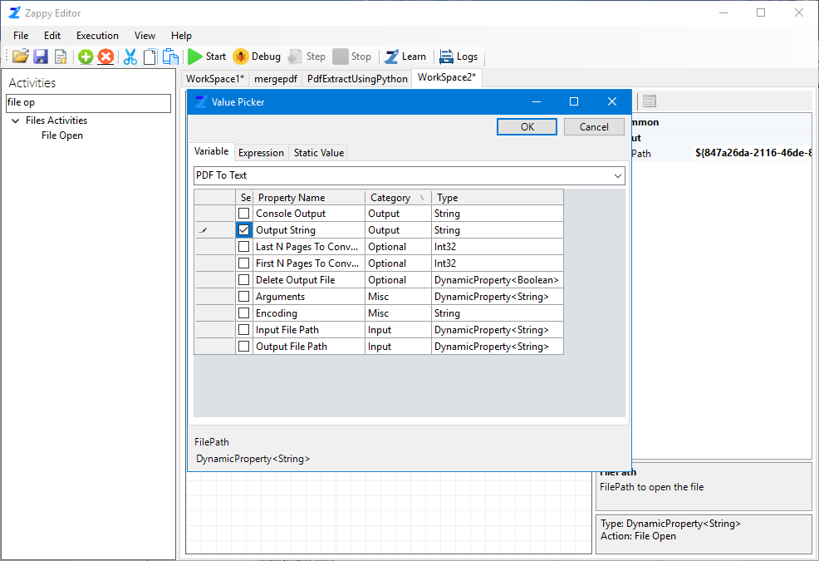

**Step 6:** Save your automation.

**Step 7**: **Execute** it (Once the automation is created,you can execute it whenever you want).

**Output:** Converted PDF file.

