**Add Patient Details into Internal Application**

**Step 1:** Open an excel file which contain patient details .

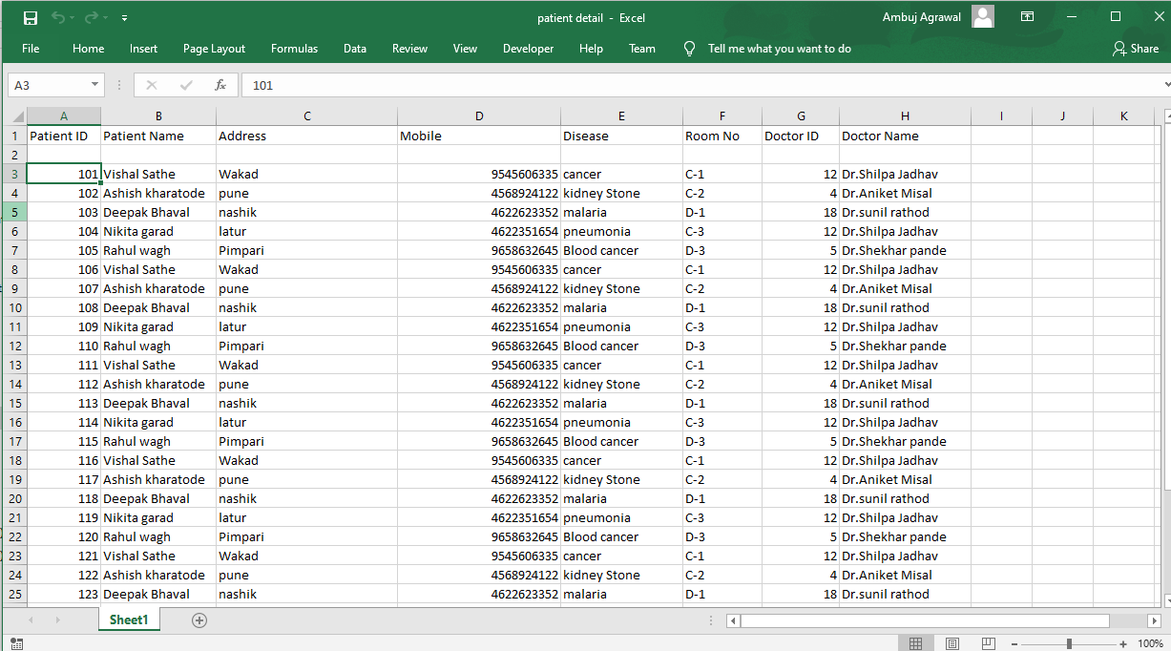

**Set the cursor on the row and column from where your data entry starts.**

**Step 2:** Open **AddPatient.exe**

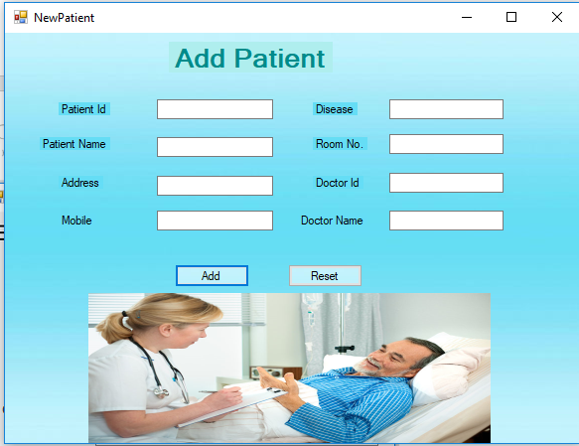

**Step 3:** Double click on **Patient.zappy** automation.

**Step 4:** Run Zappy Task window will pop up, clcik on **OK**.

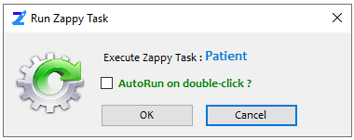

Will see Zap automatically paste each row contents from the excel sheet to **AddPatient.exe**

You can see “**Successfully Executed Task**” message from Zap Automation on successful execution.

**In this way we can use Zap Automation to fill any form details.**