**Settlement Upload**

This document explains you how to use Start/Stop Functionality of Zap Automation.

**Step 1:** Open an excel file.

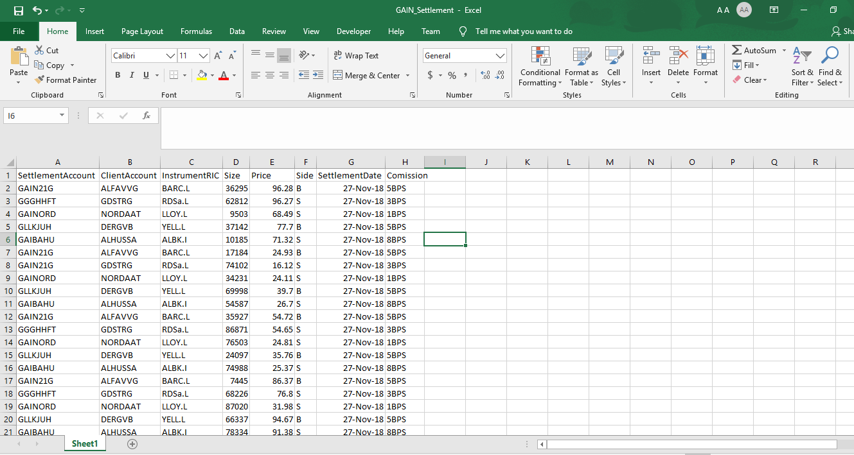

**Step 2:** Open internal applications **- MiraiSettlements.exe** and **SettlementUpload.exe**

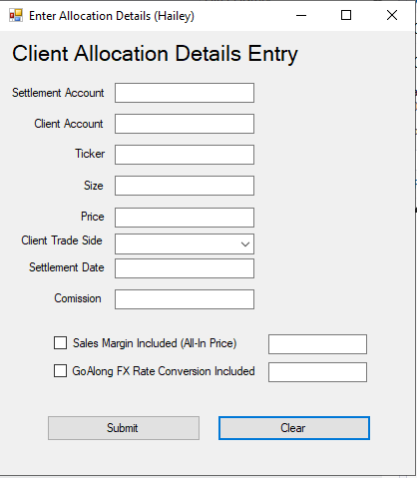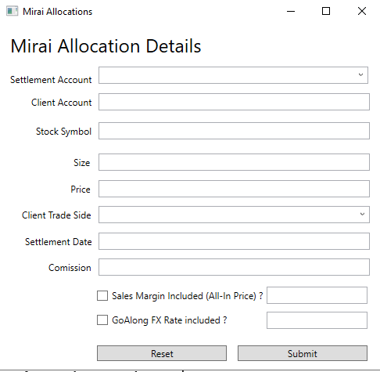

**Step 3**: Right Click on **Zap** icon and select **Start Learning.**

Copy the 1st data row from excel and paste it in both internal application.

Click on two check box and click on Submit in both application as shown .

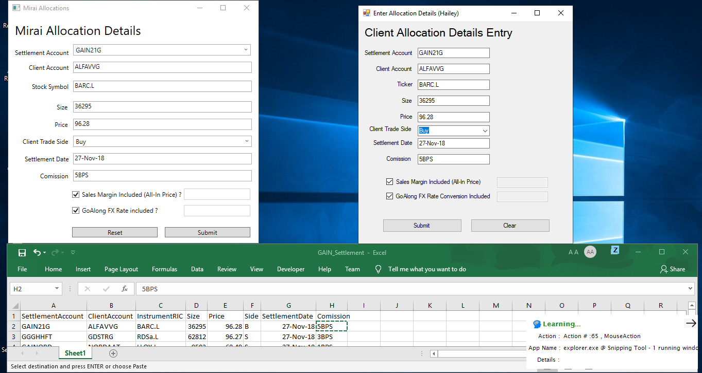

**Step 4:** Put the Cursor on next row. Now **Select stop learning**.

**Step 5:** Click on **Z** icon that appears on the top of excel window. Select all **LearnedActivities** from drop down list and select how many times you want to run the task and Click on **Run**.

If you want to run till the end of excel sheet then select Last Row Excel and it will repeat the automation till the last row in excel sheet.

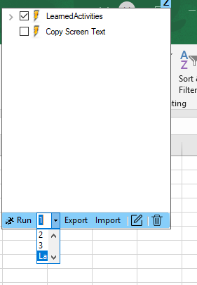

Zap Automation automatically paste each row contents from the excel sheet into both the internal application, clicks on Check Box and also submit the data by clicking on Submit button.

**How To Modify:**

We can also modify automation by opening this automation in Task Editor.

After running LearnedActivity we will see **CustomActivities**.

Select all CustomActivities and click on **Task Editor Icon** as shown.

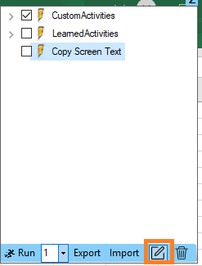

We can see the automation in Task editor,

