**Extract Required data from PDF**

Following are the steps for how to use Zap Automation to extract the data from PDF files and save it into Excel.

**Step 1:**Open **ExtractedPdfTexts.xlsx** file.

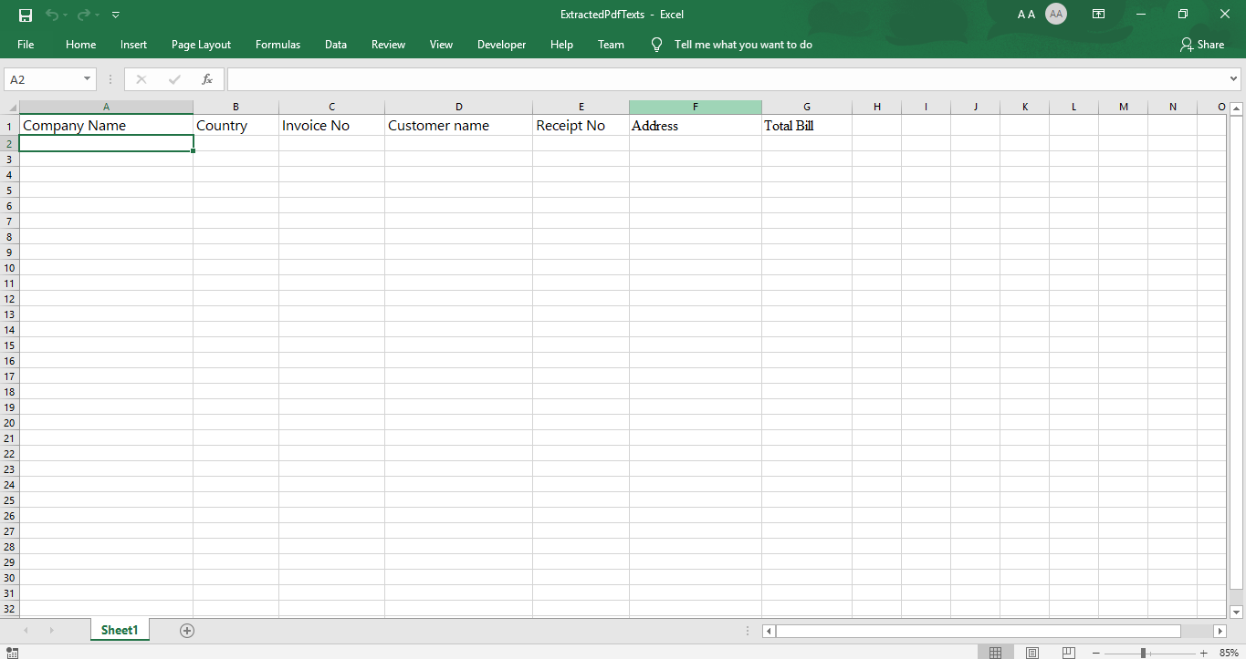

**Step 2:** Right click on Zap icon at bottom right corner of your window and select **Task Editor** or double click on **Zap** icon.

**Step 3:** Open the **ExtractValues.zappy** task.

**Automation:**

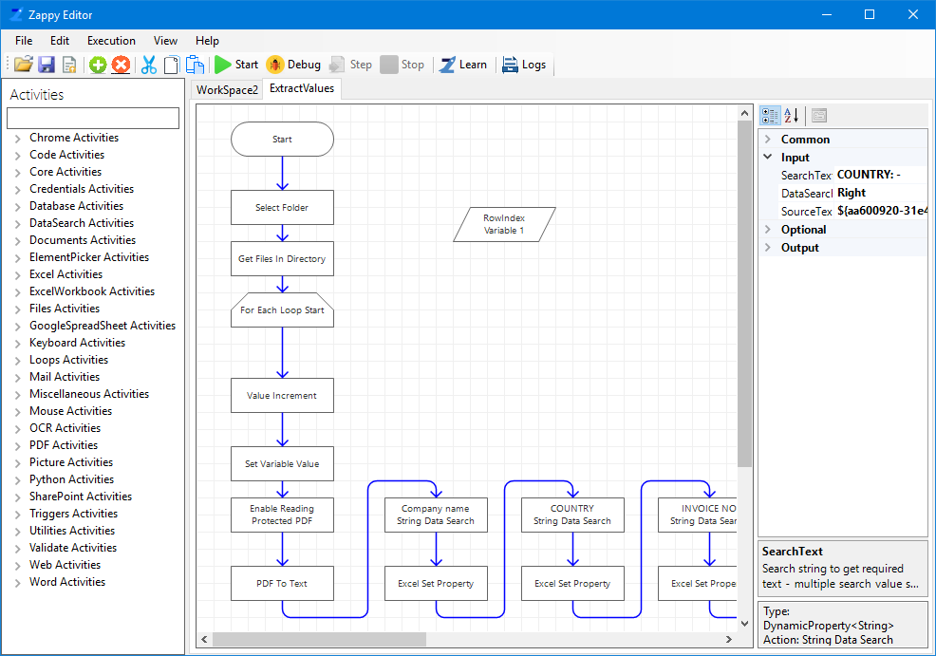

**Step 4:** Click on the action “**String Data Search**” and make changes on property panel according to your PDF file.

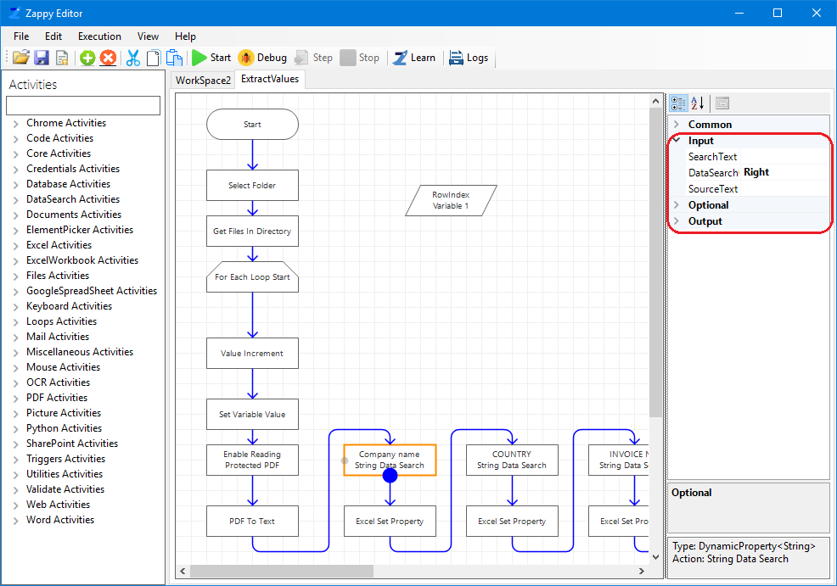

* **DataSearchOrientation –** Select the orientation of searching as “Right”, “Left”, “Top”, “Bottom”, “CustomOffset”.
* **Result Text Position –** Set the text position where you search the data.
  + **Allwords-** Returns full string on the (Right”, “Left”, “Top”, “Bottom”) according to the selection in DataSearchOrientation.
  + **SingleWordFirst-** Returns first word on the (Right”, “Left”, “Top”, “Bottom”) according to the selection in DataSearchOrientation.
  + **SingleWordLast-** Returns last word on the (Right”, “Left”, “Top”, “Bottom”) according to the selection in DataSearchOrientation.
  + **CustomOffsetHorizontal-** Returns the text until the selected separator in ResultValueSplitChar.
* **SearchText –** Enter the text you want to search.
* **SourceText –** Source text in which you have to search for data.

(On the right hand side in SearchText, enter the text you want to search. In DataSearchOrientations select the position of the data from the drop down box to be extracted from your input document. We have selected Right from the drop down box as our Company’s Name is on the right side of the field Company Name.)

**Step 5:** Click on **Excel Set Property** and on RHS enter your created **Workbook Name** and **SheetName** as shown below.

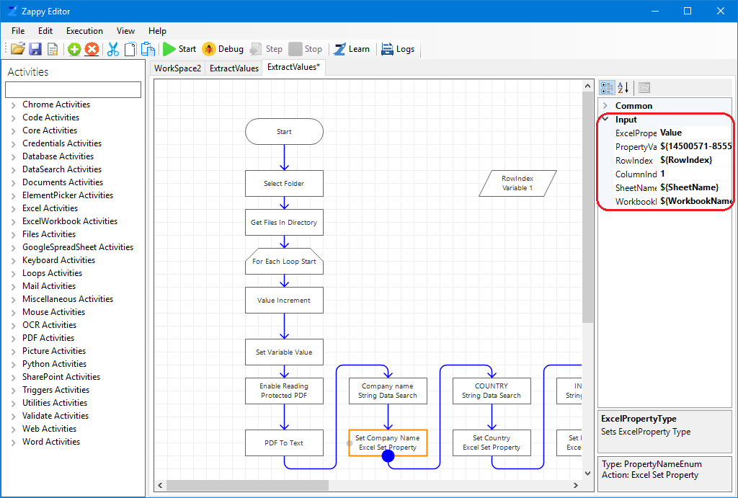

Then save your automation by clicking on.

**Step 6:** Click on **Start**.

You will see “**Successfully Executed Task**” message from Zap on successful execution.

**Output:**

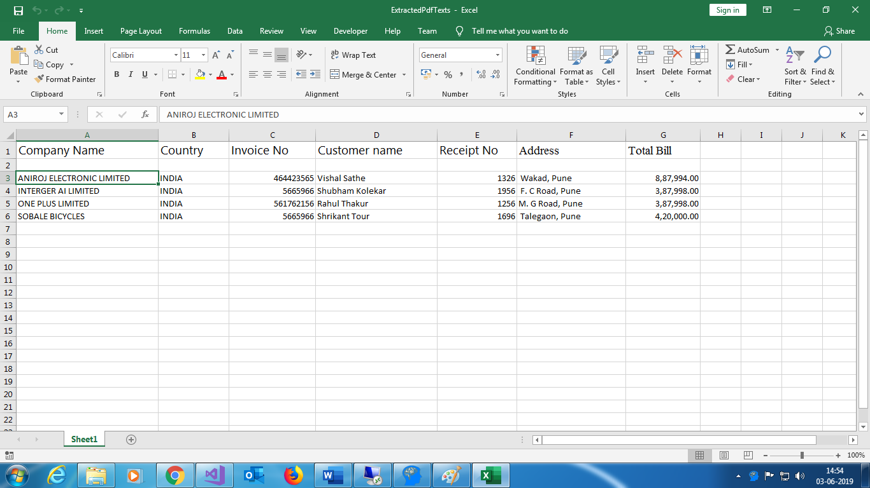

**In this way we can modify the automation for your PDF’s and save it. This saved automation can be used for any number of PDF’s for extracting same fields.**

**If you have to add new fields or delete the existing fields you can easily do it by dragging and dropping StringDataSearch action from the activity panel in task editor of saved automation and use it for other PDF’s also.**